Installing and Running the Wordpress

Acceptance Testing Suite

Acceptance testing, also known as functional testing, black-box testing, release acceptance, and many other names, is designed to test “user stories”. These are high level tests designed to check how the application actually works by covering business logic and user interface components. This is slightly different from Unit Testing, which is designed to test individual pieces of code in isolation.

The Wordpress acceptance test suite relies on two pieces of technology, Selenium RC and PHPUnit. They are “black-box” tests; they do NOT have to be run on the server where a copy of Wordpress is installed. However you do need to be on a system that can access the Wordpress install you want to test via an internet browser.

This document is designed to help users on Windows operating systems install and run the test suite.

# Technologies

1. Selenium – Web application testing system, allows automated testing of browser interaction, RC is the remote control component of the system.
2. JAVA – engine that runs Selenium
3. PHPUnit – industry standard framework for writing, running, and analyzing tests for PHP.
4. PHP – language used for interpreting and running PHPUnit tests.
5. Testing_Selenium – simple library to send requests and interpret responses from Selenium RC
6. PEAR – both a script for installing PHP library packages, and the repository providing PHP library packages

# Requirements

1. An operating system with a browser that can access the site you want to test. Selenium supports multiple browsers, including Internet Explorer and Firefox.
2. Selenium RC. This is a JAVA based server that talks to browsers and submits results back in a format that PHPUnit understands.
3. PHPUnit and the Testing_Selenium package from PEAR. PHPUnit is the industry standard for PHP testing. The Testing_Selenium package from PEAR helps PHPUnit talk to the RC server correctly.
4. The Wordpress Acceptance Testing Suite.
5. Some version of PHP installed on your system, used by PHPUnit to run the unit tests. This does NOT have to be the same version as the PHP used for the Wordpress install you are testing and you only need the CLI version of PHP.

# Step by Step Installation

1. Install Java. The majority of systems already have Java installed.
   1. Visit <http://www.java.com/>
   2. Click on the “Do I have Java?” link
   3. If you have Java, verify your Java version and install any updates, if you do not have Java, follow the on screen instructions for installation.
2. Install Selenium RC
   1. Download from <http://seleniumhq.org/download/>
      1. You want the Selenium RC package, you do not need any of the other packages
      2. Currently the RC version is 1.0.3 (as of 6/2010)
      3. This may download very slowly, be patient

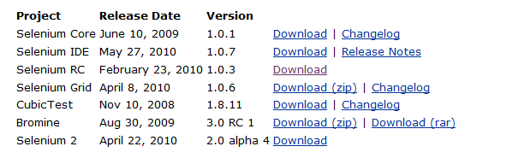

* 1. Extract the .zip file and place it in a location where the executable can run.
     1. This means you will most likely need administrator permissions.
     2. Your program files folder (usually “C:\Program Files (x86) “ on 64 bit systems and “C:\Program Files“ on 32 bit systems) is a good location.

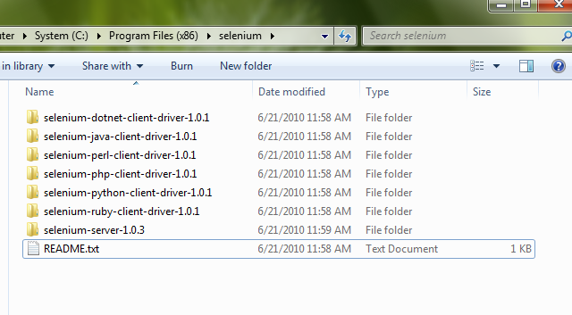

1. Install PHPUnit
   1. If you have PEAR on your system, you may install PHPUnit using PEAR, however generally most windows systems do not have PEAR installed, or do not know how to use PEAR on a windows system. If you feel comfortable with this method the following commands will work.

**pear channel-discover pear.phpunit.de**

**pear channel-discover pear.symfony-project.com**

**pear install phpunit/PHPUnit**

* 1. If you do not have PEAR installed or do not feel comfortable in a command line environment, you can install PHPUnit by hand.
     1. Download the lasted version of PHPUnit from <http://pear.phpunit.de/get/>
     2. Currently the lastest version is 3.4.14 (as of 6/2010)
     3. The archive is in .tgz format. If you do not have the tools to unarchive this format, I would recommend <http://www.7-zip.org/> - it is free, open source, works on all versions of windows and opens just about any archive format.
     4. Unarchive the downloaded files and place them on your filesystem. I currently keep my PHPUnit installs in C:\htdocs\PHPUnit . The location doesn’t really matter; just remember where you placed the files.

1. Install Testing_Selenium
   1. As with PHPUnit, you may install Testing_Selenium using PEAR.

**pear install Testing_Selenium-0.4.3**

* 1. You many also install Testing_Selenium manually
     1. Download the latest version from <http://pear.php.net/package/Testing_Selenium/download>
     2. Extract it as you did PHPUnit and place it somewhere you remember

1. Install PHP
   1. You may install PHP using the .msi from php.net
   2. Or do my famous “5 minute install”
      1. Download the zip version (I suggest VC9 NTS) from <http://windows.php.net/download/>
      2. Unzip the archive
      3. Drop it somewhere – C:/Program Files is always a good choice
      4. Rename php.ini-dist to php.ini
2. Grab the test suite
   1. Use tortoisesvn or some other windows subversion client
   2. Check out <https://svn.omniti.com/wp_mssql/trunk/tests>

# Finally – Running the Tests

You now have all the pieces to run the tests. Running the tests involves some command line work, but there are batch files provided to make things a bit easier

1. Start the Selenium RC server
   1. There is a batch file in the tests directory named selenium-rc.bat. You need to change two lines in the file – the absolute path to your java.exe and the absolute path to your selenium server .jar file. You can use the paths currently in the file for a template as to where the files are usually located. Save your changes and double click the bat file to start the server.
   2. Alternatively you can open cmd.exe and do all the commands for starting the server by yourself

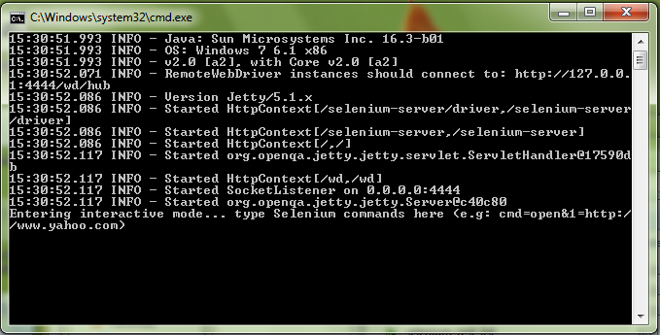

1. Run the Tests
   1. Make sure you’ve started the selenium-rc server. Do not close the dos box that popped up.
   2. Open up run-tests.bat. You need to change the path to your PHPUnit install, the Path to your Testing_Selenium location, and the Path to your php.exe. Then double click the .bat file to run the tests

Current caveats – the test bootstrap work is not complete yet. The testing paths are currently hard coded to localhost, so you currently need to open the file and edit the urls or test a local install. I’d like to have a small script to write out the batch files for the user instead of having them enter them manually.