# Choosing your stack up

This document is intended to be used to specify the stack up used when manufacturing a PCB.

First, we’ll go through common stack up for 2, 4 and 6 layers. If you need some specific stack up, the next part will go into detail on how PCB are made, how to choose and understand the thickness of each layer.

Finally, we’ll talk about impedance matching.

Surface finish.

# Common stack up

# 2 layers examples:

# 

# You can also find some manufacturer stack up with multiple prepreg instead of a core.

# 4 layers examples:

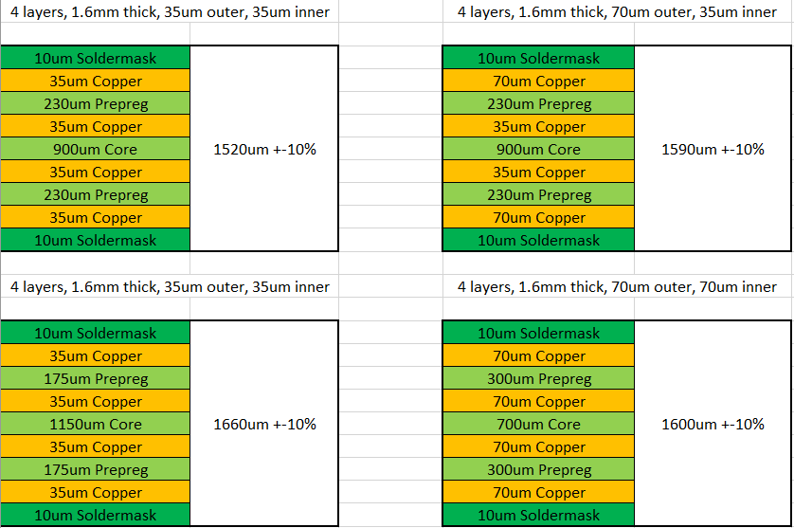

# 6 layers examples:

# 

# Keep in mind that you can have ‘uncommon’ stack up. To understand that let’s see how we make a PCB.

## How PCBs are made

PCBs are made from core insulator with outer copper foil.

The core is pressed with another core or a copper foil using prepreg material.

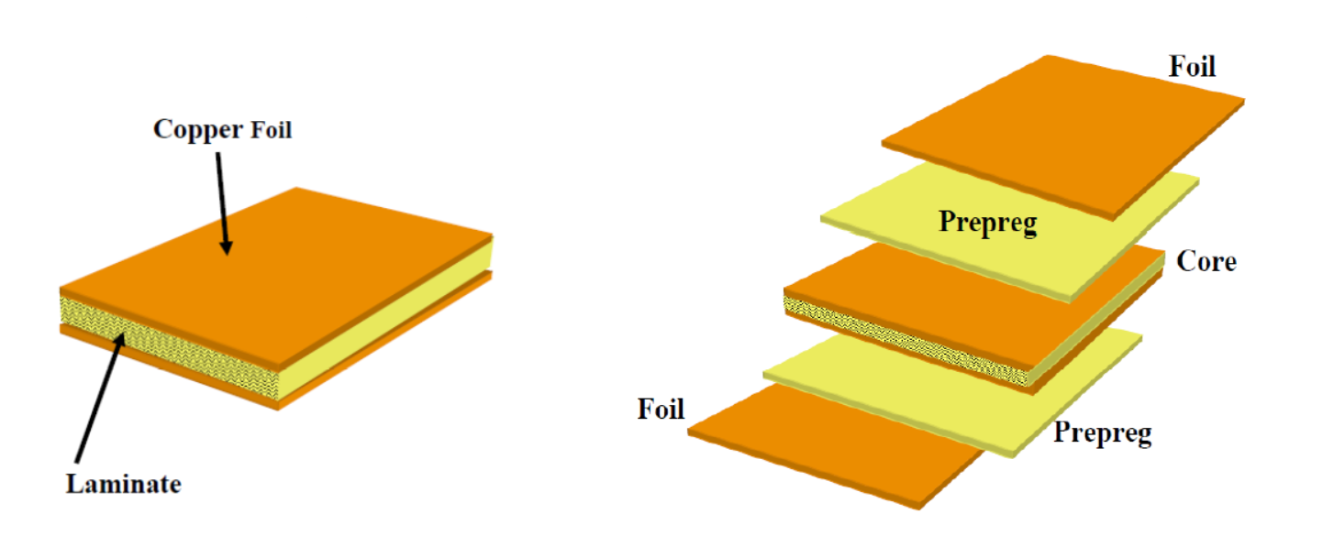

2 layers: 1 core

4 layers: 1 core, 2 prepreg, 2 copper foil

6 layers: 2 cores, 3 prepreg, 2 copper foil or 1 core, 4 prepreg, 2 copper foil

Here are the standard cores thickness with the copper thickness available.

|  |  |
| --- | --- |
| Standard Cores | |
| Core thickness (µm) | Allowed copper thickness |
| 50 | 18µm/18µm |
| 100 | 18µm/18µm; 35µm/35µm |
| 150 | 18µm/18µm; 35µm/35µm; 70µm/70µm; 105µm/105µm |
| 200 | 18µm/18µm; 35µm/35µm; 70µm/70µm; 105µm/105µm |
| 300 | 18µm/18µm; 35µm/35µm; 70µm/70µm; 105µm/105µm; 140µm/140µm |
| 350 | 18µm/18µm; 35µm/35µm; 70µm/70µm; 105µm/105µm; 140µm/140µm; 210µm/210µm |
| 400 | 18µm/18µm; 35µm/35µm; 70µm/70µm; 105µm/105µm; 140µm/140µm; 210µm/210µm |
| 500 | 18µm/18µm; 35µm/35µm; 70µm/70µm; 105µm/105µm; 140µm/140µm; 210µm/210µm |
| 550 | 18µm/18µm; 35µm/35µm; 70µm/70µm; 105µm/105µm; 140µm/140µm; 210µm/210µm |
| 600 | 18µm/18µm; 35µm/35µm; 70µm/70µm; 105µm/105µm; 140µm/140µm |
| 700 | 18µm/18µm; 35µm/35µm; 70µm/70µm; 105µm/105µm; 140µm/140µm |
| 800 | 18µm/18µm; 35µm/35µm; 70µm/70µm; 105µm/105µm; 140µm/140µm |
| 900 | 18µm/18µm; 35µm/35µm; 70µm/70µm; 105µm/105µm |
| 1000 | 18µm/18µm; 35µm/35µm; 70µm/70µm; 105µm/105µm |
| 1200 | 18µm/18µm; 35µm/35µm; 70µm/70µm; 105µm/105µm |
| 1500 | 18µm/18µm; 35µm/35µm; 70µm/70µm; 105µm/105µm |
| 2000 | 18µm/18µm; 35µm/35µm; 70µm/70µm; 105µm/105µm |
| 2400 | 18µm/18µm; 35µm/35µm; 70µm/70µm; 105µm/105µm |
| 3200 | 18µm/18µm; 35µm/35µm; 70µm/70µm; 105µm/105µm |

To ‘glue’ an etched core to another core, or a core to a copper foil, we use prepreg (thin layer of glass fiber). You can stack multiple layers of prepreg together to reach the desired thickness.

As the prepreg are pressed with other materials, the thickness may vary, but this variation is included in the final tolerances.

Here is a reduced list of common prepreg:

|  |  |  |
| --- | --- | --- |
| Standard FR4-Prepreg thickness | | |
| Glass style | Typical thickness (µm) | Thickness after 1 pressing (mm) |
| 1080 | 75 | 70 |
| 2116 | 120 | 115 |
| 7628 | 190 | 180 |
| 106 | 60 | 55 |
| 2125 | 105 | 100 |
| 2165 | 160 | 150 |

## FR4-PCB

Standard FR4-PCB thickness:

|  |  |
| --- | --- |
| Standard FR4-PCB thickness | |
| 2 layers | 0.2mm/0.4mm/0.6mm/0.8mm/1mm/1.2mm/1.6mm/2mm/2.4mm/3.2mm |
| 4 layers | 0.4mm/0.6mm/0.8mm/1mm/1.2mm/1.6mm/2mm/2.4mm/3.2mm |
| 6 layers | 0.6mm/0.8mm/1mm/1.2mm/1.6mm/2mm/2.4mm/3.2mm |

Total PCB thickness tolerance:

* Thickness < 1 mm: +- 0.1 mm
* Thickness >= 1 mm: +- 10%

Standard copper thickness:

|  |  |  |  |
| --- | --- | --- | --- |
| Standard Copper Foil thickness | | | |
| Industry terminology | Area weight (g/m²) | Nominal thickness (µm) | Min recommended spacing (mm) |
| 12 µm | 106.8 | 12 | 0.09 |
| 1/2 Oz | 152.5 | 17.5 | 0.09 |
| 1 Oz | 305 | 35 | 0.09 |
| 2 Oz | 610 | 70 | 0.2 |
| 3 Oz | 915 | 105 | 0.254 |
| 4 Oz | 1220 | 140 | 0.355 |

In your board specifications, the stack up should appear like following:

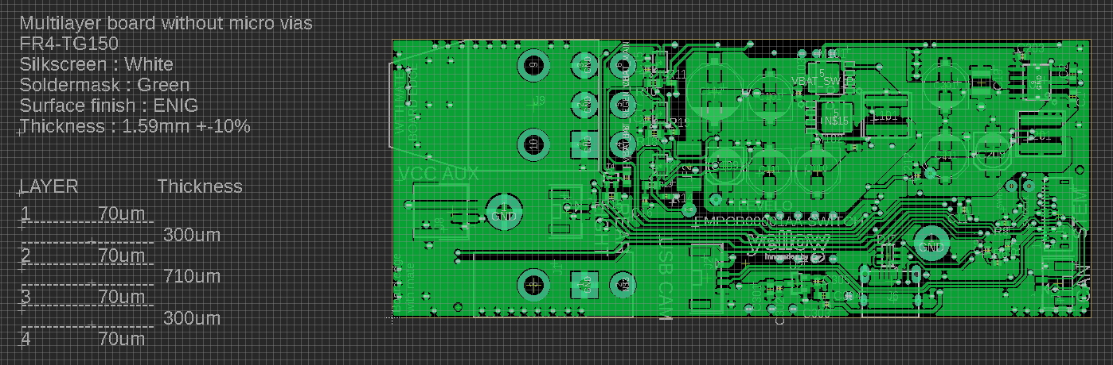

Note that you should also specify the Tg coefficient. Eurocircuit define Tg as following:

*“Tg stands for Glass transition temperature. Tg is the base material parameter that stands for the temperature (°C) on which the base material become mechanically unstable. Tg is the value that needs to guarantee the mechanical stability of the PCB during operational lifetime of the PCB.”*

Permittivity of FR4 :

εr@1 MHz = 4.2

## FFC / FPC

## FFC: Flexible flat cable

## FPC: Flexible printed circuit

## Flexible board looks like the following picture:

## C:\Users\Sylvain Rouland\AppData\Local\Packages\Microsoft.Office.Desktop_8wekyb3d8bbwe\AC\INetCache\Content.MSO\8D91BF22.tmp

## They are often used to replace a cable harness (FFC), or as a PCB but flexible (FPC).

## The thickness is usually between 0.1 and 0.3mm for 1 or 2 or 4 layers.

## For this type of printed circuit, the base material is polyimide. To stack polyimide to copper we use adhesive material. The external dielectric (coverlay) is also polyimide.

|  |  |
| --- | --- |
| Standard polyimide thickness (µm) | 12.5 / 25 / 50 / 75 / 100 |
| Copper foil thickness (µm) | 5 / 7 / 9 / 12 / 18 / 35 / 70 |
| Adhesive thickness (µm) | 13 / 20 / 25 |

## If you are designing an FFC, you will probably need to increase the thickness of your flex on the ZIF connector. To do this, you have to specify a Stiffener thickness to reach the desire thickness. You can also use it under big components where delamination is a problem. Depending on the thickness, stiffener can be polyimide of FR4.

|  |  |  |
| --- | --- | --- |
| Stiffener | FR-4 | Thickness between 0.13mm to 3.18mm |
| Polyimide | 12.5μm / 25μm / 50μm / 75μm / 125μm |

## Stiffener minimum hole diameter: 0.38 mm

## εr@1 KHz = 3.5

## More information : <https://www.minco.com/~/media/WWW/Resource%20Library/Flex/Minco_FullFlexDesignGuide.ashx>

## AL-PCB

Aluminum PCB are often needed when a high dissipative coefficient is crucial, such as high power leds design.

While standard FR4 has a thermal conductivity of 0.3W/mK (depending on copper thickness and width), aluminum PCB can reach 4W/mK up to 8W/mK.

In addition, aluminum has a higher durability, and is a lightweight metal.

For 2 layers design, you can either choose an aluminum core with copper on each side or a double layer with aluminum on one side.

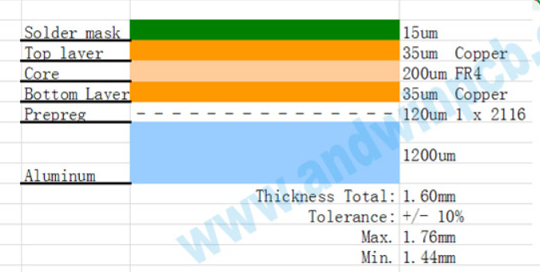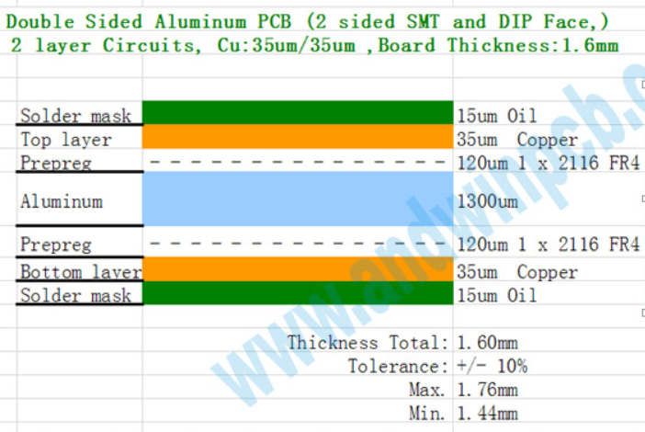

|  |  |
| --- | --- |
| Metal core (AL) 1 or 2 layers | |
| Standard thickness (mm) | 0.5 / 0.8 / 1.0 / 1.6 / 2.0 |
| Copper thickness (µm) | 35µm / 70µm / 105µm |
| Insulation thickness (µm) | 75µm / 100µm / 125µm / 150µm |
| Thermal conductivity | 1.0 - 8.0W/mK (1W/mK steps) |

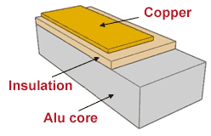

## Impedance calculation

## Suggested tool to use: <http://www.saturnpcb.com/pcb_toolkit/>

## Impedance matching is useful when you want to maximize power transfer and reduce SWR (or reflection coefficient).

## When defining your stack up, you have to know if you have impedance matching to reach.

## Each stack-up will have a specific impedance for each trace width. To calculate it you have to know:

## Copper thickness

## Reference Plane distance to trace

## Physical configuration (coplanar, coplanar waveguide, broadside or stripline)

## εr at 1GHz (depending if you are on a FR4 or a flex board)

## The purpose of this is to determine if the stack-up that you design allow you to easily route a define impedance trace. The closer the trace is to the reference plane, the lower the impedance. Reference plane can be ground or power rail, as long as it is continuous under the trace.

## *Exemple:*

## *Two layers stack-up with a total thickness of 1mm. Core is 0.9mm and copper is 35µm.*

## *A 50* *Ω signal needs to be matched.*

## *From the calculation, to reach target impedance, trace of signal needs to be 1.6mm width. This is too big. A 4 layers board would be more suitable.*

## 

## To keep your impedance as close a your target, you have to follow some rules :

## Care should be taken concerning signal return path and length matching. Also, be sure to avoid impedance break (when the reference plane under the signal is not continuous).

## 

Figure Avoid routing over split planes

## To avoid that an adjacent signal changes the impedance of the conductor, a rule is to keep a clearance of 3xWidth of trace.

## Trace stubs (open-circuit or short-circuit) changes the impedance. Avoid them if they are not intended. A common rule is to keep stubs shorter than a tenth of the wavelength. Don’t forget that vias are also stubs if the signal doesn’t fully go through it.

## 

Figure Avoid stubs

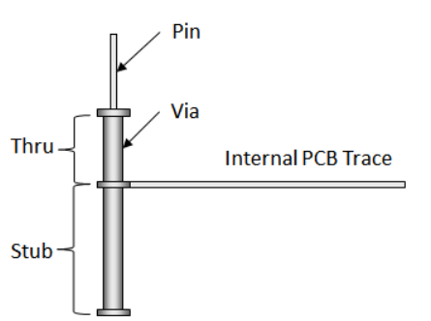

Figure Via stubs

## Here is a non-exhaustive list of signals that need with their respective impedance target:

|  |  |
| --- | --- |
| Type | Trace impedance |
| PCI Express | 100Ω +-10% Differential |
| USB (2/3) | 90Ω +-10% Differential |
| HDMI | 100Ω +-10% Differential |
| EDP | 90Ω +-10% Differential |
| Display port | 90Ω +-10% Differential |
| MIPI | 100Ω +-10% Differential |
| SPI | 50Ω +-10% Single ended |
| SDIO | 50Ω +-10% Single ended |
| UART | 50Ω +-10% Single ended |
| CAN | 120Ω +-10% Differential |
| RF trace | 50Ω +-10% Single ended |
| DDRx | 50Ω +-10% Single ended |
| 100Ω +-10% Differential |

*Exemple:*

|  |  |  |
| --- | --- | --- |
|  | 4 layers, 1.6mm thick, 35um outer, 35um inner | |
|  |  |  |
|  | 10um Soldermask | 1660um +-10% |
| Signal | 35um Copper |
|  | 175um Prepreg |
| Reference plane | 35um Copper |
|  | 1150um Core |
| Reference plane | 35um Copper |
|  | 175um Prepreg |
| Signal | 35um Copper |
|  | 10um Soldermask |

*If you are routing USB signals on this stack-up, here is what you should have.*

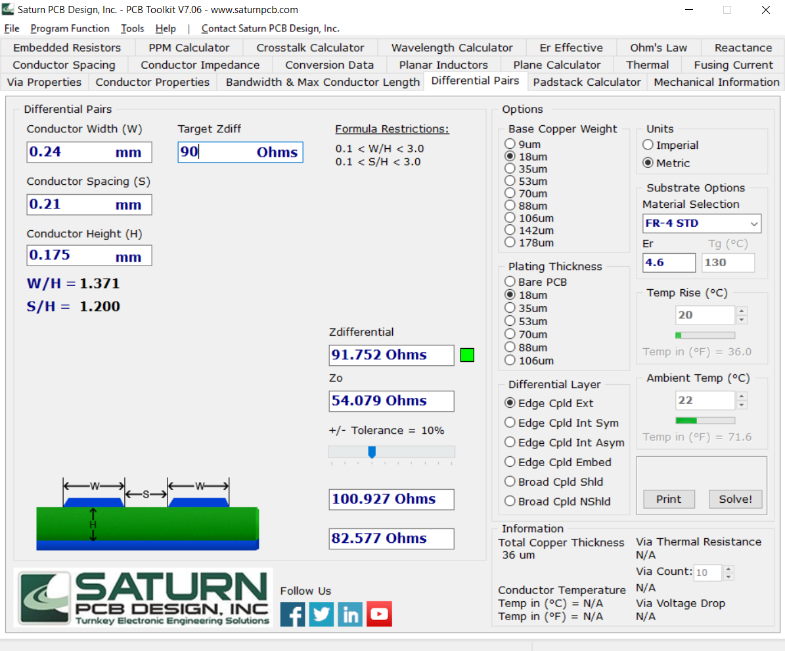

If you want your manufacturer to check if what you calculated is correct according to how they will really build your PCB, you can add it on your specification file next to your PCB:

