**User Manual for Diary System with Flask**

정현성

1. Requirement / Installation

This System is developed with Python, Flask, MongoDB. So, you need to install these.

Flask is a Python framework for developing web applications and MongoDB was used to store user and diary information.

You can download Python from <https://www.python.org/downloads/>. And then, you can install Flask with this command.

-pip install Flask.

You also need your own MongoDB ID to use database. Then, you can use MongoDB with Pymongo. PyMongo is a Python distribution containing tools for working with MongoDB, and is the recommended way to work with MongoDB from Python. You can install Pymongo with this command.

-pip install pymongo

2. Running the System

If all requirements are ready, you can run the system by running app.py with this command.

python app.py

Then, the system will run in your local environment. (<http://127.0.0.1:5000/>)

1) Sign In

You can see the first page of the Diary System like this.

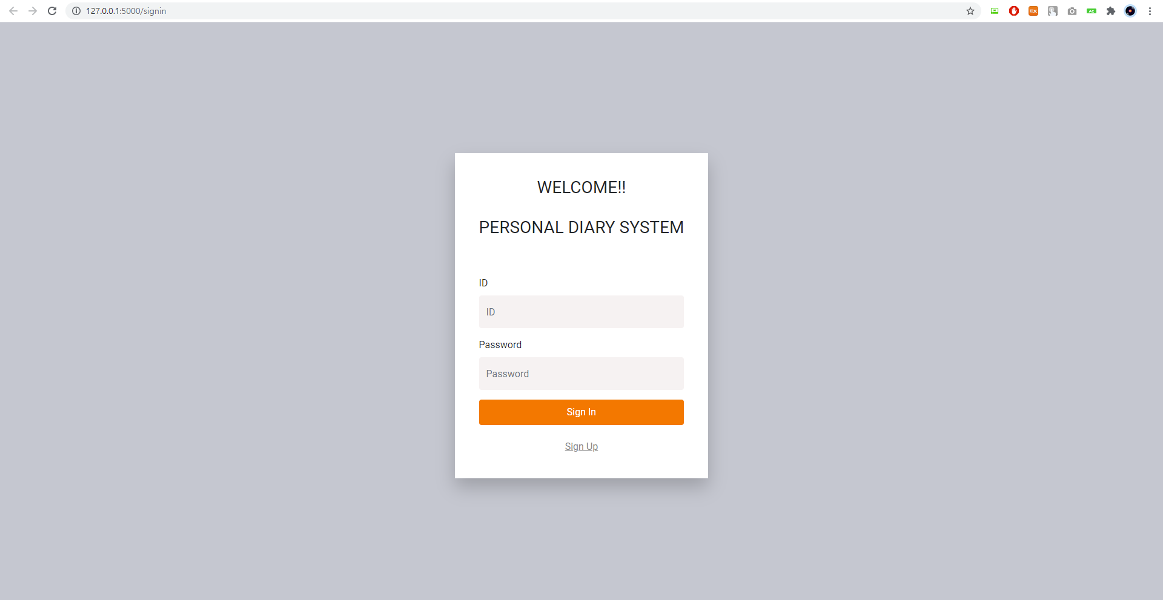

This is Sign in Page to access the system.

If you have ID and password, you can sign in by entering them in the blanks. But if not, you can become a member of the system by clicking the [Sign Up] button below.

2) Sign Up

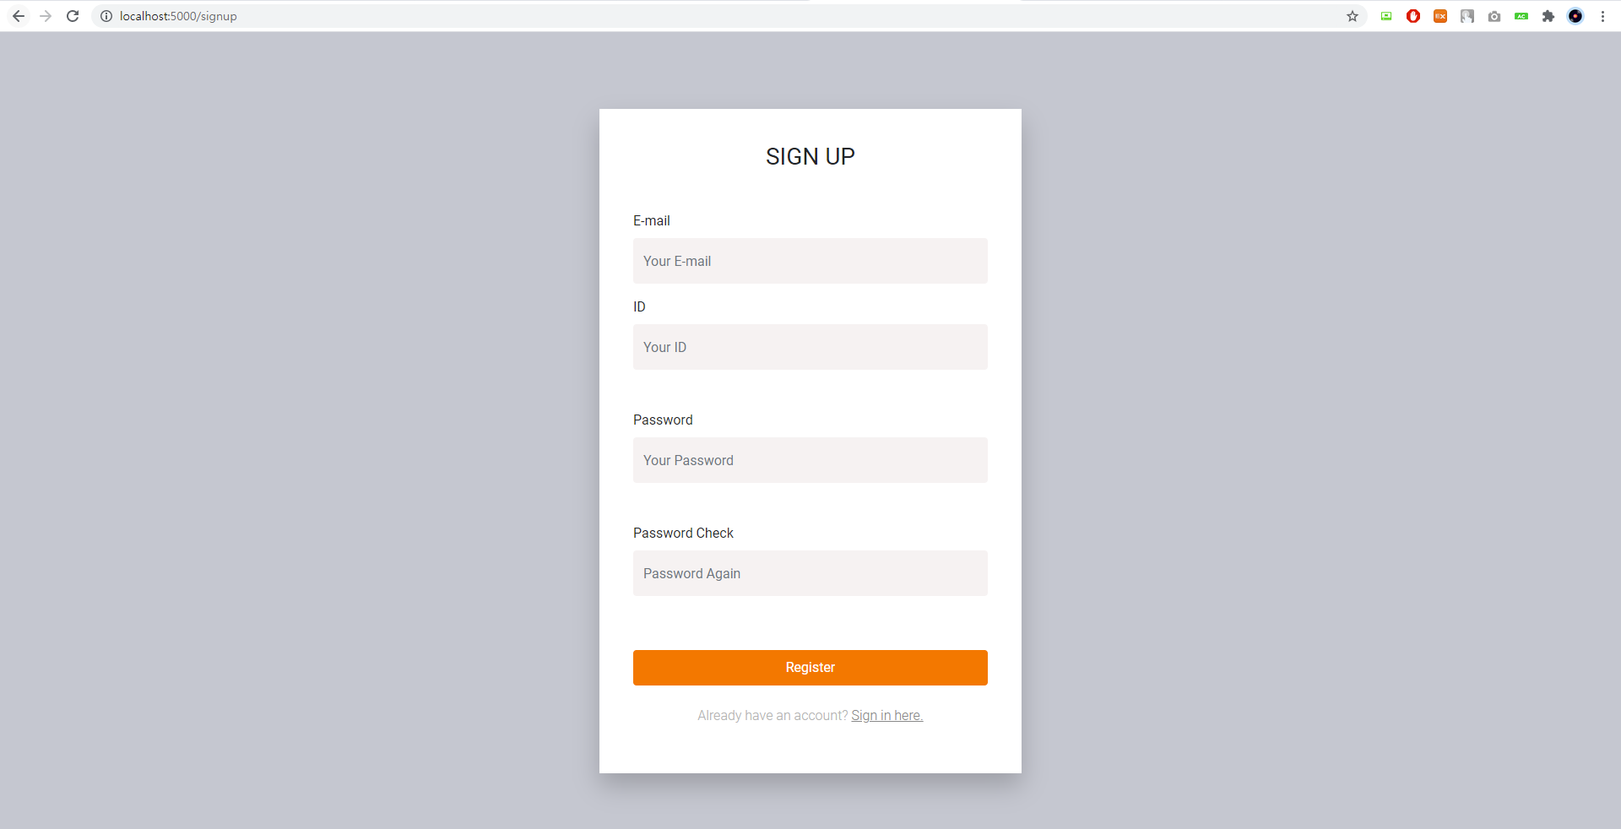

When you click the Sign up button, the sign up page appears like this. Now you fill in all the blanks and click the register button to complete sign up.

3) Main Diary Page

If you have completed Sign up, you can sign in by entering your ID and password on the sign in page above.

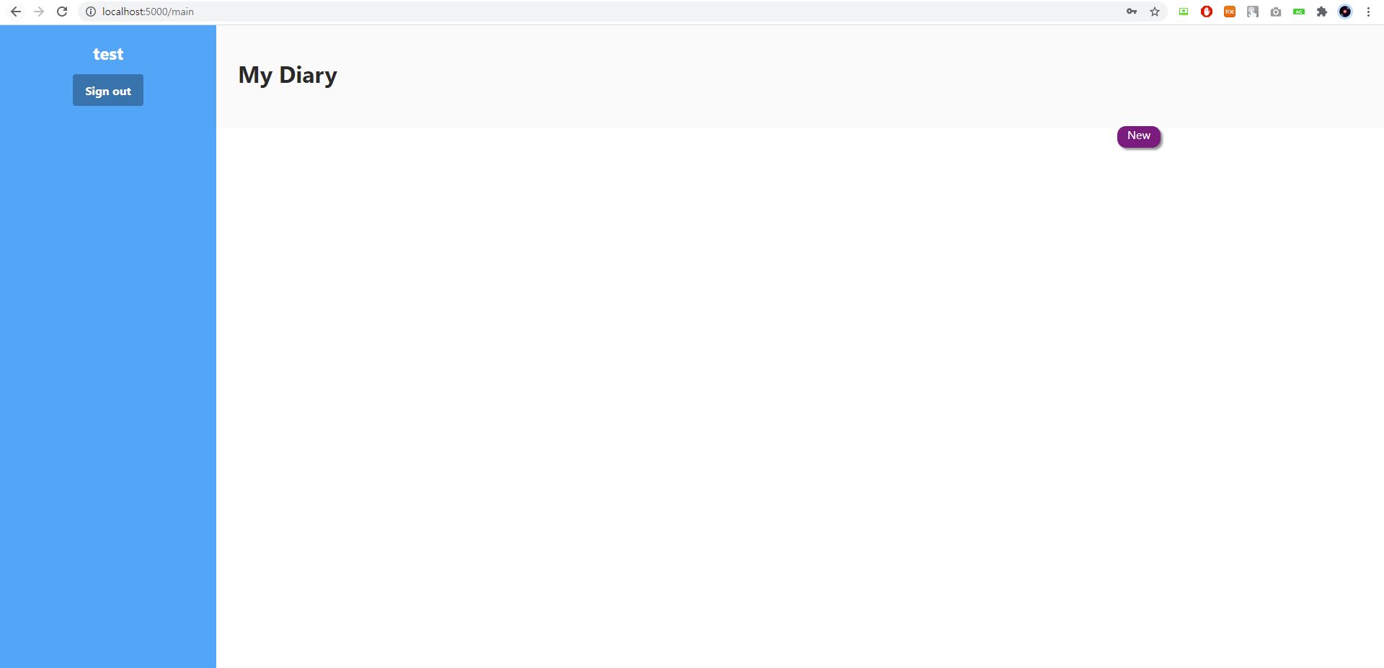

Then, you can see the main diary page with nothing as above. Your ID is on the top left. If you want to sign out, you can click Sign out button below your ID. If you want to add a new diary, click the new button in the upper right corner to move to the addDiary page.

4) Add Diary

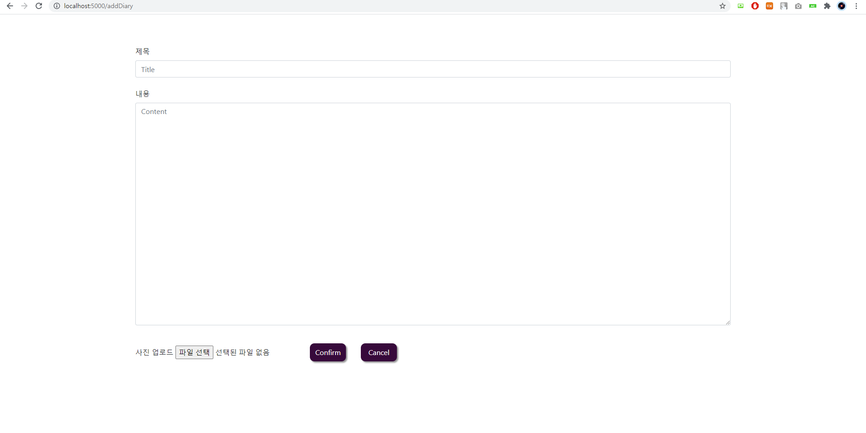

This is addDiary Page. You can add any title, content and photo you want.

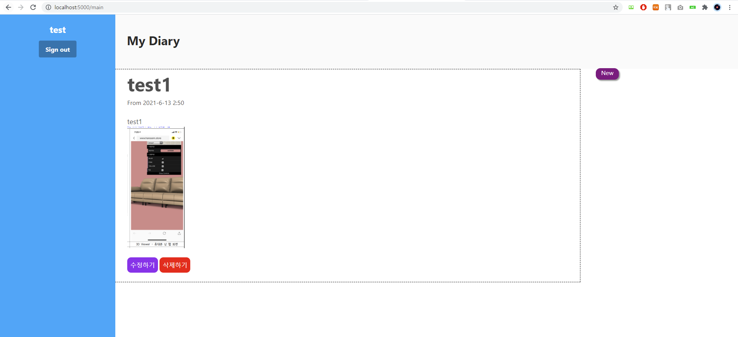

Then, you can see that the diary you added has been added to the main page with title, date and content.

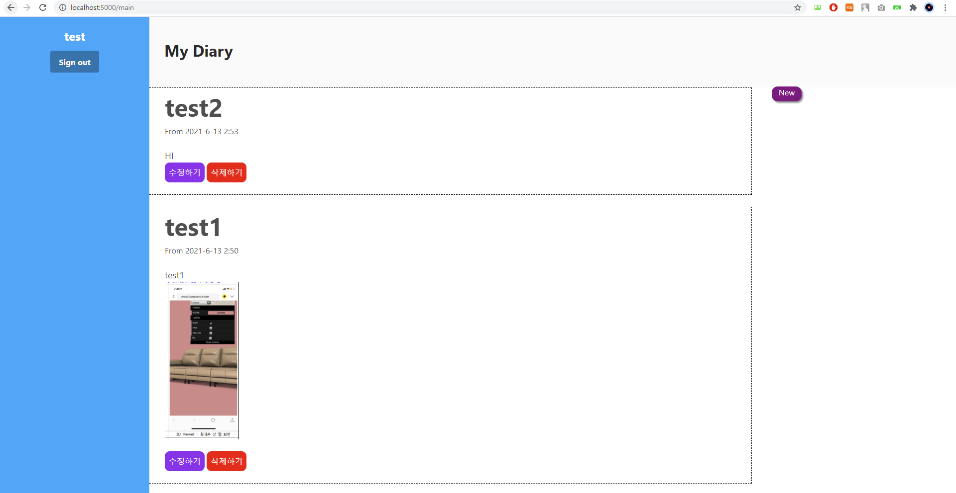

If you add diaries, the diaries are arranged in the most recent order.

5) Edit Diary

If you want to edit the previous diary, click the '수정하기' button to go to the edit page.

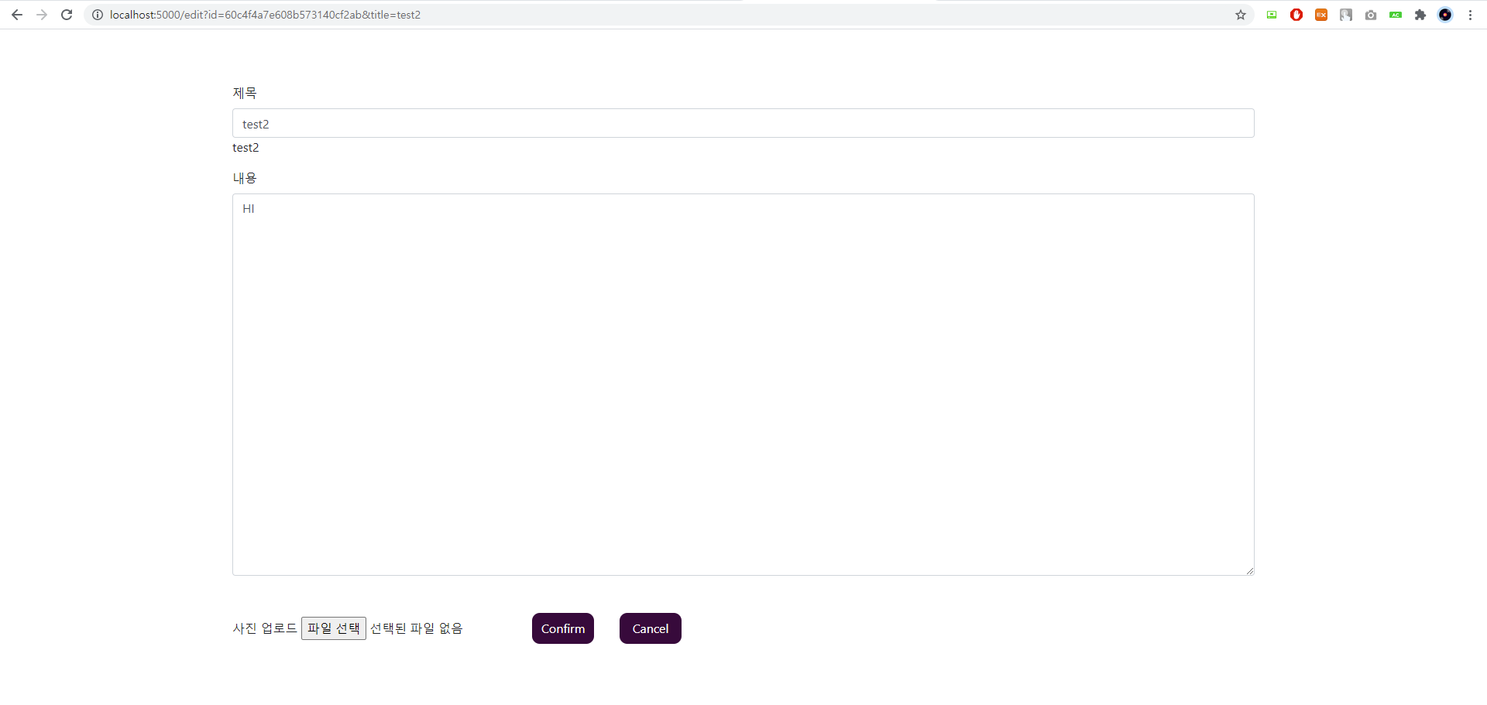

If you click the '수정하기' button, you can edit the previously entered information as shown above.

6) Delete Diary

If there is a diary you want to delete among the added diaries, you can delete it by clicking the '삭제하기' button.