These are two mockup screens.

User Sign Up form.

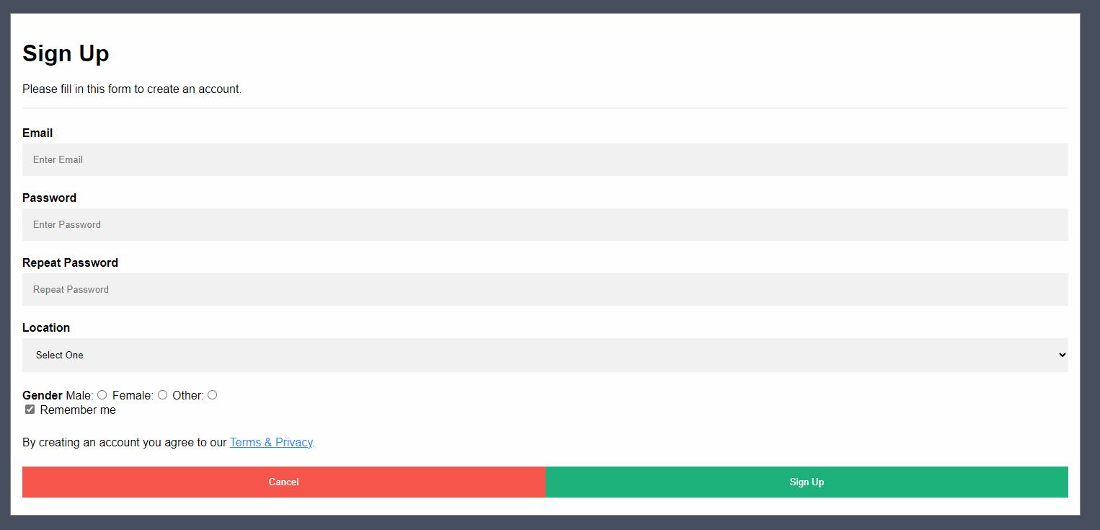

Power Trade Screen

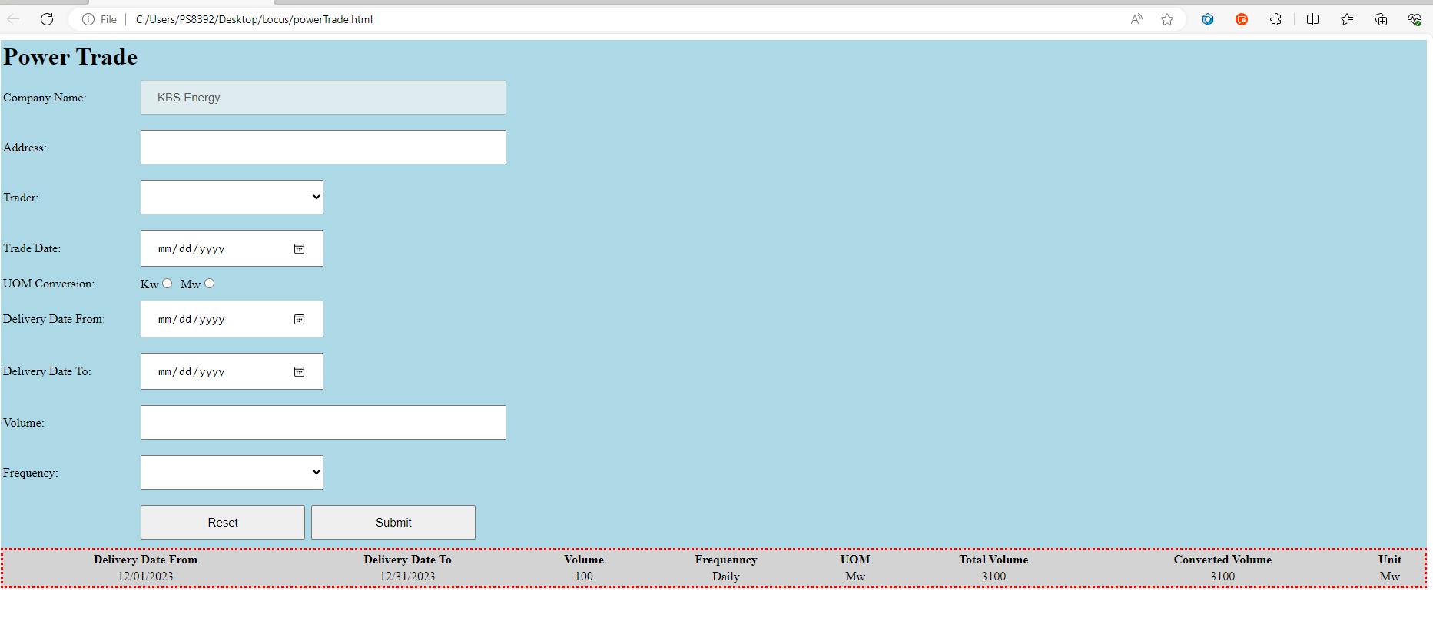

1. Please investigate this screen, can you please analyze the requirements of this screen? Please highlight the major requirements in the bullet.
2. Now convert your requirements into test cases
3. Your test cases must have
   1. Title
   2. Pre-condition
   3. Objectives
   4. Test steps
   5. Test data
   6. Expected results.
   7. Remarks
4. After manual test cases are completed, please start thinking about the automation script, we will provide the same mockup in “HTML” format.