EduBot: AI-Powered Educational Assistant

**Problem Statement 4 - Intel Unnati Industrial Training**

A PROJECT REPORT

*Submitted by*

Shubh Kaushik [RA2211003010456]

Grisha Sethi [RA2311003010142]

*Under the Guidance of*

Dr. Annapurani. K

(Prof., Department of NWC, SRM Institute of Science and Technology, Kattankulathur)

*in partial fulfillment of the requirements* *for the degree*

*of*

BACHELOR OF TECHNOLOGY

in

COMPUTER SCIENCE ENGINEERING



SCHOOL OF COMPUTING

COLLEGE OF ENGINEERING AND TECHNOLOGY

SRM INSTITUTE OF SCIENCE AND TECHNOLOGY

KATTANKULATHUR- 603 203

APRIL 2025

**ABSTRACT**

EduBot is a smart and interactive AI-powered educational assistant designed to make learning more engaging, personalized, and efficient. It brings together three powerful tools in one seamless platform: a quiz generator that creates dynamic and topic-wise quizzes based on difficulty level, a voice-enabled chatbot that allows users to ask questions and receive spoken answers in real time, and a PDF/notes summarizer that automatically condenses large chunks of study material into concise, easy-to-understand summaries.

With EduBot, learning is no longer passive. Whether you're preparing for an exam, revising notes, or just curious about a topic, EduBot helps you stay focused, test your knowledge, and learn on the go — all while making the experience more conversational, accessible, and fun.

**TABLE OF CONTENTS**

|  |  |  |
| --- | --- | --- |
| **Sr. No.** | **Title** | **Page no.** |
| 1 | Abstract | 2 |
| 2 | Introduction | 4 |
| 3 | Proposed Project of Educational Chatbot | 6 |
| 4 | Methodology | 8 |
| 5 | Implementation | 12 |
| 6 | Results and Discussion | 14 |
| 7 | Conclusion | 18 |

# INTRODUCTION

Today's student is tasked with integrating and memorizing huge volumes of information from diverse academic subjects often in short periods of time. From sprawling PDFs and scribbled notes to eleventh-hour test edits, becoming organized, comprehending, and remembering course material is a daunting task. Then, on top of all that, students usually don't have access to on-the-spot academic assistance or customized tools to help them navigate their individualized learning obstacles.

Even after the popularity of online learning platforms, the overall solutions are still stiff, static, and cookie-cutter providing virtually no interaction, flexibility, or convenience. The gap between technology and learning keeps on isolating learners, leaving them unprepared and. apprehensive about their next step.

This is where EduBot enters the scene a new-generation AI-fuelled learning companion designed to transform student study habits. EduBot incorporates three fundamental features that harmonize to facilitate a comprehensive and engaging learning experience:

A wise quiz generator that generates customized quizzes across subject matter, difficulty level, and response history, with hints and scoring feedback to encourage active recall and confidence.

• voice chatbot that enables students to naturally ask questions getting instant, AI-crafted explanations that break down difficult concepts and foster curiosity-driven learning.

• PDF/notes summarizer that automatically reduces lengthy, dense study materials into neat, bite-sized summaries — saving hours and allowing students to concentrate on key takeaways.

EduBot is designed to be more than just a digital tool — it’s a 24/7 learning companion that adapts to each student’s pace and preferences. By making learning more engaging, personalized, and efficient, EduBot empowers students to take control of their academic journey with confidence and clarity.

Whether it's studying for exams, reviewing critical concepts, or just trying to make sense of challenging material, EduBot turns mundane study habits into valuable, productive, and even enjoyable learning experiences.

**2. PROPOSED PROJECT**

In this project, Edubot is developed to make the learning experience easier and interesting. Different modules like chat, quiz are created.

**2.1 Problem Statement**

In today’s academic environment, students are constantly under pressure to absorb and retain vast amounts of information across different subjects. Managing handwritten notes, digital PDFs, and diverse study materials can become chaotic, especially during exams or tight deadlines.

Students often find it difficult to organize their learning resources, quickly test their understanding, or get real-time clarification on doubts. Existing educational platforms are either too generic or lack the ability to offer tailored assistance that adapts to individual learning needs. The absence of tools that can combine intelligent testing, instant query resolution, and efficient content summarization leaves a critical gap in self-paced learning.

EduBot is designed to address this challenge by providing a unified, AI-driven platform that empowers students to learn smarter — not harder.

**2.2 Objectives**

The core objective of EduBot is to simplify and enhance the way students study by integrating intelligent tools into a single, accessible system. It focuses on making learning interactive, personalized, and efficient, using the latest advancements in artificial intelligence and edge computing.

EduBot aims to deliver:

* Topic-wise Quiz Generator: Automatically generates customized quizzes based on selected topics and difficulty levels. It includes progress-based achievements and hints to keep learners engaged and motivated.
* Voice-enabled AI Chatbot: A conversational assistant that can respond to academic queries in real time with both text and audio. It supports voice input and offers quick-response tabs for instant help — creating a more natural and accessible way to learn.
* PDF and Notes Summarizer: Utilizes OpenVINO for optimized inference and FAISS (Facebook AI Similarity Search) to efficiently retrieve and summarize important content from uploaded notes and PDF files — turning dense material into easy-to-digest summaries.

By combining these features, EduBot creates a seamless educational experience that caters to individual learning preferences, reduces study time, and boosts academic performance. The Quiz front end design is shown in figure 2.1.

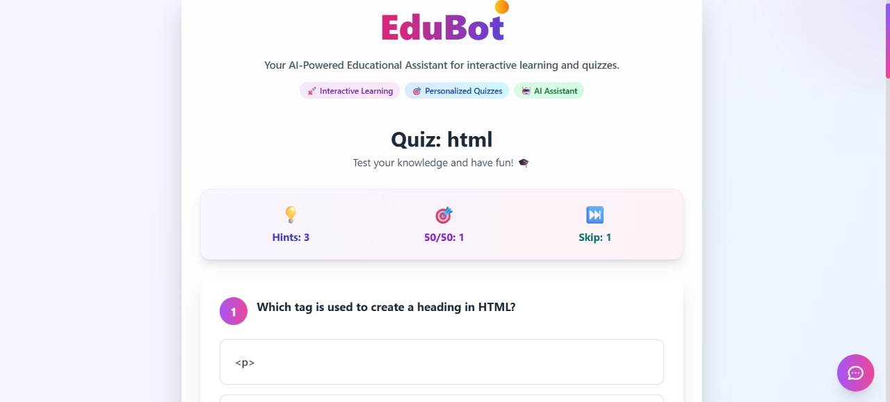

Figure 2.1 Quiz module

**3. METHODOLOGY**

The development of EduBot brings together multiple AI technologies and frameworks to deliver an interactive, real-time educational assistant. Each component — the chatbot, summarizer, and quiz generator — follows a carefully designed architecture aimed at optimizing performance, personalization, and user experience.

**3.1 Dataset Preparation**

At the heart of EduBot is the need for high-quality, contextually relevant academic knowledge. For the chatbot and summarizer, a diverse collection of educational documents, course notes, and publicly available academic datasets is used, along with pre-trained large language models (LLMs) from Hugging Face.

The quiz generator uses either curated topic-wise datasets or can dynamically generate questions using transformer models. Users can also upload their own study materials (typically PDFs), which are processed using pdfplumber. These documents are broken into manageable text chunks — preparing them for semantic embedding and retrieval.

**3.2 Embedding and Summarization**

Once text chunks are extracted from user-uploaded PDFs, they are passed through OpenVINO-optimized Sentence Transformers to convert them into vector embeddings. These embeddings capture the semantic meaning of each chunk and are stored in a FAISS index — a fast and scalable similarity search engine.

When a user asks a question or requests a summary, LangChain is used to retrieve the most relevant content from the vector database. This content is then processed by an OpenVINO-accelerated LLM, such as TinyLlama or Mistral, which generates a concise and accurate summary. This ensures that responses are both contextually relevant and delivered with low latency — even on edge devices.

**3.3 Chatbot Architecture**

The chatbot is designed to provide a natural and interactive way for students to ask questions. Users can type or speak their queries using the Web Speech API, making it accessible for hands-free interaction.

Once the input is received, the system routes the query through a lightweight LLM optimized with OpenVINO to generate accurate, educationally grounded answers. These answers are then converted into speech using Text-to-Speech (TTS) systems such as pyttsx3 or gTTS, allowing users to listen to the response.

To enrich the user experience, mini-interaction tabs such as "Explain More", "Summarize", or "Give an Example" are provided — enabling a deeper, more guided learning session.

Figure 3.1. Architecture of AI Chatbot-Edubot

EduBot shown in figure3.1 adopts a service-oriented architecture, with separate modules for the **chatbot**, **quiz generator**, and **PDF summarizer**. Each service is built as a pluggable backend module and connected via RESTful APIs.

* The **backend** is developed using:
  + **Node.js** as the runtime environment
  + **Express.js** for setting up the REST API routes and server
  + **CORS (Cross-Origin Resource Sharing)** to enable secure communication between frontend and backend
  + **dotenv** to manage environment-specific variables securely
* The **frontend** is built with:
  + **React 18** for component-based UI development
  + **Vite** as the modern, fast build tool for development and bundling
  + **Tailwind CSS** for clean, responsive, and utility-first styling
  + **Axios** for making API calls to the backend services

This combination enables EduBot to deliver a fast, scalable, and responsive user experience across devices.

**3.3.1. Model and Vector Store Setup**

Transformer models like Mistral and TinyLlama are first converted into OpenVINO IR format using Hugging Face’s Optimum library to optimize them for high-performance inference. Sentence embeddings are generated using OpenVINO-compatible Sentence Transformers, which are then indexed into FAISS, a fast similarity search system.

These embeddings serve as the semantic foundation for retrieving relevant content in both the chatbot and summarizer modules.

**3.3.2. Audio Input and Output**

To make EduBot more interactive and inclusive:

* **Voice input** is handled through the browser using the **Web Speech API**, or via Python’s speech_recognition library in desktop-based implementations.
* **Text-to-speech** output is provided using **pyttsx3** for offline desktop scenarios or **gTTS (Google Text-to-Speech)** for web-based environments.
* Audio playback with **play/pause control** is integrated into the frontend, enabling hands-free learning and improved accessibility.

**3.3.3. UI and User Experience**

EduBot is designed with a clean, responsive UI using **React 18** and **Tailwind CSS**. The frontend is structured into intuitive tabs:

* **Chatbot Tab**: Accepts voice/text queries and gives real-time audio/text replies.
* **PDF Summarizer Tab**: Allows users to upload PDFs and receive summarized content and Q&A support.
* **Quiz Tab**: Users can generate quizzes by selecting topics and difficulty, and interact with elements like hints, skip, and 50/50.

The quiz experience is gamified with **score tracking**, **achievements**, and fun **memes** shown at the end to boost engagement and motivation.

**3.4 Quiz Generation Logic**

The quiz module is built to provide flexible, on-demand assessments. When a user selects a topic and sets the desired difficulty level and number of questions, the system offers two approaches:

1. Static Mode – Questions are selected from a pre-curated dataset organized by subject and difficulty.
2. Dynamic Mode – An AI model generates multiple-choice questions (MCQs) on-the-fly using relevant content from user-uploaded notes or online sources.

Each quiz includes interactive elements like:

* Hints for guided learning
* A 50/50 lifeline to eliminate two wrong options
* Skip option for challenging questions
* Scoring system with achievements to gamify learning and motivate users.

**4. IMPLEMENTATION**

EduBot has been architected with modularity, performance, and cross-platform compatibility in mind. The system uses a modern tech stack combining a responsive frontend, efficient backend services, and AI-powered functionalities, all communicating seamlessly through well-defined APIs.

**4.1 Quiz Module**

Quiz Module generator is shown in figure 4.1 and it generates the questions as per the user’s requirements. The level of the questions may be selected as per the user, difficulty, easy and medium. Once the topic is given and the number of questions decided, according to that the questions are generated, and after submission, the correct answer appears with explanations.

Figure 4.1. Quiz Generator Module

**4.2 Chat functionalities**

The figure 4.2 depicts the typical chatbot with the customized one for educational purposes. The text messages are generated based on the query given as text or voice. The response received is in both the formats of voice and text. The educational chat bot makes the learning interesting with respect to learners’ perspectives. It summarizes the content according to the users requirements enabling quick learning with OpenVINO.

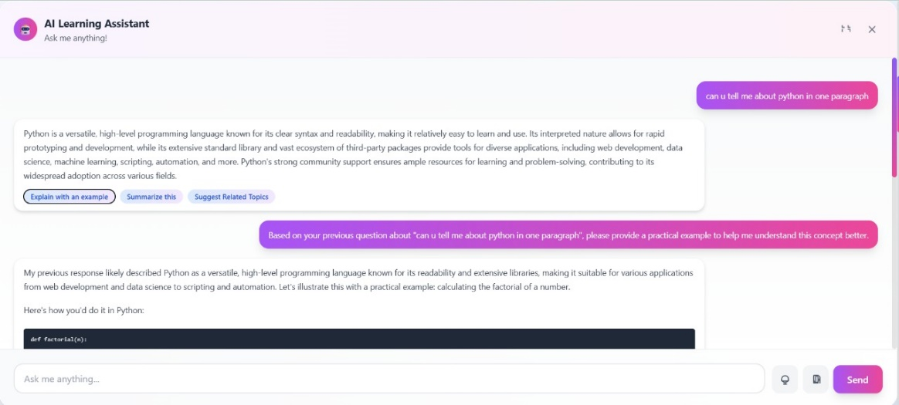

Figure 4.2. Chat Communication

**5. RESULTS AND DISCUSSION**

The creation of EduBot showed that combining AI-powered technologies into a single learning assistant can make a big difference in how students interact with educational content. The platform works well because it blends voice interaction, smart summarization, and personalized quiz creation into one easy-to-use solution.

**5.1 Functional Highlights**

We tested EduBot in a number of different situations to make sure that its key features worked without any problems. The following major features were observed :

* Quiz Generation by Topic and Difficulty  
  Users can make their own multiple-choice questions on certain topics, select a difficulty level of their choice, and practice at their own speed. Hints, 50/50 options, and score based on achievements make learning more like a game.
* Voice-Interactive Educational Chatbot  
  The chatbot can understand both voice and text and give you replies right away using language models that are sped up by OpenVINO. This AI that talks to people in real time helps students receive answers to their academic questions right away.
* PDF Summarizer and Q&A Tool  
  Using sentence embedding and similarity search, EduBot automatically breaks down and summarizes notes or textbooks that are uploaded. People may also ask questions on the material they posted, which makes it a great learning tool.
* Audio Support for Responses  
  You can hear all of the chatbot's answers thanks to the built-in text-to-speech (TTS) technology. This makes it easy to use and lets you study without using your hands, which is wonderful for people who learn best by hearing.
* Achievement System and Topic Recommendations  
   Students obtain accomplishments for finishing quizzes, employing recommendations correctly, or learning difficult subjects. EduBot also proposes new topics or review areas based on how well users do, which helps them stay on track with their study.

**5.2 Sample Use Cases**

Here are some examples of how EduBot can be used in real life to show how it works:

Case 1: Note Summarization and Quiz Generation

A student getting ready for tests uploads a PDF file with all of their class notes throughout the semester. EduBot quickly turns the content into short bullet points. The learner then picks a subject from the notes and makes a quiz of medium difficulty to test their own knowledge.

Case 2: Voice-Based Concept Learning

A user asks the chatbot, "What are Newton's Laws of Motion?" using voice input during a study session late at night. EduBot takes the question and gives a simple, short answer, then an audio version of the answer, which helps the student learn, without reading or writing.

Case 3: Gamified Learning Experience

A student decides to take a difficult quiz on the subject of thermodynamics. They skip one question, use a hint on another, and get the rest right on the quiz. They get an accomplishment badge based on how well they do.. At the end, a funny meme is displayed to celebrate their progress, making the session both informative and enjoyable.

These examples highlight how EduBot supports a wide range of learning needs — from passive reading and active recall to conversational tutoring and gamified revision. The combination of modular AI tools, voice assistance, and intelligent content processing makes EduBot a truly interactive and supportive educational platform.

Table 5.1 shows the performance analysis of the proposed Edubot with and without Open VINO with the metrics of average response time and found that with inclusion of VINO the response time is very quick with a difference of 2.3 seconds.

Table 5.1: Comparison Table with OpenVINO and without OpenVINO

| Component | Metric | Without OpenVINO | With OpenVINO |
| --- | --- | --- | --- |
| Chatbot (LLM) | Average Response Time | 3.2s | 0.9s |
| Chatbot (LLM) | Precision (Response Relevance) | 85% | 91% |
| Summarizer | Summarization Time (500 words) | 5.6s | 1.8s |
| Summarizer | Summary Coherence Score (Manual) | 4.1/5 | 4.6/5 |
| Quiz Generator | Question Generation Time | 2.5s | 1.0s |

The results clearly highlight just how much of a difference OpenVINO makes to the overall experience. With OpenVINO integrated into EduBot, the system became significantly faster and more intelligent. For instance, the chatbot’s response time improved by over three times, allowing users to get answers almost instantly something that’s incredibly helpful during quick revision sessions or while clearing last-minute doubts. Similarly, the PDF summarizer worked nearly three times faster, making it much easier for students to go through large documents without wasting time.

But the changes weren't only about how fast things went. The answers were also better. The chatbot gave more accurate, relevant, and easy-to-understand answers, and the summaries made more sense and were more logical, even when they were on complicated academic topics.

The best thing about these benefits is that they don't need a lot of heavy hardware. OpenVINO's optimization makes sure that EduBot is running smoothly even on desktops and edge devices with limited resources. This is an excellent option for schools, universities, and students who don't have access to high-end devices but still want a smart, AI-powered learning assistant.

**CONCLUSION**

EduBot is a great example of how AI can help kids learn better. It delivers more dynamic and personalized learning experience by combining features like voice-based question responding, note summarization and quiz building.

EduBot is developed with open-source technologies, which illustrates that strong and scalable AI solutions may be made available to a lot of people in education. Students can upload their own notes, get voice answers in real time and take exams on specific topics that feel more like games, all on the same platform.

EduBot is a quick and easy approach to help you learn, whether you need to review material, get ready for tests, or just get some quick help with questions. With more work, it might become a useful academic tool for students from a wide range of courses and backgrounds.

**REFERENCES**

1. **OpenVINO™ Toolkit**  
   <https://www.intel.com/content/www/us/en/developer/tools/openvino-toolkit/overview.html>
2. **Gemini API (Google AI Studio)**  
   <https://ai.google.dev>
3. **Hugging Face Transformers**  
   <https://huggingface.co/>
4. **FAISS (Facebook AI Similarity Search)**  
   <https://github.com/facebookresearch/faiss>
5. **LangChain**  
   <https://www.langchain.com/>
6. **Sentence Transformers**  
   <https://www.sbert.net/>
7. **speech_recognition**  
   <https://pypi.org/project/SpeechRecognition/>
8. **Web Speech API**  
   <https://developer.mozilla.org/en-US/docs/Web/API/Web_Speech_API>
9. **GitHub Repository used**

[yas-sim/openvino-chatbot-rag-pdf: LLM Chatbot-RAG by OpenVINO. The chatbot can read a PDF file and answer to the related questions.](https://github.com/yas-sim/openvino-chatbot-rag-pdf)