Задание:
Дана выборка: 44 значения.
1. Для первых 10 элементов найти:
а). 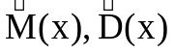 - обычным способом;
б). 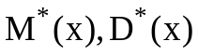 - по методу бутстреп;
в). 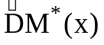, 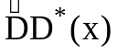.
2. Для следующих 20 элементов:
а). - обычным способом;
б). - по методу бутстреп;
в). , .

3. Для всей выборки найти M(x), D(x).

Дано:

0,1 | 12,79
0,26 | 9,13
5,44 | 1,68
3,17 | 8,2
5,11 | 6,02
1,55 | 15,86
1,91 | 1,05
18,59 | 17,84
12,67 | 12,33
15,94 | 2,81
3,12 | 8,08
2,46 | 6,04
5,64 | 0,69
3,79 | 32,86
12,74 | 14,93
0,11 | 20,22
22,4 | 7,27
7,2 | 10,45
16,61 | 4,01
8,49 | 12,43
3,23 | 4,43
2,46 | 12,74

1. Для первых 10 элементов:
а). 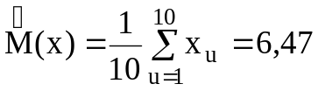, 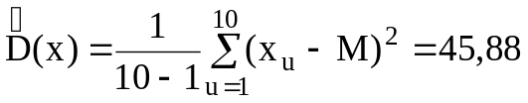.
б). Число бутстреп М=10.
Таблица1
 | 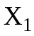 | 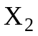 | 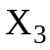 | 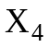 | 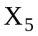 | 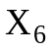 | 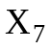 | 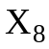 | 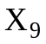 | 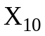
 | 0,10 | 0,26 | 5,44 | 3,17 | 5,11 | 1,55 | 1,91 | 18,59 | 12,67 | 15,94
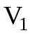 | 1 | 2 | 1 | 0 | 0 | 0 | 0 | 3 | 1 | 2
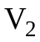 | 0 | 1 | 4 | 1 | 1 | 1 | 2 | 0 | 0 | 0
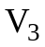 | 0 | 1 | 1 | 0 | 1 | 1 | 1 | 1 | 2 | 2
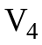 | 1 | 1 | 0 | 1 | 2 | 1 | 2 | 0 | 1 | 1
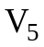 | 4 | 2 | 0 | 0 | 1 | 2 | 0 | 1 | 0 | 0
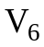 | 1 | 1 | 0 | 0 | 3 | 1 | 2 | 2 | 0 | 0
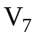 | 2 | 1 | 0 | 2 | 1 | 1 | 1 | 1 | 0 | 1
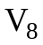 | 1 | 2 | 2 | 0 | 2 | 1 | 0 | 1 | 1 | 0
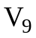 | 1 | 0 | 1 | 1 | 2 | 2 | 2 | 0 | 1 | 0
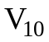 | 2 | 1 | 2 | 1 | 1 | 2 | 0 | 1 | 0 | 0
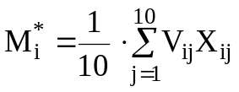
Таблица2
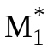 | 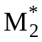 | 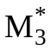 | 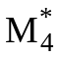 | 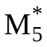 | 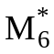 | 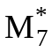 | 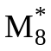 | 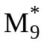 | 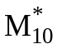
10,64 | 3,57 | 9,01 | 4,77 | 2,77 | 5,82 | 4,99 | 5,45 | 3,85 | 4,13
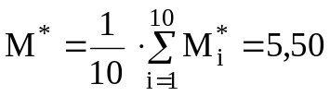, 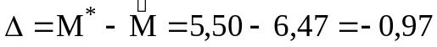.
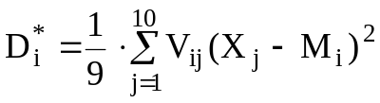
Результат действия 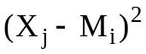, i, j = 1..10 представлено в табл.3.
Таблица3
1 | 2 | 3 | 4 | 5 | 6 | 7 | 8 | 9 | 10
111,05 | 107,70 | 27,02 | 55,77 | 30,56 | 82,59 | 76,18 | 63,23 | 4,13 | 28,11
12,02 | 10,94 | 3,51 | 0,16 | 2,38 | 4,07 | 2,75 | 225,69 | 82,86 | 153,09
79,35 | 76,53 | 12,73 | 34,08 | 15,19 | 55,62 | 50,38 | 91,81 | 13,41 | 48,05
21,84 | 20,37 | 0,44 | 2,57 | 0,11 | 10,39 | 8,20 | 190,91 | 62,36 | 124,70
7,14 | 6,31 | 7,12 | 0,16 | 5,47 | 1,49 | 0,74 | 250,21 | 97,97 | 173,40
32,76 | 30,96 | 0,15 | 7,04 | 0,51 | 18,27 | 15,32 | 162,97 | 46,87 | 102,33
23,91 | 22,37 | 0,20 | 3,31 | 0,01 | 11,83 | 9,49 | 184,96 | 58,98 | 119,90
28,65 | 26,97 | 0,00 | 5,21 | 0,12 | 15,23 | 12,55 | 172,58 | 52,09 | 109,98
14,08 | 12,90 | 2,52 | 0,47 | 1,58 | 5,30 | 3,77 | 217,21 | 77,76 | 146,12
16,25 | 14,98 | 1,71 | 0,92 | 0,96 | 6,66 | 4,93 | 209,06 | 72,91 | 139,45

Таблица4
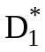 | 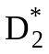 | 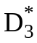 | 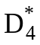 | 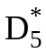 | 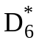 | 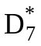 | 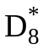 | 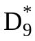 | 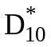
67,06 | 4,12 | 47,24 | 28,76 | 33,32 | 48,90 | 44,78 | 35,86 | 12,90 | 30,58

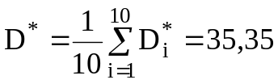, 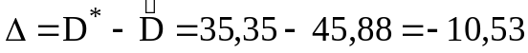.

Число бутстреп М=30.

Таблица5

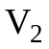 | 0 | 1 | 4 | 1 | 1 | 1 | 2 | 0 | 0 | 0
 | 0 | 1 | 1 | 0 | 1 | 1 | 1 | 1 | 2 | 2
 | 1 | 1 | 0 | 1 | 2 | 1 | 2 | 0 | 1 | 1
 | 4 | 2 | 0 | 0 | 1 | 2 | 0 | 1 | 0 | 0
 | 1 | 1 | 0 | 0 | 3 | 1 | 2 | 2 | 0 | 0
 | 2 | 1 | 0 | 2 | 1 | 1 | 1 | 1 | 0 | 1
 | 1 | 2 | 2 | 0 | 2 | 1 | 0 | 1 | 1 | 0
 | 1 | 0 | 1 | 1 | 2 | 2 | 2 | 0 | 1 | 0
 | 2 | 1 | 2 | 1 | 1 | 2 | 0 | 1 | 0 | 0
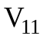 | 0 | 0 | 0 | 0 | 1 | 2 | 2 | 3 | 0 | 2
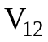 | 1 | 2 | 0 | 3 | 1 | 1 | 0 | 0 | 2 | 0
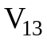 | 3 | 0 | 0 | 2 | 0 | 0 | 1 | 2 | 1 | 1
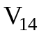 | 2 | 1 | 0 | 2 | 1 | 1 | 1 | 1 | 1 | 0
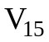 | 1 | 1 | 0 | 1 | 2 | 2 | 0 | 0 | 1 | 2
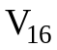 | 0 | 0 | 2 | 0 | 1 | 1 | 3 | 1 | 0 | 2
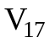 | 2 | 1 | 1 | 0 | 0 | 2 | 0 | 0 | 4 | 0
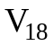 | 1 | 2 | 1 | 2 | 1 | 0 | 2 | 0 | 0 | 1
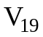 | 1 | 0 | 1 | 1 | 1 | 2 | 2 | 1 | 1 | 0
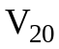 | 2 | 3 | 2 | 0 | 0 | 1 | 0 | 1 | 0 | 1
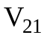 | 0 | 0 | 1 | 4 | 0 | 0 | 0 | 2 | 3 | 0
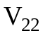 | 1 | 1 | 1 | 1 | 2 | 1 | 2 | 0 | 0 | 1
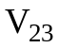 | 0 | 1 | 0 | 2 | 2 | 2 | 1 | 0 | 1 | 1
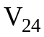 | 2 | 1 | 1 | 2 | 2 | 0 | 0 | 2 | 0 | 0
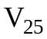 | 2 | 1 | 0 | 1 | 2 | 0 | 1 | 0 | 2 | 1
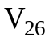 | 1 | 2 | 2 | 0 | 0 | 1 | 2 | 1 | 1 | 0
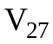 | 2 | 0 | 1 | 1 | 1 | 0 | 2 | 1 | 0 | 2
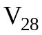 | 3 | 0 | 0 | 0 | 3 | 1 | 2 | 1 | 0 | 0
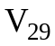 | 2 | 1 | 1 | 0 | 1 | 0 | 0 | 4 | 1 | 0
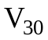 | 0 | 2 | 0 | 0 | 2 | 2 | 2 | 1 | 1 | 0

Таблица6
M*1 | M*2 | M*3 | M*4 | M*5 | M*6 | M*7 | M*8 | M*9 | M*10
10,64 | 3,57 | 9,01 | 4,77 | 2,77 | 5,82 | 4,99 | 5,45 | 3,85 | 4,13
M*11 | M*12 | M*13 | M*14 | M*15 | M*16 | M*17 | M*18 | M*19 | M*20
9,97 | 4,21 | 7,43 | 4,66 | 6,14 | 7,37 | 5,97 | 3,73 | 5,20 | 4,79
M*21 | M*22 | M*23 | M*24 | M*25 | M*26 | M*27 | M*28 | M*29 | M*30
9,33 | 4,05 | 5,04 | 5,96 | 5,70 | 4,81 | 6,82 | 3,96 | 9,80 | 4,89

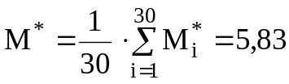.

Результат действия , j,j = 1..10 представлено в табл.7.
Таблица7
111,05 | 107,70 | 27,02 | 55,77 | 30,56 | 82,59 | 76,18 | 63,23 | 4,13 | 28,11
12,02 | 10,94 | 3,51 | 0,16 | 2,38 | 4,07 | 2,75 | 225,69 | 82,86 | 153,09
79,35 | 76,53 | 12,73 | 34,08 | 15,19 | 55,62 | 50,38 | 91,81 | 13,41 | 48,05
21,84 | 20,37 | 0,44 | 2,57 | 0,11 | 10,39 | 8,20 | 190,91 | 62,36 | 124,70
7,14 | 6,31 | 7,12 | 0,16 | 5,47 | 1,49 | 0,74 | 250,21 | 97,97 | 173,40
32,76 | 30,96 | 0,15 | 7,04 | 0,51 | 18,27 | 15,32 | 162,97 | 46,87 | 102,33
23,91 | 22,37 | 0,20 | 3,31 | 0,01 | 11,83 | 9,49 | 184,96 | 58,98 | 119,90
28,65 | 26,97 | 0,00 | 5,21 | 0,12 | 15,23 | 12,55 | 172,58 | 52,09 | 109,98
14,08 | 12,90 | 2,52 | 0,47 | 1,58 | 5,30 | 3,77 | 217,21 | 77,76 | 146,12
16,25 | 14,98 | 1,71 | 0,92 | 0,96 | 6,66 | 4,93 | 209,06 | 72,91 | 139,45
97,38 | 94,25 | 20,50 | 46,21 | 23,60 | 70,86 | 64,93 | 74,34 | 7,30 | 35,66
16,92 | 15,63 | 1,51 | 1,09 | 0,80 | 7,09 | 5,30 | 206,70 | 71,52 | 137,52
53,79 | 51,47 | 3,98 | 18,18 | 5,40 | 34,62 | 30,51 | 124,46 | 27,42 | 72,35
20,82 | 19,39 | 0,60 | 2,23 | 0,20 | 9,69 | 7,58 | 193,96 | 64,11 | 127,17
36,48 | 34,57 | 0,49 | 8,82 | 1,06 | 21,07 | 17,89 | 155,00 | 42,64 | 96,04
52,91 | 50,61 | 3,74 | 17,67 | 5,13 | 33,92 | 29,86 | 125,80 | 28,05 | 73,38
34,43 | 32,58 | 0,28 | 7,83 | 0,74 | 19,52 | 16,47 | 159,31 | 44,92 | 99,44
13,16 | 12,02 | 2,93 | 0,31 | 1,91 | 4,74 | 3,30 | 220,91 | 79,98 | 149,16
26,01 | 24,40 | 0,06 | 4,12 | 0,01 | 13,32 | 10,82 | 179,29 | 55,80 | 115,35
22,03 | 20,56 | 0,42 | 2,64 | 0,10 | 10,52 | 8,32 | 190,33 | 62,03 | 124,23
85,21 | 82,28 | 15,14 | 37,96 | 17,82 | 60,54 | 55,07 | 85,73 | 11,15 | 43,68
15,60 | 14,36 | 1,93 | 0,77 | 1,12 | 6,25 | 4,58 | 211,41 | 74,30 | 141,37
24,44 | 22,89 | 0,16 | 3,51 | 0,00 | 12,21 | 9,82 | 183,49 | 58,16 | 118,72
34,39 | 32,54 | 0,27 | 7,81 | 0,73 | 19,48 | 16,43 | 159,42 | 44,97 | 99,52
31,40 | 29,64 | 0,07 | 6,42 | 0,35 | 17,26 | 14,39 | 166,05 | 48,53 | 104,78
22,21 | 20,73 | 0,39 | 2,70 | 0,09 | 10,65 | 8,43 | 189,81 | 61,73 | 123,81
45,17 | 43,05 | 1,91 | 13,33 | 2,93 | 27,78 | 24,12 | 138,51 | 34,21 | 83,16
14,89 | 13,68 | 2,19 | 0,62 | 1,32 | 5,80 | 4,20 | 214,07 | 75,88 | 143,54
94,17 | 91,09 | 19,04 | 44,01 | 22,03 | 68,13 | 62,32 | 77,19 | 8,21 | 37,65
22,96 | 21,46 | 0,30 | 2,97 | 0,05 | 11,17 | 8,89 | 187,64 | 60,50 | 122,06

Таблица8
D*1 | D*2 | D*3 | D*4 | D*5 | D*6 | D*7 | D*8 | D*9 | D*10
67,06 | 4,12 | 47,24 | 28,76 | 33,32 | 48,90 | 44,78 | 35,86 | 12,90 | 30,58
D*11 | D*12 | D*13 | D*14 | D*15 | D*16 | D*17 | D*18 | D*19 | D*20
65,50 | 22,49 | 64,10 | 37,89 | 39,87 | 45,40 | 35,60 | 22,05 | 34,84 | 47,96
D*21 | D*22 | D*23 | D*24 | D*25 | D*26 | D*27 | D*28 | D*29 | D*30
41,32 | 21,30 | 26,78 | 48,61 | 35,09 | 38,17 | 51,29 | 30,77 | 70,83 | 36,81

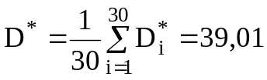, 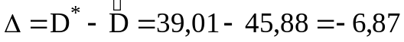

Число бутстреп М=50.
Таблица9
V1 | V2 | V3 | V4 | V5 | V6 | V7 | V8 | V9 | V10
1 | 0 | 0 | 1 | 4 | 1 | 2 | 1 | 1 | 2
2 | 1 | 1 | 1 | 2 | 1 | 1 | 2 | 0 | 1
1 | 4 | 1 | 0 | 0 | 0 | 0 | 2 | 1 | 2
0 | 1 | 0 | 1 | 0 | 0 | 2 | 0 | 1 | 1
0 | 1 | 1 | 2 | 1 | 3 | 1 | 2 | 2 | 1
0 | 1 | 1 | 1 | 2 | 1 | 1 | 1 | 2 | 2
0 | 2 | 1 | 2 | 0 | 2 | 1 | 0 | 2 | 0
3 | 0 | 1 | 0 | 1 | 2 | 1 | 1 | 0 | 1
1 | 0 | 2 | 1 | 0 | 0 | 0 | 1 | 1 | 0
2 | 0 | 2 | 1 | 0 | 0 | 1 | 0 | 0 | 0
V11 | V12 | V13 | V14 | V15 | V16 | V17 | V18 | V19 | V20
0 | 1 | 3 | 2 | 1 | 0 | 2 | 1 | 1 | 2
0 | 2 | 0 | 1 | 1 | 0 | 1 | 2 | 0 | 3
0 | 0 | 0 | 0 | 0 | 2 | 1 | 1 | 1 | 2
0 | 3 | 2 | 2 | 1 | 0 | 0 | 2 | 1 | 0
1 | 1 | 0 | 1 | 2 | 1 | 0 | 1 | 1 | 0
2 | 1 | 0 | 1 | 2 | 1 | 2 | 0 | 2 | 1
2 | 0 | 1 | 1 | 0 | 3 | 0 | 2 | 2 | 0
3 | 0 | 2 | 1 | 0 | 1 | 0 | 0 | 1 | 1
0 | 2 | 1 | 1 | 1 | 0 | 4 | 0 | 1 | 0
2 | 0 | 1 | 0 | 2 | 2 | 0 | 1 | 0 | 1
V21 | V22 | V23 | V24 | V25 | V26 | V27 | V28 | V29 | V30
0 | 1 | 0 | 2 | 2 | 1 | 2 | 3 | 2 | 0
0 | 1 | 1 | 1 | 1 | 2 | 0 | 0 | 1 | 2
1 | 1 | 0 | 1 | 0 | 2 | 1 | 0 | 1 | 0
4 | 1 | 2 | 2 | 1 | 0 | 1 | 0 | 0 | 0
0 | 2 | 2 | 2 | 2 | 0 | 1 | 3 | 1 | 2
0 | 1 | 2 | 0 | 0 | 1 | 0 | 1 | 0 | 2
0 | 2 | 1 | 0 | 1 | 2 | 2 | 2 | 0 | 2
2 | 0 | 0 | 2 | 0 | 1 | 1 | 1 | 4 | 1
3 | 0 | 1 | 0 | 2 | 1 | 0 | 0 | 1 | 1
0 | 1 | 1 | 0 | 1 | 0 | 2 | 0 | 0 | 0
V31 | V32 | V33 | V34 | V35 | V36 | V37 | V38 | V39 | V40
1 | 2 | 0 | 1 | 1 | 0 | 1 | 1 | 1 | 0
1 | 0 | 1 | 2 | 2 | 1 | 2 | 0 | 0 | 1
3 | 1 | 0 | 1 | 1 | 0 | 3 | 1 | 3 | 2
0 | 1 | 1 | 2 | 0 | 2 | 0 | 2 | 0 | 1
1 | 1 | 1 | 1 | 2 | 1 | 2 | 0 | 2 | 0
1 | 1 | 2 | 0 | 2 | 2 | 0 | 1 | 1 | 3
1 | 0 | 1 | 1 | 2 | 1 | 0 | 2 | 0 | 1
0 | 2 | 1 | 1 | 0 | 1 | 1 | 0 | 2 | 1
1 | 2 | 0 | 1 | 0 | 2 | 1 | 1 | 0 | 1
1 | 0 | 3 | 0 | 0 | 0 | 0 | 2 | 1 | 0
V41 | V42 | V43 | V44 | V45 | V46 | V47 | V48 | V49 | V50
1 | 0 | 1 | 1 | 2 | 0 | 1 | 3 | 0 | 1
0 | 0 | 0 | 1 | 0 | 0 | 0 | 1 | 1 | 2
2 | 0 | 1 | 1 | 0 | 2 | 0 | 3 | 0 | 0
0 | 5 | 1 | 2 | 3 | 2 | 0 | 0 | 1 | 0
1 | 1 | 0 | 2 | 0 | 0 | 1 | 0 | 1 | 1
3 | 0 | 1 | 0 | 0 | 3 | 1 | 1 | 2 | 1
1 | 1 | 1 | 1 | 0 | 0 | 2 | 0 | 0 | 0
0 | 3 | 2 | 1 | 1 | 0 | 0 | 0 | 3 | 3
1 | 0 | 2 | 0 | 3 | 2 | 3 | 1 | 1 | 0
1 | 0 | 1 | 1 | 1 | 1 | 2 | 1 | 1 | 2

.
Таблица10
M*1 | M*2 | M*3 | M*4 | M*5 | M*6 | M*7 | M*8 | M*9 | M*10
10,64 | 3,57 | 9,01 | 4,77 | 2,77 | 5,82 | 4,99 | 5,45 | 3,85 | 4,13
M*11 | M*12 | M*13 | M*14 | M*15 | M*16 | M*17 | M*18 | M*19 | M*20
9,97 | 4,21 | 7,43 | 4,66 | 6,14 | 7,37 | 5,97 | 3,73 | 5,20 | 4,79
M*21 | M*22 | M*23 | M*24 | M*25 | M*26 | M*27 | M*28 | M*29 | M*30
9,33 | 4,05 | 5,04 | 5,96 | 5,70 | 4,81 | 6,82 | 3,96 | 9,80 | 4,89
M*31 | M*32 | M*33 | M*34 | M*35 | M*36 | M*37 | M*38 | M*39 | M*40
5,39 | 7,80 | 8,00 | 5,07 | 2,32 | 6,07 | 5,84 | 6,18 | 8,13 | 5,21
M*41 | M*42 | M*43 | M*44 | M*45 | M*46 | M*47 | M*48 | M*49 | M*50
5,13 | 7,86 | 9,06 | 5,88 | 8,23 | 6,32 | 8,05 | 4,70 | 9,60 | 9,49
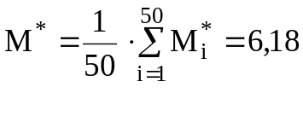
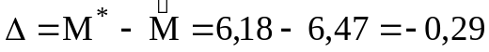
.
Таблица11
D*1 | D*2 | D*3 | D*4 | D*5 | D*6 | D*7 | D*8 | D*9 | D*10
67,06 | 4,12 | 47,24 | 28,76 | 33,32 | 48,90 | 44,78 | 35,86 | 12,90 | 30,58
D*11 | D*12 | D*13 | D*14 | D*15 | D*16 | D*17 | D*18 | D*19 | D*20
65,50 | 22,49 | 64,10 | 37,89 | 39,87 | 45,40 | 35,60 | 22,05 | 34,84 | 47,96
D*21 | D*22 | D*23 | D*24 | D*25 | D*26 | D*27 | D*28 | D*29 | D*30
41,32 | 21,30 | 26,78 | 48,61 | 35,09 | 38,17 | 51,29 | 30,77 | 70,83 | 36,81
D*31 | D*32 | D*33 | D*34 | D*35 | D*36 | D*37 | D*38 | D*39 | D*40
27,28 | 52,46 | 57,02 | 36,54 | 4,47 | 39,28 | 34,00 | 38,46 | 47,51 | 34,95
D*41 | D*42 | D*43 | D*44 | D*45 | D*46 | D*47 | D*48 | D*49 | D*50
27,56 | 55,37 | 54,52 | 39,95 | 48,32 | 29,20 | 42,00 | 31,62 | 63,38 | 74,71

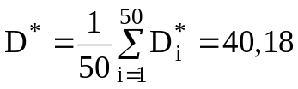, 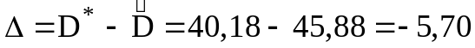.
в). Находим дисперсии оценок
Число бутстреп М=10:
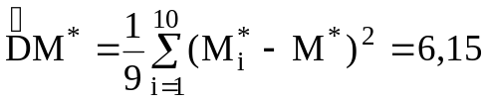,
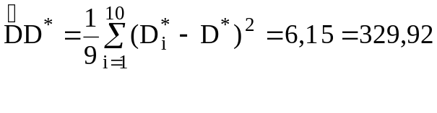
Число бутстреп М=30
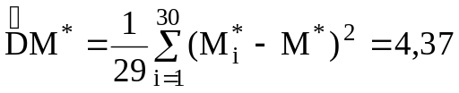,
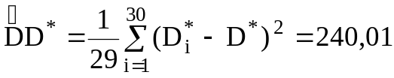.
Число бутстреп М=50:

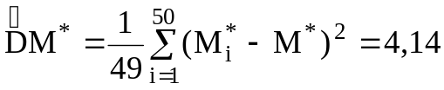,
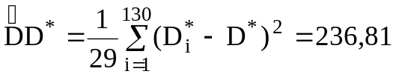.
2. Для следующих 20 элементов:
а). 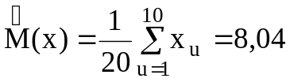, 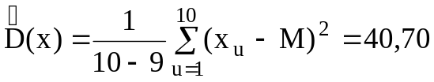
Число бутстреп М = 10:
Таблица12
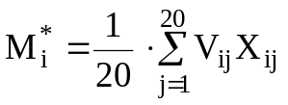
 | V1 | V2 | V3 | V4 | V5 | V6 | V7 | V8 | V9 | V10
1 | 0 | 0 | 2 | 1 | 1 | 0 | 0 | 2 | 1 | 1
2 | 2 | 0 | 1 | 2 | 1 | 1 | 3 | 0 | 2 | 1
3 | 0 | 3 | 0 | 0 | 0 | 1 | 2 | 2 | 0 | 3
4 | 0 | 0 | 1 | 1 | 1 | 0 | 0 | 1 | 1 | 1
5 | 3 | 2 | 1 | 1 | 2 | 0 | 1 | 0 | 2 | 0
6 | 0 | 0 | 2 | 3 | 0 | 2 | 0 | 3 | 0 | 0
7 | 1 | 0 | 0 | 0 | 0 | 1 | 1 | 0 | 1 | 1
8 | 1 | 1 | 2 | 2 | 0 | 2 | 1 | 1 | 1 | 1
9 | 0 | 0 | 2 | 0 | 1 | 2 | 0 | 0 | 1 | 1
10 | 3 | 0 | 1 | 1 | 0 | 1 | 4 | 3 | 1 | 3
11 | 1 | 0 | 3 | 1 | 3 | 1 | 1 | 2 | 0 | 0
12 | 1 | 1 | 0 | 1 | 1 | 2 | 0 | 0 | 1 | 1
13 | 3 | 1 | 1 | 0 | 1 | 1 | 2 | 0 | 2 | 0
14 | 1 | 1 | 1 | 0 | 0 | 0 | 2 | 1 | 3 | 0
15 | 1 | 3 | 0 | 1 | 3 | 1 | 0 | 2 | 1 | 3
16 | 2 | 0 | 0 | 2 | 3 | 1 | 0 | 2 | 0 | 1
17 | 0 | 2 | 0 | 1 | 2 | 0 | 2 | 0 | 0 | 0
18 | 1 | 3 | 2 | 0 | 0 | 1 | 1 | 0 | 0 | 1
19 | 0 | 2 | 0 | 2 | 0 | 2 | 0 | 0 | 0 | 0
20 | 0 | 1 | 1 | 1 | 1 | 1 | 0 | 1 | 3 | 2
Таблица13
9,267 | 7,929 | 8,1365 | 4,876 | 6,796 | 7,6725 | 8,4965 | 5,375 | 10,132 | 8,2605

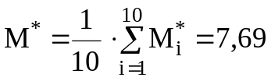, 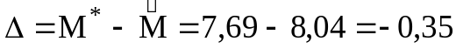.
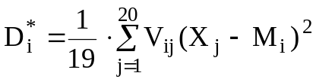
Таблица14
27,93 | 32,82 | 37,12 | 21,54 | 26,78 | 48,32 | 24,76 | 18,44 | 39,48 | 40,86

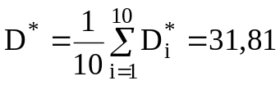, 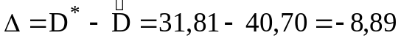.
Число бутстреп М = 30:
Таблица15
V1 | V2 | V3 | V4 | V5 | V6 | V7 | V8 | V9 | V10
0 | 2 | 0 | 0 | 3 | 0 | 1 | 1 | 0 | 3
0 | 0 | 3 | 0 | 2 | 0 | 0 | 1 | 0 | 0
2 | 1 | 0 | 1 | 1 | 2 | 0 | 2 | 2 | 1
1 | 2 | 0 | 1 | 1 | 3 | 0 | 2 | 0 | 1
1 | 1 | 0 | 1 | 2 | 0 | 0 | 0 | 1 | 0
0 | 1 | 1 | 0 | 0 | 2 | 1 | 2 | 2 | 1
0 | 3 | 2 | 0 | 1 | 0 | 1 | 1 | 0 | 4
2 | 0 | 2 | 1 | 0 | 3 | 0 | 1 | 0 | 3
1 | 2 | 0 | 1 | 2 | 0 | 1 | 1 | 1 | 1
1 | 1 | 3 | 1 | 0 | 0 | 1 | 1 | 1 | 3
2 | 3 | 0 | 1 | 2 | 2 | 1 | 0 | 1 | 1
0 | 2 | 2 | 1 | 0 | 0 | 2 | 1 | 0 | 1
0 | 1 | 1 | 0 | 2 | 2 | 2 | 0 | 0 | 2
1 | 1 | 2 | 1 | 3 | 0 | 0 | 0 | 0 | 1
2 | 2 | 1 | 1 | 1 | 2 | 0 | 0 | 0 | 0
1 | 2 | 1 | 1 | 0 | 1 | 2 | 0 | 3 | 0
1 | 1 | 1 | 2 | 0 | 1 | 1 | 1 | 1 | 1
0 | 3 | 1 | 1 | 0 | 0 | 1 | 1 | 2 | 1
0 | 0 | 0 | 1 | 1 | 1 | 4 | 0 | 2 | 1
2 | 1 | 1 | 0 | 0 | 1 | 1 | 0 | 0 | 0
1 | 1 | 3 | 0 | 1 | 1 | 0 | 0 | 1 | 0
0 | 4 | 1 | 1 | 0 | 1 | 0 | 1 | 0 | 1
1 | 1 | 0 | 1 | 1 | 3 | 2 | 1 | 0 | 1
0 | 1 | 0 | 0 | 0 | 1 | 4 | 2 | 1 | 2
5 | 0 | 3 | 1 | 0 | 0 | 0 | 0 | 2 | 2
1 | 1 | 0 | 2 | 2 | 3 | 0 | 0 | 1 | 1
0 | 2 | 2 | 0 | 1 | 0 | 3 | 2 | 1 | 0
2 | 0 | 0 | 1 | 1 | 2 | 0 | 1 | 0 | 0
0 | 2 | 1 | 0 | 2 | 0 | 0 | 0 | 2 | 1
1 | 0 | 3 | 1 | 0 | 2 | 2 | 0 | 1 | 0

Окончание таблицы15
V11 | V12 | V13 | V14 | V15 | V16 | V17 | V18 | V19 | V20
1 | 1 | 3 | 1 | 1 | 2 | 0 | 1 | 0 | 0
0 | 1 | 1 | 1 | 3 | 0 | 2 | 3 | 2 | 1
3 | 0 | 1 | 1 | 0 | 0 | 0 | 2 | 0 | 1
1 | 1 | 0 | 0 | 1 | 2 | 1 | 0 | 2 | 1
3 | 1 | 1 | 0 | 3 | 3 | 2 | 0 | 0 | 1
1 | 2 | 1 | 0 | 1 | 1 | 0 | 1 | 2 | 1
1 | 0 | 2 | 2 | 0 | 0 | 2 | 1 | 0 | 0
2 | 0 | 0 | 1 | 2 | 2 | 0 | 0 | 0 | 1
0 | 1 | 2 | 3 | 1 | 0 | 0 | 0 | 0 | 3
0 | 1 | 0 | 0 | 3 | 1 | 0 | 1 | 0 | 2
0 | 0 | 1 | 3 | 2 | 0 | 0 | 0 | 1 | 0
0 | 2 | 1 | 1 | 1 | 1 | 1 | 1 | 1 | 2
0 | 0 | 2 | 1 | 1 | 1 | 1 | 1 | 1 | 2
0 | 3 | 0 | 1 | 0 | 2 | 0 | 0 | 3 | 2
1 | 2 | 0 | 0 | 1 | 1 | 2 | 0 | 2 | 2
1 | 0 | 3 | 0 | 1 | 1 | 2 | 1 | 0 | 0
0 | 1 | 1 | 1 | 2 | 1 | 0 | 2 | 0 | 2
1 | 0 | 0 | 1 | 1 | 0 | 0 | 1 | 2 | 4
1 | 1 | 1 | 1 | 0 | 1 | 0 | 1 | 3 | 1
1 | 2 | 1 | 0 | 2 | 3 | 2 | 0 | 2 | 1
2 | 0 | 1 | 1 | 1 | 1 | 4 | 1 | 1 | 0
0 | 0 | 0 | 3 | 1 | 1 | 1 | 2 | 0 | 3
1 | 0 | 0 | 2 | 2 | 0 | 2 | 1 | 0 | 1
1 | 1 | 0 | 0 | 2 | 1 | 1 | 1 | 0 | 2
0 | 0 | 1 | 0 | 1 | 0 | 0 | 1 | 2 | 2
0 | 0 | 2 | 2 | 1 | 1 | 1 | 2 | 0 | 0
2 | 0 | 1 | 1 | 2 | 1 | 0 | 2 | 0 | 0
1 | 1 | 2 | 0 | 1 | 2 | 1 | 2 | 2 | 1
0 | 0 | 0 | 2 | 3 | 2 | 1 | 1 | 0 | 3
1 | 4 | 0 | 1 | 1 | 0 | 1 | 1 | 1 | 0

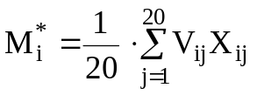
Таблица16
9,27 | 7,93 | 8,14 | 4,88 | 6,80 | 7,67 | 8,50 | 5,38 | 10,13 | 8,26
6,76 | 8,79 | 9,94 | 6,96 | 5,07 | 9,58 | 8,85 | 9,57 | 11,03 | 5,89
6,56 | 8,18 | 7,68 | 10,75 | 7,73 | 7,78 | 9,94 | 6,86 | 9,64 | 6,61

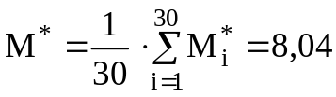, 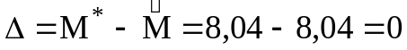.
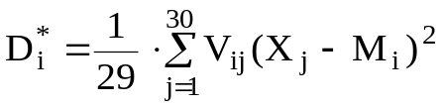
Таблица17
27,93 | 32,82 | 37,12 | 21,54 | 26,78 | 48,32 | 24,76 | 18,44 | 39,48 | 40,86
38,57 | 48,77 | 49,50 | 29,53 | 27,88 | 50,48 | 46,20 | 54,31 | 67,26 | 34,34
22,32 | 35,28 | 50,87 | 65,26 | 37,67 | 32,15 | 52,13 | 34,07 | 36,06 | 49,15

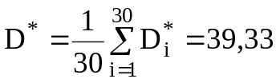, 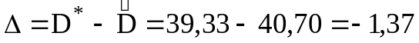.
Число бутстреп М=50:
Таблица18
V1 | 0 | 2 | 0 | 0 | 3 | 0 | 1 | 1 | 0
V2 | 0 | 0 | 3 | 0 | 2 | 0 | 0 | 1 | 0
V3 | 2 | 1 | 0 | 1 | 1 | 2 | 0 | 2 | 2
V4 | 1 | 2 | 0 | 1 | 1 | 3 | 0 | 2 | 0
V5 | 1 | 1 | 0 | 1 | 2 | 0 | 0 | 0 | 1
V6 | 0 | 1 | 1 | 0 | 0 | 2 | 1 | 2 | 2
V7 | 0 | 3 | 2 | 0 | 1 | 0 | 1 | 1 | 0
V8 | 2 | 0 | 2 | 1 | 0 | 3 | 0 | 1 | 0
V9 | 1 | 2 | 0 | 1 | 2 | 0 | 1 | 1 | 1
V10 | 1 | 1 | 3 | 1 | 0 | 0 | 1 | 1 | 1
V11 | 2 | 3 | 0 | 1 | 2 | 2 | 1 | 0 | 1
V12 | 0 | 2 | 2 | 1 | 0 | 0 | 2 | 1 | 0
V13 | 0 | 1 | 1 | 0 | 2 | 2 | 2 | 0 | 0
V14 | 1 | 1 | 2 | 1 | 3 | 0 | 0 | 0 | 0
V15 | 2 | 2 | 1 | 1 | 1 | 2 | 0 | 0 | 0
V16 | 1 | 2 | 1 | 1 | 0 | 1 | 2 | 0 | 3
V17 | 1 | 1 | 1 | 2 | 0 | 1 | 1 | 1 | 1
V18 | 0 | 3 | 1 | 1 | 0 | 0 | 1 | 1 | 2
V19 | 0 | 0 | 0 | 1 | 1 | 1 | 4 | 0 | 2
V20 | 2 | 1 | 1 | 0 | 0 | 1 | 1 | 0 | 0
V21 | 1 | 1 | 3 | 0 | 1 | 1 | 0 | 0 | 1
V22 | 0 | 4 | 1 | 1 | 0 | 1 | 0 | 1 | 0
V23 | 1 | 1 | 0 | 1 | 1 | 3 | 2 | 1 | 0
V24 | 0 | 1 | 0 | 0 | 0 | 1 | 4 | 2 | 1
V25 | 5 | 0 | 3 | 1 | 0 | 0 | 0 | 0 | 2
V26 | 1 | 1 | 0 | 2 | 2 | 3 | 0 | 0 | 1
V27 | 0 | 2 | 2 | 0 | 1 | 0 | 3 | 2 | 1
V28 | 2 | 0 | 0 | 1 | 1 | 2 | 0 | 1 | 0
V29 | 0 | 2 | 1 | 0 | 2 | 0 | 0 | 0 | 2
V30 | 1 | 0 | 3 | 1 | 0 | 2 | 2 | 0 | 1
V31 | 1 | 3 | 1 | 1 | 0 | 1 | 1 | 0 | 3
V32 | 0 | 0 | 2 | 1 | 3 | 0 | 2 | 0 | 0
V33 | 0 | 0 | 2 | 2 | 0 | 1 | 0 | 2 | 1
V34 | 3 | 1 | 1 | 1 | 2 | 0 | 1 | 0 | 2
V35 | 2 | 1 | 2 | 0 | 0 | 2 | 2 | 1 | 0
V36 | 0 | 0 | 1 | 0 | 3 | 0 | 1 | 0 | 0
V37 | 0 | 4 | 1 | 1 | 2 | 1 | 1 | 0 | 0
V38 | 0 | 2 | 1 | 1 | 1 | 1 | 3 | 0 | 0
V39 | 1 | 1 | 2 | 2 | 1 | 0 | 1 | 1 | 0
V40 | 1 | 2 | 0 | 0 | 3 | 0 | 1 | 0 | 1
V41 | 3 | 0 | 0 | 1 | 0 | 1 | 2 | 0 | 1
V42 | 1 | 1 | 1 | 1 | 2 | 1 | 1 | 0 | 2
V43 | 1 | 0 | 0 | 1 | 0 | 1 | 1 | 2 | 0
V44 | 1 | 0 | 2 | 2 | 0 | 2 | 0 | 0 | 1
V45 | 1 | 2 | 0 | 2 | 0 | 1 | 2 | 1 | 1
V46 | 0 | 0 | 0 | 1 | 0 | 1 | 4 | 1 | 0
V47 | 0 | 0 | 1 | 2 | 0 | 1 | 1 | 3 | 0
V48 | 2 | 1 | 0 | 1 | 1 | 0 | 1 | 1 | 2
V49 | 1 | 1 | 1 | 0 | 0 | 1 | 1 | 2 | 0
V50 | 0 | 0 | 2 | 0 | 0 | 1 | 1 | 2 | 0

V1 | 3 | 1 | 1 | 3 | 1 | 1 | 2 | 0 | 1 | 0 | 0
V2 | 0 | 0 | 1 | 1 | 1 | 3 | 0 | 2 | 3 | 2 | 1
V3 | 1 | 3 | 0 | 1 | 1 | 0 | 0 | 0 | 2 | 0 | 1
V4 | 1 | 1 | 1 | 0 | 0 | 1 | 2 | 1 | 0 | 2 | 1
V5 | 0 | 3 | 1 | 1 | 0 | 3 | 3 | 2 | 0 | 0 | 1
V6 | 1 | 1 | 2 | 1 | 0 | 1 | 1 | 0 | 1 | 2 | 1
V7 | 4 | 1 | 0 | 2 | 2 | 0 | 0 | 2 | 1 | 0 | 0
V8 | 3 | 2 | 0 | 0 | 1 | 2 | 2 | 0 | 0 | 0 | 1
V9 | 1 | 0 | 1 | 2 | 3 | 1 | 0 | 0 | 0 | 0 | 3
V10 | 3 | 0 | 1 | 0 | 0 | 3 | 1 | 0 | 1 | 0 | 2
V11 | 1 | 0 | 0 | 1 | 3 | 2 | 0 | 0 | 0 | 1 | 0
V12 | 1 | 0 | 2 | 1 | 1 | 1 | 1 | 1 | 1 | 1 | 2
V13 | 2 | 0 | 0 | 2 | 1 | 1 | 1 | 1 | 1 | 1 | 2
V14 | 1 | 0 | 3 | 0 | 1 | 0 | 2 | 0 | 0 | 3 | 2
V15 | 0 | 1 | 2 | 0 | 0 | 1 | 1 | 2 | 0 | 2 | 2
V16 | 0 | 1 | 0 | 3 | 0 | 1 | 1 | 2 | 1 | 0 | 0
V17 | 1 | 0 | 1 | 1 | 1 | 2 | 1 | 0 | 2 | 0 | 2
V18 | 1 | 1 | 0 | 0 | 1 | 1 | 0 | 0 | 1 | 2 | 4
V19 | 1 | 1 | 1 | 1 | 1 | 0 | 1 | 0 | 1 | 3 | 1
V20 | 0 | 1 | 2 | 1 | 0 | 2 | 3 | 2 | 0 | 2 | 1
V21 | 0 | 2 | 0 | 1 | 1 | 1 | 1 | 4 | 1 | 1 | 0
V22 | 1 | 0 | 0 | 0 | 3 | 1 | 1 | 1 | 2 | 0 | 3
V23 | 1 | 1 | 0 | 0 | 2 | 2 | 0 | 2 | 1 | 0 | 1
V24 | 2 | 1 | 1 | 0 | 0 | 2 | 1 | 1 | 1 | 0 | 2
V25 | 2 | 0 | 0 | 1 | 0 | 1 | 0 | 0 | 1 | 2 | 2
V26 | 1 | 0 | 0 | 2 | 2 | 1 | 1 | 1 | 2 | 0 | 0
V27 | 0 | 2 | 0 | 1 | 1 | 2 | 1 | 0 | 2 | 0 | 0
V28 | 0 | 1 | 1 | 2 | 0 | 1 | 2 | 1 | 2 | 2 | 1
V29 | 1 | 0 | 0 | 0 | 2 | 3 | 2 | 1 | 1 | 0 | 3
V30 | 0 | 1 | 4 | 0 | 1 | 1 | 0 | 1 | 1 | 1 | 0
V31 | 0 | 1 | 0 | 0 | 2 | 0 | 1 | 1 | 2 | 1 | 1
V32 | 0 | 1 | 2 | 1 | 2 | 0 | 1 | 1 | 1 | 2 | 1
V33 | 2 | 0 | 2 | 1 | 0 | 2 | 1 | 1 | 0 | 0 | 3
V34 | 1 | 0 | 2 | 1 | 1 | 1 | 1 | 0 | 0 | 0 | 2
V35 | 3 | 1 | 0 | 0 | 1 | 0 | 1 | 2 | 2 | 0 | 0
V36 | 1 | 1 | 1 | 2 | 1 | 2 | 3 | 0 | 2 | 1 | 1
V37 | 1 | 1 | 0 | 3 | 2 | 1 | 0 | 1 | 0 | 0 | 1
V38 | 0 | 1 | 2 | 1 | 4 | 0 | 1 | 1 | 1 | 0 | 0
V39 | 1 | 1 | 0 | 2 | 0 | 0 | 3 | 1 | 1 | 1 | 1
V40 | 2 | 0 | 1 | 1 | 1 | 1 | 0 | 1 | 3 | 2 | 0
V41 | 3 | 2 | 1 | 2 | 0 | 0 | 0 | 0 | 4 | 0 | 0
V42 | 1 | 1 | 1 | 1 | 1 | 2 | 3 | 0 | 0 | 0 | 0
V43 | 3 | 1 | 2 | 2 | 0 | 0 | 1 | 2 | 0 | 2 | 1
V44 | 0 | 1 | 1 | 1 | 0 | 1 | 0 | 1 | 1 | 3 | 3
V45 | 2 | 1 | 1 | 0 | 0 | 0 | 1 | 0 | 1 | 3 | 1
V46 | 0 | 2 | 2 | 1 | 0 | 1 | 1 | 2 | 1 | 2 | 1
V47 | 1 | 0 | 1 | 1 | 1 | 1 | 3 | 1 | 2 | 1 | 0
V48 | 1 | 0 | 2 | 1 | 1 | 0 | 2 | 0 | 2 | 2 | 0
V49 | 0 | 2 | 2 | 0 | 1 | 0 | 1 | 1 | 2 | 1 | 3
V50 | 0 | 3 | 2 | 0 | 1 | 0 | 0 | 0 | 2 | 2 | 4

Таблица19
M*1 | M*2 | M*3 | M*4 | M*5 | M*6 | M*7 | M*8 | M*9 | M*10
9,27 | 7,93 | 8,14 | 4,88 | 6,80 | 7,67 | 8,50 | 5,38 | 10,13 | 8,26
M*11 | M*12 | M*13 | M*14 | M*15 | M*16 | M*17 | M*18 | M*19 | M*20
6,76 | 8,79 | 9,94 | 6,96 | 5,07 | 9,58 | 8,85 | 9,57 | 11,03 | 5,89
M*21 | M*22 | M*23 | M*24 | M*25 | M*26 | M*27 | M*28 | M*29 | M*30
6,56 | 8,18 | 7,68 | 10,75 | 7,73 | 7,78 | 9,94 | 6,86 | 9,64 | 6,61
M*31 | M*32 | M*33 | M*34 | M*35 | M*36 | M*37 | M*38 | M*39 | M*40
8,93 | 9,37 | 7,79 | 9,16 | 8,10 | 9,69 | 8,06 | 9,10 | 8,47 | 9,20
M*41 | M*42 | M*43 | M*44 | M*45 | M*46 | M*47 | M*48 | M*49 | M*50
9,90 | 8,01 | 7,16 | 6,88 | 7,60 | 9,13 | 7,76 | 8,68 | 8,46 | 8,86
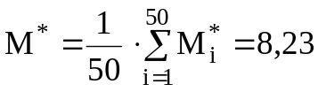, 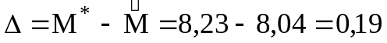.
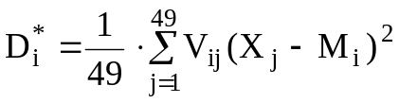
Таблица20
D*1 | D*2 | D*3 | D*4 | D*5 | D*6 | D*7 | D*8 | D*9 | D*10
27,93 | 32,82 | 37,12 | 21,54 | 26,78 | 48,32 | 24,76 | 18,44 | 39,48 | 40,86
D*11 | D*12 | D*13 | D*14 | D*15 | D*16 | D*17 | D*18 | D*19 | D*20
38,57 | 48,77 | 49,50 | 29,53 | 27,88 | 50,48 | 46,20 | 54,31 | 67,26 | 34,34
D*21 | D*22 | D*23 | D*24 | D*25 | D*26 | D*27 | D*28 | D*29 | D*30
22,32 | 35,28 | 50,87 | 65,26 | 37,67 | 32,15 | 52,13 | 34,07 | 36,06 | 49,15
D*31 | D*32 | D*33 | D*34 | D*35 | D*36 | D*37 | D*38 | D*39 | D*40
47,99 | 44,34 | 33,82 | 43,08 | 41,33 | 35,42 | 36,61 | 49,75 | 31,94 | 41,39
D*41 | D*42 | D*43 | D*44 | D*45 | D*46 | D*47 | D*48 | D*49 | D*50
49,35 | 36,76 | 33,18 | 45,33 | 54,04 | 69,34 | 30,65 | 40,61 | 47,43 | 52,94
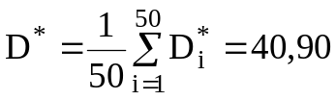, 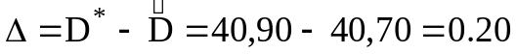.
в). Находим дисперсии оценок
Число бутстреп М=10:
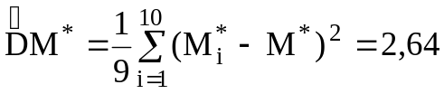,
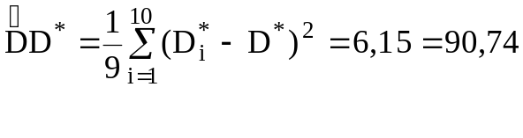
Число бутстреп М=30
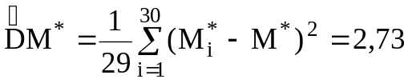,
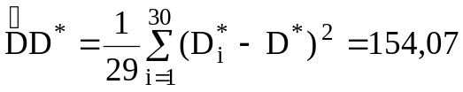.
Число бутстреп М=50:
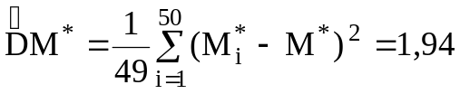,
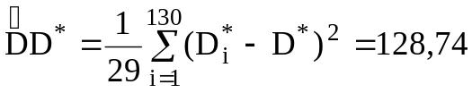.
3. Для всей выборке найдем M(x), D(x).

 