**Background**

As Toronto grows in population and high-density housing gets built, Toronto School Boards are faced with a problematic situation in which Toronto schools get overcrowded or their resources are overwhelmed. Many parents and officials from the City of Toronto have proposed to collect levies from real estate developers and builders as each new building permit is granted. However, the current legislation has requirements for school boards to “qualify for education development charges” or levies and specifies the “limits on how that money can be spent”. One of the requirements needed from the school boards are that the “board’s total enrolment has to exceed capacity.” The Toronto District School Board, which is Canada’s largest school board, “has surplus space and underused schools in some areas”, which leaves it in a position in which they are “unable to collect development levies to fund the expansion of many schools that are overcrowded”. However, the smaller Toronto Catholic District School Board has collected millions of dollars a year in development levies, however due to the city regulations, the funds can only be used to buy new land and not for additions or repairs to its existing schools.School boards currently address this problem by placing portable classrooms on overcrowded schools’ properties. However, many parents and teachers complain that the portable classrooms have “missing ceiling tiles, unfinished drywall and molding”, which poses a health concern to students.

**Research Questions/Objectives**

Research Question: Which schools in Toronto are overcrowded or are going to be overwhelmed?

I will try to solve for this research question by observing the spatial clustering of school age

children by census tract and then check which schools are located in census tracts with high

amounts of school age children. I expect most of the overcrowded schools in Toronto to be in

North York and along the Yonge St. Corridor.

**Data**

University of Toronto Map & Data Library Website – Census tract boundaries of Toronto

Toronto Open Data Website–School locations In Toronto

CHASS (Computing in the Humanities and Social Sciences) Website – 2016 Census Data for Toronto (Total of school age children aged 4-11 years)

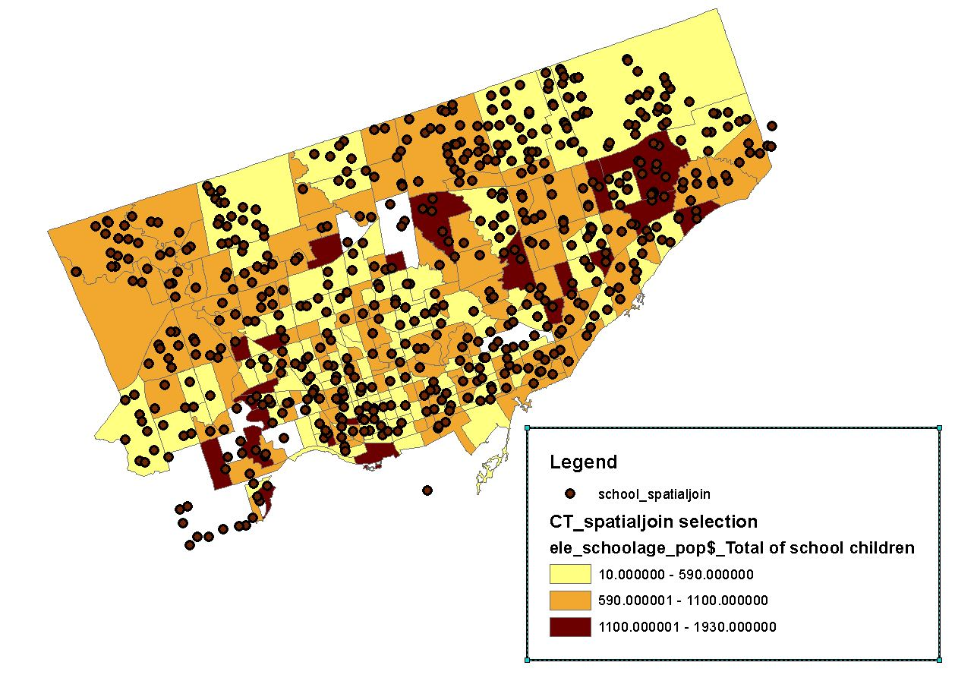

**Methods**

**Descriptive Statistics of School Locations**

* Mean Center
* Standard Deviational Ellipse
* Standard Distance Circle

The settings I used for my Global and Local Moran’s I statistics are: row standardization, Euclidean distance and False Discovery Rate.

**Global Moran’s I**

**Local Moran’s I**

* Inverse Distance using 3500 meter distance band
* Queen Contiguity

**Results**

**Descriptive Statistics**

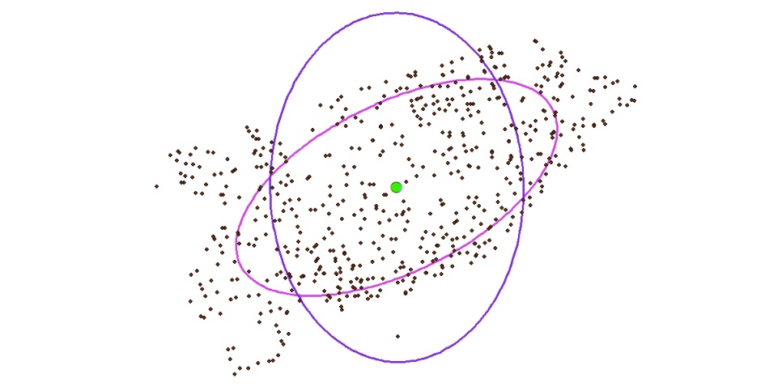

Mean Center: The “center of gravity” of all the schools points.

Standard distance circle: Used to measure the dispersion of the school points from the mean center

Standard deviational ellipse: Shows how the school points are dispersed through a rotation of the coordinate system using a regression slope and it’s transect.

**Global Moran’s I**

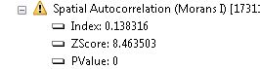

The correlation of census tract population of school-aged children across all the census tracts.

**Local Moran’s I**

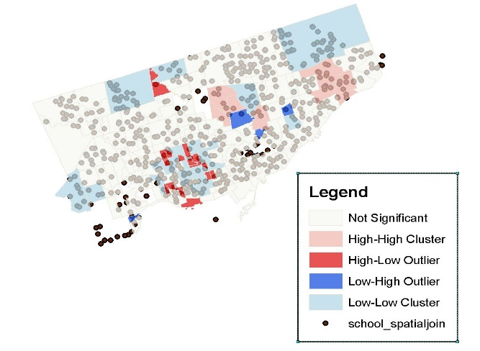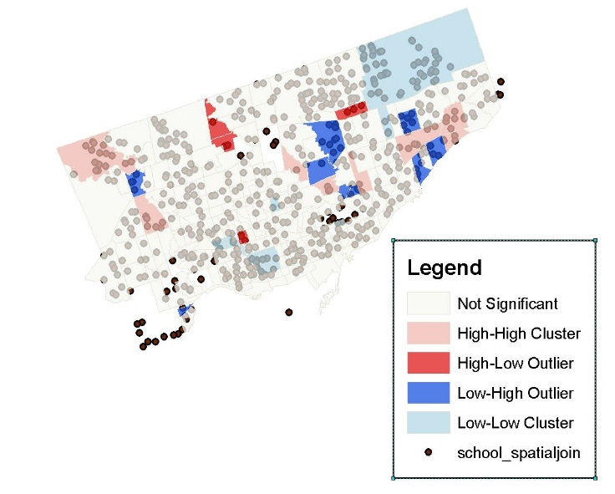

Detects which census tracts have clusters of high populations of school-aged children and clusters of low populations of school-aged children. A statistic or Moran’s I is generated for each census tract.

**Discussion**

The Global Moran’s I is 0.138316, which indicates that the population of school-aged children across Toronto is slightly more clustered than random. The Z-score is very large and the P-Value is 0, which indicates that we reject the null hypothesis school aged children are randomly distributed across Toronto.As a result, the Global Moran’s I that has been calculated is statistically significant.

For my Local Moran’s I using Inverse distance,I used 3500 meters as my distance band because I saw a map of the fixed school boundaries for each school in TCDSB and according to the scale, I made a rough estimate that 3500 meters on average is good measure of how spread out people live close to the school.

For my Local Moran’s I map using Inverse distance,I found many High-Low clusters, High-High clusters and Low-Low clusters. Schools in census tracts with High-Low and High-High clusters are most probably overcrowded, while those in Low-Low clusters are most probably underutilized. For my Local Moran’s I using Queen’s Contiguity map, I found more Low-High clusters, which implies that their might not be many school children in the cluster, but the cluster is surrounded by census tracts with many school-aged children. As a result, the schools in this cluster must be either overcrowded or at near full capacity.

**Conclusion**

As a result, I have made an analysis in which we can infer which Toronto schools in certain census tracts are overcrowded or are prone to being overwhelmed. However, there are some flaws and limitations to my analysis, such as it does not consider the capacity of the schools, the 3500 meter distance band for Local Moran’s I is probably a biased estimate. Some census tracts are missing from my analysis due to the spatial join between census tracts and school point locations. Also, it does not consider commutes between census tracts.

**References**

* [**http://maps.library.utoronto.ca/cgi-bin/files.pl?idnum=1422**](http://maps.library.utoronto.ca/cgi-bin/files.pl?idnum=1422)
* [**https://www1.toronto.ca/wps/portal/contentonly?vgnextoid=16a91e22fe370410VgnVCM10000071d60f89RCRD&vgnextchannel=75d6e03bb8d1e310VgnVCM10000071d60f89RCRD**](https://www1.toronto.ca/wps/portal/contentonly?vgnextoid=16a91e22fe370410VgnVCM10000071d60f89RCRD&vgnextchannel=75d6e03bb8d1e310VgnVCM10000071d60f89RCRD)
* [**https://www.tcdsb.org/ProgramsServices/EarlyYears/Kindergarten/Documents/TCDSB_FixedAttendanceBoundary_KeyMap_Website.pdf**](https://www.tcdsb.org/ProgramsServices/EarlyYears/Kindergarten/Documents/TCDSB_FixedAttendanceBoundary_KeyMap_Website.pdf)
* [**https://www.insidetoronto.com/news-story/1938795-east-york-parents-ask-tdsb-to-fix-decaying-infested-and-overflowing-schools/**](https://www.insidetoronto.com/news-story/1938795-east-york-parents-ask-tdsb-to-fix-decaying-infested-and-overflowing-schools/)
* [**https://www.thestar.com/yourtoronto/education/2017/10/29/parents-want-developers-to-kick-in-and-help-expand-overcrowded-toronto-schools.html**](https://www.thestar.com/yourtoronto/education/2017/10/29/parents-want-developers-to-kick-in-and-help-expand-overcrowded-toronto-schools.html)