CGPA_Changes

Grisham Nathan

October 12, 2017

## `stat_bin()` using `bins = 30`. Pick better value with `binwidth`.

## Warning: Removed 170 rows containing non-finite values (stat_bin).

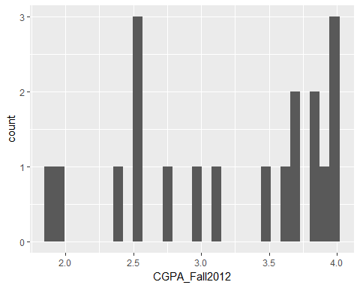

## Min. 1st Qu. Median Mean 3rd Qu. Max. NA's   
## 1.900 2.525 3.500 3.189 3.835 4.000 170

## [1] "Standard Deviation: 0.726188479392464"

## `stat_bin()` using `bins = 30`. Pick better value with `binwidth`.

## Warning: Removed 170 rows containing non-finite values (stat_bin).

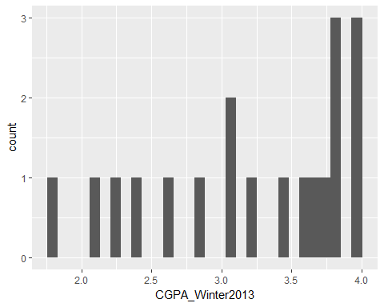

## Min. 1st Qu. Median Mean 3rd Qu. Max. NA's   
## 1.800 2.735 3.470 3.220 3.840 3.970 170

## [1] "Standard Deviation: 0.708582309184253"

## `stat_bin()` using `bins = 30`. Pick better value with `binwidth`.

## Warning: Removed 178 rows containing non-finite values (stat_bin).

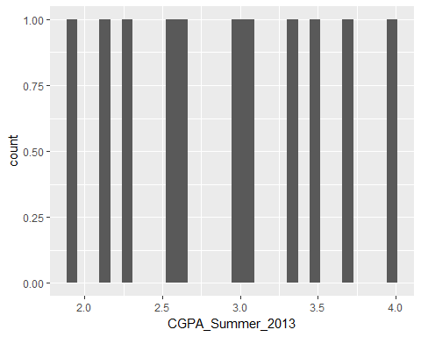

## Min. 1st Qu. Median Mean 3rd Qu. Max. NA's   
## 1.920 2.410 3.010 2.911 3.415 3.980 178

## [1] "Standard Deviation: 0.671780537757005"

## `stat_bin()` using `bins = 30`. Pick better value with `binwidth`.

## Warning: Removed 160 rows containing non-finite values (stat_bin).

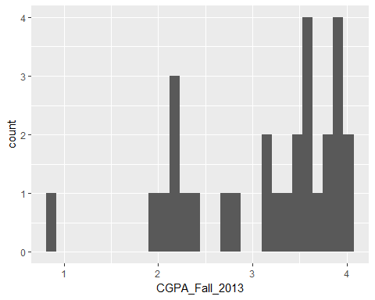

## Min. 1st Qu. Median Mean 3rd Qu. Max. NA's   
## 0.850 2.420 3.430 3.128 3.800 4.000 160

## [1] "Standard Deviation: 0.810358735862197"

## `stat_bin()` using `bins = 30`. Pick better value with `binwidth`.

## Warning: Removed 158 rows containing non-finite values (stat_bin).

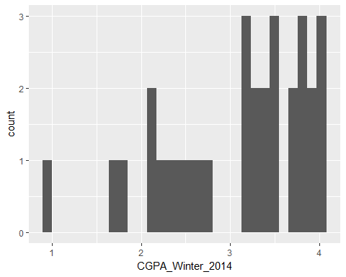

## Min. 1st Qu. Median Mean 3rd Qu. Max. NA's   
## 0.930 2.480 3.320 3.085 3.755 4.000 158

## [1] "Standard Deviation: 0.801622816407409"

## `stat_bin()` using `bins = 30`. Pick better value with `binwidth`.

## Warning: Removed 173 rows containing non-finite values (stat_bin).

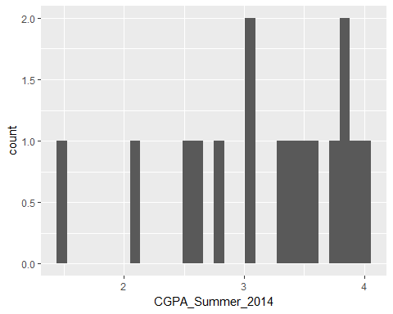

## Min. 1st Qu. Median Mean 3rd Qu. Max. NA's   
## 1.450 2.748 3.390 3.175 3.792 3.980 173

## [1] "Standard Deviation: 0.729474696842415"

## `stat_bin()` using `bins = 30`. Pick better value with `binwidth`.

## Warning: Removed 119 rows containing non-finite values (stat_bin).

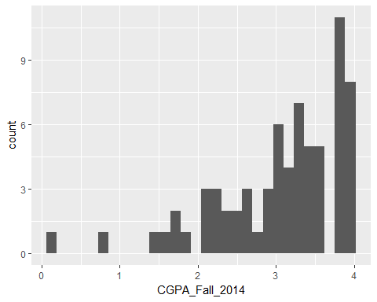

## Min. 1st Qu. Median Mean 3rd Qu. Max. NA's   
## 0.180 2.612 3.240 3.059 3.780 4.000 119

## [1] "Standard Deviation: 0.814093114050036"

## `stat_bin()` using `bins = 30`. Pick better value with `binwidth`.

## Warning: Removed 119 rows containing non-finite values (stat_bin).

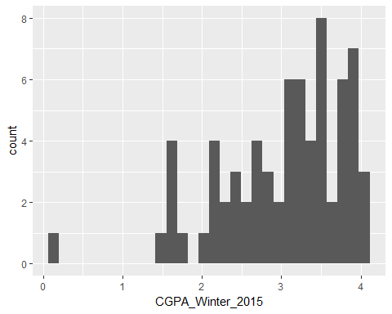

## Min. 1st Qu. Median Mean 3rd Qu. Max. NA's   
## 0.090 2.538 3.195 3.021 3.583 4.000 119

## [1] "Standard Deviation: 0.782862243262163"

## `stat_bin()` using `bins = 30`. Pick better value with `binwidth`.

## Warning: Removed 142 rows containing non-finite values (stat_bin).

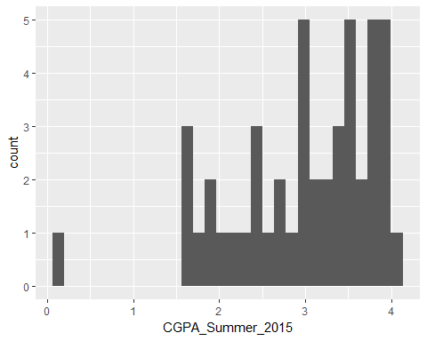

## Min. 1st Qu. Median Mean 3rd Qu. Max. NA's   
## 0.070 2.495 3.110 2.987 3.645 4.000 142

## [1] "Standard Deviation: 0.852013233166723"

## `stat_bin()` using `bins = 30`. Pick better value with `binwidth`.

## Warning: Removed 104 rows containing non-finite values (stat_bin).

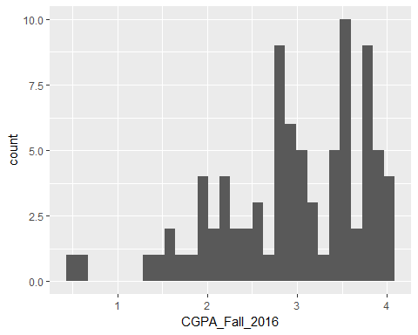

## Min. 1st Qu. Median Mean 3rd Qu. Max. NA's   
## 0.460 2.500 3.040 2.959 3.600 4.000 104

## [1] "Standard Deviation: 0.798087314361366"

## `stat_bin()` using `bins = 30`. Pick better value with `binwidth`.

## Warning: Removed 107 rows containing non-finite values (stat_bin).

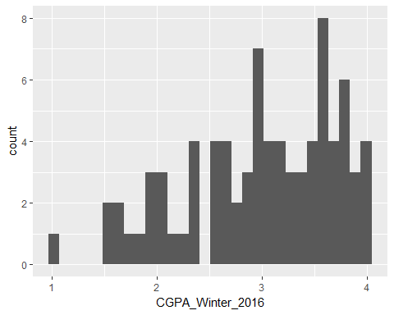

## Min. 1st Qu. Median Mean 3rd Qu. Max. NA's   
## 1.030 2.565 3.095 2.989 3.560 4.000 107

## [1] "Standard Deviation: 0.713974460510997"

## `stat_bin()` using `bins = 30`. Pick better value with `binwidth`.

## Warning: Removed 149 rows containing non-finite values (stat_bin).

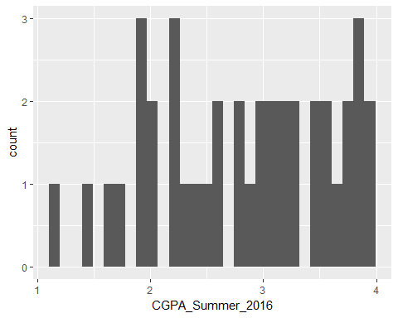

## Min. 1st Qu. Median Mean 3rd Qu. Max. NA's   
## 1.200 2.230 2.935 2.821 3.500 3.990 149

## [1] "Standard Deviation: 0.772802260176129"

## `stat_bin()` using `bins = 30`. Pick better value with `binwidth`.

## Warning: Removed 67 rows containing non-finite values (stat_bin).

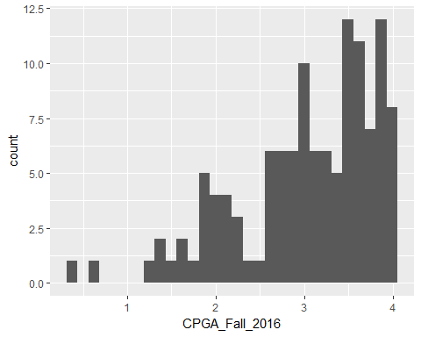

## Min. 1st Qu. Median Mean 3rd Qu. Max. NA's   
## 0.460 2.500 3.040 2.959 3.600 4.000 104

## [1] "Standard Deviation: 0.798087314361366"

## `stat_bin()` using `bins = 30`. Pick better value with `binwidth`.

## Warning: Removed 69 rows containing non-finite values (stat_bin).

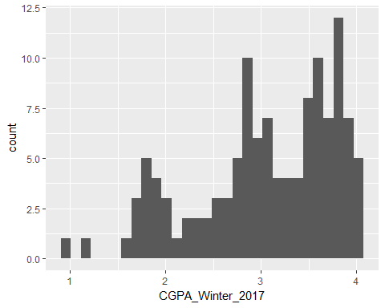

## Min. 1st Qu. Median Mean 3rd Qu. Max. NA's   
## 0.93 2.66 3.18 3.06 3.68 4.00 69

## [1] "Standard Deviation: 0.727205382314534"