Changes

Grisham Nathan

October 12, 2017

## R Markdown

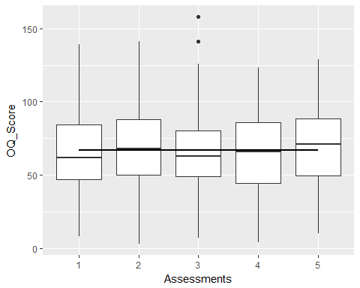

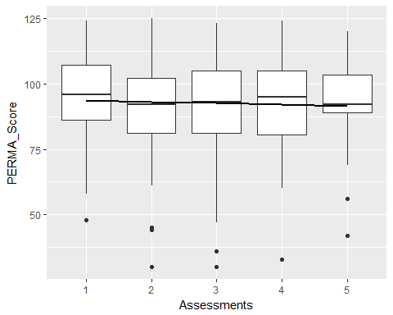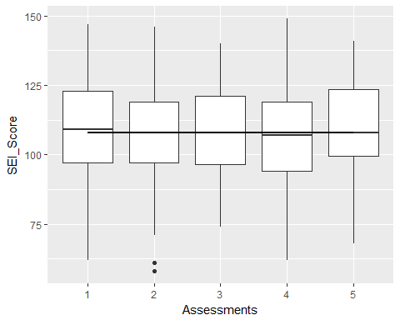

## Assessment 1 OQ_Score PERMA_Score SEI_Score   
## Length:204 Min. : 8.00 Min. : 48.00 Min. : 62.0   
## Class :character 1st Qu.: 47.00 1st Qu.: 86.00 1st Qu.: 97.0   
## Mode :character Median : 62.00 Median : 96.00 Median :109.0   
## Mean : 65.52 Mean : 95.08 Mean :108.4   
## 3rd Qu.: 84.25 3rd Qu.:107.00 3rd Qu.:123.0   
## Max. :139.00 Max. :124.00 Max. :147.0

## Assessment 2 OQ_Score PERMA_Score SEI_Score   
## Length:189 Min. : 3.00 Min. : 30.00 Min. : 58.0   
## Class :character 1st Qu.: 50.00 1st Qu.: 81.00 1st Qu.: 97.0   
## Mode :character Median : 68.00 Median : 92.00 Median :108.0   
## Mean : 70.03 Mean : 91.18 Mean :107.5   
## 3rd Qu.: 88.00 3rd Qu.:102.00 3rd Qu.:119.0   
## Max. :141.00 Max. :125.00 Max. :146.0

## Assessment 3 OQ_Score PERMA_Score SEI_Score   
## Length:143 Min. : 7.00 Min. : 30.00 Min. : 74.0   
## Class :character 1st Qu.: 49.00 1st Qu.: 81.00 1st Qu.: 96.5   
## Mode :character Median : 63.00 Median : 93.00 Median :108.0   
## Mean : 66.06 Mean : 92.48 Mean :107.6   
## 3rd Qu.: 80.50 3rd Qu.:105.00 3rd Qu.:121.0   
## Max. :158.00 Max. :123.00 Max. :140.0

## Assessment 4 OQ_Score PERMA_Score SEI_Score   
## Length:55 Min. : 4.00 Min. : 33.00 Min. : 62.0   
## Class :character 1st Qu.: 44.50 1st Qu.: 80.50 1st Qu.: 94.0   
## Mode :character Median : 66.00 Median : 95.00 Median :107.0   
## Mean : 65.33 Mean : 93.15 Mean :107.1   
## 3rd Qu.: 86.00 3rd Qu.:105.00 3rd Qu.:119.0   
## Max. :123.00 Max. :124.00 Max. :149.0

## Assessment 5 OQ_Score PERMA_Score SEI_Score   
## Length:31 Min. : 10.00 Min. : 42.00 Min. : 68.0   
## Class :character 1st Qu.: 49.50 1st Qu.: 89.00 1st Qu.: 99.5   
## Mode :character Median : 71.00 Median : 92.00 Median :108.0   
## Mean : 67.65 Mean : 93.48 Mean :109.8   
## 3rd Qu.: 88.50 3rd Qu.:103.50 3rd Qu.:123.5   
## Max. :129.00 Max. :120.00 Max. :141.0