Relationship

Grisham Nathan

October 15, 2017

## First assessment

##   
## Call:  
## lm(formula = Fall2014 ~ First_OQ + First_PERMA + First_SEI)  
##   
## Residuals:  
## Min 1Q Median 3Q Max   
## -0.95645 -0.27931 -0.03271 0.38304 0.54863   
##   
## Coefficients:  
## Estimate Std. Error t value Pr(>|t|)   
## (Intercept) 3.6748084 1.8043052 2.037 0.0665 .  
## First_OQ -0.0006068 0.0072182 -0.084 0.9345   
## First_PERMA -0.0083479 0.0158671 -0.526 0.6093   
## First_SEI 0.0058340 0.0091330 0.639 0.5360   
## ---  
## Signif. codes: 0 '***' 0.001 '**' 0.01 '*' 0.05 '.' 0.1 ' ' 1  
##   
## Residual standard error: 0.4748 on 11 degrees of freedom  
## Multiple R-squared: 0.04311, Adjusted R-squared: -0.2179   
## F-statistic: 0.1652 on 3 and 11 DF, p-value: 0.9176

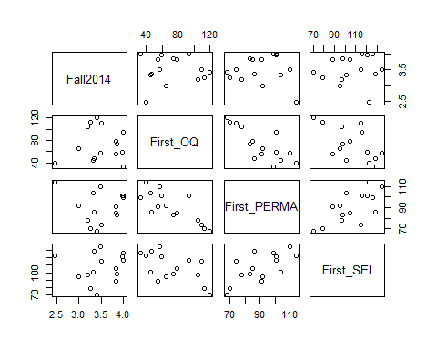

## CGPA_Fall_2014 OQ_Total PERMA_Total SEI_Total  
## CGPA_Fall_2014 1.00000000 0.02364827 -0.07028921 0.09480084  
## OQ_Total 0.02364827 1.00000000 -0.78850807 -0.59781260  
## PERMA_Total -0.07028921 -0.78850807 1.00000000 0.67792717  
## SEI_Total 0.09480084 -0.59781260 0.67792717 1.00000000

## Second assessment

##   
## Call:  
## lm(formula = Winter2015 ~ Second_OQ + Second_PERMA + Second_SEI)  
##   
## Residuals:  
## Min 1Q Median 3Q Max   
## -0.83518 -0.40393 0.05757 0.26515 1.09050   
##   
## Coefficients:  
## Estimate Std. Error t value Pr(>|t|)   
## (Intercept) 1.197954 1.021004 1.173 0.248   
## Second_OQ 0.002867 0.004597 0.624 0.536   
## Second_PERMA -0.007058 0.007403 -0.953 0.346   
## Second_SEI 0.023970 0.005194 4.615 4.19e-05 ***  
## ---  
## Signif. codes: 0 '***' 0.001 '**' 0.01 '*' 0.05 '.' 0.1 ' ' 1  
##   
## Residual standard error: 0.5108 on 39 degrees of freedom  
## Multiple R-squared: 0.36, Adjusted R-squared: 0.3108   
## F-statistic: 7.314 on 3 and 39 DF, p-value: 0.0005266

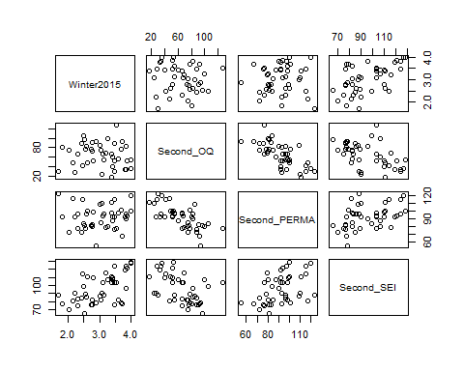

## CGPA_Winter_2015 OQ_Total PERMA_Total SEI_Total  
## CGPA_Winter_2015 1.00000000 -0.09554895 0.03880553 0.5531580  
## OQ_Total -0.09554895 1.00000000 -0.69636477 -0.4854458  
## PERMA_Total 0.03880553 -0.69636477 1.00000000 0.4270863  
## SEI_Total 0.55315805 -0.48544584 0.42708635 1.0000000

## Third assessment

##   
## Call:  
## lm(formula = Summer2015 ~ Third_OQ + Third_PERMA + Third_SEI)  
##   
## Residuals:  
## Min 1Q Median 3Q Max   
## -1.44975 -0.40920 0.01497 0.52450 0.91395   
##   
## Coefficients:  
## Estimate Std. Error t value Pr(>|t|)   
## (Intercept) 2.209e+00 1.179e+00 1.874 0.0682 .  
## Third_OQ 2.681e-05 5.589e-03 0.005 0.9962   
## Third_PERMA -5.722e-03 9.293e-03 -0.616 0.5416   
## Third_SEI 1.232e-02 7.949e-03 1.549 0.1292   
## ---  
## Signif. codes: 0 '***' 0.001 '**' 0.01 '*' 0.05 '.' 0.1 ' ' 1  
##   
## Residual standard error: 0.6204 on 40 degrees of freedom  
## Multiple R-squared: 0.05896, Adjusted R-squared: -0.01162   
## F-statistic: 0.8354 on 3 and 40 DF, p-value: 0.4824

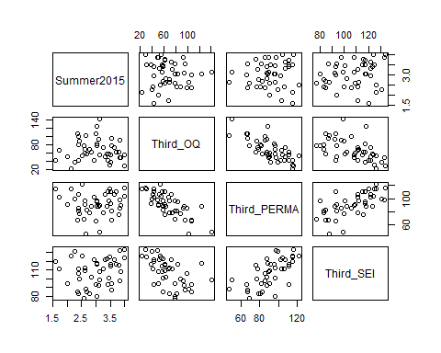

## CGPA_Summer_2015 OQ_Total PERMA_Total SEI_Total  
## CGPA_Summer_2015 1.00000000 -0.04689799 0.04634656 0.2102031  
## OQ_Total -0.04689799 1.00000000 -0.74827102 -0.5315344  
## PERMA_Total 0.04634656 -0.74827102 1.00000000 0.6566244  
## SEI_Total 0.21020310 -0.53153436 0.65662443 1.0000000