**Covid Management System**

**Problem Statement:**

We all know that Covid-19 has had a significant impact on the entire world, resulting in a global health catastrophe. During this crisis, we experienced significant losses in terms of lost lives and income, and the medical ecosystem was impacted. The number of COVID-19 disease cases that have been confirmed or are presumed to be positive and have been reported in the United States is still increasing, given the current situation.

Sequence Diagram:

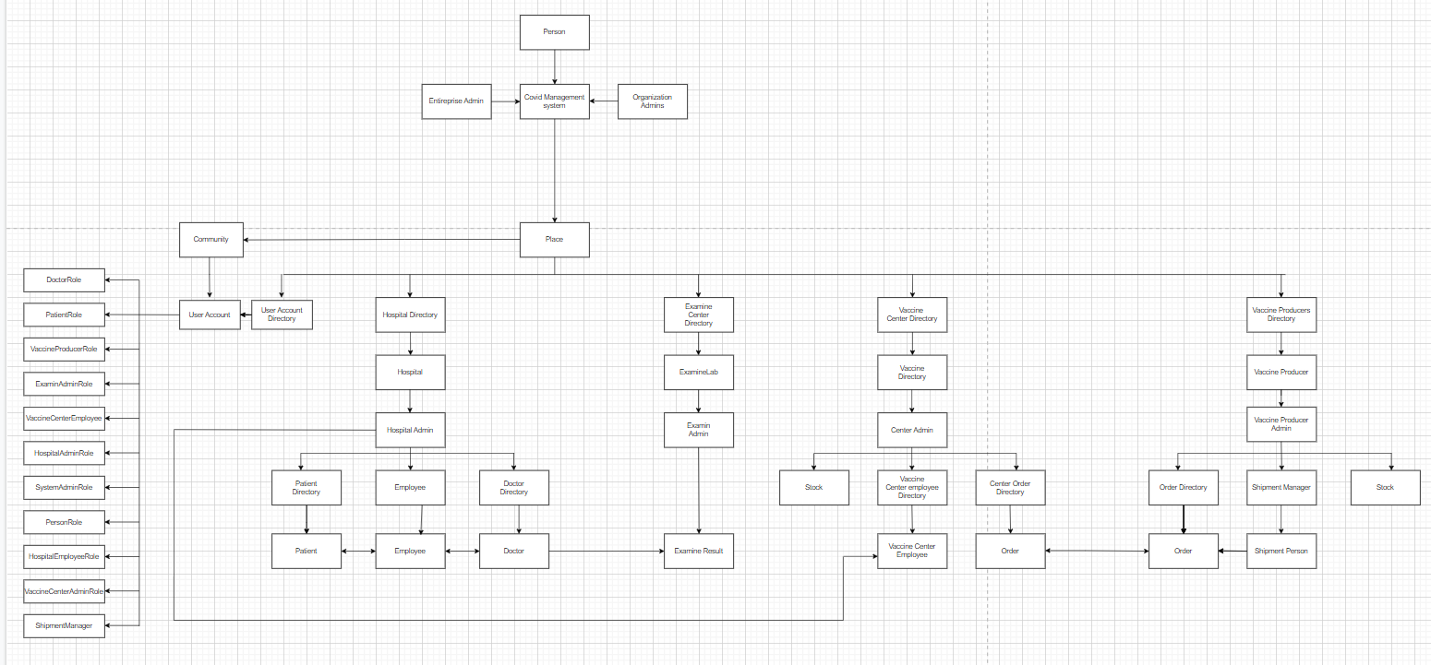

In a managed system, our proposal intends to create a network that links an entire community to a hospital, immunization clinics, vaccine producers, and related institutions. The need for a system that keeps track of Covid patients' medical histories, vaccination records, and overall health in a location or community is pressing. The system may keep track of information about the inhabitants of the city, the hospitals in the community with their staff and physicians, the vaccination centre, and the vaccination suppliers. Our objective is to offer a practical way to handle the demographic records of a community.

There are total 4 Enterprise, 10 Organization and 10 Role.

Enterprise

* Examine Laboratory
* Hospital
* Vaccine Producer
* Vaccine Center

Organization

* Doctor
* Examine Lab Admin
* Hospital Admin
* Hospital Employee
* Patient
* Shipment Manager
* System Admin
* Vaccine Center Admin
* Vaccine Center Employee
* Vaccine Producer

Role

* Doctor
* Examine Lab Admin
* HosAdmin
* HosEmployee
* Patient
* Shipment Manager
* System Admin
* Vaccine Center Admin
* Vaccine Center Emp
* Vaccine Producer

Model Diagram:

