**Assignment-1**

**1.What is a computer network?**

A computer network is a group of interconnected computing devices (e.g., computers, servers, mobile devices) that can exchange data and share resources.

**2. Usages of computer networks:**

• Communication: Email, instant messaging, video conferencing, social networking.

• Resource Sharing: Printers, files, storage devices.

• Information Access: World Wide Web, databases.

• Distributed Computing: Grid computing, cloud computing.

• Entertainment: Online gaming, streaming media.

**3. Layers of the OSI model and their functions:**

The Open Systems Interconnection (OSI) model is a conceptual framework that

divides network communication into seven layers:

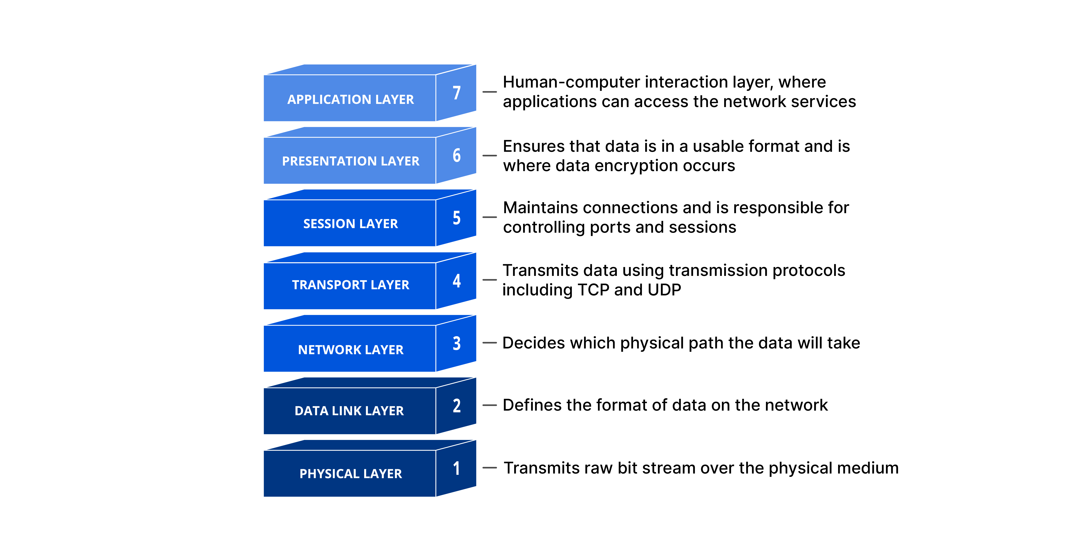

Fig: OSI model

• **Application Layer:** Interfaces with user applications (e.g., web browsers,

email clients), providing network services.

• **Presentation Layer:** Handles data formatting, encryption, and compression for compatibility between systems.

•**Session Layer:** Manages and controls connections (sessions) between applications.

• **Transport Layer:** Ensures reliable and efficient end-to-end data delivery

between applications.

• **Network Layer:** Responsible for routing data packets across multiple networks.

• **Data Link Layer:** Provides error-free transmission of data frames between

nodes within a network segment.

• **Physical Layer:** Transmits raw bits over the physical medium (e.g., cables,

wireless signals).

**4. Difference between OSI and TCP/IP models:**

|  |  |
| --- | --- |
| **OSI Model** | **TCP/IP Model** |
| Theoretical model | Practical implementation |
| 7 layers | 4 layers |
| Clear distinction between services, inter-  faces, and protocols | Overlaps between layers |
| Rarely used in real-world implementations | Widely used for Internet protocols |

**Assignment-2**

**What is Private and Public IP Address?**

Private IP Address:

Private IP addresses are IP addresses used within private networks that are not routable on the global internet. They are designated for use within a single organization or local area network (LAN). Private IP addresses are defined by three IP address blocks:

- Class A: 10.0.0.0 to 10.255.255.255

- Class B: 172.16.0.0 to 172.31.255.255

- Class C: 192.168.0.0 to 192.168.255.255

**Public IP Addresses**

Private IP addresses are IP addresses used within private networks that are Public IP addresses are IP addresses that are routable on the global internet. They are assigned by Internet Assigned Numbers Authority (IANA) and distributed by ISPs.

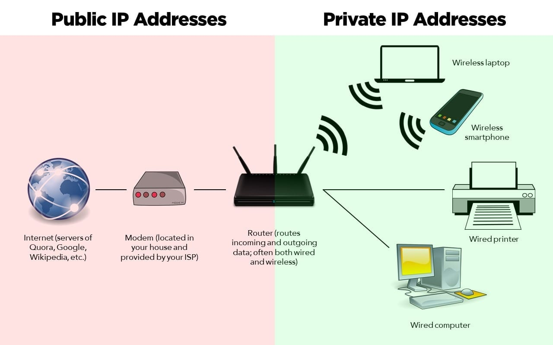

**Differences Between Private and Public IP Addresses**

|  |  |  |
| --- | --- | --- |
| **Feature** | **Private IP Address** | **Public IP Address** |
| **Accessibility** | **Used within private networks, not routable on the internet** | **Routable on the internet, accessible globally** |
| **Assignment** | **Assigned manually or automatically within a private network** | **Assigned by ISPs or organizations for public use** |
| **Network Scope** | **Limited to a specific private network** | **Global scope, accessible from anywhere** |
| **Address Space** | **Can be reused within different private networks** | **Unique across the entire internet** |
| **Security** | **Provides an additional layer of security within a network** | **Requires additional security measures to protect against unauthorized access** |

**How NAT (Network Address Translation)Works**

* A router connects the private network to the internet. The router has a public IP address that is visible on the internet.
* When a device in the private network wants to communicate with the internet, the router translates the private IP address to its public IP address. This process is known as NAT.
* The router keeps track of which internal device made the request and forwards the response from the internet back to the correct device.

**Benefits of NAT**

- Address Conservation: Allows multiple devices to share a single public IP address, conserving the limited number of available public IP addresses.

- Security: Hides the internal network structure from the internet, providing an additional layer of security.