**1.Connecting Two Host on the same network**

**Steps:**

- Open Cisco Packet Tracer

- Create a new network by selecting File > New from the menu.

- From the device type selection box at the bottom, choose End Devices.

- Drag and drop one PC and one Laptop devices onto the workspace.

- Establish connection between them using a 'Copper Straight-Through' cable.

- Click on laptop

- Go to the Desktop tab and select IP Configuration.

- Set the IP Address to 192.168.1.7 and the Subnet Mask to 255.255.255.0.

- Repeat above step for PC, but this time set IP Address to 192.168.1.6

- To test the connectivity

- Click on PC0.

- Go to the Desktop tab and select Command Prompt.

- Type ping 192.168.1.6 and press Enter.

Fig:1

Fig:2

**2.Simulate Connecting Hosts on Different Networks Using Packet Tracer**

**Steps:**

- First add the 4 Laptops, 1 Router, 2 Switches to form network topology

- Connect devices

- Connect Laptop0 and Laptop1 to Switch0

- Connect Laptop2 and Laptop3 to Switch1

- Connect Switch0 to Router (GigabitEthernet0/0)

- Connect Switch1 to Router (GigabitEthernet0/1)

- Configure Laptop0 and Laptop1 to Switch0 and finally to router with IPv3 192.168.1.0. Assign IPs on the devices accordingly.

- For laptop 0 (For example)

- IP Address: 192.168.1.2

- Subnet Mask: 255.255.255.0

- Default Gateway: 192.168.1.1

- Configure Laptop2 and Laptop2 to Switch1 and finally to router with IPv3 11.12.1.0. Assign IPs on the devices accordingly.

- Enable Routing on Router

- Test the network

- Open Command Prompt on Laptop0

- Execute: ping 11.12.1.2

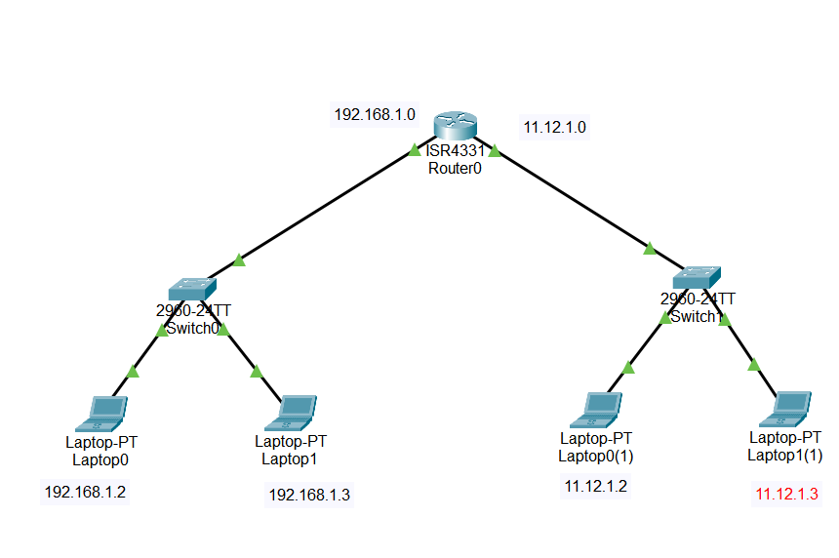

fig:3

Fig:4

3.**Configure DHCP on the Server**

**Steps**

1. **Configure the DHCP Server:**
   * Click on the server (Server1).
   * Go to the "Config" tab.
   * Select the "DHCP" option from the left panel.
   * Enable the DHCP service by checking the "On" box.
   * Configure the DHCP pool:
     + **Pool Name**: Give it a name (e.g., "Pool1").
     + **Default Gateway**: Enter the IP address of the router or the switch's VLAN interface that acts as the gateway (e.g., 192.168.1.1).
     + **DNS Server**: If you have a DNS server, enter its IP address, otherwise, leave it blank.
     + **Start IP Address**: Enter the starting IP address for the DHCP pool (e.g., 192.168.1.10).
     + **Subnet Mask**: Enter the subnet mask (e.g., 255.255.255.0).
     + **Maximum Number of Users**: Set the number of IP addresses to allocate from the pool (e.g., 50).
   * Click "Add" to save the DHCP pool configuration.
2. **Configure the PCs to Obtain IP Addresses Automatically:**
   * Click on each PC (PC0, PC1, PC2).
   * Go to the "Desktop" tab.
   * Click on "IP Configuration".
   * Select "DHCP" to enable the PC to obtain an IP address automatically from the DHCP server.

Fig:1

Fig:2

Fig:3