Game Design Document

Fill up the Following document

1. Write the title of your project.

Bubble Shooter

1. What is the goal of the game?

Shoot all of the bubbles.

1. Write a brief story of your game?

You want to shoot all of the bubbles before it hits the line at the bottom. If you don’t the game will be over. If there are two yellow bubbles, and there is a yellow bubble in the shooter, aim it towards the two yellow bubbles and all the bubbles touching them will pop.

1. Which are the playing characters of this game?

* Playing characters are the ones which respond to the user based on the input from the user
* Cars, monkeys, dinos, wizards etc, are the playing characters in the game.

|  |  |  |
| --- | --- | --- |
| Number | Character Name | What can this character do? |
| 1 | Shooter (shooter image, it’s not a person though) | Shoots the bubbles |
| 2 |  |  |
| 3 |  |  |
| 4 |  |  |
| 5 |  |  |
| 6 |  |  |
| 7 |  |  |
| 8 |  |  |

1. Which are the Non Playing Characters of this game?

* Non Playing characters are the ones which don't have an action or a behaviour when the user interacts with the game.
* Hurdles, stones, bananas, coins, etc are non playing characters in the game.

|  |  |  |
| --- | --- | --- |
| Number | Character Name | What can this character do? |
| 1 | Bubbles | They pop when the shooter hits them with their color |
| 2 | Panda (just stands next to the shooter) | The panda doesn’t do anything, it’s just there for fun |
| 3 | <script src="https://cdnjs.cloudflare.com/ajax/libs/matter-js/0.14.2/matter.min.js"></script>        <script src="https://cdnjs.cloudflare.com/ajax/libs/p5.js/1.0.0/p5.min.js"></script> |  |
| 4 |  |  |
| 5 |  |  |
| 6 |  |  |
| 7 |  |  |
| 8 |  |  |

Draw your imagination of this game. What does this game look like?

* Draw the game either on your computer or on paper,
* Add images of scenes of the game to show each of the playing and non-playing characters at least once.

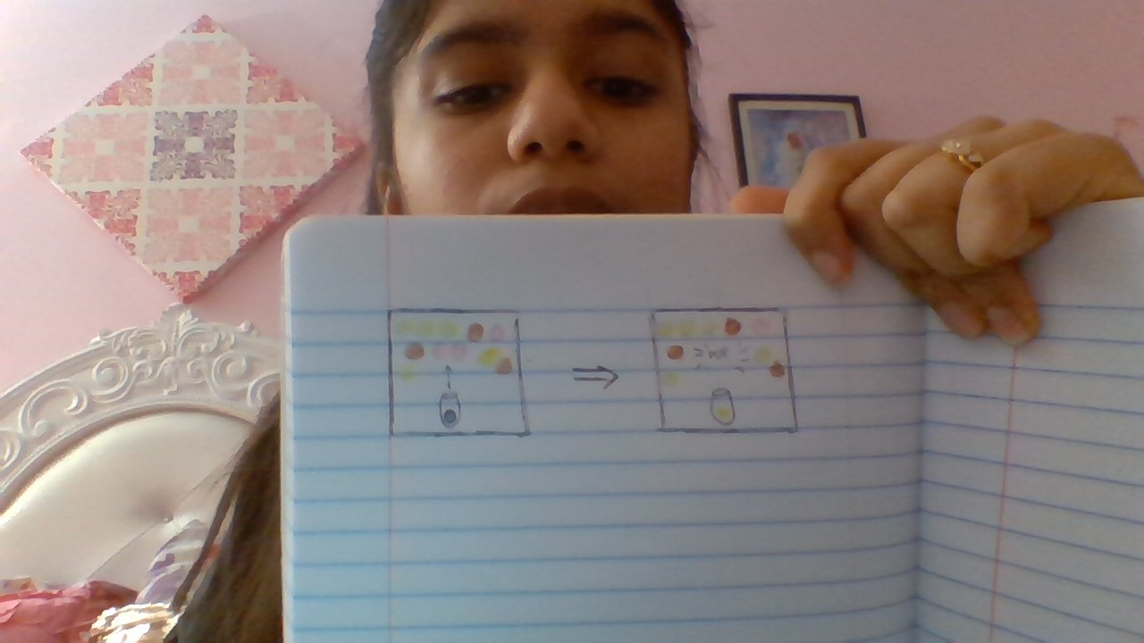­­

How do you plan to make your game engaging?

Make it very colorful, so it isn’t boring