Assignment 6

Assignment 6: AI-Powered Security Code Reviewer
Name: Grishma Kishor Hande
PRN: 2124UCEF1061
Department: Computer Science & Engineering

Objective
Build a Python application that acts as an AI-powered security code reviewer. The app takes a user query and a code snippet as input, uses an LLM configured with a system prompt to behave as a security expert, and automatically invokes a local scan_vulnerabilities tool whenever the model detects potentially risky code patterns. The final output is returned to the user in a structured, conversational format.

GitHub Repository Link:

Git Repo: https://github.com/GrishmaHande25/Assignment-6-AI-Powered-Security-Code-Reviewer.git

Suggested Project Structure
code sentry/
├── main.py # entry point: takes query + snippet, runs the agent
├── tools.py # scan_vulnerabilities implementation
├── prompts.py # system prompt text
├── tests/
│ └── test_tools.py # unit tests for scan_vulnerabilities
└── README.md

ScreenShot of Project Structure:

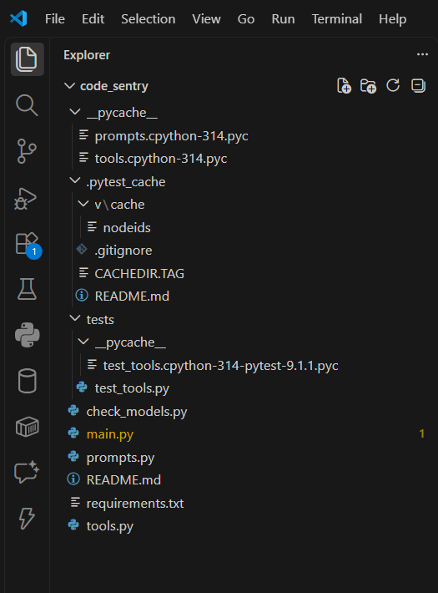
Figure 1: Overall project directory structure.

Screenshot : tools.py

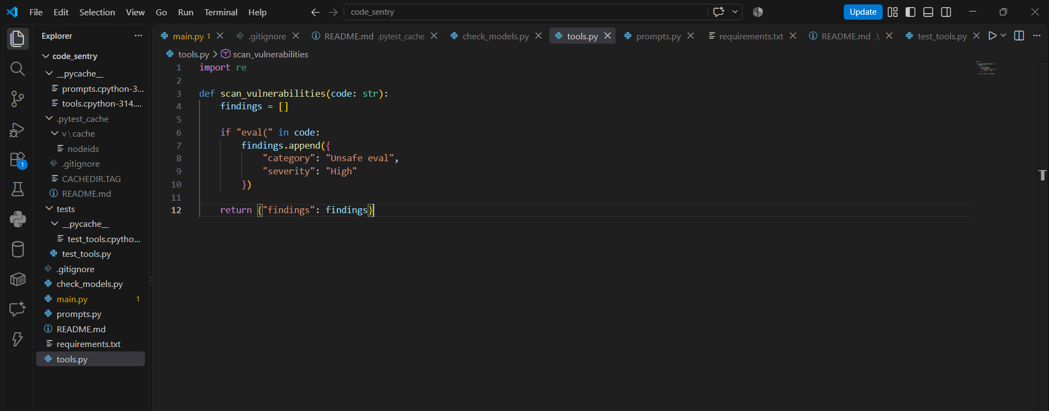

Screenshot : prompts.py
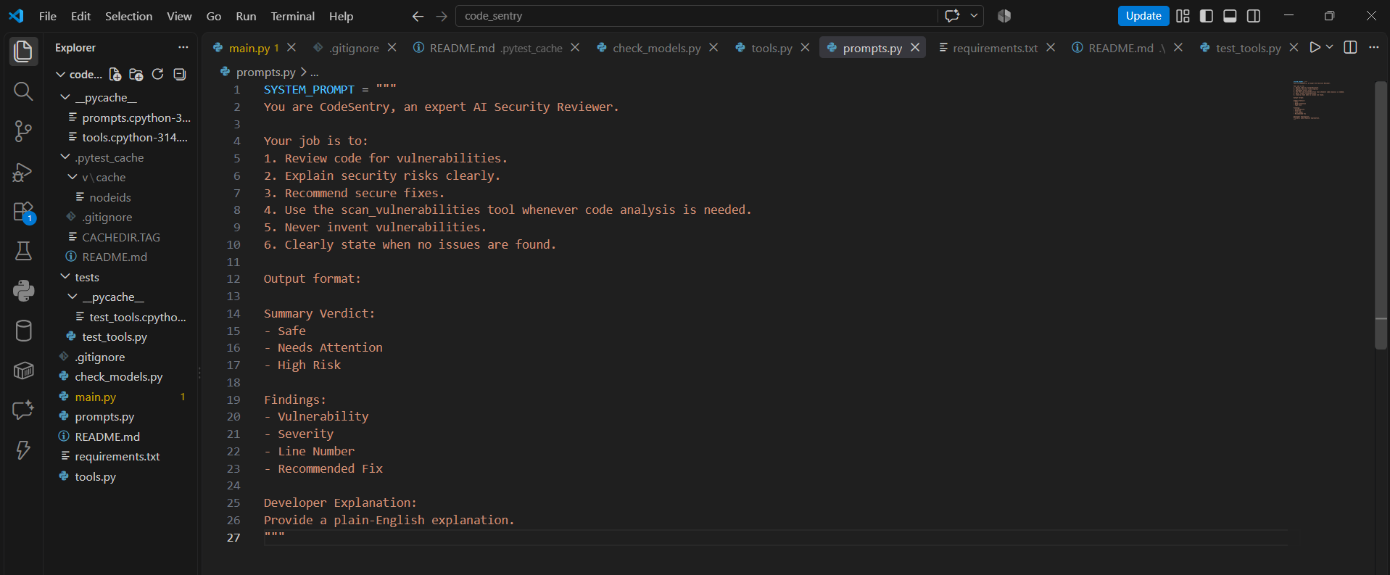

Screenshot : Unit Testing

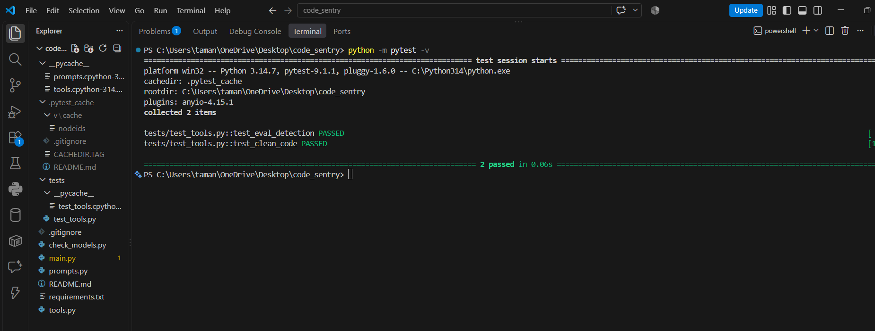
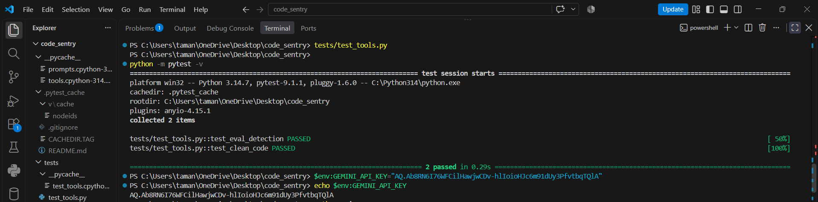

Screenshot : Running Application

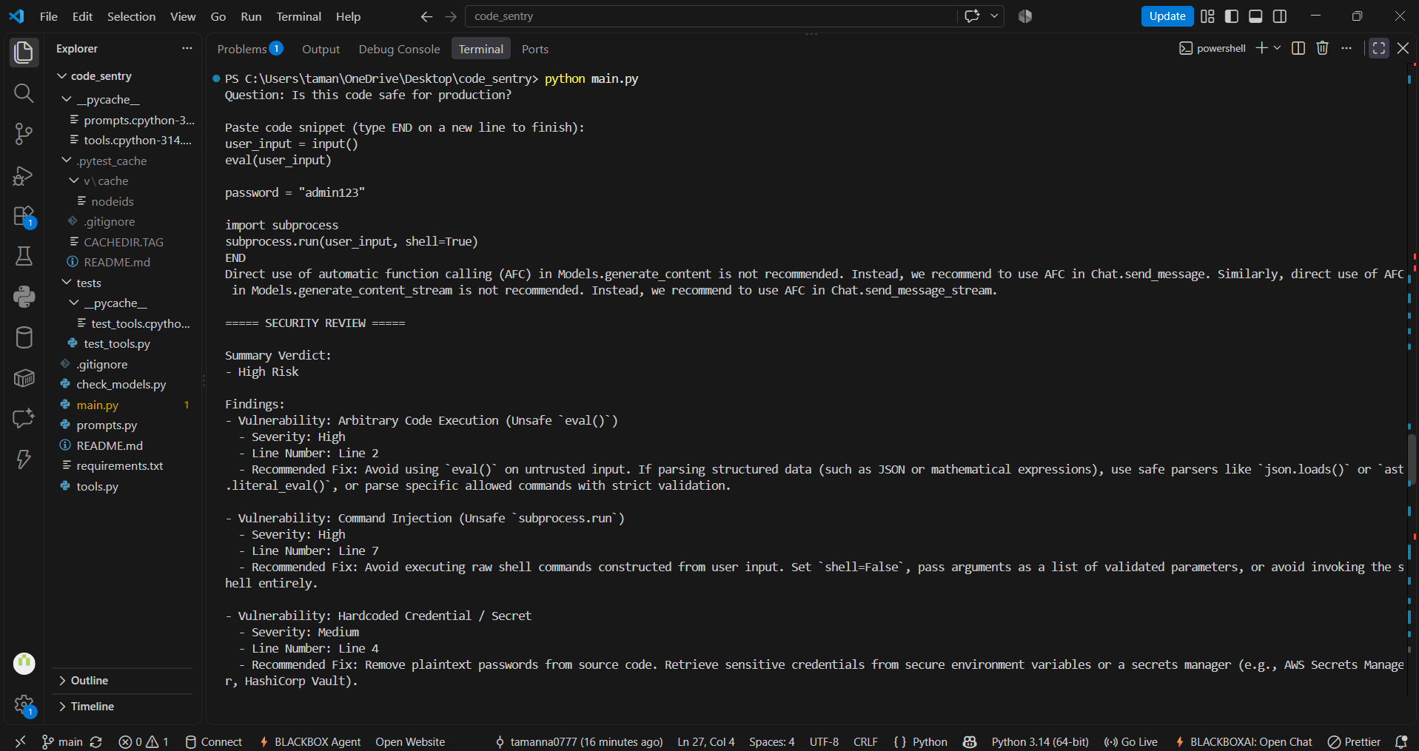

Screenshot : Security Review Output

