NAME: Grishma Kishor Hande
PRN: 2124UCEF1061
Task: Write a program to generate prompt responses using different temperature using any gpt model.
Code:
from google import genai
client = genai.Client(api_key="YOUR_API_KEY")
prompt = "Write a short paragraph about Artificial Intelligence."
temperatures = [0.2, 0.5, 0.8, 1.0]
for temp in temperatures:
print("=" * 60)
print(f"Temperature: {temp}")
response = client.models.generate_content(
model="gemini-3.5-flash",
contents=prompt,
config={"temperature": temp}
)
print(response.text)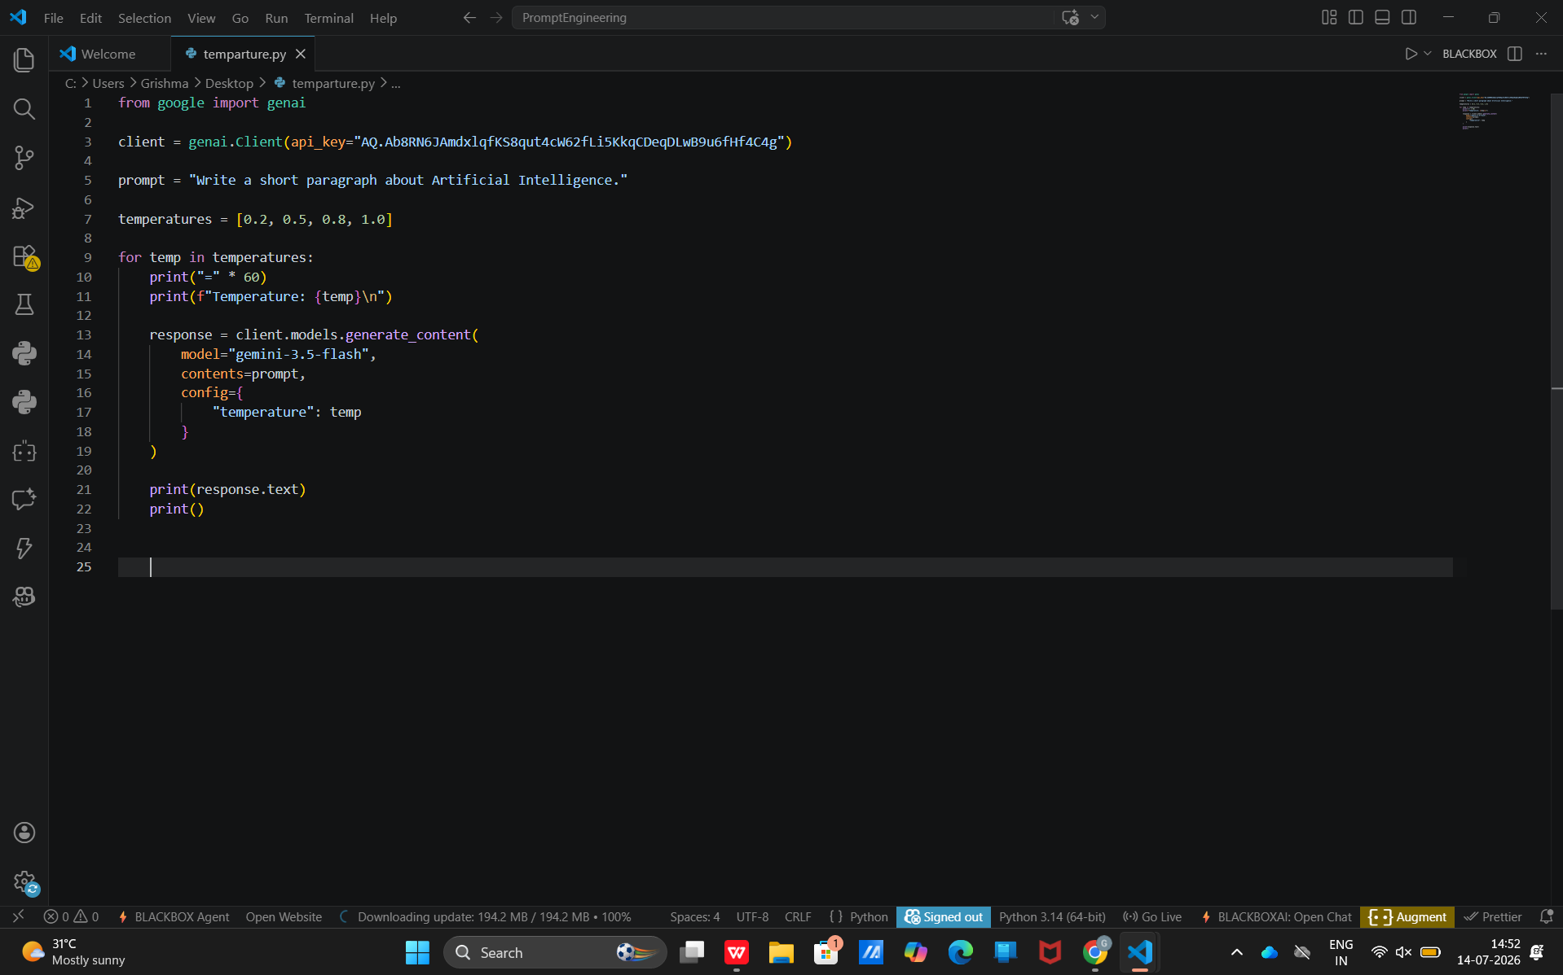

Output:
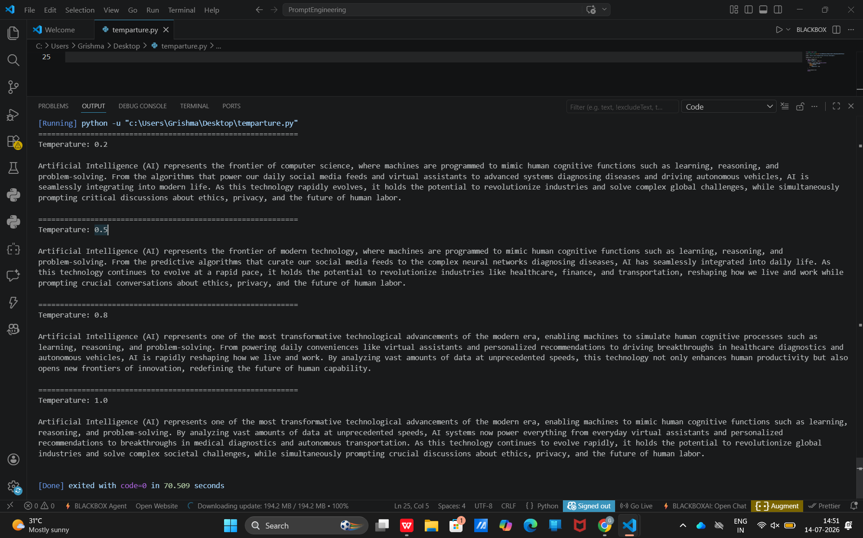
Explanation of how temperature affects the prompts:
- Temperature controls the randomness and creativity of AI-generated responses.
- Lower temperature values (0.2) produce clear, accurate, and consistent responses with less variation.
- Medium temperature values (0.5) provide a balance between accuracy and creativity by adding slightly more detail.
- Higher temperature values (0.8–1.0) generate more descriptive, creative, and diverse responses.
- Lower temperature is suitable for coding, factual answers, and technical explanations.
- Higher temperature is suitable for brainstorming, storytelling, and creative writing.
- Thus, changing the temperature affects the writing style, creativity, and diversity of the generated response while keeping the main idea the same for factual prompts.

Temperature | Effect on Response
0.2 | Produces clear, accurate, and consistent responses. Best for factual and technical tasks.
0.5 | Adds moderate detail and variation while maintaining accuracy.
0.8 | Produces more creative, descriptive, and engaging responses.
1.0 | Generates highly creative and diverse responses with richer wording and varied sentence structure.

