**SWAPPING OF NUMBERS**

**EXP NO: 15**

**AIM:**To compute swapping of numbers using 8085 processor.

**ALGORITHM:**  
1)  Load a 8-bit number from memory location into accumulator.  
2)   Move value of accumulator into register H.  
3)   Load a 8-bit number from next memory location into accumulator.  
4)  Move value of accumulator into register D.  
5)   Exchange both the registers pairs.  
6)  Halt  
  
**PROGRAM:**  
LDA 2001  
MOV B,A  
LDA 2002  
STA 2001  
MOV A,B  
STA 2002  
HLT  
  
  
**INPUT & OUTPUT:**

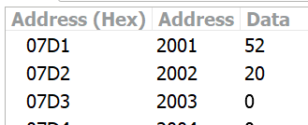

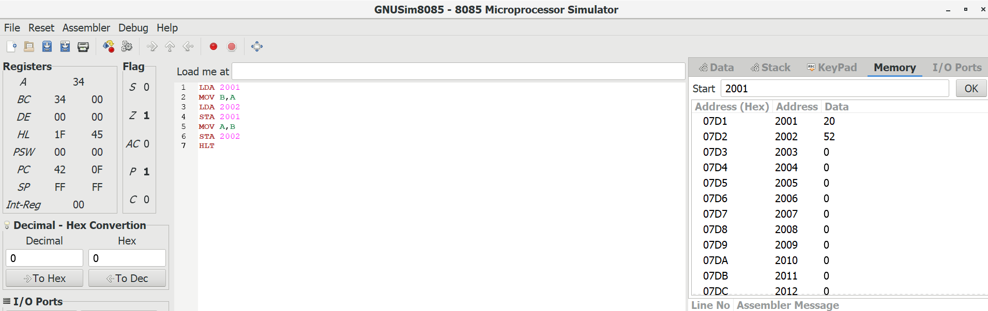

**RESULT:**Thus the program was executed successfully using 8085 processor simulator.