ildaGen
By Gitle Mikkelsen / Grix / GrixM / gitlem@gmail.com
BitLasers.com

ildaGen is an affordable ILDA file creator and editor. It is currently in beta, and have versions for Windows, and Web (HTML5).

The official site for downloading and purchasing ildaGen can be found here.

To get the most out of ildaGen, it is recommended to read through this manual.

If you have any questions, bug reports or feature suggestions, please don’t hesitate to contact me at gitlem@gmail.com .

Table of Contents
List of Keyboard Controls 2
User interface and buttons 3
Button tips and tricks 3
Drawing and preview area 4
The shape area 5
The color area 6
The blanking area 7
Misc buttons 7
The animation area 8
Laserboy 11
Loading files into Laserboy 11
Optimizing and converting to other formats 11
System Requirements 12

List of Keyboard Controls

Mouse) Selects drawing tool and draws
Enter) Remakes object, finalizes curve, or presses OK
Left/Right Arrow) Cycles frames
Up/Down Arrow) Cycles selected object
Delete) Deletes currently selected object
Space) Changes previewing mode between 2D and 3D (simulated scanner)
Shift) Forces straight lines/angles when drawing
Q) Snaps cursor to nearest ending or starting position of any object.
Alt) Snaps cursor to ending position of last placed object for chaining.
Ctrl+Alt) Snaps cursor to starting position of last placed object for chaining.

S) Shows/snaps to square grid. Double click to toggle.
R) Shows radial grid. Double click to toggle.
A) Shows symmetry/alignment guidelines of objects. Green lines mark the center
of the screen. Gray lines mark the ending and starting points of objects, red
lines are symmetrical to gray lines.

Z) Zooms in around the cursor for extra precision.

E) Clones the color that the cursor is pointing at, for example from a background image or a previously placed object. Left click the mouse while holding E to clone the color.

Ctrl) Moves all color sliders, or centers symmetrical sliders
Backspace) Cancels object placing (used with curve tool)
Ctrl+Z) Undo
0) Jumps to the first frame

Mouse wheel) Adjusts wave amplitude
Ctrl+Mouse wheel) Adjusts wave frequency

N) Resets window aspect ratio
M) Resets window size

If you forget the keyboard controls, you can hover the mouse cursor over the HELP button to display a list.

User interface and buttons

When starting ildaGen, you will be met with this window:

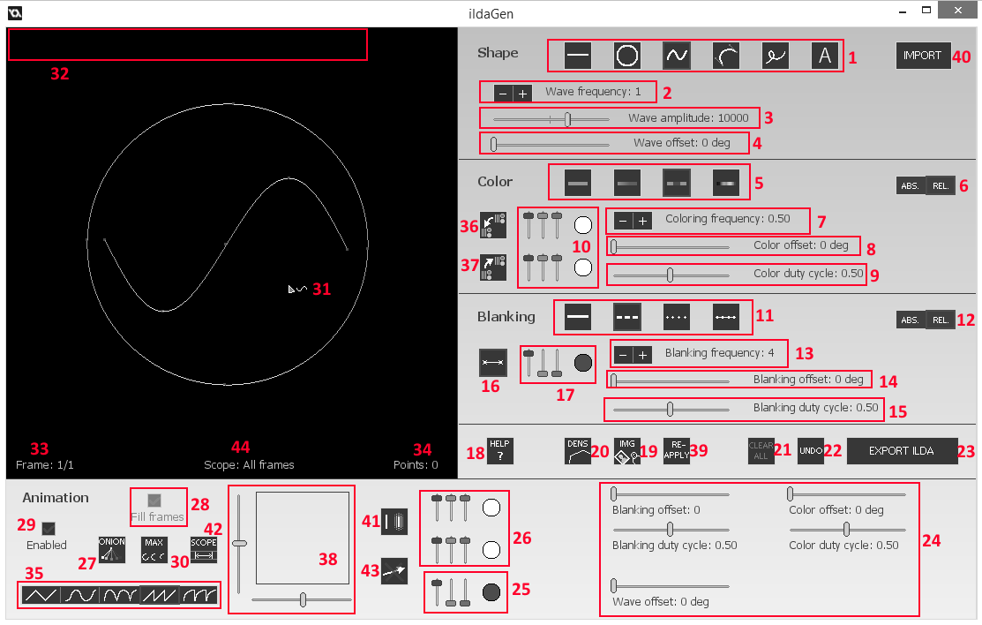

Button tips and tricks

Some of the sliders and selectors in the screenshot above may not appear to you, this is because they are only visible when the relevant drawing mode is selected. For example, the wave settings (numbered 2, 3 and 4) are only visible if you have selected the wave drawing tool.

Some buttons have drop-down menus with additional settings that can be accessed by right-clicking on them. Pay attention to the tooltip in the corner which will inform you of this.

By holding down CTRL and using sliders, you can control them in alternative ways. Colors sliders will move both the red, green and blue channel at the same time, and sliders with a neutral center point will snap back there. On some sliders you can right-click to enter a specific value.

Toggleable buttons will be marked with a red outline when they are enabled.

Drawing and preview area

The large black square is the drawing and preview area. Your ILDA file in progress is shown here. To make additions, select a drawing tool (see below), and click or drag your mouse anywhere in this area.

On the screenshot above the drawing area have the following numbered items:

- This is your mouse cursor.

- In this corner you will see tooltips when hovering your mouse over the different items/tools on screen.

- This shows you which frame you are viewing, and the total number of frames in the animation. Use your arrow keys to cycle between them.

- This shows you the number of data points in the current frame.

44) This tells you the current editing scope, in other words what frames the editing you do will affect. For example, if your scope is 5-10 and you place an animated object, the object will be placed and animated from frame 5 to 10, and not in the frames before or after. This affects both creating new elements and reapplying properties. You can edit the scope with button 42).

The shape area

This area contains the drawing tools selectors, and various settings related to the shape of the drawing.

On the screenshot above the shape area have the following numbered items:

- This is the drawing tools selector. As of v0.9.6 you can choose between a line tool, circle tool, wave tool, curve tool, free drawing and text. Click the buttons to select them.

The line, circle, wave and free drawing tool will be created just as they are previewed
at the time you release the mouse button.

However, when the curve tool is selected and you release the button, you will enter adjustment mode. Two green bars will appear next to the curve. By dragging the tips of those bars with your mouse, you can manipulate how the curve looks. When you are done, click the enter button to finalize and create the object. If you wish to cancel while in adjustment mode, press delete or backspace.
In the text mode, you must first load a font to use. You can do this by right clicking on the text button and pressing Load. In the file selection dialog you must navigate to the Laserboy folder, then the ild folder. In there you will find several font files to choose from. To place text, click on the desired point of origin (top left of the text) and enter the text.

- The + and - button lets you increase or decrease the wave frequency.

- The slider lets you adjust the wave amplitude (height). Negative values are possible, and inverts the wave.

- This slider lets you adjust the offset of the wave, from 0 (no offset) to 360 (one full period offset)

- This button lets you import an existing ILDA file for editing. NB: Only ILDA format 4 or 5 is supported as of now. The amount of frames will extend to fit the entire ilda file into the project. You can use button 39) to edit the imported frames and apply effects like blanking and coloring.

The color area

This area contains settings related to the coloring of objects.

On the screenshot above the color area have the following numbered items:

- This is the color tools selector. As of v0.9.1 you can choose between one solid color, two-color gradient, and two-color alternating (dashed)

- This lets you switch between absolute and relative interval length when using the dashed og gradient color tool. When relative is selected, the number of intervals per drawn object is constant, and when absolute is selected, the length of the interval is constant.

- This lets you choose the frequency (number of intervals per object) of the dashed or gradient coloring. When relative mode is selected (see 6), this is switched with a slider that lets you adjust the length of the intervals.

- Here you can change the offset of the dashed or gradient coloring, from 0 (no offset) to 360 (one full period offset)

- Here you can change the duty cycle (ratio of color 1 to color 2) of the dashed coloring. The higher the duty cycle, the shorter the intervals of color 2.

- These are the color selectors. The top selector is for the primary color and the bottom is for the secondary color, used when in for example gradient or dashed color modes. When solid coloring mode is selected, only the selector for color 1 is visible. The selectors have three sliders each, for red, green and blue. They are blended additively, like laser light, so for example red at max, green at max and blue at zero creates the color yellow.

- This button lets you copy the animation end colors (numbered 26 and 25) over to the main colors (numbered 10 and 17).

- Opposite of 36), this lets you copy the main colors over to the animation end colors.

The blanking area

This area contains settings related to the blanking (on/off modulation) of objects.

On the screenshot above the blanking area have the following numbered items:

- These are the blanking tools. As of now you can choose between no blanking, dashed blanking (intervals), dotted blanking and no blanking but with dots added periodically.

- Similar to 6), this lets you choose between absolute and relative blanking interval lengths.

- Similar to 7), this lets you adjust the frequency or length of the blanking intervals.

- Similar to 8), this lets you adjust the blanking offset.

- Similar to 9), this lets you adjust the blanking duty cycle.

- This toggles dotted ends, meaning that a dot is placed at the start and end of blanking intervals.

- This color selector lets you choose the color of the dots at the end of blanking intervals, as explained in 16), or the colors of the dots in the "no blanking but with periodic dots" blanking mode.

Misc buttons
Between the blanking and animation areas, you will find some miscellaneous buttons that does not belong to any category:

- This button downloads this manual, or shows tells you the keyboard controls when hovering over it.

- This buttons lets you load a PNG image from your computer to get superimposed on the screen, allowing you to trace the outlines when drawing the frame. Clicking it a second time will disable the image.

- This button lets you select the point density/resolution (detail level) of the points in the ilda frame. The lower number the smoother the curves and color fading becomes, but the file size and bandwidth requirements increases and program performance drops. At the standard value of 256, points are about 2 pixels on the screen apart. This varies linearly, so for example a value of 512 makes the points separated by about 4 pixels. The start and ending points are constant, so if you are drawing straight single-colored lines, you might want to increase this value very high so that the line only consists of two points. When animating blanking, or using gradient coloring, it is recommended to select a low value for best accuracy, for example 128.

- This button discards your work and clears all objects in every frame. Not undoable, so be careful.

- This button lets you undo your last action. You can also press Ctrl+Z. As of now only drawing an object and clicking the DENS or MAX buttons counts as undoable actions.

- This button exports your work into an ILDA file. If you have not yet entered a registration serial code, it will ask you for one. You must remember to end the name of the file in ".ild", or the program creates a file with no extension and you need to rename it to be able to open it with other programs.

- This button remakes the selected object (you can select objects by using the up/down arrow keys). In other words it reapplies new properties such as blanking and coloring to the object. The shape of the object stays the same, however. A shortcut for this button is the Enter key. You can edit various settings or select which types of properties (color, blanking, displacement, etc) should be reapplied by right-clicking on the button.

The animation area

This area contains tools to automatically animate your objects. By default animation is disabled, and most settings in this area is hidden. If animation is enabled, the objects you draw, will transition from the main settings (in the shape, color and blanking areas), to the settings in this animation area, over the course of the frames inside the animation scope (see item number 42).
On the screenshot above the animation area have the following numbered items:

- These sliders are the end-of-animation equivalents of some of the sliders explained above. They let you animate their values. If you for example set the main "blanking offset" slider to 0 degrees, and the second "blanking offset" slider in this area to 360 degrees, the object will be animated, starting with a blanking offset of 0, and transitioning to 360 over the course of the animation.

- Same as 24), except with the dotted ends color.

- Same as 24), except with the color 1 and color 2 selectors, from left to right respectively.

- This button toggles onion skinning. It superimposes the previous frames over the current one, to let you manually draw animated frames easier.

- This checkbox toggles filling all the frames with the current object. If this is selected, an object, even if animation is disabled, will be copied to all the frames rather than just the active one. Also, this decides whether the last frame will be copied to the rest when using button 19) to extend the number of frames.

When loading external ilda files, this button decides whether or not the ilda file loops after reaching the end if the number of frames is lower than that of the ildagen project. For example, when this button is checked and you load a 10 frame long file into a project that currently have 30 frames, the loaded file will loop three times.

- This checkbox enables or disables animation. If this is unchecked, the objects you place will be unchanging in all frames.

- This button lets you adjust the number of total frames in the ilda file.

- This is the animation mode selector. It lets you choose the animation function, in other words how the transition over time looks, and whether or not the animation loops seamlessly.

- This is the displacement animator. It lets you move the objects you place from their original location to another location over the course of the animation. The horizontal and vertical sliders decide horizontal and vertical displacement. The arrow in the middle lets you preview the combined movement of the object.

41)This button toggles shaking. It will shift the object slightly in a random direction for every frame.

42) This is the editing scope button. It lets you edit the starting and ending frame of the editing scope, in other words what frames the editing you do will affect. For example, if your scope is 5-10 and you place an animated object, the object will be placed and animated from frame 5 to 10, and not in the frames before or after. This affects both creating new elements and reapplying properties.

43) This button resets all the displacement/movement animation. It copies the x and y coordinated of the object in the first frame, to all other frames.

LaserBoy

Included with the Windows version of ildaGen is the free and open program LaserBoy, created by James Lehman. IldaGen uses ILDA font files generated by LaserBoy to create text, and it's also a great supplement to ildaGen as you can do further editing of ILDA files exported, like manipulating individual points, and converting to additional formats like ILDA version 0 and 1, wave files for playing on sound card DACs and more.

The version of LaserBoy distributed with ildaGen is stripped of some included files to save space, like the program source and sample files in various formats. To download the full version of LaserBoy, you can visit the official site: http://laserboy.org/

To start LaserBoy, navigate to its folder and double-click LaserBoy.bat. The LaserBoy folder can be found inside the ildaGen installation folder, as selected during installation.

Loading files into LaserBoy

To load and edit files in LaserBoy, they must first be moved or copied into their appropriate sub-folder inside the LaserBoy folder. In the stripped down version of LaserBoy included with ildaGen, you will only find one folder, called “ild”, for ILDA files. If you wish to load files in a different format, you need to create the a folder manually with the same name as the file extension, such as “wav” for wave files. Once you have moved the file(s) you wish to load you can start up LaserBoy.

Once you have started LaserBoy, press the “i”-key and then the “1”-key to load an ILDA file. Type the name of the file you want to load and press Enter. Now select what you want from the options on the screen, for example press “1” to replace everything with the loaded file. You should now be back to the main menu, with the file loaded. You can use the left and right arrow keys to preview all the frames in the file.

Optimizing and converting to other formats

While in the main menu of LaserBoy, press “x”, this brings you to a menu where you can adjust various settings for the exported file. You can see all the options with their buttons listed in the window. For example, use buttons “7”, “8” and “a” to toggle settings related to optimization and minimizing files. Use button “b” to toggle exporting to legacy ILDA format 0/1, or 4/5. When you are finished, press Escape to save and go back to the main menu.

To export the file, simply press “o” while in the main menu. Then select the desired file format, for example “1” for ILDA. Now press “3” to export the whole file, or one of the other options on the screen. Now give you file a name, including the file extension at the end, for example “test.ild”, and press Enter. Your file will now have been created in the same folder as the file you loaded.

System Requirements

Minimum:
- Windows XP, Vista, 7 or 8 with DirectX (windows version)
- Modern browser with HTML5 support (web version)
- 512MB RAM
- 128MB graphics

Recommended:
- Windows Vista, 7 or 8 (windows version)
- 2GB RAM
- Modern graphics card with at least 256MB memory
- For the web version, a relatively powerful processor

