
LaserShowGen
By Gitle Mikkelsen

Revision: 2026-03-13

Introduction

LaserShowGen (formerly ildaGen) is an affordable laser show editor and player. It can both export to the open ILDA file format, and output directly to laser projectors using various compatible hardware such as laser DACs. A free version with limited functionality is available. LaserShowGen is available on Windows, macOS, and Linux. A limited version is also available as a website that you can run directly in your web browser.

The official website for LaserShowGen can be found here: https://bitlasers.com/lasershowgen-sw/

If you have any questions, bug reports or feature suggestions, please don’t hesitate to contact the author at gitle@bitlasers.com .

LaserShowGen currently consists of three modes. When you start the program, what you see is the editor mode. Here you can edit or create laser frames by using various drawing, coloring, stroke and animation tools. The second mode is the timeline mode. In the timeline mode, you can create longer and more complex laser shows by placing multiple laser frame files, either imported or made in the editor mode, on a timeline with layers. You can also import music. The third mode is the grid view. In this mode you can trigger files to play on demand using mouse, keyboard shortcuts, or MIDI/Art-Net/sACN input signals. This mode is also called the Live Mode, because it is design for live performancs.
To switch between the three modes, press [Tab] or use the menu at the top-right of the window.

In all modes, when hovering the mouse over a button etc., a tooltip will appear in the top-left corner, briefly explaining its function. You can also get a list of keyboard shortcuts by hovering the mouse over the “HELP” button.

It is recommended to read through this manual to get the most out of LaserShowGen, or at least the getting started guides for each mode.

There is also a series of video tutorials here:
https://www.youtube.com/playlist?list=PLjwxW1_pwj6DQdtcGfUkv_O2mrEjI7Omt

Table of Contents
Introduction 1
The Editor Mode 4
Getting started guide 4
Keyboard Controls in the editor mode 6
Buttons and user interface 7
Button tips and tricks 8
The drawing and preview area 8
Shape 9
Color 10
Stroke type 11
Settings and tools 12
Edit 13
Settings/tools in top menu 13
File area 15
The animation area 16
More on key features 17
Reapplying 17
Blend modes 17
Arbitrary function modes 19
The Timeline Mode 23
Getting started guide 23
Playlists 25
Keyboard controls in the timeline mode 26
The Grid View (live mode) 27
Getting started guide 27
Keyboard controls in the live mode 29
Keyboard/mouse control 29
MIDI control 30
Network DMX (Art-Net or sACN) control 30
DMX Channel List 31
Regarding timing / BPM 33
Settings 34
Optimization and adjustment 34
Output (DAC/Projector connection) 36
Input devices 37
Simulated preview 37
Misc options 38
Troubleshooting 39
Exported files don't play on my projector at all or are unrecognizable 39
Exported ILDA files don't play well on my projector (warped, bad quality) 39
Exported ILDA files have incorrect colors 39
Output with WiFi is unstable (such as on LaserCube or HeliosPRO) 40
Buttons and menus in the program don't work or react slowly 40
Files are not saved/exported 40
“Error defining an external function” 41
“Unable to find game” 41
Anything else 41
LaserBoy 42
Fonts 42
Loading files into LaserBoy 43
Optimizing and converting to other formats 43
System Requirements 45
Extra credits and licenses 46
Main License 48

The Editor Mode

Getting started guide

What you see when you open LaserShowGen is the editor mode. In this mode you can create and edit laser frames. The frames you create can either be exported to ILDA files, or sent to the timeline mode as part of a larger project. You can read more about the timeline mode in the next chapter.

To start drawing to your laser frames, select a drawing tool in the top right corner of the screen, and adjust various settings such as color and blanking with the sliders and buttons that appear. Now click and drag the cursor somewhere in the large black area to the left. Depending on the drawing tool selected, you should now see what you drew created as an object.

You can select any objects you have previously created by holding down [Ctrl] and clicking on them, or by pressing the “SELECT” button. Selected objects are marked by a blue square. By clicking and dragging the arrow icons in the corner of the blue square you can rotate and scale the object. You can also edit the object by selecting new settings and then pressing the button REAPPLY, or the keyboard key Enter. Not only can you rewrite the settings like color and blanking, but you can also layer edits on top of each other to create complex patterns that would not be possible in a single edit. More on the REAPPLY button in another chapter.

If you have selected an object, you can also copy it [Ctrl+C] or cut it [Ctrl+X], then paste it somewhere else [Ctrl+V]. You can also delete elements using the Delete key. You can right click on the selected object or click the “Edit” button in the top menu for more options.

You can change the total number of frames in the editor by clicking “Properties”->”Change number of frames” in the menu at the top of the screen. Use the left/right arrow keys to navigate between frames. Use the [Space] key or the playback control buttons to play/pause.

LaserShowGen can create automatic animations by gradually changing settings over the course of several frames. You can do this by first enabling animation by using the checkbox marked “Enabled” in the Animation area (bottom right) of the interface, then editing the final values using the new cyan colored sliders that appear next to the main sliders.

You can edit the scope, that is the active frames that animations or reapplying spans over, by using the SCOPE button, or by holding down [Shift] while dragging the mouse over the area of the timeline below the frame. If you only wish to edit a single frame, there is a checkbox in the Animation area for that too.

When you are done with creating the frames in the editor, you can either:

- Click the EXPORT ILDA button to export them to an ILDA file. You must remember to end the name of the file in ".ild", or the program creates a file with no extension and you need to rename it for other programs to be able to recognize it as an ILDA file.

- Send the frames to the timeline mode as part of a larger project. To do this, first enter the timeline mode by pressing [Tab]. Then select a position on one of the layers in the timeline by clicking on it. This marks where your frames from the editor will be inserted. When you have marked a position, you can click the “Send to timeline”-button or press [ I ] to copy the frames from the editor mode to the timeline. You can read more about the timeline mode in the next chapter.

You can save and load the LaserShowGen frames by using the SAVE- and LOAD FRAMES buttons so you can continue your work later. Remember, this is different from exporting the ILDA file, the saved frames can only be opened by LaserShowGen itself.

You can enable live laser output via DACs by clicking the “LASER ON” button. You must first select a DAC (see the settings chapter).

Keyboard Controls in the editor mode

Left Mouse) Select drawing tool and draws
Right Mouse) Open context menu, or edits value of sliders manually
Enter) Remake (Reapply) object, finalizes curve, or presses OK
Space) Play/Pause
Tab) Enter other mode (either timeline or grid view, whichever was last used)
I) Send frames from the editor mode to the selected position in timeline mode.
L) Send frames from the editor mode to the live mode.
Right/Left Arrow) Move one frame back or ahead
Ctrl+Mouse) Select object
P) Change previewing mode between 2D and 3D (simulated scanner)
Shift) Force straight lines/angles when drawing
Q) Snap cursor to nearest ending or starting position of any object.
Alt) Snap cursor to ending position of last placed object for chaining.
Ctrl+Alt) Snap cursor to starting position of last placed object for chaining.
S) Show/snap to square grid. Double press to toggle.
S+Up/Down Keys) Resize the square grid
R) Show radial grid. Double press to toggle.
Z) Zoom in around the cursor for extra precision.
A) Show symmetry/alignment guidelines of objects. Double press to toggle.
E+Mouse) Clone the color that the cursor is pointing at, for example from a background image or a previously placed object.
H) Highlight/show all objects in the frame
Delete) Delete selected objects
Backspace) Cancel object placing (used with curve tool)
Ctrl+Z) Undo
Ctrl+Y) Redo
Ctrl+C) Copy selected objects
Ctrl+X) Cut selected objects
Ctrl+V) Paste selection
0) Jump to first frame
Esc) Stop laser output
Ctrl) Move all color sliders, or centers symmetrical sliders
Mouse wheel) Adjust amplitude in wave drawing tool
Ctrl+Mouse wheel) Adjust frequency in wave drawing tool

N) Reset window aspect ratio
M) Reset window size
F11) Toggle fullscreen
F1) Open this document

Buttons and user interface

In the editor mode, you will see with this interface:
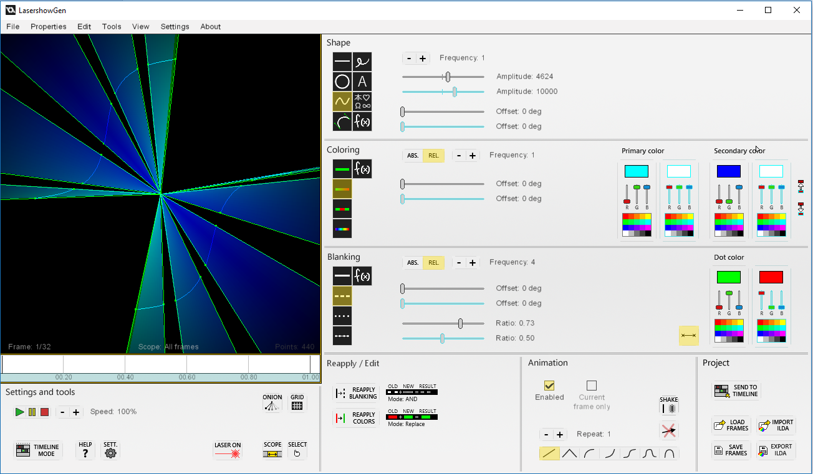

The window is divided into 7 main sections. The drawing and previewing window which is the large black area to the left, and the six gray sections marked with their names written in their respective upper-left corners. There is a chapter for each of these sections below, where the buttons and tools are explained.

Button tips and tricks

Some of the sliders and selectors in the screen-shot above may not appear to you, this is because they are only visible when the relevant settings are activated. For example, the settings related to making waves such as the amplitude and frequency sliders, are only visible if the wave drawing tool is selected.

Some buttons have drop-down menus with additional settings that can be accessed by right-clicking on them. Pay attention to the tool-tip in the corner which will inform you if this is the case.

By holding down [Ctrl] and using sliders, you can control them in alternative ways. Colors sliders will move both the red, green and blue channel at the same time, and sliders with a neutral center point will snap back there.

On most sliders you can right-click to enter a specific value.

Toggle-able buttons will be marked with a yellow tinge when they are enabled.

The drawing and preview area

The large black square is the drawing and preview area. Your frames as they currently look, are shown here. To make additions to the file, select a drawing tool (see below), and click or drag your mouse anywhere in this area.

In the bottom of this area, you will find some information:

Frame: This shows the current frame out of total frames in the animation you are viewing. You can move between frames by using the left and right arrow keys.
Scope: This shows the frames that are selected as the editing scope, all modifications you do to the project will only happen within these frames.
Points: This shows the approximate number of data points in the frame you are viewing, minus any interpolation points added or removed after optimization. If your frame is too complex, in other words if you have too many points in your frame, this text will turn red. If that happens, you should remove some objects from the frame until the text turns orange or preferably white, otherwise the frame might not scan well when played on a projector.

Below these three numbers there is a simple time-line, showing the editing scope marked in yellow, and the current frame marked with a black line. If you have loaded music in the timeline mode, a visualization is shown here, synced to the selected position in the timeline.

You can select objects by holding [Ctrl] and clicking on them with the mouse. The selected objects will be marked with a blue square. When an object is selected, some extra editing tools become visible. There is a small blue anchor symbol, which marks the anchor point of rotations and resizing. You can move this point around by dragging it with the mouse, or you can right-click on it to automatically move it to the center of the selected object for symmetrical and uniform rotation/resizing.

To rotate a selected object, click and drag the curved arrow symbol in the bottom-left corner of the blue square. To resize it, click and drag the straight arrow symbol in the bottom-right corner. If animation is enabled, the change will happen gradually over the frames in the editing scope, so the result may not be immediately apparent depending on what frame you are currently viewing.
You can also copy, cut and paste selected objects by using the [Ctrl]+[C] / [X] / [V] keyboard shortcuts, or the Edit menu in the top menu bar.

You can press P or click the “2D/3D”-button to toggle 3D preview, showing how the current frame would look like when projected from a scanner.

Shape

This area contains the drawing tools selectors, and various settings related to the shape of the drawing.

Furthest to the left you will find the drawing tools selector. As of v1.0.0 you can choose between line, circle, wave, curve, free drawing, text, symbol and arbitrary function tools. Click the buttons to select them.

The line, circle, wave, symbol and free drawing tool will be created as they are previewed at the time you release the mouse button.

However, when the curve tool is selected and you release the button, you will enter adjustment mode. Two green bars will appear next to the curve. By dragging the tips of those bars with your mouse, you can manipulate how the curve looks. When you are done, click the enter button to finalize and create the object. If you wish to cancel while in adjustment mode, press backspace.

With the text tool, you must first load a font to use. You can do this by right-clicking on the text button and pressing Load. LaserShowGen comes with Arial, which you can find in the folder that you installed LaserShowGen to. You can find many other fonts by installing LaserBoy. Read more about this in the dedicated chapter. To place text, click on the desired point of origin (bottom left of the text) and enter the text. NB: The text tool can not be used in the web version, instead you can use the symbol tool (see below).

The symbol tool lets you draw various symbols and text glyphs. Select a symbol from the table, then click in the drawing area to place it. There are over 2000 symbols to select from, including English, Japanese (hiragana, katakana and some kanji), Greek and Cyrillic letters in various fonts, math, music and weather notation, and other miscellaneous symbols.

The arbitrary function drawing tool lets you enter a mathematical function for the X and Y value, rather than drawing the shape yourself. It is a quite powerful tool but also the most complicated. To learn more about it, read the dedicated chapter on arbitrary function tools.

Depending on the drawing mode selected, one or more settings in the form of sliders or more buttons will become visible. For explanations on what each setting does, check their tooltips by hovering the mouse cursor over them.

Color

This area contains settings related to the coloring of objects.

To the left you will find the color mode buttons. As of v1.0.0 there are five coloring modes:

- Single-colored
- Dashed coloring that alternates sharply between the primary and secondary color,
- Gradient coloring that alternates gradually between the primary and secondary color,
- Rainbow coloring that gradually alternates the hue,
- Arbitrary function coloring, which lets you enter mathematical functions that describe the color.

There are also up to four color selectors visible to the right, depending on what coloring mode is selected. The primary color selector is on top, and below it is the secondary color selector. For each selector, you have three sliders, one for the red, green and blue channel respectively. They are blended additively, like laser light, so for example red at max, green at max and blue at zero creates the color yellow. The selected color is previewed in the circle next to the three sliders. You can hold CTRL to move all channel sliders simultaneously, or right-click on a slider to manually enter the value for the channel.

When animation is enabled, the amount of selectors are doubled, and two arrow symbol buttons are revealed below the selectors. You can click these arrows to copy the color to or from the main color selectors to the animation color selectors, marked with a cyan tint.

Between the color mode buttons and the color selectors, there may be some extra settings depending on what color mode is selected. These modify how the coloring is applied in various ways. For explanations on what each setting does, check its tooltip by hovering the mouse cursor over it. There is a button in the upper right corner that modifies some of these settings by switching from a relative (for example 5 cycles per object) to an absolute (for example 10 000 length units between cycles) metric.

Stroke type

This area contains settings related to the stroke type of objects. Different stroke types use “blanking” (fast on/off modulation) of the laser to create effects like dashed or dotted lines.

To the left you will find the blanking mode buttons. As of v1.0.0 there are five stroke types:

- Solid line (no blanking).
- Dashed blanking that alternates between on and off.
- Dotted blanking that places a single point that creates a straight laser beam periodically along the object path.
- Connected dotted blanking, similar to dotted blanking except the laser is on/unblanked between the points.
- Arbitrary function blanking, which lets you enter a mathematical function that describes the blanking pattern.

Next to the blanking mode buttons, there may be some extra settings depending on what blanking mode is selected. These modify the blanking in various ways. For explanations on what each setting does, check its tooltip by hovering the mouse cursor over it . There is a button in the upper right corner that modifies some of these settings by switching from a relative (for example 5 cycles per object) to an absolute (for example 10 000 length units between cycles) metric.

In the bottom right corner, there is a button that lets you enable dotted ends, that means that whenever the blanking switches from on to off and vice versa, a dot is placed. These dots can have their own separate color, which can be chosen using the color selector next to the button.

Settings and tools
In the bottom left area of the window you will find buttons for various settings and useful tools.

HELP: This button opens this manual, or shows the keyboard controls when hovering over it with the cursor.

SETT.: This button opens the settings view, see separate chapter.

SCOPE: This is the editing scope button. It lets you edit the starting and ending frame of the editing scope, in other words what frames your edits will affect. For example, if your scope is 5-10 and you create an animated object, the object will be placed and animated from frame 5 to 10, no other frames before or after will change. This affects both creating new elements and reapplying.

ONION: This toggles onion skinning. It superimposes the previous frames over the current one, to let you manually draw animated frames easier. By right-clicking, you can edit various settings, such as the number of earlier frames to preview, or the transparency level of the previewed frames.

GRID: This button changes the grid displayed over the drawing area, you can choose between a square and radial grid and alignment guidelines. There are also keyboard shortcuts for these that lets you change settings and display several grids at the same time, see the section for keyboard controls.

2D/3D: This button toggles a 3D preview of how the laser looks when viewed from the audience.

IMG.: This button lets you load an image file as the background of the canvas. See the entry for the equivalent menu item on page 13 for more information.

There is also a button that opens the timeline mode (Shortcut key: [Tab]). See the chapter on the timeline mode for more information.

Above the timeline button, there are controls for playback (Play, pause and stop) and buttons to increase or slow down playback speed.

You can enable live laser output via DACs by clicking the “LASER ON” button. You must first select a DAC (see the settings chapter).

Edit

In this area you will find tools for reapplying properties, in other words editing, selected objects. These buttons will only appear if you have selected an object, as they don’t do anything otherwise. To select an object, hold [Ctrl] or click the “SELECT” button, and click on the object(s) you want to select. More info in the “getting started guide” in the beginning of this chapter.

REAPPLY: These buttons remakes the selected object (you can select objects by using the up/down arrow keys). In other words it reapplies new properties such as stroke type and coloring to the object, depending on whether you press the blanking or coloring reapply buttons respectively. The shape of the object stays the same, however. Other properties, such as displacement and removing overlapping points can be done using either button. A shortcut for both buttons is the [Enter] key, this triggers both recoloring and reblanking. Next to the reapply buttons there are buttons for related settings, such as color and blanking blend modes. See the dedicated chapter later in this document for more information on reapplying.

The check-box marked “Force original point order” will make the selected object always be scanned from one specific end to another. This can get rid of glitches or abrupt jumps of an object during animation. If the check-box is not checked, the optimizing algorithm will choose the scanning order that minimizes the length of blanking jumps.

PATH: When animating movement, rotation or resizing of objects, this button toggles whether the animation uses the custom path you draw with your mouse when dragging the object. In other words, it lets you “record” a custom animation. By contrast, when the button is off (default), the animation will only linearly transition from the original state, to the end state where you release the mouse after dragging the object.
When this button is on, the speed of the path is linearized so that it doesn’t matter how fast you draw the custom path. If, however, you instead want the speed to matter, for example if you want to add pauses or other effects to the animation, you can disable linearization by right clicking on the PATH button.

Settings/tools in top menu

You will also find some more tools and settings in the menu at the top of the screen. If you have used an earlier version of LaserShowGen, some of these tools used to be buttons in the “Settings and tools” area rather than being part of the top menu. A more detailed explanation of a few of these can be found here:

Tools → Load/toggle background image: This buttons lets you load an image from your computer to get superimposed on the screen, allowing you to trace the outlines when drawing the frame. Clicking it a second time will disable the image. Only JPEG and PNG file types supported right now. The image will stretch to fill the entire drawing area, so if the aspect ratio is not square, or if the image is supposed to be small, it is recommended to open the image in an image editor first, and using the Resize->Canvas.. tool to add some blank space around the image to force a certain size and shape when stretched.

Tools → Toggle alignment guidelines: This toggles guidelines on the screen that helps you create symmetrical and aligned frames. Green lines mark the center of the screen. Gray lines mark the ending and starting points of objects, red lines are symmetrical to gray lines. Keyboard shortcut: [A]

Tools → Toggle onion skinning: This toggles onion skinning. It superimposes the previous frames over the current one, to let you manually draw animated frames easier. By clicking Options → “Onion skinning settings”, you can edit various settings, such as the number of earlier frames to preview, or the transparency level of the previewed frames.

Properties → Change number of frames (Pad): This sets the number of frames in the current animation by either deleting or adding new blank frames at the end of the existing animation. The existing animation will thus keep its current speed.

Properties → Change number of frames (Stetch): This sets the number of frames in the current animation by stretching the existing animation to fit the new number of frames. This makes the existing animation slower or faster.

Properties → Change FPS: This sets the nominal playback speed in frames per second. Default is 30. FPS and scan rate (see chapter on settings) determines the amount of points in an outputted frame when optimization is enabled.

Edit → Reverse animation: This reverses the animation of the frames in the current scope.

Edit → Merge selected objects: This combines all the selected objects on the canvas into one single object. NB: Except by using the “undo” function, a merged object can not be un-merged, so only do this if all the objects being merged should always act as one from now on.

File area

This area contains buttons related to the input and output of files from the program. As of v0.9.7 there are only two buttons here:

Export ILDA
This button exports your work into an ILDA file. If you have not yet entered a license code, it will ask you for one. You must remember to end the name of the file in ".ild", or the program will create a file with no extension and you will probably need to rename it to be able to open it with other programs.

By right clicking on this button, you can choose between optimized and raw output, and ILDA format 5 and 0 output. More information about this in the “Settings and tools” chapter (previous page).

Import ILDA
This button imports an existing file into the project. ILDA formats 0 and 1 (with default 63 color palette) and 4 and 5 are supported.

Save Frames
This button saves all the frames in the LaserShowGen project into a file of format IGF (LaserShowGen Frames), so that you can save the progress and resume work later. This is different from exporting the ILDA file, the saved file can only be opened by LaserShowGen itself.

Load Frames
This button loads an IGF file (see SAVE for more information).

Send to Timeline
This button sends the frames to the timeline mode. Before clicking this, you must have selected a position on the timeline. To do this, enter the timeline mode by pressing [Tab]. Then select a position on one of the layers in the timeline by clicking on it. This marks where your frames from the editor will be inserted. When you have marked a position, you can click the “Send to timeline”-button or press [ I ] to copy the frames from the editor mode to the timeline. You can read more about the timeline mode in the next chapter.

Send to Grid
This button sends the frames to the grid view, creating a new cell. The grid view can be used for live shows, or for organizing frames when working with timeline shows or other workflows.

The animation area

This area contains tools to automatically animate your objects. By default animation is disabled, but if you click the check-box marked “Enabled”, many new buttons and tools with a cyan tinge, should appear. These are the animation-end equivalents of their neighboring tools. The objects you now draw will transition from the main settings, to the animation-end settings (marked with a cyan tinge), over the course of the frames within the animation scope.
Other than the enable checkbox, there are four tools inside the animation interface area:

The check-box marked “Current frame only” toggles filling all the frames with the objects that you draw. If this is unchecked, an object, even if animation is disabled, will be copied to all the frames rather than just the active one when placed. Also, this check-box decides whether or not the last frame will be copied to the rest when using MAX button to extend the number of frames in the project.
When loading external ILDA files, this check-box decides whether or not the ILDA file will loop after reaching the end if the number of frames is lower than that of the LaserShowGen project. For example, when this button is checked and you load a 10 frame long file into a project that currently have 30 frames, the loaded file will loop three times, filling all the frames available.

The row of buttons in the bottom of the area, is the animation mode selector. It lets you choose the animation function, in other words how the transition over time looks, and whether or not the animation loops seamlessly. Examples include ease-in and ease-out animations, bouncing effects, sine curves, etc. Experiment with different modes to find what looks best for your desired effect.

The checkbox marked Reverse will toggle whether or not the animation function is mirrored/reversed. In other words, rather than animating from start to end, it will animate from end to start. This can be useful if your animation is hard to draw in the normal order, for example if you want to enlarge an object that is too small to handle accurately. In this case you can instead start with the object large and then shrink it, with the reverse checkbox checked. This will animate the object from being small to large, the opposite of what you drew.

This button above, with one clear and one blurry line, toggles shaking. It will shift the object slightly in a random direction for every frame, making it shake when the animation is played back. When shaking is enabled, a slider that lets you adjust the intensity becomes visible.

The button to the right with the red X resets all the displacement/movement animation of an object, including shaking. It copies the X and Y origin coordinates of the object in its first frame, to all its other frames.

More on key features

Reapplying

The REAPPLY buttons are very useful tools. To use them you must first select an object you have placed by holding down [Ctrl] and clicking on the object, or using the Edit → Select All tool in the top menu. Once selected, if you click either reapply button, the object is remade with all the properties like color, blanking and displacement that is currently set. As the name implies, the REAPPLY COLORING button recolors the object and the REAPPLY BLANKING button reblanks it. To reapply other properties like displacement and removing overlapping points, either button can be used. There is also a keyboard shortcut, [Enter], that triggers both coloring and blanking reapplying. Only the shape of the object stays the same. For example, if you have a plain solid line, and reapply it while the blanking mode in the sidebar is set to dashed, and the color set to rainbow, the plain line changed into a dashed line with rainbow coloring.

By right clicking on either button, you can edit various settings, including:

- Affect displacement, which will toggle whether or not to reapply the displacement (movement) of the object, for example using the shaking effect.

- Remove overlapping points, which will cause all overlapping points in the object, like dots, to be removed and transformed into a single point and smooth segment.

- Interpolate points, which will adjust the number of points in the object to suit the selected resolution. Sometimes this is required to get for example a smooth color gradient when the object consists of too few points.

Blend modes

Next to the reapplying buttons there are two selectors for the blend modes, one for color and one for blanking. The blend mode controls how the original and the new settings are blended together when using the reapply buttons. The default blend modes simply replace the old settings with the new, but by changing this, you can layer settings on top of each other in many different ways to create complex patterns and effects.

The blanking blend mode uses binary logic, in other words AND, OR and XOR.

For example, if you combine these two blanking settings using the AND blend mode..
______ ______ ______ ______
. . . . . . . . . . . . . . . . . . . . . . . . . . . . . . . . . . . .

..you get this, because the AND blend mode only turns on the laser when both the original AND the new blanking settings would turn the laser on:
. . . . . . . . . . . . . . . . . . . . . . . .

The color blend mode chooses how the individual RGB components of the color should combine. You can either replace (default), add or subtract the new RGB values from the original values. For example, the color red combined with the color green in the Additive blend mode gives you the result red+green which is yellow. Then, if you have yellow and subtract green, you get the original red, because yellow, which is red+green – green = red.

The reapplying tool abides the scope settings. This means you can choose to only change the object for certain frames. See the explanation for the scope button in the “Settings and tools” chapter earlier in this document.

Arbitrary function modes

For the shape, blanking and coloring, you have arbitrary function modes available. These modes let you create your own mathematical functions to describe the data of new objects. Functions are equations that use variables and mathematical expressions to get a resulting value depending on what value the variables have. For example, the function “2*a+1” has one variable: a. If for example a=1, the result is 2*1+1 = 3.

For the shape function mode, you must create two functions, one for the X value (horizontal) and one for the Y value (vertical). Both of these range from 0 to 65535 (FFFF in hexadecimal), where 0 is the far left for X, and the far top for Y. The number of points to calculate and place can be edited by using the slider above the function input buttons.

For the color function mode, you must create three functions, one for each color channel. However, you can choose between using the channels red, green and blue as usual, or you can use a different set of channels: hue, saturation and value/brightness. Use the “RGB|HSV” button to toggle this. All channels range from 0 to 255, where 255 is the maximum.

For the stroke type function mode, you must create one function to control the blanking, on or off. The laser is on (unblanked) if the result of the function is 1 or higher, off otherwise.

In all functions, you have a set of variables and constants that you must use to make the functions non-constant. The most important ones are:

“point” - This variable changes form 0 to 1 over the course of the object (path of points), symbolizing the how the ratio between the current point and total number of points in the object.
“frame” - This variable changes from 0 to 1 over the course of the animation, symbolizing the ratio of the current frame to the total number of frames.
“max” - This is a shortcut to the max value of the function result, 65535 for shapes and 255 for colors.

You can also use built-in helper functions inside your functions, such as sine and cosine, logarithms, exponential, lerp, etc.

Here are two example functions for X and Y respectively:

point*max

max/2+sin(2*pi*point)*10000

These functions will create a simple sine wave in the middle of the screen. The X function increases gradually, pushing the points further to the right than the previous. The Y function is one period of a sine wave with an amplitude of 10000 and a mean of max/2 = 32767.5, which is the center of the canvas. As you can see, all functions like sine use radians instead of degrees when describing angles.

Here is a full list of built-in variables and functions:

Variables

Items marked * are not available for the shape (X and Y) functions.

Variable name | Description
point | The current point, ranging from 0 to 1
frame | The current frame, ranging from 0 to 1
startx | The X coordinate of the starting point of the object.
starty | The Y coordinate of the starting point of the object.
endx | The X coordinate of the ending point of the object.
endy | The Y coordinate of the ending point of the object.
*anchorx | The X coordinate of the anchor point when editing objects
*anchory | The Y coordinate of the anchor point when editing objects
*pri_red | The value of red in the current primary color (from 0 to 255)
*pri_green | The value of green in the current primary color (from 0 to 255)
*pri_blue | The value of blue in the current primary color (from 0 to 255)
*sec_red | The value of red in the current secondary color (from 0 to 255)
*sec_green | The value of green in the current secondary color (from 0 to 255)
*sec_blue | The value of blue in the current secondary color (from 0 to 255)
*x | The X coordinate of the current point
*y | The Y coordinate of the current point
max | The max value of the current function, 65535 for X/Y and 255 for color channels
width | The max value of the X coordinate (65535)
height | The max value of the Y coordinate (65535)
pi | 3.14.....
e | Epsilon = 2.71.…
audio_wave | Contains the raw sample data of audio if audio in the timeline mode is loaded. One point is one sample. Possible value ranging approximately from -1 to 1.
audio_spectrum | Contains the spectrum (Fourier transform) of audio if audio is loaded. Varies like the point variable, from 0 Hz and up to the Nyquist frequency. Possible value ranging approximately from 0 to 1.
audio_loudness | Contains the approximate loudness of audio if audio is loaded. Constant for the whole frame. Possible value ranging approximately from 0 to 1.

Functions and operators

Thanks to the ML Parse documentation for the following tables:
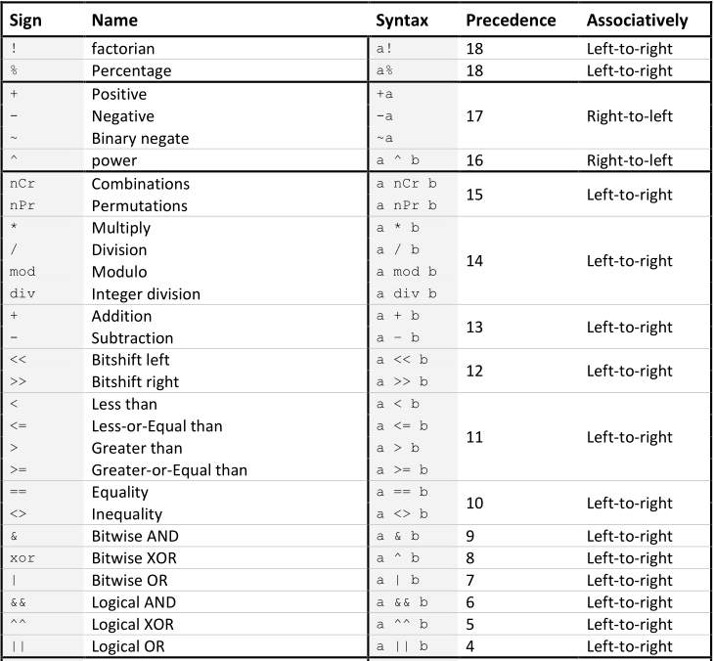
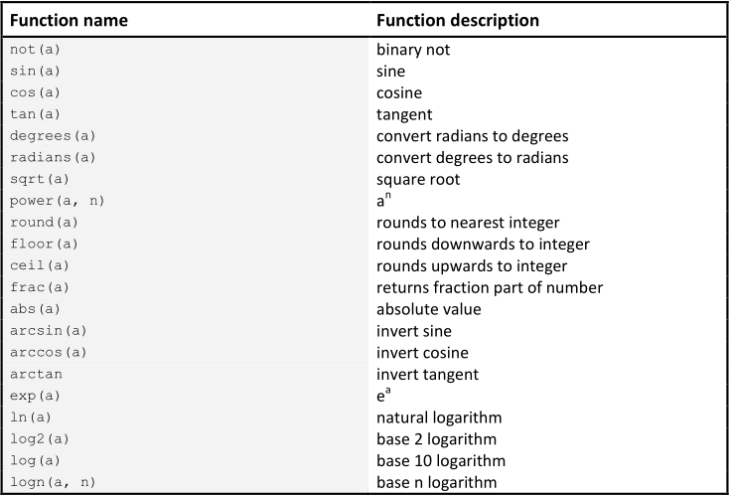
lerp(min, max, ratio) | Returns a number weighed between min and max
random(min, max) | Returns a random number between min and max
random_normal(mean, standard deviation) | Return a random number with a normal distribution

The Timeline Mode
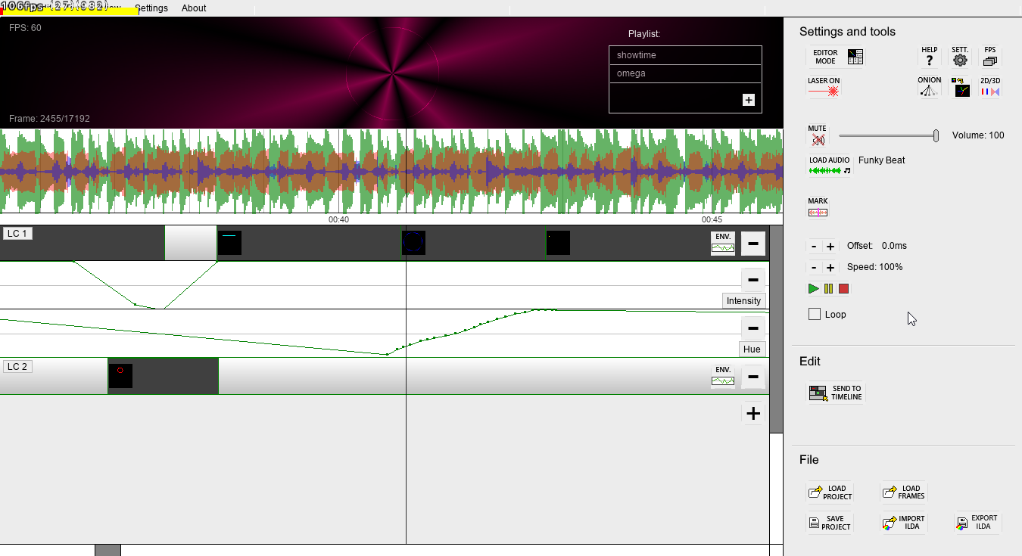

Getting started guide

The timeline mode allows you to create longer and more complex laser frames, such as full-length shows synced to music. The timeline mode lets you place previously created frames, either made in the editor mode, or imported from ILDA files, in a timeline with layers. The timeline mode is only available in the paid version of LSG, “LaserShowGen Pro”.

To enter the timeline mode from the editor mode, press [Tab], or use the “Timeline mode” button in the corner of the window.

To add content to the timeline, first select a position by clicking on a layer. The selected position will be marked with a small red line. Then, you can send the frames from the editor mode to the timeline by pressing [ I ], or using the “Send to timeline” button. You can also use the buttons in the “File” area in the window to import .ILD files or .IGF files directly to the timeline.

To create a new layer, press the + button in the rightmost area of the layers, below the lowest existing layer. To delete a layer, press the – button located on the layer itself.

Once you have placed frames on the layer, they can be moved around by dragging and dropping them with the mouse. You can also resize them (change their duration) by clicking and dragging the far right edge of the frames. If you resize a series of frames by more than the number of frames it contains, it will loop from the beginning after the last frame. If you instead want to stretch the item to slow down or speed up its animation, hold [Shift] while dragging the far edge. By double-clicking on an object on the timeline, or selecting it then clicking the button “Send to editor”, you will open the frames in the editor mode for editing. You can copy and paste frames in the timeline by selecting them and pressing [Ctrl+C] and [Ctrl-V] respectively.
To manipulate more than one timeline object at a time, you can select multiple of them by holding down [Ctrl] and either dragging the mouse over the objects, or clicking them one by one. Holding down [Ctrl] and clicking on a selected object will also deselect it.

By pressing the “Env.” button on a layer, you can create an envelope for the layer. Envelopes are
flexible ways to edit and add effects to the content of the layer. Each envelope controls a single property, such as horizontal or vertical displacement, intensity/brightness, or color hue. It envelopes the content of a layer and changes its chosen property in real-time Using this you can achieve many effects easily, such as fading in or out, changing colors, etc.
An envelope appears as a graph below the layer, with a value for each point in time. You can edit the graph by clicking or dragging the mouse over it, or clicking to put down individual points on the graph. If you instead hold down and drag the right mouse button, you can select an area of the envelope, and you can choose to delete, move or duplicate this section. When moving or duplicating a section, a preview will show up under your mouse, and when you click once more, this preview will be applied to the envelope. You can press Esc to cancel this action.

You can load music to the timeline by clicking the “Load audio” button. When you do this, the audio will be parsed to show an audio visualization in the timeline, above the layers. NB: It can take a few minutes for the parsing to complete. There are several different colors in the visualization for more accurate cues: Green is the volume of the music, red is the amount of bass, and blue is the amount of treble.

You can click on the timeline (except on a layer) to change the playback cursor position. Press space to play or pause.

You can navigate the timeline by using the scroll bars, and the mouse wheel or [F7]/[F8] to zoom.

By pressing [L] or using the “Add Marker” button in the “Timeline tools” area, you can add a visual marker to the current cursor position. You can for example use this to tap to the beat of the music in order to align frames properly. The markers can be moved around by dragging them.

In the timeline tools area there are also settings for playback speed, and audio offset.

Once you are happy with the project, you can click the EXPORT ILDA button to export it to an ILDA file. You must remember to end the name of the file in ".ild", or the program creates a file with no extension and you need to rename it for other programs to be able to recognize it as an ILDA file.

You can save and load the whole LaserShowGen project by using the SAVE- and LOAD PROJECT buttons so you can continue your work later. Remember, this is different from exporting the ILDA file, the saved project can only be opened by LaserShowGen itself.

The blue and red line marked “Start” and “End” marks the start frame and end frame of what will be exported if you click the EXPORT ILDA button. You can drag and drop them to change their position to envelop the portion you want to export.

Your can assign each timeline layer to a specific DAC for shows with multiple laser projectors. This is done in the settings mode, see that chapter for more information.
Information on which DAC is assigned is saved together with the project. However, the references that are saved is based on the names of the DACs, which for some models may differ from time to time due to being plugged into different USB ports or having different network IP addresses. You should therefore double check that the layer have correct DACs assigned to them before playing a show.

Playlists

The timeline mode has a playlist feature where you can queue up several shows in order to play them consecutively. The playlist is located in the right side of the black preview area, as a simple list. To add new shows to the playlist, click the [+] button in the lower right corner of the list, or right click it and choose “Add to playlist..”. To remove shows from the playlist, you can right click them and choose “Remove from playlist”.
When you have shows in the playlist, they will start playing when the current show reaches the “End” line. At this time, the current show will be closed, so make sure you have no unsaved changes in it.
If the playlist contains queued shows, the “Loop” checkbox in the sidebar acts on the whole playlist instead of individual shows. I.e, when a show in the playlist has finished playing, it will be sent to the back of the playlist again. This will in practice make the playlist start over once all shows has been played. If instead the Loop checkbox is disabled, shows will be removed from the playlist as they finish playing, and the playback will stop once the last show has finished and the playlist has emptied.

Keyboard controls in the timeline mode

Mouse) Select object or time on timeline (Ctrl to select multiple objects)
Left/Right Arrows) Move one frame back or ahead
Control + Mouse click) Hold and click objects on the timeline to select multiple of them
Control + Mouse drag) Hold and drag the timeline mode to scroll vertically or horizontally
Space) Play/Pause
Tab) Enter frame editor mode
P) Changes previewing mode between 2D and 3D (simulated scanner)
I) Send frames from editor mode to timeline mode
L) Insert marker on timeline
D) Hold to delete points in envelopes when dragging mouse
J) Adds a jump point to the current timeline position (you can then select a keyboard shortcut that will make the timeline position jump to the jump point). Alternatively, [J] deletes a jump point if one already exists at the current timeline position.

R) Reverses the animation of the selected object
S) Splits the selected object in two at the position of the mouse cursor
Delete) Delete selected objects
Ctrl+Z) Undo
Ctrl+Y) Redo
Ctrl+C) Copy selected objects
Ctrl+X) Cut selected objects
Ctrl+V) Paste

0) Jump to first frame
Mouse wheel or F7/F8) Scroll/Zoom (where applicable)
M) Reset window size
F11) Toggle fullscreen
F1) Open this document

The Grid View (live mode)

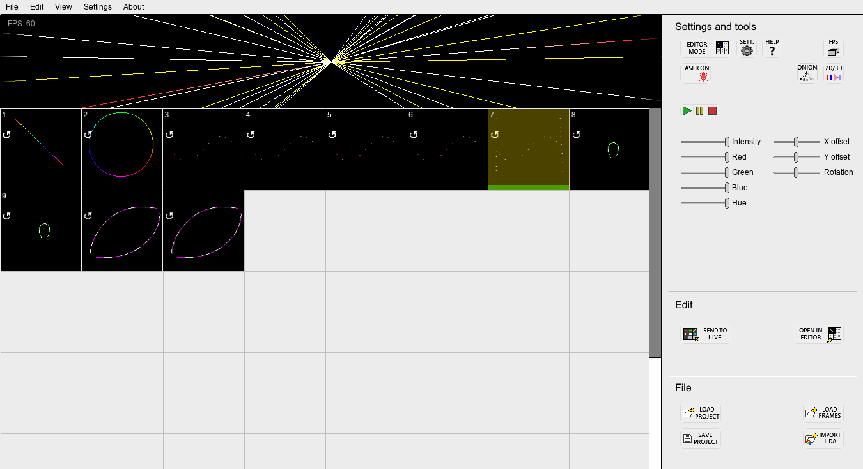
Getting started guide

Introduced in LaserShowGen 1.7.0, the Grid View (previously called “Live Mode”) allows you to add files to a grid. This mode has two main purposes:
- One use case is to use the grid as a general-purpose browser for .ILD files. For example, you can load a folder of .ILD files to the grid to visualize them, as well as to have easy access to these files for opening them in the editor mode or sending them to the timeline in the timeline mode. To open a file from the grid in the editor or timeline, select the file by clicking on it, then click the “Open in editor” or “Send to timeline” buttons.
- The other use case is to enable live performances, as each file in the grid can be triggered to play on demand. The rest of this chapter will elaborate on this use case.

To play a file, you can either click on it with the mouse, press its keyboard shortcut using your keyboard, press a MIDI key shortcut on your MIDI controller or keyboard, or send a specific value to a DMX channel using either Art-Net or sACN.
The shortcuts for keyboard, MIDI and DMX triggers are indicated in the corner of each file square, but they can be freely changed. Please see more details on the different input method in the next chapters.

Files can be set up to stop once they complete their animation, or they can loop until they are explicitly stopped by triggering it a second time. This toggle setting is available in the menu that pops up if you right click the file cell, or by pressing [O].
In this menu there is also a setting for changing the file’s trigger shortcuts, and other toggle options like exclusive on (all other files are invisible), resume at play (when triggering playback of the file, it continues from where it previously was paused, rather than replay from the beginning), and set push to play / set toggle playing, which sets whether the selected object toggles play/pause when triggered, or whether the trigger needs to be held down for it to play.

To add files to the grid, you can either import .ILD files, send the currently opened file from the editor mode (button or [L]-key), or open a LaserShowGen frames file (.igf) saved from the editor mode. You can also save and load the whole grid of files you have opened as a live mode project. All these options are available either from buttons, or in the “File” top menu, much like in the timeline mode.

To the right of the grid there are various sliders that can modify the color and position of the output, like an on-demand version of the envelopes in the timeline mode. The red, green and blue slider change the brightness of the individual color channels. The intensity slider changes the brightness of the whole file. The hue slider changes the color hue. The X and Y offset sliders shift the projection horizontally and vertically, respectively. Finally, the rotation slider will rotate the projection, with the pivot/anchor in the center of the objects.
These sliders can also be controlled by bound MIDI knobs, or dedicated DMX channels over Art-Net or sACN.

Most other buttons present in this mode is also present in other modes, so you can read the previous chapters in this manual for more information on them.

NB: In the free version of LSG, you can only add up to 10 files to the grid.

Keyboard controls in the live mode

Mouse) Select object in the grid
Left/Right Arrows) Move one frame back or ahead
Space) Pause all playing files (or resume if already paused)

Delete) Delete selected objects
Ctrl+Z) Undo
Ctrl+Y) Redo
X) Toggle exclusive playback of the selected object
O) Toggle looped playback of the selected object
R) Toggle whether to resume or restart the selected object when playing it
H) Toggles whether the selected object toggles play/pause when triggered, or whether the trigger needs to be held down for it to play.

Tab) Enter frame editor mode
P) Changes previewing mode between 2D and 3D (simulated scanner)
L) Send frames from editor mode to live mode
0) Stop and reset all playing files.
M) Reset window size
F11) Toggle fullscreen
F1) Open this document

Any bound shortcut key will also trigger playback of the file that the key is bound to.

Keyboard/mouse control

The simplest way to trigger playback of files in the grid is using a regular mouse or keyboard. This requires no specialized equipment like other input methods.
Using a mouse is straight-forward, simply click on a file in the grid to start playing it. Click again to stop, or you can wait for it to stop by itself when the animation is finished, unless it is set up to loop.
Using a keyboard requires setting up keyboard shortcuts for each file on the grid. To play a file, press any bound shortcut key on the keyboard. The first 9 files added to the grid are automatically assigned a keyboard shortcut: The number keys 1-9. The current keyboard shortcut is indicated in white text in the top left of a file cell. The shortcut for any cell can be changed or assigned by right-clicking on the file and choosing “Change keyboard shortcut..”. Then, press the desired shortcut key, and this key will then become assigned to the file. To remove a shortcut entirely, you can right-click again and choose “Unbind shortcut”.

MIDI control

A standard MIDI controller or keyboard can also be used to trigger files. To enable this feature, you must first go to the settings window (see next main chapter), and choose a connected MIDI device in the “MIDI Input” dropdown selector.
In the grid view, no files have a MIDI shortcut by default. To assign or change a MIDI shortcut, right-click the file and choose “Change MIDI shortcut..”. Then, press a key/pad on your MIDI controller, and this key will become bound to the file. The current MIDI shortcut is indicated in green text in the upper right corner of each file cell. The shortcut notation is the musical note that the MIDI key represents (for example 0C4 would be a C in the 4th octave, in the default MIDI channel 0).
Sliders can also be bound to knobs/slider on MIDI controllers. By default, only the MIDI volume signal is bound to a slider, specifically the master intensity slider that controls the brightness of laser output. But all sliders can have their MIDI source changed, by right-clicking on them and choosing “Change MIDI shortcut”, and then turning the desired knob on the MIDI controller to teach LSG which signal to listen for. When a slider is bound to a MIDI source, a green text indicating this will appear above the slider.

Network DMX (Art-Net or sACN) control

LaserShowGen’s Grid View supports basic control via the network DMX protocols sACN (E1.31) and Art-Net. To enable this feature, you must first go to the settings window (see next chapter) and enable one of the two “Enable Art-Net” or “Enable sACN” checkboxes. Both DMX input methods cannot be used at the same time.
Once a DMX input method has been enabled, new settings will appear. You must choose a DMX universe that LSG will listen on. The “Net interface” selector can be left at default, unless you wish to specify which network card in your computer that the DMX protocol will use. This may be necessary if you have multiple network ports and your DMX equipment is only connected to one of these ports.
To see whether you’ve configured LSG correctly, a Test monitor is visible to the right, where the value of the first DMX channel in the selected universe will be indicated. When you change this value in your DMX controller, the value in LSG should automatically update.
Once you have enabled and configured either Art-Net or sACN, you can control LSG in two ways:
Files can be played by assigning a DMX trigger ID to each file. To do this, right-click on files and choose “Change DMX trigger ID..”. In the following popup, enter a numeric ID between 16 and 255. The current DMX trigger ID of a file will be displayed in the upper right corner of the file cell, in orange color text. Once a trigger ID is assigned, you can send the value corresponding to this ID to any one of 8 DMX file playback channels. See the detailed list of DMX channels below.
When LSG receives a matching ID in these channels, the specified file starts playing. Since there are only 8 such DMX channels, there are a max of 8 files that can be triggered at the same time.
LSG sliders can also be controlled by DMX. Unlike MIDI, the sliders do not need to be manually bound to a specific source, instead each slider have their own dedicated DMX channel. For example, the master intensity slider corresponds to the value in DMX channel 1. Again, see the list below for a full specification. However, please note that by default all sliders except the master intensity has DMX input disabled, to avoid the sliders being stuck at 0 if you do not configure your DMX console to control them. To enable slider DMX control, right click on a slider and choose “Toggle DMX input”.

DMX Channel List

Channel # | Name | Description
1 | Master Intensity | Corresponds to the “Intensity” slider. Controls the brightness of all laser output. 0 = laser off.
2 | Reserved | Not in use yet. Keep at 0 for forward compatibility.
3 | File trigger ID #1 | If this value is 16 or above, play the file with the DMX trigger ID equal to this value.
4 | File #1 speed modifier | Not in use yet. Keep at 0 for forward compatibility.
5 | File #1 intensity modifier | Not in use yet. Keep at 255 for forward compatibility.
6 | File trigger ID #2 | If this value is 16 or above, play the file with the DMX trigger ID equal to this value.
7 | File #2 speed modifier | Not in use yet. Keep at 0 for forward compatibility.
8 | File #2 intensity modifier | Not in use yet. Keep at 255 for forward compatibility.
9 | File trigger ID #3 | If this value is 16 or above, play the file with the DMX trigger ID equal to this value.
10 | File #3 speed modifier | Not in use yet. Keep at 0 for forward compatibility.
11 | File #3 intensity modifier | Not in use yet. Keep at 255 for forward compatibility.
12 | File trigger ID #4 | If this value is 16 or above, play the file with the DMX trigger ID equal to this value.
13 | File #4 speed modifier | Not in use yet. Keep at 0 for forward compatibility.
14 | File #4 intensity modifier | Not in use yet. Keep at 255 for forward compatibility.
15 | File trigger ID #5 | If this value is 16 or above, play the file with the DMX trigger ID equal to this value.
16 | File #5 speed modifier | Not in use yet. Keep at 0 for forward compatibility.
17 | File #5 intensity modifier | Not in use yet. Keep at 255 for forward compatibility.
18 | File trigger ID #6 | If this value is 16 or above, play the file with the DMX trigger ID equal to this value.
19 | File #6 speed modifier | Not in use yet. Keep at 0 for forward compatibility.
20 | File #6 intensity modifier | Not in use yet. Keep at 255 for forward compatibility.
21 | File trigger ID #7 | If this value is 16 or above, play the file with the DMX trigger ID equal to this value.
22 | File #7 speed modifier | Not in use yet. Keep at 0 for forward compatibility.
23 | File #7 intensity modifier | Not in use yet. Keep at 255 for forward compatibility.
24 | File trigger ID #8 | If this value is 16 or above, play the file with the DMX trigger ID equal to this value.
25 | File #8 speed modifier | Not in use yet. Keep at 0 for forward compatibility.
26 | File #8 intensity modifier | Not in use yet. Keep at 255 for forward compatibility.
27 | Master Red Color Intensity | Controls the “Red” slider. (Disabled by default)
28 | Master Green Color Intensity | Controls the “Green” slider. (Disabled by default)
29 | Master Blue Color Intensity | Controls the “Blue” slider. (Disabled by default)
30 | Master Color Hue Shift | Controls the “Hue” slider. (Disabled by default)
31 | Master X offset | Controls the “X offset” slider. (Disabled by default)
32 | Master Y offset | Controls the “Y offset” slider. (Disabled by default)
33 | Master Rotation | Controls the “Rotation” slider. (Disabled by default)
34 | Master Speed | Controls the “Adjusted speed” modifier. (Disabled by default)

In most channels there are deadbands of around 4 units around the extremes and around the default value.

Regarding timing / BPM

The Grid View has a separate time modifier control called the “Adjusted speed” (or “Adjusted BPM” if BPM timing is enabled in the settings). This control adjusts the playback speed of all the files in the grid, meant to be used to match the output to songs with different tempo during a live performance. This adjusted speed control can be bound to MIDI / sACN / Art-Net external source like the sliders. When BPM timing is enabled, it can also be modified on the fly by tapping the “TAP” button to the right along with the desired beat. The keyboard shortcut T does the same thing as the button.
The difference between the main BPM setting in the Settings View, and the adjusted BPM in the Grid View, is that the program assumes that the animations in the grid is by default designed to play at the main BPM and FPS settings from the Settings View. This speed is inherently built into the animation files, implied by the number of frames in them. The adjusted BPM in the Grid View is a raw speed modifier that speeds up or slows down the playback relative to the main BPM. That is why the adjusted BPM is expressed as a fraction of the main BPM, or in percent if BPM timing is disabled. For example, an adjusted speed of 100%, or an adjusted BPM the same as the main BPM (such as 120/120), means no speed modification at all: the files will play as quickly as they were originally designed.
In practice, this means that in order for the files in the grid to play at the correct speed, the main BPM and FPS from the Settings View needs to be the same as when the animations were originally created. It is recommended to build up a library of animations that can be re-used in different shows, that all have the exact same BPM and FPS settings, for example the default which is 120 BPM at 60 FPS. If you already have files with the wrong speed that you wish to use, you can stretch them in the Editor Mode to match the new desired duration measured in beats.
If this prerequisite is fulfilled, the adjusted BPM / speed in the Grid View will correctly modify the speed of the grid animations. For example, an adjusted BPM of 180/120 will play all files at 180 BPM if they were originally created with a setting of 120 BPM.

Settings

The settings / options mode can be accessed either by clicking “Settings” in the top menu or the SETT. button.

Settings are saved in profiles. There is a list of profiles in the “General” area in the bottom-left corner of the window. To select the default profile, which will be used to configure the ILDA files exported, or the live output to DACs unless otherwise specified. You can use the [+] button to create a new profile, or right click the list for more options such as deleting existing profiles, or renaming them.

LaserShowGen comes with three built-in example profiles:
- “Basic DAC output” is for outputting directly to a projector using a DAC.
- “ILDA file for sharing” is for raw, unoptimized ILDA files, meant to be imported into other software that applies their own optimization. This profile should NOT be used when outputting directly to DACs.
- “ILDA file for SD card projector” is for exporting an optimized ILDA file to be played on a projector with a typical ILDA SD-card reader. Many of these SD-card readers do not support modern ILDA format 5, so this profile uses the legacy format 0.

Optimization and adjustment

In this area you will find settings related to the output of LaserShowGen. The most important parameters are the optimization settings, including the ability to turn optimization off completely. Turning off optimization or using the “only optimize between objects” mode (see below) might yield
better results for imported ILD files that have already been optimized in a separate program.

- Sampling rate is the intended rate of points, measured in points per second. The total number of points in each frame is scan rate divided by FPS (adjustable in “Properties” in the top menu).

- Max. dwell is the maximum amount of points to dwell (stand still) at angles or the start/end of lit segments. The actual dwell will depend on the sharpness of the angle. Setting this too low might cause warped/rounded corners, however setting it too high could lead to flickering or even complete failure to draw the frame, if the frame is too complex.

- Min. dwell is the minimum amount of points to dwell at the start/end of lit segments. The actual dwell will depend on the sharpness of the angle and be somewhere between “min. dwell” and “max. dwell”.
Setting this too low might cause “tails” on the end of lines with the laser bleeding into segments that are supposed to be blanked, or opposite, however setting it too high could lead to overly bright dots at the end of segments, as well as flickering if the frame is too complex.

- Only optimize between objects is an optimization mode that keeps point data of objects intact, and only adds points between them for smoother blanking jumps. This mode is helpful if you want to combine multiple pre-optimized imported ILD files in a single frame.

- Color shift will offset the color and blanking data of each point, to the data of the point x places ahead or behind. Sometimes the position of the scanner will lag or lead the color and blanking of the lasers, causing inaccurate coloring and blanking such as tails or premature ending of lit segments. This setting can fix this issue. There is a separate color shift setting for each color channel (red, green and blue), as well as one for intensity. If you hold [Ctrl] while adjusting the values, all the color channels will be adjusted simultaneously. For live output to DACs, the color shifts for each channel should be turned down for the best result. A value of around -4 is a good starting point.

When exporting ILD files to share with others, it is best to leave the color shift settings at their defaults, and let individual users use their own settings, as different laser projectors require different settings to scan optimally.

- Max acceleration is a measure of how fast the scanner is allowed to accelerate, typically during blanked segments. Adjust this down if the image looks warped, especially around the start/end of lit segments. Adjust it up if dynamic FPS is enabled but the image starts flickering too easily.

- Enable dynamic FPS toggles whether or not LSG should automatically reduce the playback rate during complex frames. This will preserve the graphical accuracy of the frames and avoid warping, but it will also introduce flickering if the framerate drops too low.

- ILDA file format selects the format of exported ILD files. The ILD file format has multiple revisions with different specifications. It is recommended to use the default format 5 for most purposes, but some older programs and SD card readers may only support format 0. Note that format 0 uses a color palette limited to 63 colors by default, therefore some effects like gradient coloring and fading will not work properly. When exporting to format 0, LaserShowGen will automatically fit the colors of the frame into the closest available palette color, using the CIE94 color comparison definition.

- Invert X and Invert Y will flip the exported or outputted image horizontally or vertically, respectively. Swap X/Y will swap the X/Y channels, useful if for example the projector is mounted sideways.

- The Color range sliders adjust the upper and lower bounds of the color channels. The upper bounds should be set to get a good white balance at max output of all channels, and the lower bounds should be set so that the lasers turn on at the expected signal level. For example, if a color channel doesn't turn on until the modulation signal is at 20%, you can adjust the lower bound to 20% to offset that error, so that the actual light intensity match the modulation signal one-to-one.

- The Intensity slider adjusts the overall brightness of the output.

- The big square area under the text Projection mapping and blind zones lets you stretch and resize the projected or exported output. You can drag the edges of the blue rectangle with your mouse to change its shape.
You can also click the Blind zone button below to add a blind zone window. The blind zone areas represented as red rectangles will be void of laser beams. You can use them to protect eyes or cameras from direct laser exposure during shows. NB: This feature, like the rest of LaserShowGen, is used at your own risk. Certain frames that fail to optimize properly may still allow beams to stray into blind zone area, so test your shows very carefully before attempting any projection in the presence of an audience.
If you click the “Sides/Corners” button, you can move the corners of the projection window instead, to make a skewed projection. This is useful to correct for projection at a wall at an angle, etc.
To adjust the projection size or blind zones more accurately, hold [Ctrl] while dragging them. It will make the mouse movement less sensitive, and it will also bypass the minimum size limits of the areas.

Output (DAC/Projector connection)

LaserShowGen can output signals directly to laser show projectors through DACs. Many DACs are separate devices that convert output an ILDA signal that can be connected to projectors with an ILDA-port, however some lasers has the DAC built into the projector and all you need is an USB/Ethernet cable.

Currently the following controllers/DACs are supported:

- Helios Laser DAC
- Ether Dream (*Only using Ethernet)
- LaserDock / LaserCube (Both USB and network/WiFi models)
- ILDA Digital Network (IDN) protocol, including:
  - HeliosPRO Laser DAC
  - StageMate ISP
  - OpenIDN network adapter for the Helios DAC

To enable output, you must scan for connected DACs by clicking the SCAN button in the settings mode, in the lower left corner of the window. Then select your default DAC in the list above so that it gets marked with a yellow [v] symbol. Then you can click the “LASER ON” buttons to toggle live output on or off.

For the timeline mode, specific DACs can be assigned to each layer for multi-projector shows. In the settings mode there is a list marked with “Timeline mode layer DAC assignment”. Here, every layer of the current show in the timeline mode will be listed. To add DACs to the layers, right click the layers and select “Add DAC” for the DAC you wish to add. Or oppositely, you can right click on the DACs in their list and select “Attach to layer:” for the layer you wish to add the DAC to.
You may wish to have different optimization or projection zone settings for each DAC/projector. By default each DAC will use the default profile. But to assign a specific profile to a DAC, right click the DAC in the list of layers after it has been added, and select “Select profile:” for the profile you wish to associate with the DAC.

Input devices

It is possible to connect various lighting protocols to LaserShowGen and control the software in real-time with third-party devices or control software. The two main supported methods are:
- MIDI controllers
- Network DMX, specifically Art-Net and sACN

To enable a MIDI controller for input, simply select one from the drop-down menu labeled “MIDI Input”.
To enable Art-Net or sACN (only one of these protocols can be used at the same time), check the checkboxes labeled “Enable Art-Net” or “Enable sACN”, then choose a DMX universe using the “DMX universe” selector. You can test whether the DMX input works by monitoring channel 0 using the “Test monitor” label to the right. If your DMX network is using a specific Ethernet port on your computer, you may need to select it using the “Net interface” drop-down box.

Refer to the Grid View mode chapter for instructions on how to actually use these input devices to control LSG.

Simulated preview

The previewing of laser shows in the timeline mode in LaserShowGen can be customized, by moving the virtual projectors for each layer. For example, if you make a show with two side-by-side projectors, you can for example place the virtual projector of one layer to the left of center, and the other to the right of center, to match the actual layout. This can be done by clicking on each layer in the list named Timeline mode layer simulated projector positions, and dragging the accompanying 🅇-symbol in the black area next to the list to the desired projector position.

Misc options

Other options found in the “General” section include:
- Use BPM time checkbox. Checking this box changes the timing system of the entire application to beats and bars rather than frames, seconds and minutes. This is useful if you are setting a show to music in a specific BPM, and will feel familiar to music editing software. If this box is checked, you need to set the “Base BPM” and “Beats per bar” options that will appear.

- Automatically check for updates. This will make the software notify you if a new version is available when you start the software.

- Show tooltips. Enables or disables the tooltip text in the upper left corner when hovering the mouse over buttons etc.

- Tab key remembers last mode. If this is enabled, the [Tab] keyboard shortcut switches between the editor mode and whichever was most recently used of the Timeline Mode or Grid View. If this is disabled, the [Tab] shortcut cycles between all three modes regardless of what you used most recently.

- Preview frame while lasing. If this is enabled, you can see a preview of the laser output in the canvas of the editor, timeline and grid view, even when the laser is on. If it is disabled, the preview is replaced with a red text saying that the laser is currently on. This saves a little bit of performance, and makes it more apparent that the laser is on.

- Disable common confirmation messages. This option hides the most common pop-up messages that you may encounter in the software, for example messages that confirm that files were saved.

- Scaling. This selector increases the size of the UI by essentially zooming in and out. Can be useful on screens with very high resolution that would otherwise make the graphics very small and hard to see. The higher the number, the more zoomed in the UI is. A setting of 0 will automatically try to find the best scaling for the current screen.

Troubleshooting

Exported files don't play on my projector at all or are unrecognizable

First of all, make sure you have exported an ILD file by using the “Export ILDA” button instead of the “Save Frames” button, which is LaserShowGen's own file format not supported by other programs or projectors.

The most likely problem is that your projector or software may not support ILDA format 5. Try choosing the legacy ILDA format 0 in the “Options” menu at the top of the screen, then export the file again. For more info on this, see the paragraph about the export button on page 13.

Exported ILDA files don't play well on my projector (warped, bad quality)

LaserShowGen tries to optimize the exported ILD files to play well on scanners, but sometimes the optimization may be inadequate. If LSG thinks this is the case, it will warn you during export. The easiest way to make a frame scan better is to reduce its complexity. Large amounts of text or other complex graphics are especially hard for scanners to project properly.

You should try experimenting with some settings to make it better. The optimization settings can be found by clicking the SETTINGS button with a gear symbol. See the previous chapter for more information on how to use the optimization settings correctly.

If nothing works, you can use a separate program to optimize the frames instead. Examples include LaserBoy (free and included, see next chapter in this manual). LaserShowGen will continue to improve the built-in optimization in future versions.

Exported ILDA files have incorrect colors

While ILDA format 5 encodes exact colors, format 0 is based on a palette. By default the color palette limited to 63 colors, therefore some effects like gradient coloring and fading will not work properly. To make matters worse, there are multiple different standard for the palette used in ILDA files, so if your colors are completely wrong, your projector/software is probably expecting a different palette than LaserShowGen is using.
LaserShowGen does come with one extra palette that is used by some projectors instead, and this can be enabled by checking the “Alternative palette for format 0” button in the settings. Try that and re-export your file.

Advanced: If the colors are still wrong, you can try to manually change the default palette in LSG. This is done by going to LaserShowGen’s installation folder and editing the file “palette.ini”. The file contains RGB values for each value of the palette. Value 0 = Red channel for first palette color, value 1 = Green channel for first palette color, value 2 = Blue channel for first palette color, value 3 = Red channel for second palette color, and so on.

Output with WiFi is unstable (such as on LaserCube or HeliosPRO)

This might be caused by an unstable network connection, which is common in wireless mode. It is highly recommend to connect the DAC to an ethernet cable instead of WiFi. Otherwise, you could try to remove other components on the network, or nearby networks that could cause interference. Or change network mode if the DAC supports it, for example switch from server to client mode on the LaserCube.

Buttons and menus in the program don't work or react slowly

You may have a program installed that interferes with LaserShowGen, blocking mouse and button presses. One such program is ClipboardMaster, if you have this program installed and experience problems, please close it while you are using LaserShowGen.

Files are not saved/exported

If you try to save/export files, but find that no actual file were created, file output might be blocked by Windows.

- Make sure you do not open any laser files in LSG by opening the file directly in the file browser of Windows. This can cause problems when saving new files. Instead, open LaserShowGen normally, then open the file using the LSG menu buttons. If this was the cause of your problem, you may be able to find the files you tried to save in the following location (copy and paste this into Windows Explorer address bar): %appdata%/LaserShowGen
- Try to save to the Documents folder of your user (C:\Users\(username)\Documents). Some other folders, like in the root of the hard drive or program files are locked for access to regular programs.
- If that doesn't work, try to run LaserShowGen as administrator by navigating to the .exe file (C:\Program Files (x86)\LaserShowGen\LaserShowGen.exe, right clicking on it and selecting "Properties", then go to the "Compatibility" tab and check "Run as administrator".

- A third solution is to try saving the file with a name and to a directory containing only English characters, digits and symbols.

“Error defining an external function”

If you get this error message at startup, try downloading and installing Visual C++ Redistributable Packages for Visual Studio 2015-2022.

Another possible solution is to make sure the install directory of LaserShowGen only contains English characters, digits and common symbols. If your install directory contains special symbols or characters, try reinstalling LaserShowGen to for example “ C:/LaserShowGen “.

“Unable to find game”

If you get this message in Mac, make sure you have unzipped the program into the “Applications” folder. If the program is located elsewhere, it may cause this error.

Anything else

If you experience any other problems and need support, please contact the developer at gitle@bitlasers.com.

LaserBoy

Included with the Windows version of LaserShowGen is the open-source project LaserBoy, by James Lehman, Extra Stimulus Inc. james@akrobiz.com, © GPL v3 2003...2014. http://laserboy.org
LaserBoy is a great supplement to LaserShowGen as you can do further editing of ILDA files exported, like manipulating individual points, and converting to additional formats like ILDA version 0 and 1, wave files for playing on sound card DACs and more.
LaserBoy can be installed by unzipping the zip file found in the installation folder of LaserShowGen. You can also always find the newest version here: http://laserboy.org/forum/index.php?topic=10.0
To start LaserBoy, first check out its README.txt file and set its window size in LaserBoy.bat, then double-click on LaserBoy.bat.

Fonts

LaserShowGen uses ILDA font files in much the same way as they were originally designed to work in LaserBoy. LaserShowGen comes with font_arial.ild by permission of James from the LaserBoy distribution. There is a nice collection of other font files included in the LaserBoy distribution, inside of the ild folder, all starting with the name font_(name).ild
The following glyphs are available:
!"#$%&'()*+,-./0123456789:;<=>?@ABCDEFGHIJKLMNOPQRSTUVWXYZ[\]^_`abcdefghijklmnopqrstuvwxyz{|}~
This is the Latin Alphabet, digits, punctuation and other symbols from the standard ASCII text table symbols 33 to 126 in the same order. The space character, ASCII 32, is an implied part of the available characters but is not visible.
Each single glyph is a frame in a standard type 1 ILDA file, in the exact order as listed above. The coordinate location (0,0), also known as the origin, is the baseline for each glyph. Each glyph is mostly in the all positive quadrant of coordinate space but some glyphs my descend into negative Y space (in case you want to make your own font files). You can open and examine any of the LaserBoy font_(name).ild files as you would open any other ILDA file.

Loading files into LaserBoy

To load and edit ILDA files in LaserBoy, they must first be moved or copied into the ild sub-folder inside the LaserBoy folder.
With your ILDA files in place, press the "i"-key to input or import a file and then the "1"-key for type ILDA. Type the name of the file you want to load and press [Enter]. Now select what you want from the options on the screen, for example press "1" to replace everything with the loaded file. You should now be back to the main menu, with the file loaded. You can use the left and right arrow keys to preview all the frames in the file, one frame per key tap or the "`"-key (below the ~) to show the frames as a continuous animation (any key to stop).

Optimizing and converting to other formats

While in the main menu of LaserBoy, press "x", this brings you to a menu where you can adjust various on-off settings of the application's behavior. You can see all the options with their keys listed in the window.
If you plan to use LaserBoy for optimizing your frames it is imperative that you turn option "a" off before you save your ILDA file! Otherwise your optimizations will be stripped out (minimized) in the resulting file.
Use option "b" to toggle exporting to legacy ILDA format 0/1 (off), or 4/5 (on).
NOTE: If you turn option "b" off and your vector art uses any palettes other than the "Default_" palette of 63 colors, LaserBoy will save that palette as an ILDA file section 2 in front of all the frames that use it. This is not widely compatible with other laser applications, even though it is a standard part of the ILDA file format specification. If any or all of your frames are "-24-bit-" (possibly from importing formats 4 or 5), then LaserBoy will save a section 3, RGB color table in front of every 24-bit frame, which is no longer part of the ILDA file specification.
When you are finished, press [Esc] to go back to the main menu.
If you want to save any settings you have changed, from the main menu, hit "o" to output a file, "6" for type wtf and simply hit [Enter] for the default file name of "LaserBoy.wtf". This will save all settings. When LaserBoy starts it reads this file and adopts these settings. You can also save wtf files of different names and load them by name any time the application is running.
If you want your frames to be saved as the most common and widely compatible formats 0 or 1, then you can match all of your colors to the standard "Default_" palette by hitting "p" from the main menu to go into the palette transforms menu. From there you will see two palettes side-by-side. The one closest to your art will be the current palette for the frame in the view (possibly "-24-bit-" no palette). Use the up and down arrow keys to find the "Default_" palette in the target palette position. Hit "B" (capital B) to do a best color match for all frames to the target palette. Now when you save your frames they will be either format 0 (3D) or 1 (2D) standard ILDA files with no palette saved in the file.
To export the file, simply press "o" to output while in the main menu. Then select the desired file format, for example "1" for ILDA. Now press "3" to export the whole file, or one of the other options on the screen. Now give your file a name, for example "test", and press Enter. Your file will now have been created in the same folder as the file you loaded.

System Requirements

Minimum:
- 64-bit Windows 8 or newer (Windows version)
- macOS 10.15 or newer (macOS version)
- Linux distro supporting AppImages (Linux version)
- Modern browser with HTML5 support (Web version)
- 2GB RAM
- 256MB graphics

Recommended:
- Windows 10 or newer (Windows version)
- macOS 14 “Sonoma” or newer (macOS version)
- Ubuntu 24.04 or newer (Linux version)
- 8GB RAM
- A screen resolution of 1366x768 or higher
- Modern graphics card
- Modern CPU

Extra credits and licenses

Thanks to:
James Lehman, Extra Stimulus Inc. james@akrobiz.com
for LaserBoy and the included ILDA font files
© GPL v3
http://laserboy.org

Jarek Kral
for the demo laser show with song “Funky Beat”
https://www.youtube.com/watch?v=qxjEdjZ-Mes

Paul Weijtens, paul23
for ML Parser 2.0
© GPL v3
https://code.google.com/p/ml-parser/

Eli Grey
for FileSaver.js
© MIT License
https://github.com/eligrey/FileSaver.js

Firelight Technologies Pty, Ltd
for FMOD Sound Engine
© https://www.fmod.com/licensing/
http://www.fmod.org/

mstop4
for FMODGMS
© BSD 2-clause License
https://github.com/mstop4/FMODGMS

Dr. A. V. Hershey
for the Hershey vector font set
Public domain

GMSSimpleMIDI
© MIT License
https://rhymingarfunkle.itch.io/gmssimplemidi

Gary P. Scavone and various contributors
for RtMidi
© Modified MIT License:
https://www.music.mcgill.ca/~gary/rtmidi/index.html

DexLogic, Dirk Apitz
for IDN Hello client code
© MIT License
https://github.com/DexLogic/idn-C-serverList

Samuel Venable
for DialogModule
© MIT License
https://github.com/samuelvenable/DialogModule-GMExtension

hhromic
for libE131
© Apache License 2.0
https://github.com/hhromic/libe131

Simon Newton, Open Lighting Project
for libartnet
© LGPL-2.1 license
https://github.com/OpenLightingProject/libartnet

Main License
Copyright (c) 2020 Gitle Mikkelsen

Permission is hereby granted, to any person obtaining a copy
of this software and associated documentation files (the "Software"), to use, copy and
modify this software subject to the following conditions:

1. You have purchased and applied a valid license code for the software from Gitle Mikkelsen or a vendor approved by Gitle Mikkelsen OR you use only the functionality available in the free version of the software, AND
2. You do not redistribute, share or resell the software or license without permission from Gitle Mikkelsen.

The copyright holder reserves the right to revoke the validity of a purchased license should the these conditions be violated.

THE SOFTWARE IS PROVIDED "AS IS", WITHOUT WARRANTY OF ANY KIND, EXPRESS OR IMPLIED, INCLUDING BUT NOT LIMITED TO THE WARRANTIES OF MERCHANTABILITY, FITNESS FOR A PARTICULAR PURPOSE AND NONINFRINGEMENT. IN NO EVENT SHALL THE AUTHORS OR COPYRIGHT HOLDERS BE LIABLE FOR ANY CLAIM, DAMAGES OR OTHER LIABILITY, WHETHER IN AN ACTION OF CONTRACT, TORT OR OTHERWISE, ARISING FROM, OUT OF OR IN CONNECTION WITH THE SOFTWARE OR THE USE OR OTHER DEALINGS IN THE SOFTWARE.

The user retains ownership of all files created by themselves using the software.

