Project 1

CSE 619 -50

Ryan English

02/03/2021

How to run code

Code is written in C# Console application
Assuming Visual Studio 2019 is installed!
Dowload 619_Project1.csproj and Program.cs into a folder
Double click 619_Project1.csproj
This will open Visual Studio
Click Start or Press F5
View output

Code for ease
/// <summary>
/// Sorts an array using insertion sort with a sequential
/// search on the array.
/// </summary>
/// <param name="array">The array that is being sorted</param>
public static void InsertionSortSequential(int[] array)
{
int position = 1;
while (position < array.Length) {
int sub_position = position;
// Walk backwards looking for the position
while (sub_position > 0 && array[sub_position - 1] > array[sub_position]) {
// Swap the slots
int num = array[sub_position - 1];
array[sub_position - 1] = array[sub_position];
array[sub_position] = num;
sub_position -= 1;
}
position += 1;
}
}

/// <summary>
/// Sorts an array using insertion sort with a binary
/// search on the sorted portion of the array
/// </summary>
/// <param name="array">The array that is being sorted</param>
public static void InsertionSortBinary(int[] array)
{
int position = 1;
while (position < array.Length) {
int sub_position = position;

int low_position = 0;
int mid_position = 0;
int high_position = sub_position;

int found_position = -1;

while (low_position <= high_position) {
// Set the mid point
mid_position = (high_position + low_position) / 2;
if (array[sub_position] > array[mid_position]) {
low_position = mid_position + 1;
} else if (array[sub_position] < array[mid_position]) {
high_position = mid_position - 1;
} else {
found_position = mid_position;
break;
}
}

if (found_position == -1) {
// Position was not found it is low
found_position = low_position;
}

// Everything needs to move
int num = array[sub_position];
for(int i = sub_position; i > found_position; i--) {
array[i] = array[i - 1];
}
array[found_position] = num;

position += 1;
}
}

Code Output
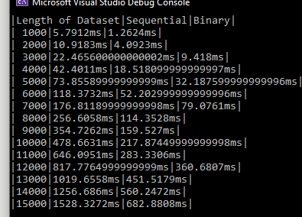

Output Graph

