Homework 1
Ryan English
09/07/2021

- Select two (real) images of your choice that are good candidates to illustrate the concepts of low pass and high pass filtering.
  - Explain why these 2 images are good candidates to illustrate these concepts.
  - Filter each image with an ideal lowpass filter with cutoff frequencies set at radii values of 5 and 20. Show the input image, filter, and output image in the spatial domain and in the frequency domain. Explain the process and analyze the results
  - Repeat (b) with an ideal high-pass filter.

Notes to myself
Low pass: Attenuate high freq pass on low freq – Blurs the image
High pass: Attenuate low freq pass on high freq – Sharpens image

d0 = cutoff frequency that generates the radius of the circle that determines if H = 1 or 0

a)
Penguins
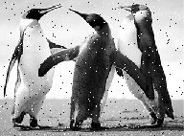
Low pass
This image was chosen as the low pass filtering due to the noise throughout the image. When applying the low pass filter to the image the noise will be removed and replaced with the ringing affect; the “hardness” of the affect is determined by the cutoff frequency, so the higher the cutoff the more ringing and the lower the cutoff the blurrier the image will be.

NOTE: I got this image from an example about low pass filters, as seen here: MATLAB - Ideal Lowpass Filter in Image Processing - GeeksforGeeks

Ideal if the frequency is less than it will be 0.

Microbes
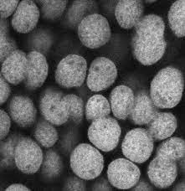
High pass
This image was chosen as the high pass filtering due to the microbes being a bit blurry and by utilizing the high pass filter we can get a bit more detail on the image by sharpening the details.

b)
Low Pass Filter

Original Image

Spatial Domain

D0 = 5
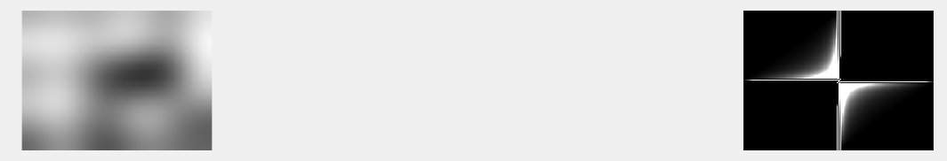
Spatial Domain Frequency Domain

D0 = 20
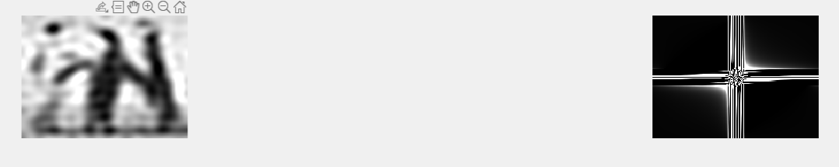
Spatial Domain/Frequency Domain

D0 = 50

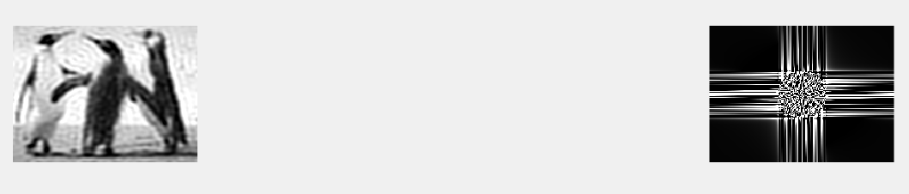
Spatial Domain / Frequency Domain

Analysis

High Pass Filter

Original Image
D0 = 5
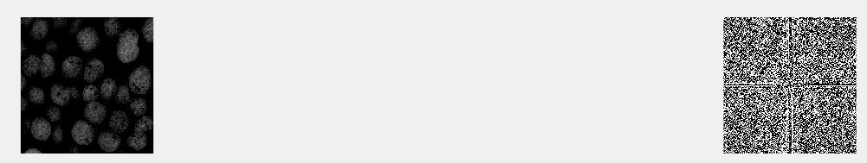
Spatial Domain/Frequency Domain

D0 = 20
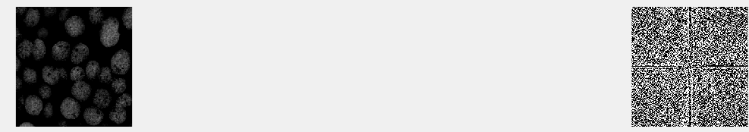
Spatial Domain/Frequency Domain

D0 = 50
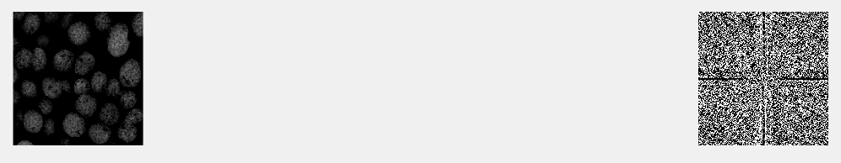
Spatial Domain/Frequency Domain

Analysis

- Apply 2 different smoothing filters (with different sizes and different weights), in the spatial domain, to the two images in problem 1. Compare the results of the different filters and explain their differences and similarities.

Average Filter

Original Image

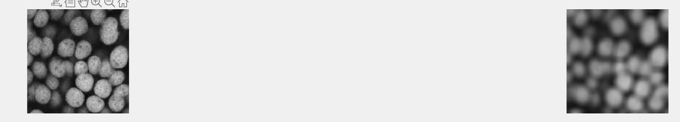
[3 3] Mask / [15 15] Mask

Original Image
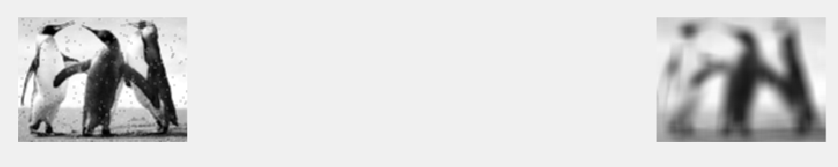
[3 3] Mask / [15 15] Mask

Gaussian
Original Image
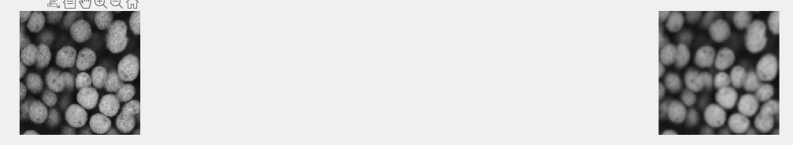
[3 3] Mask 5.0 sigma / [8 8] Mask 2.0 sigma

Original Image
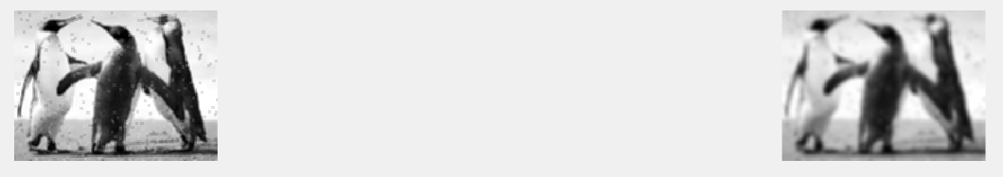
[3 3] Mask 5.0 sigma / [8 8] Mask 2.0 sigma

Analysis

Average filter, being one of the simplest smoothing filters, creates a mask that has an average of its size. For example the [3 3] mask has a value of 1/9 since there are nine slots and each take up one position and for the [15 15] it would be 1/15. This mask then is convoluted across the original image and averages out the neighborhood of the pixels. So as one would expect the higher the mask the more pixels are being averaged and the blurry the image will be. This is show in both images that get the [15 15] mask which are so blurry they lost most of their detail – like the penguins noise is non existent.

Gaussian filter, on the other hand, has the heaviest weights in the middle and lowers the weights as it moves from the center location based on the sigma. As with the average filter the larger the mask the more blurring the output image will have, however, with the Gaussian the sigma has a much higher blur rate, as you can see in the above images. The 2.0 sigma created a much heavier blurred imaged, but if you look at the penguins it still has a smooth enough surface you can make out the penguins just fine.

- For each of the two images in Problem 1, use spatial filtering techniques to detect the edges. Discuss the detected edges, their strength as a function of their orientations, and any interesting observations (e.g., double edges, disconnected edges, weak edges, etc.). You may need to threshold the detected edges as binary images to support your observations.

Original Image

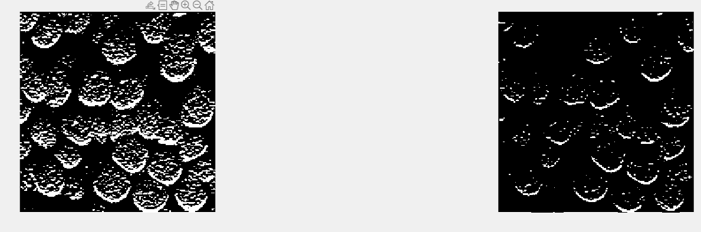
Sobel 0.2 Threshold / Sobel 0.5 Threshold

Analysis

Original Image

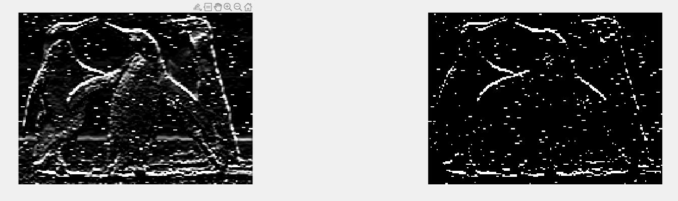
Sobel No Threshold / Sobel 0.9 Threshold

Analysis

Utilizing a sobel mask for edge detection, without transposing in order to get horizontal edges. The sobel generates the edge detection because it detects the hard changes in pixels by having the zeros in the horizontal center and positive values on the top and negative values on the bottom, so when the mask is convoluted on the original image it sets the hard changes (edges) to zero.

In the penguins image it really outlines the noise in the image because if you view the original image the noise consists of hard black ~4 pixels horizontal/vertical lines. Therefore, when the sobel mask is applied give it is only a [3 3] matrix it will detect these as edges.

In the microbes image the horizontal edge detection only gets about half the edges due them being circular in nature, so in order to fully detect the edges around the microbes. The microbes suffer the same problem as the penguins however, where the center of the microbes has those hard changes in pixels so I applied a threshold to remove as much as I could from the center without loosing too much in the edge of the microbes.

- Select one (real) image of your choice that is a good candidate to illustrate the concepts of histogram equalization

  - Explain why this image is a good candidate to illustrate this concept.
  - Perform histogram equalization with 256 and 32 levels
  - Compare the input image and the two histogram equalized images. You should include the histograms of the 3 images to support your analysis.

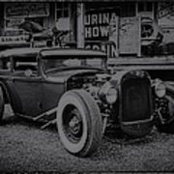
a) Image

I took an original image of a car and opened it in paint to darken it by painting over it by 0.5 black alpha. This created a much deeper black image; thus, giving me the perfect candidate for histogram equalization.

I chose this image to portray the histogram equalization since it is much darker it will have a much heavier histogram below ~180 intensity (see B). When we apply the histogram equalization it will spread the intensity across the 256 intensity spectrum allowing more of the detail to be visible and almost returning the image to its original state before I altered it.

b)
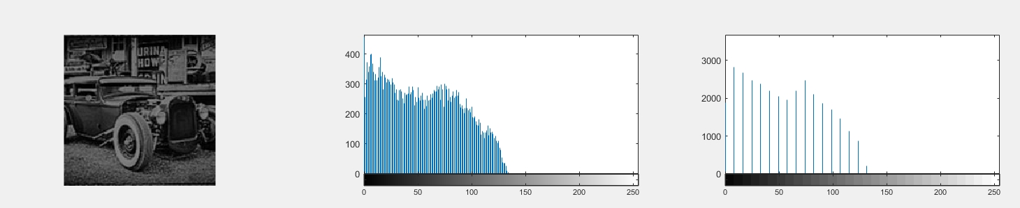
Original Image, Histogram 256, and Histogram 32

c)
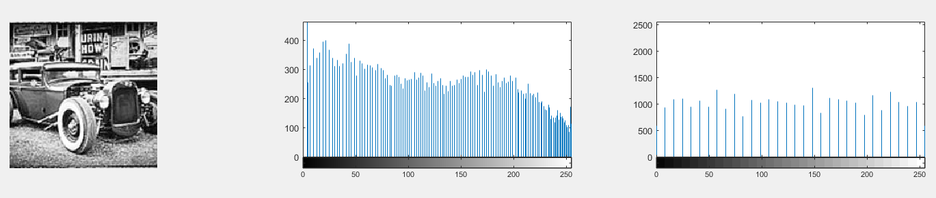
256 Histogram Equalized Image, Histogram 256, and Histogram 32

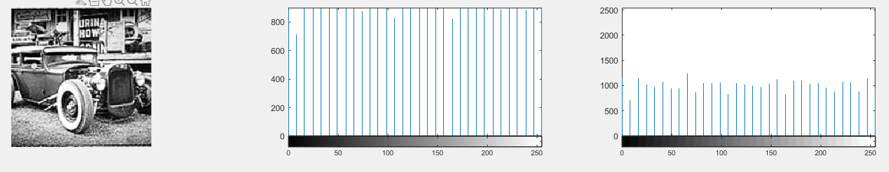
32 Histogram Equalized Image, Histogram 256, and Histogram 32

Analysis

