READY-TO-POST LINKEDIN ARTICLE. Paste the title, upload the header image, then paste the body. Hashtags and a short hook are at the end.

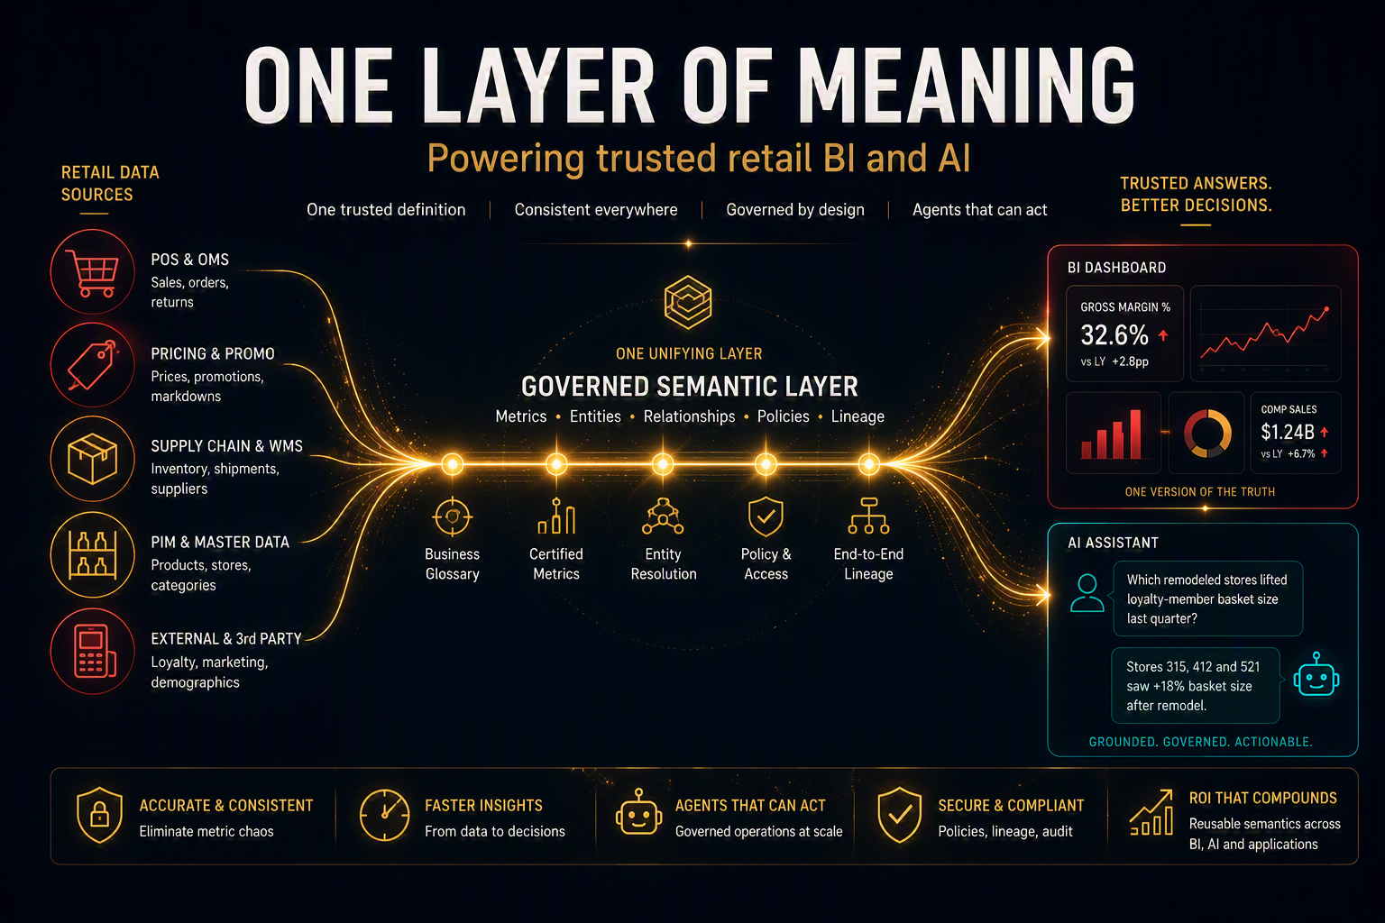
One governed layer of meaning — from the shelf and the checkout to every dashboard and AI agent.
Do Retailers Really Need an “Ontology”? Cutting Through the Context-Layer Hype
Snowflake, Databricks, Microsoft, dbt — and now every consultant — says you need a “context layer” or an “ontology.” It has become the buzzword of the year. Here’s what a retailer actually needs, when a real ontology earns its place, and how to tell the difference before you overspend.
Ask Merchandising and Finance for last quarter’s “gross margin” and you’ll often get two different numbers — from the same POS data. Nobody made a mistake. Each team quietly encoded its own version of the metric into a dashboard, a spreadsheet, or a BI model. Now point an AI agent at those same raw tables and ask “which remodeled stores lifted loyalty-member basket size last quarter?” — and you don’t get a slow answer. You get a confident wrong one.
So the whole industry is racing to build the same thing: one governed layer of meaning that serves both BI dashboards and AI agents. The trouble is the vocabulary. “Semantic layer,” “context layer,” “ontology,” “knowledge graph” — every vendor and SI markets it differently, and it’s genuinely hard to tell which one a retailer needs. Let me make it simple, with retail examples throughout.

Part 1 · The word “ontology” is doing two very different jobs
Most of the confusion dissolves the moment you separate two things vendors deliberately blur into one word:
 | Analytics semantics (the metric/semantic layer) | Knowledge semantics (a formal ontology)
Encodes | Entities, metrics, dimensions, joins, KPIs | Classes, formal relationships, axioms, inference rules, global IDs
Retail example | “What is comp-store sales, and how is it aggregated across banners?” | “Is a BOPIS order an in-store or e-comm sale? Infer it across channels.”
Built with | SQL views, YAML metrics-as-code, metric objects | RDF / OWL / SHACL / SPARQL, a triplestore
Who plays here | Snowflake Semantic Views, Databricks Metric Views/Genie, Microsoft Fabric IQ, dbt Semantic Layer, Cube | Dedicated graph/ontology platforms (a special case — see Part 3)
The punchline: about 90% of what a retailer needs — to serve BI and to ground AI agents — lives in the left column. When a vendor says “we have an ontology,” they almost always mean the left column dressed in a fancier word. SHACL and OWL are the right column: powerful, but a specialist tool — not the price of entry.

Part 2 · What every major platform actually shipped (2025–26)
Strip away the branding and the convergence is striking. Everyone moved the semantic layer DOWN out of the BI tool and INTO the data platform / catalog — defined once, served to both BI and AI. Here’s the concrete capability set, with a retail lens.

Snowflake — Semantic Views + Cortex Analyst
- Semantic Views are schema-level database objects: model logical tables, dimensions, time dimensions, and measures with exact aggregations — e.g., net sales = SUM(gross × (1−markdown)) — plus synonyms like “basket” for “transaction.”
- Cortex Analyst is a managed text-to-SQL service over those views (REST API, multi-turn), so a category manager can ask “top 10 SKUs by margin in the Northeast last month” and get a trustworthy answer — reportedly ~90% text-to-SQL accuracy.
- Verified Query Repository pins trusted question→SQL pairs (e.g., the “official” comp-sales query); Autopilot auto-builds semantic views from existing merchandising dashboards.

Databricks — Unity Catalog Business Semantics, Metric Views + Genie
- Metric Views are YAML objects that define each KPI once (Total Revenue, Shrinkage %, Sell-Through, GMROI) and compute at query time — composable metrics, filtered/window measures, multi-level joins across store, product, and channel.
- Genie is a compound-AI conversational layer reading those Metric Views (plus synonyms/display names) so store ops can ask plain-English questions; recent additions include memory and evaluation benchmarks.
- Unity AI Gateway governs what agents do — models, tools, MCP servers — not just what data they read; vital when a pricing agent can move real prices.
- Openness: the core Metric View implementation is being open-sourced in Apache Spark, and Databricks joined the Open Semantic Interchange — so definitions stay portable.

Microsoft — Fabric IQ Ontology
- Ontology defines retail entity types (Store, Product, Order, Shipment), their properties and relationships, bound to OneLake data — elevating meaning above any single table.
- NL2Ontology turns natural-language questions into structured queries; Graph enables no-code multi-hop queries — e.g., “which suppliers feed the SKUs most exposed to the port delay?”
- Reach: an Ontology MCP server exposes governed entities to external agents across Foundry and Copilot.

dbt — Semantic Layer (MetricFlow)
- Metrics-as-code: define semantic models and metrics in YAML; MetricFlow compiles warehouse-specific SQL on the fly — versioned in Git, tested in CI, so “active customer” is defined once for the whole retailer.
- Consumption: query via JDBC, GraphQL, and a Python SDK; saved queries bundle common merchandising metrics/dimensions — the same definition flows to Tableau, Excel, notebooks, and agents.

Part 3 · So why is every consultant talking about ontology?
Here’s the honest nuance I owe you. There is a second, genuinely different kind of “ontology” — the operational kind that a growing set of platforms champion. It is NOT the academic RDF/OWL stack above. It has two halves:
- Meaning elements — objects, properties, links (the “nouns”: Store, SKU, Purchase Order, Shipment).
- Action elements — governed operations, functions, dynamic security (the “verbs”: reorder, reroute, reprice, write back to the ERP/WMS).
That second half is the difference. A metric layer lets an agent read a governed number. An operational ontology lets an agent act — execute a governed transaction that writes back to source systems, under the same security as a human employee. That’s why it’s having a moment: LLMs know words, not your world, and 40–70% of IT spend goes to integration because “customer” means different things across 50–200 apps. An operational model genuinely fixes that.
But be skeptical of the pitch. Ontology work is high-value, sticky, consulting-led — far more billable than “we set up a metric layer.” Beware anyone who leads with “you need an enterprise ontology” before understanding your use case. The right question isn’t if, it’s which tier — and for which use case.

The three tiers, side by side
 | Tier 1 · Semantic / Metric Layer | Tier 2 · Operational Ontology | Tier 3 · Formal Ontology
Core job | Answer questions on governed metrics — BI + conversational AI | Fuse many systems into live objects and TAKE governed action | Formal inference, classification, machine-verifiable logic
Verb | READ | ACT | INFER
Who plays | Snowflake, Databricks, dbt, Fabric IQ, Cube | Operational-ontology platforms; Fabric IQ (moving here) | Stardog, RelationalAI; Ontop/Timbr (light, no triplestore)
Cost / lock-in | Low · open | High · premium | Medium · specialist
The key distinction: Tier 2’s edge is governed action — not RDF reasoning. A metric layer can’t drive an action workflow; a triplestore is overkill for answering a merchandising question. Match the capability to the job.

Part 4 · A retail decision map — match the use case to the tier
Retail use case | Right tier | Why
Store / sales / labor reporting; conversational BI | Tier 1 | Pure “answer a question” — a metric layer is enough
Customer 360 / personalization / loyalty analytics | Tier 1 | Unification + metrics + CDP; not OWL reasoning despite “360” branding
Real-time recommendations / offers at checkout | Tier 1 | Feature-store / rec-engine problem, not an ontology problem
Product / PIM — item↔variant↔supplier↔price↔asset | Tier 1→2 | Relational + cross-domain; ontology helps if entity resolution + actions needed
Merchandising & trade-promotion decisions (act, not chart) | Tier 2 | Cross-system, and the output is a governed ACTION
Supply-chain / inventory control tower (reroute, reorder) | Tier 2 | Flagship action case — fuse POS/WMS/3PL/supplier + real-time write-back
Regulatory / formal logic across domains (rare in retail) | Tier 3 | Only when inference / machine-verifiable constraints are mandatory

Part 5 · The retailer’s blueprint — five layers, only one is optional
Layer | What it is | Retail guidance
1 | Data + platform governance | Data stays in the lakehouse/warehouse; access, lineage, and PII (loyalty data!) enforced at source.
2 | Governed semantic layer (the heart) | Metrics, dimensions, entities defined ONCE at the data/catalog layer — comp sales, GMROI, sell-through, active customer — not in the BI tool. Invest ~80% of effort here.
3 | Interoperability format (OSI) | Author/export definitions in the OSI YAML spec so they’re portable and vendor-neutral across your stack.
4 | Serving + agent governance | Expose to BI (governed views) and to AI over MCP, behind a gateway that controls which agents can act — essential once a pricing or reorder agent can move real money.
5 | Operational / formal ontology (OPTIONAL) | Add a Tier-2 operational ontology only for genuinely action-oriented domains — supply-chain control tower, merchandising ops. Add Tier-3 RDF/OWL only for rare formal-logic needs.
The mistake most retailers make is starting at Layer 5. Start at Layer 2, standardize with 3, govern with 4, and reach for 5 only when a real, action-oriented use case forces it.

The bottom line for retail
You don’t need a triplestore — or a heavyweight ontology platform — to answer a merchandising question in a governed way. Build a governed metric/semantic layer on the platform you already own, keep it portable with OSI, expose it over MCP behind a governance gateway. That covers ~80% of retail analytics and conversational AI. Reserve an operational ontology (Tier 2) for the one or two genuinely action-oriented domains — supply-chain control tower and merchandising ops — where agents must act and write back. Match the tier to the verb: READ, ACT, or INFER.
Everyone is trying to build one context layer for retail BI and AI. The good news: the industry has largely agreed on how. Get the semantic layer right, keep it open, govern the agents — and treat the ontology debate as a targeted, use-case decision, not a platform you buy on day one.
What’s your take — is your retail organization building this at the BI tool, the data platform, or reaching straight for an operational ontology? I’d love to hear what’s working (and what isn’t) in the comments.

Suggested hashtags
#RetailTech #SemanticLayer #DataAndAI #EnterpriseAI #DataGovernance #AIAgents #Ontology #KnowledgeGraph #ContextLayer #MCP #OpenSemanticInterchange #SupplyChain #Merchandising #RetailAI #DataStrategy

Optional short hook (for the post text above the article)
“Every vendor and consultant is telling retailers they need an ‘ontology.’ It’s the buzzword of the year. But do you actually need one to govern AI agents — or just a good semantic layer? Here’s a retail decision map: when READ is enough, when you need ACT, and when INFER is worth the spend.”
Sources: Snowflake (Semantic Views, Cortex Analyst, Verified Query Repository), Databricks (Unity Catalog Business Semantics, Metric Views, Genie, Unity AI Gateway), Microsoft (Fabric IQ Ontology, NL2Ontology), dbt (Semantic Layer / MetricFlow), Open Semantic Interchange, BCG “Your AI Won’t Scale Without a Shared Language” (2026). Compiled July 2026.

