|  |  |  |  |
| --- | --- | --- | --- |
| Main Attribute | Attribute | Meaning | Example |
| U’geometry’ | U’coordinates’ | List of x and y coordinates in WGS1984 | [[5.57818, 51.38162],  [5.57886, 51.3816]] |
| U’type’ | The type of the coordinate track | U’LineString’ |
| U’properties’ | U’TOD’ |  | 2 |
| U’averageSpeed’ | The average speed of a run | 1.8382 |
| U’day’ | Day of the month (?) | 4 (5, as day 0 is day 1) |
| U’daylight’ | If the run was done in daylight (?) | 0 (no) |
| U’distance’ | The total distance ran in meters | 3315.82839 |
| U’duration’ | The total time duration either in minutes or seconds | 1882 = 18,82 minutes  1882 seconds |
| U’effectiveTime’ | The effective running time (stationary time left out?) in either minutes or seconds | 1814 = 18,14 minutes  1814 seconds |
| U’hour’ | In which hour of the day the run began (?) | 18 (19, meaning 7 pm) |
| U’month’ | The month of the year the run took place | 2 (3, March) |
| U’runid’ | An unique ID for the run | U’CLkpzVpjPa’ |
| U’season’ | The season the run took place in | 1 (winter) (?) |
| U’startTime’ | The time at which the run started (unclear!) | 1426786286 |
| U’training’ |  | U’0’ |
| U’week’ | The week in the month the run was done | 1 (2) |
| U’year’ | The year in which the run was done | 2015 |
| U’type’ | U’type’ | The type of this object | U’Feature’ |

**EHV-clean.geojson**

{u’geometry’: {u’coordinates’: [[x,y],

[x,y],

[Etc.]]

u’type’: value},

u’properties’: {attribute1: value1,

attribute2: value2},

u’type’: value},

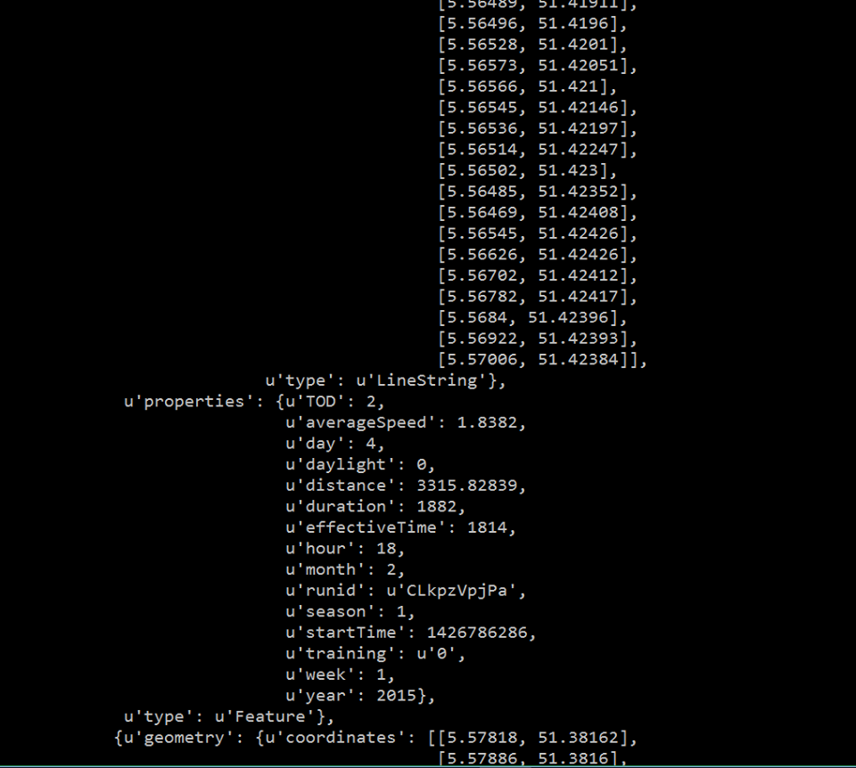

**EHV0.json**

|  |  |  |  |
| --- | --- | --- | --- |
| Main Attribute | Attribute | Meaning | Example |
| U’summary’ | U’__v’ |  | 0 |
| U’_id’ | An unique ID for the run | U’57a4ed788b2bcceb23ac0283 |
| U’averageSpeed’ | The average speed of the run | 2.457119750938434 |
| U’country’ | The country in which the run took place | U’BE’ (Belgium) |
| U’distance’ | The distance of the run in meters | 5159.951541704152 |
| U’duration’ | The total duration of the run in either minutes or seconds | 2101 = 21,01 minutes  2101 seconds |
| U’effectiveTime’ | The effective running time (stationary time left out?) in either minutes or seconds | 2101 = 21,01 minutes  2101 seconds |
| U’lat’ | The latitude coordinate of the starting point | 51.416267333600125 |
| U’lon’ | The longitude coordinate of the starting point | 5.384172583003886 |
| U’points’ |  | 4 |
| U’runid’ | An unique ID for the run (same format as in the geojson file) | U’CETFOsGzTq’ |
| U’startTime’ | The start time of the run (?) | 1450118403 |
| U’training’ | Another unique ID for the run (?) | U’gQr1YktTcM’ |
| U’trail’ | U’trail’ | List of x and y coordinates in WGS1984 | [[5.38417, 51.41627],  [5.38429, 51.41643]] |

{u’summary’: {attribute1: value1,

Attribute2: value2},

u’trail’: [[x,y],

[x,y],

[etc.]]},

