Housing Market Analysis in Hungary
A policy-relevant data analysis portfolio project

Prepared for a data analyst / policy-oriented portfolio
Built exclusively from official KSH and MNB publications

What the project shows | Why it matters
Housing prices re-accelerated after the 2023 slowdown. | Shows that the market is still in a strong cyclical phase, not a one-off spike.
Demand recovered, but unevenly across cities and regions. | A good entry point for policy and market segmentation analysis.
Supply stayed weak: completions and permits fell in 2024. | Supports the narrative of structural imbalance.
Wages grew, but prices still outpaced them and MNB estimated overvaluation. | Adds an affordability and policy dimension, which is useful for think-tank or public-policy paths.

Executive summary
- Using official KSH and MNB releases, the project shows that Hungarian housing prices fell back in 2023 but re-accelerated in 2024 and remained elevated in early 2025.
- The demand side recovered from the 2023 slump, but activity was uneven: national transactions rose, while Budapest and county-seat sales were weaker in Q1 2025.
- Supply remained constrained. In 2024, completed dwellings fell by 29% and building permits by 27%, while the domestic housing stock renewal rate reached only 0.29%.
- Affordability worsened: average gross earnings rose by 13.2% in 2024, but MNB still estimated 14.3% overvaluation in 2024 Q4.

1. Research question and portfolio angle
Research question: how have Hungarian housing prices evolved in the last few years, and how do those changes compare with demand, supply and income growth? This is a strong portfolio topic because it combines data cleaning, descriptive analysis, macroeconomic interpretation and policy relevance.

2. Data sources and method
Only official sources were used:
- KSH housing price index releases (Q3 2022, Q4 2023, Q1 2024, Q2 2024, Q3 2024, Q1 2025).
- MNB Housing Market Report - May 2025.
- KSH Hungary 2024 annual statistical summary for earnings.
Methodology in short:
- Selected the most policy-relevant indicators from the official releases.
- Compiled them into a single project dataset.
- Compared price growth, turnover / transactions, supply-side indicators and earnings.

3. Key indicators
Indicator | Value | Period | Source
Overall housing market price growth | 5.8% y/y | 2023 | KSH Q4 2023
Overall housing market price growth | 12.5% y/y | 2025 Q1 (KSH) | KSH Q1 2025
Overall housing market price growth | 15.1% y/y | 2024 Q4 | MNB May 2025
Budapest housing price growth | 19.2% y/y | 2025 Q1 | MNB May 2025
Transactions nationwide | +7% y/y | 2025 Q1 | MNB May 2025
Completed dwellings | 13,300 (-29%) | 2024 | MNB May 2025
Building permits | 20,500 (-27%) | 2024 | MNB May 2025
Average gross earnings | HUF 646,600 (+13.2%) | 2024 | KSH Hungary 2024
Housing overvaluation | 14.3% | 2024 Q4 | MNB May 2025

4. Findings

4.1 Prices re-accelerated
KSH reported that the overall housing market price level was 5.8% higher in 2023 than a year earlier. By Q4 2024, MNB reported 15.1% annual growth nationwide, and KSH estimated 12.5% annual growth in Q1 2025.
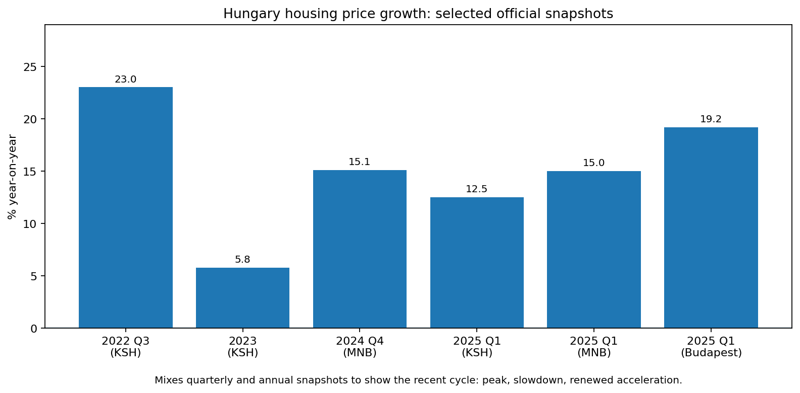
Figure 1. Selected official snapshots of Hungarian housing price growth.

4.2 Demand recovered, but in a segmented way
After the 2023 decline in turnover, sales and transactions recovered in 2024 and early 2025. MNB reported that Q1 2025 transactions were up 7% year on year nationwide, but KSH noted declines in Budapest and county seats. This is a useful pattern for a portfolio project because it shows that a single national trend can hide large regional differences.
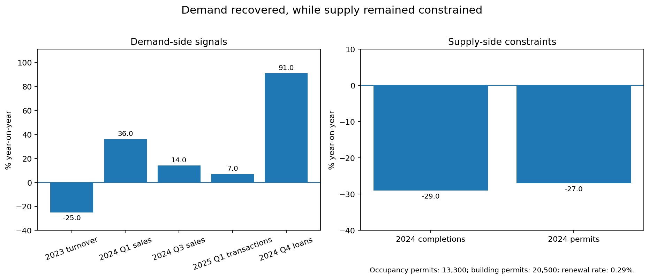
Figure 2. Demand recovered while supply stayed constrained.

4.3 Supply lagged behind demand
MNB reported 13,300 completed dwellings in 2024, down 29% from 2023, and 20,500 building permits, down 27%. The domestic housing stock renewal rate was only 0.29%, the lowest in Europe according to the report.

4.4 Affordability remained under pressure
KSH reported average gross earnings of HUF 646,600 in 2024, up 13.2% year on year, and real earnings up 9.0%. Even so, MNB estimated that housing prices exceeded the level justified by fundamentals by 14.3% in 2024 Q4.
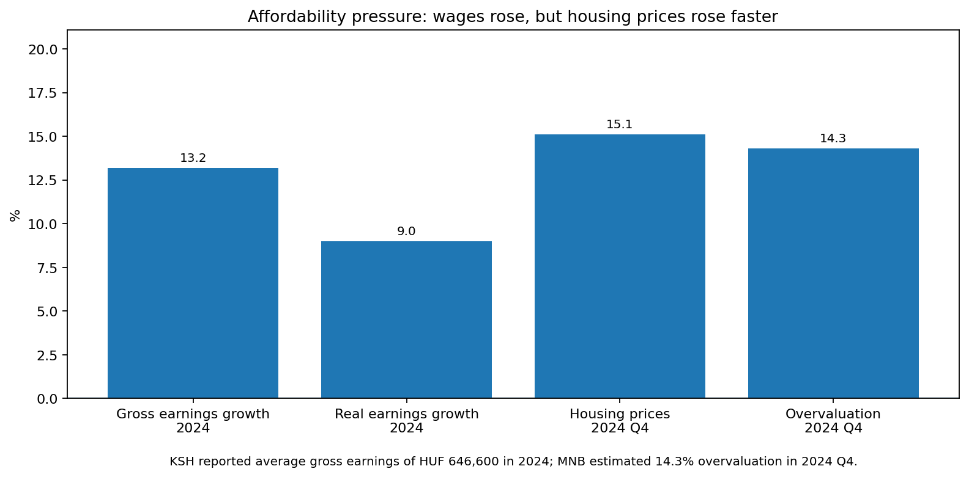
Figure 3. Wages improved, but housing prices still moved faster.

5. Interpretation
- The market is driven by a combination of recovering demand, constrained supply and still-strong affordability pressure.
- This gives the project a clear policy angle: housing is not only a market story, but also a public policy and social issue.

6. Reproducibility
The project folder also contains:
- a CSV file with the official snapshot data used in the analysis
- a Python script that regenerates the charts
- the rendered report in DOCX format

7. Official source list
- KSH - Housing prices, housing price index, Q3 2022.
- KSH - Housing prices, housing price index, Q4 2023.
- KSH - Housing prices, housing price index, Q1 2024.
- KSH - Housing prices, housing price index, Q2 2024.
- KSH - Housing prices, housing price index, Q3 2024.
- KSH - Housing prices, housing price index, Q1 2025.
- KSH - Hungary, 2024 (annual earnings).
- MNB - Housing Market Report - May 2025.

