# import pygame

# # Intialize the pygame

# pygame.init()

# #create the screen

# screen = pygame.display.set_mode((800,600))

# #Title and Icon

# pygame.display.set_caption("Call of Number War")

# icon = pygame.image.load('city-on-fire.png')

# pygame.display.set_icon(icon)

# #Game loop

# running = True

# while running:

# for event in pygame.event.get():

# if event.type == pygame.quit():

# running = False

# #RGB - Red, Green, Blue 3

# screen.fill ((255,0, 0))

# pygame.display.update()

This is as far I got with pygame. It did create the screen but I could not get the avatar and the colors to show. The icon did display,

So, I continue to make the rest of the program work. There is functionally in addAlley, DiviDucks, MultiplicationMetro, subSquare and in Menu. I will continue to work in adding the memory bank during the break and also graphics.

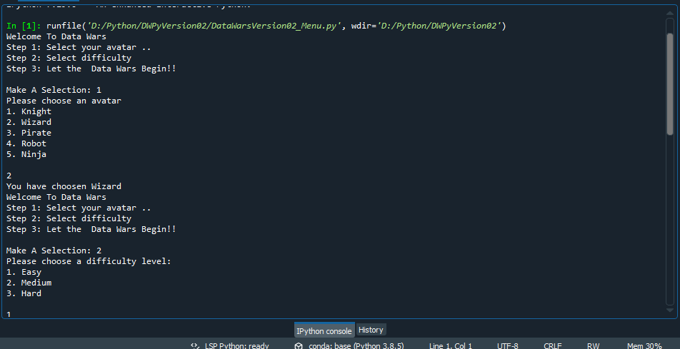

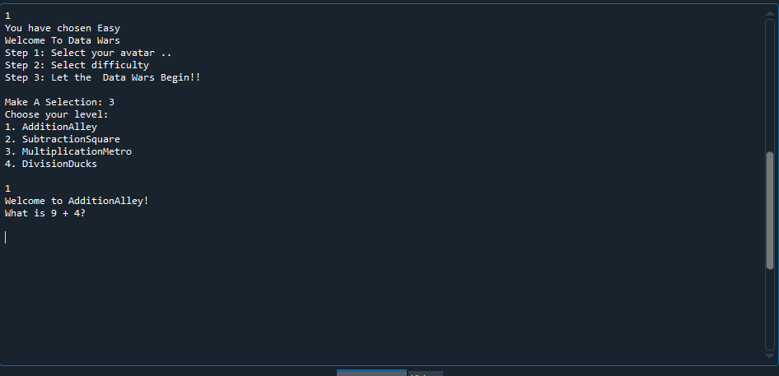

Users stories:

As a player, I want to get better pass each level of Data Wars to get better in math.

As a level designer, I want to have specific memory banks levels so the is test in each level.

As a player, I want to pass each levels theme of easy to hard.

As a level designer, I want to have a theme for each level so that player can be keep interested.

As a player, I want to be able to choose from several avatars.

