
Mana cost: For Pokémon  based on color identity, otherwise .
Power: Player’s chosen attack / 10
(ex. 30 / 10 = 3)
Toughness: HP / 10 / 2 rounded up
(ex. 150 / 10 / 2 = 7.5 = 8)
Mana card: Energy & card turned upside down based on color identity.
If a Pokémon is known to be flying, it has Flying .
Players may only have one Pokémon on the field. Players can switch to another Pokémon in their hand on their own turn.
If a player gets a Pokémon on the field some other way, they return the Pokémon already on the field to their hand.
Bench = Hand
Weakness, Resistance and Retreat are in use. Weakness- and Resistance results are rounded up.
Prize Card = Draw a card
HP → Toughness cheat sheet:
10 - 20 = 1
30 - 40 = 2
50 – 60 = 3
70 – 80 = 4
90 – 100 = 5
110 – 120 = 6
130 – 140 = 7
150 – 160 = 8
170 – 180 = 9
190 – 200 = 10

Mana cost: What it says on the card.
Power: Power / 1000 rounded up.
(ex. 1500 / 1000 = 1.5 = 2)
Toughness: Power / 1000 rounded up.
(ex. 3000 / 1000 = 3)
Mana card: Kortti käännettynä manakentälle ylösalaisin, väri-identiteetin mukaan.
Blocker = Defender 
Double Breaker = Double Strike 
Triple Breaker = Creature can attack three times
Shield Trigger = Instant  or Flash 
Slayer = Deathtouch 
Speed Attacker = Haste 

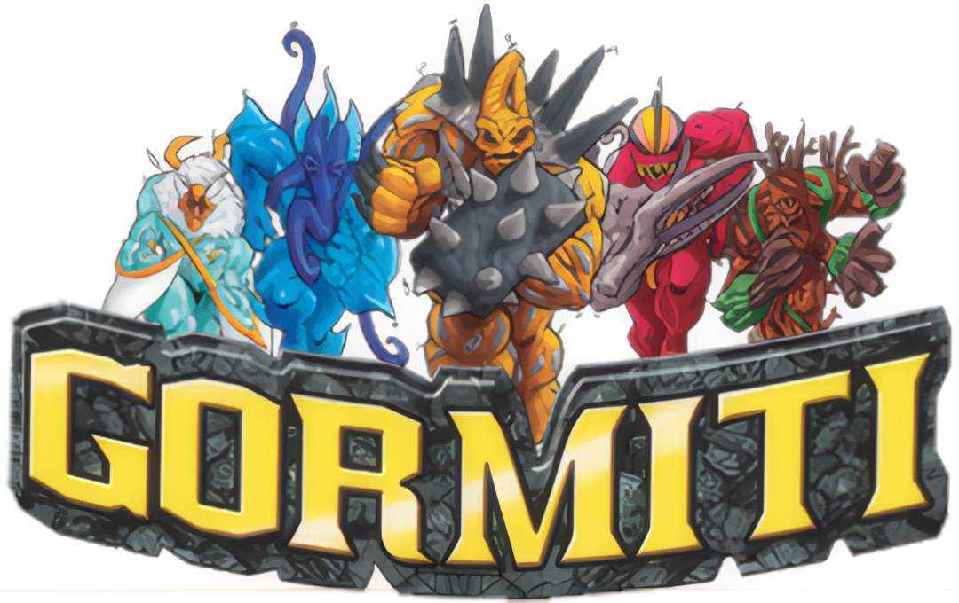
Mana cost: Power
Power: Power
Toughness: Power
Mana card: Card turned upside down based on color identity.


Mana cost: V x 
Power: M or S (higher value)
(ex. M = 4, S = 5 = 5)
Toughness: A
Mana card: Card turned upside down based on color identity.
Doomtroopers do not have a color identity, except for Brotherhood and Dark Legion. They are:
Brotherhood 
Dark Legion 
If a creatures S is higher than M, it has Reach.
All cards, except creatures mana cost is .
Promotion Points (PP) = 
Victory Points (VP) = Mana point of any color.


Mana cost: Attack + Defence / 2 rounded up.
(ex. 6 + 7 / 2 = 6.5 = 7)
Power: Attack
Toughness: Defence
Mana card: Card turned upside down based on color identity.


Mana cost: Cards Level based on color identity.
Power: ATK / 100 / 2 rounded up
(esim. 500 / 100 / 2 = 2.5 = 3)
Toughness: DEF / 100 / 2 rounded up
(esim. 2100 / 100 / 2 = 10.5 = 11)
Manakortti: Card turned upside down based on color identity.
Attribuutit per väri:
LIGHT 
DARK 
WATER 
FIRE 
WIND 
EARTH 
Defense Position can only be forced through spells, abilities etc.
Defense Position = Defender 
Trap Card = Instant 
ATK / DEF → Power / Toughness lunttilappu:
100 - 200 = 1
300 - 400 = 2
500 – 600 = 3
700 – 800 = 4
900 – 1000 = 5
1100 – 1200 = 6
1300 – 1400 = 7
1500 – 1600 = 8
1700 – 1800 = 9
1900 – 2000 = 10
Numberless / Hard to define cards
Mana cost: 
Power: 1
Toughness: 1
Mana card: Card turned upside down. Produces colorless mana.

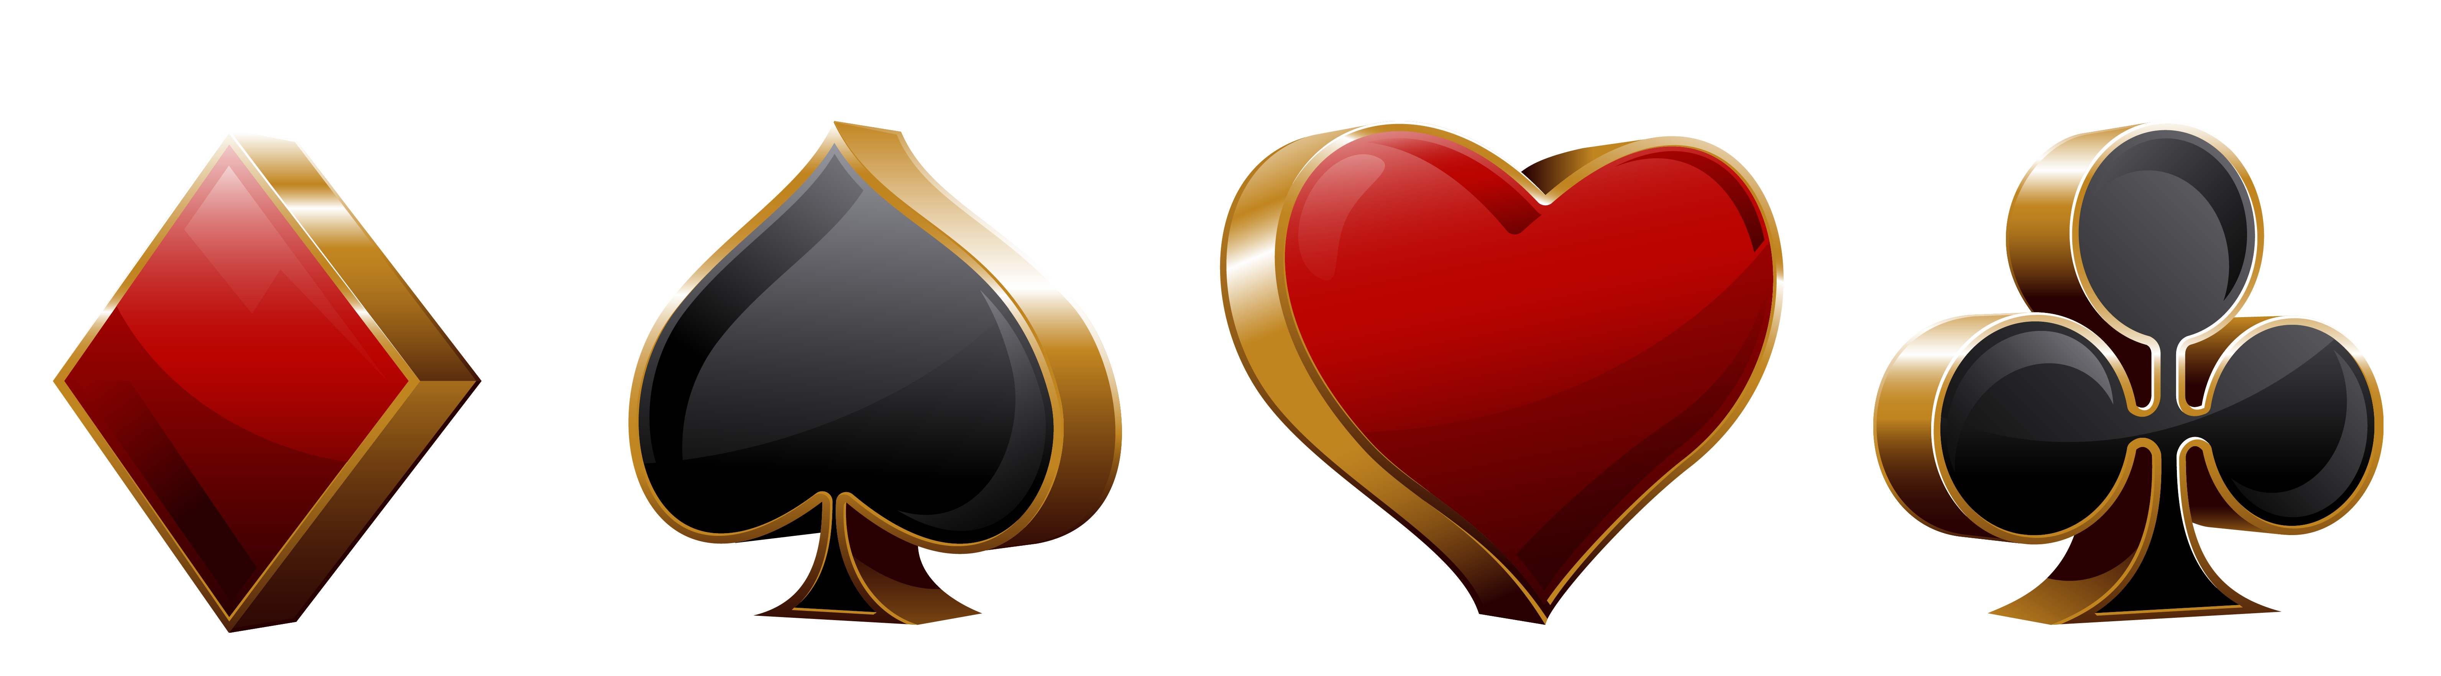
Mana cost: Card value + 1
Power: Card value
Toughness: Card value
Mana card: Card turned upside down based on color identity.
 Spade = Menace
 Club = Double Strike
 Heart = Lifelink
 Diamond = First Strike
J =  11/11
Q =  12/12
K =  13/13
A =  1/1
Joker =  Sorcery with the effect “Put target creature card from your graveyard onto the battlefield under your control. You lose life equal to its mana value.”

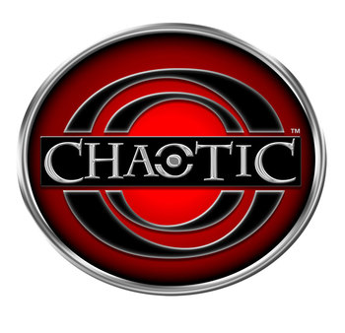
Mana cost: 2d6 
Power: Random stat value / 10 rounded up.
(ex. 95 / 10 = 9.5 = 10)
Toughness: Random stat value / 10 rounded up.
Mana card: Card turned upside down. Produces colorless mana.
When you cast a card, toss two dice (2d6). Pay the total sum with colorless mana. If you can’t or don’t want to, the card goes to the graveyard.
Cards Power and Toughness are defined by a dice toss made with a d4. Put the thrown die on top of the card as a reminder. During upkeep the die is thrown again.
1 = Wisdom
2 = Power
3 = Courage
4 = Speed
Weapon cards give Power/Toughness by taking the first two values divided by ten rounded up. If the card only has one value, it will only raise Power.
Location cards = Enchantment
Example:
Wisdom 0, Power +10,
Courage 0, Speed +5
= +1/+1

