
Mana cost: 
Power: Player’s chosen attack / 10.
(ex. 30 / 10 = 3).
Toughness: HP / 10 / 2 rounded up.
(ex. 150 / 10 / 2 = 7.5 = 8).
Mana card: Energy & card turned face down.
If a Pokémon is known to be flying, it has Flying .
Players may only have one Pokémon on the field. Players can switch to another Pokémon in their hand on their own turn.
If a player gets a Pokémon on the field some other way, they return the Pokémon already on the field to their hand.
Attach cards face down to Pokémon for Energy. Attach one per turn. Tap the cards to attack or use abilities. Mana cost is specified on the card. Tap the creature when you attack or use abilities.
Bench = Hand
Prize Card = Draw a card
Weakness, Resistance and Retreat are in use. Weakness and Resistance results are rounded up.
HP → Toughness cheat sheet:
10 - 20 = 1 110 – 120 = 6
30 - 40 = 2 130 – 140 = 7
50 – 60 = 3 150 – 160 = 8
70 – 80 = 4 170 – 180 = 9
90 – 100 = 5 190 – 200 = 10


Mana cost: What it says on the card.
Power: Power / 1000 rounded up.
(ex. 1500 / 1000 = 1.5 = 2).
Toughness: Power / 1000 rounded up.
(ex. 3000 / 1000 = 3).
Mana card: Card turned face down.
Blocker = Defender 
Double Breaker = Double Strike 
Triple Breaker = Creature can attack three times
Shield Trigger = Instant  or Flash 
Slayer = Deathtouch 
Speed Attacker = Haste 

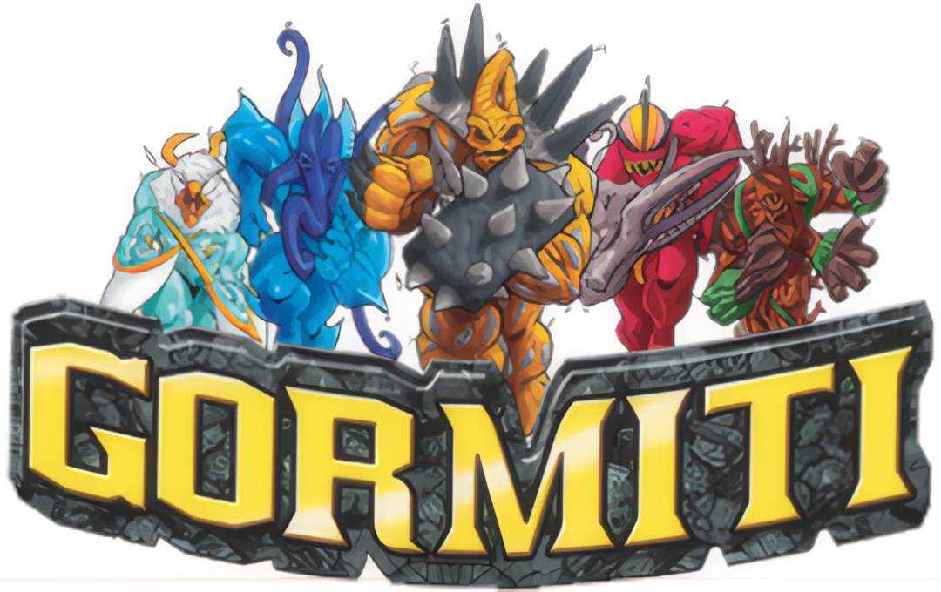
Mana cost: Power
Power: Power
Toughness: Power
Mana card: Card turned face down.


Mana cost: V x 
Power: M or S (higher value).
(ex. M = 4, S = 5 = 5).
Toughness: A.
Mana card: Card turned face down.
Personality = Legendary
Doomtroopers color identity is , except for Brotherhood and Dark Legion. They are:
Brotherhood 
Dark Legion 
If a creatures S is higher than M, it has Reach .
Weapon cards increasing S give Reach .
All cards, except creatures mana cost is .
Promotion Points (PP) = 
Victory Points (VP) = 


Mana cost: Attack + Defense / 2 rounded up.
(e.g. 6 + 7 / 2 = 6.5 = 7).
Power: Attack.
Toughness: Defense.
Mana card: Card turned face down.
Colored border = Legendary
If a creature is known to be flying, it has Flying .
 Monsters of the Past (RED)
Haste 
 Nightmares of Nature (GREEN)
Trample 
 Monsters of the Deep (BLUE) Flash 
 Toxic Terrors (PINK) Infect
 Tiny Terrors (ORANGE)
First strike 
 Strange Wonders (TEAL) Reach 
 Monsters of the Mind (PURPLE) Menace 


Mana cost: Cards Level.
Power: ATK / 100 / 2 rounded up.
(esim. 500 / 100 / 2 = 2.5 = 3).
Toughness: DEF / 100 / 2 rounded up.
(e.g. 2100 / 100 / 2 = 10.5 = 11).
Mana card: Card turned face down.
Attributes per color:
LIGHT 
WATER 
DARK 
FIRE 
WIND 
EARTH 
Defense Position can only be forced through spells, abilities etc.
Attack Position = Untapped
Defense Position = Defender 
Trap Card = Instant 
ATK / DEF → Power / Toughness cheat sheet:
100 - 200 = 1 1100 – 1200 = 6
300 - 400 = 2 1300 – 1400 = 7
500 – 600 = 3 1500 – 1600 = 8
700 – 800 = 4 1700 – 1800 = 9
900 – 1000 = 5 1900 – 2000 = 10

Numberless / Hard to define cards
Mana cost: 
Power: 1 per creature pictured.
Toughness: 1 per creature pictured.
Mana card: Card turned face down.
Cards with no creatures are  Artifact cards with the ability: “, Discard this card: Add .”

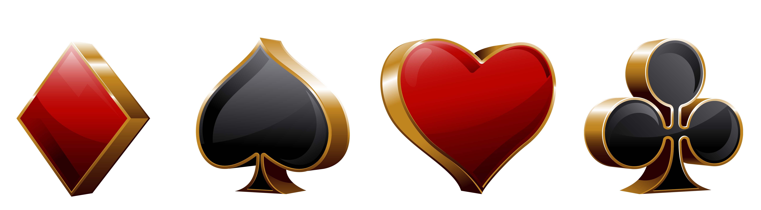
Mana cost: Card value.
Power: Card value.
Toughness: Card value.
Mana card: Card turned face down.
 Spade = Menace 
 Club = Double Strike 
 Heart = Lifelink 
 Diamond = First Strike 
J =  11/11
Q =  12/12
K =  13/13
A =  1/1
Joker =  Sorcery with the effect “Put target creature card from your graveyard onto the battlefield under your control. You lose life equal to its mana value.”

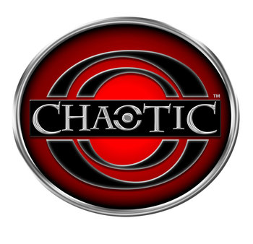
Mana cost: 2d6 
Power: Random stat value / 10 rounded up.
(ex. 95 / 10 = 9.5 = 10)
Toughness: Random stat value / 10 rounded up.
Mana card: Location cards. Other cards turned face down.
When you cast a card, toss two dice (2d6). Pay the total sum with mana. If you can’t or don’t want to, the card goes to the graveyard.
Creatures Power and Toughness are defined by a dice toss made with a d4. Put the thrown die on top of the card as a reminder. During upkeep the die is thrown again.
1 = Wisdom
2 = Power
3 = Courage
4 = Speed
Weapon cards give Power/Toughness by taking the first two values divided by ten rounded up. If the card only has one value, it will only raise Power.
Example:
Wisdom 0, Power +10,
Courage 0, Speed +5
= +1/+1


Mana cost: Destiny score
(top right number).
Power: Strength score
(left side number).
Toughness: Strength score.
Mana card: Card turned face down.
PC = Legendary Creature
Log out = Return to the bottom of the deck
Bottom left symbol determines color. They are as follows:
EARTH 
WATER 
THUNDER 
FIRE 
WOOD 
If there is no symbol, the card is colorless.

Mana cost: Top left number.
Power: Power (left side number).
Toughness: Power.
Mana card: Resource and card turned face down.
Unique = Legendary 
Resource = Mana
All cards are classified as colorless.


Mana cost: Top left number.
Power: Power (left side number).
Toughness: Power.
Mana card: Resource and card turned face down.
Unique = Legendary 
Resource = Mana
All cards are classified as colorless.
SPELLFIRE
Mana cost: Level (top left number).
Power: Level.
Toughness: Level.
Mana card: Realm and card turned face down.
Ally = Humanoid creature
Monster = Non-humanoid creature
Realm = Land
Level = Power/Toughness
Razed = Land tapped
Realm cards act as shields, what opponents must attack first before the player. They are still put in the mana zone. You cannot attack with them and you can’t defend with them if they are tapped.
They are 1/1 Lands.
If the card says that they can cast certain spells, for example Wizard spells, you can cast Wizard creatures from your hand for no cost.

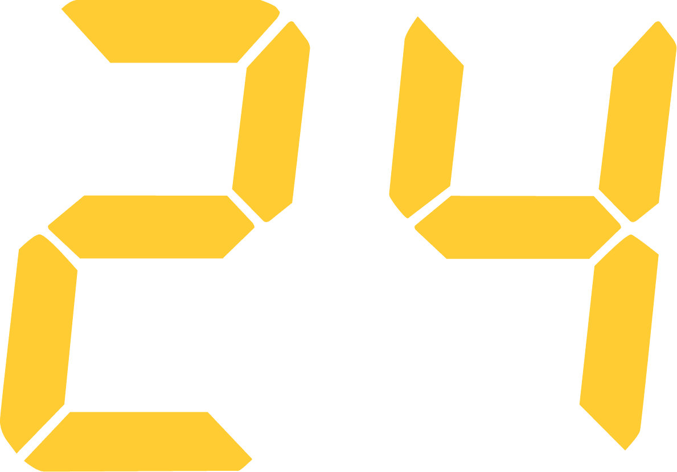
Mana cost: Top left number.
Power: Combat, Intelligence etc.
Toughness: Health.
Mana card: Card turned face down.
Agenda = Enchantment 
Briefing room = Hand
Heal = Remove enchantments and counters
Wound = -1/-1 Counter
Lethal = Deathtouch 
Focused = Remove one Time counter 
Expert = Draw a card
Adept = First strike 
Unique = Legendary 
Agenda cards are cards, that progress each turn. You cast it with its highest turn number face up. Turn the card 90 degrees during upkeep. When it’s turned to the last number, the cards effect activates.
When you cast a card from your hand, take a card from the communal deck and put it into exile. Then put Time counters on the exiled card denoted by the number on the bottom right. Remove a Time counter during upkeep. When there are no Time counters, cast the card for no cost.
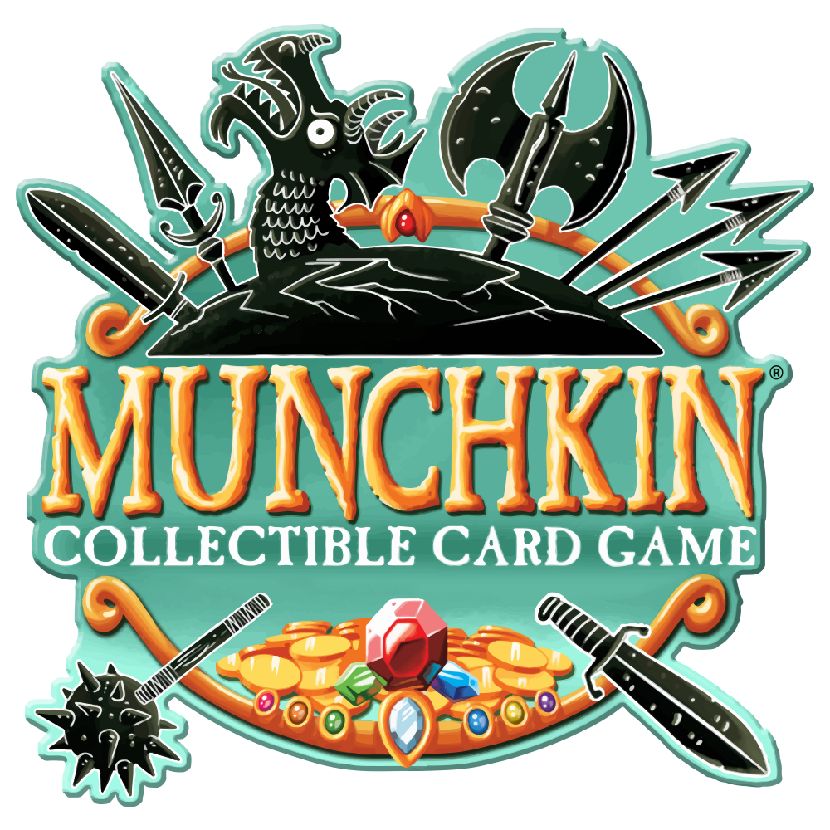
Mana cost: Top left number.
Power: Bottom left number.
Toughness: Bottom right number.
Mana card: Card turned face down.
Hero = Player
Ally & Monster = Creature 
Location = Land 
Bleeding = Taken damage
Loot = Artifact 
Squish = Destroy
Zap = Tap
Mischief = Sorcery  or Enchantment , depending on effect.

