

Have you always wanted to play Magic: The Gathering, but there weren’t enough Pikachus, Billion Degree Dragons or Pot of Greeds? Now it’s possible, playing SALTYBOX!

SALTYBOX is a card game, where you can use any cards to play. Any cards. If it is a piece of cardboard about the size of an average playing card, that is enough. In this document are the rules of the game. This manual assumes you know the rules of Magic: The Gathering, but it is not necessary to get started. Counting skills are also recommended.

Basic rules

Player count: 2-8

Every player should have:
- 40 card deck
- 2 10-sided die (2d10) or some other method of keeping track of their health

Other supplements include:
- Role playing die set (d4, d6, d8, d10, d12, d20)
- Dice for Counters
- Extra pieces of paper for tokens
- Pen

The game has a communal deck, where anyone can draw cards. This decks size does not have a limit. You may only draw one card from this deck per turn, but the player must summon it without paying it’s mana cost or cast it as a shield.

Every player will take the top 40 cards from the communal deck. Set starting health to 40.

Players throw two dice. Person with the highest value starts. Order of play goes clockwise. Every player must have 7 cards in their hand at the beginning of their turn. Cards are drawn from the players own deck.

Every card can be used as a mana card in addition to the games own mana cards. The card is cast on the mana field upside down.
Players turn

1. Starting phase
- Untap
- Upkeep
- Draw cards, until you have 7 cards in your hand.
- Draw and cast a card from the communal deck as a spell or a shield.

2. First main phase
- Cast a mana card.
- Summon creatures.
- Cast equipment.
- Cast spells.
- Activate creature abilities.

3. Combat phase
- Declare attackers.
- Opponent(s) declare defenders.
- Solve damage.

4. Second main phase
- Cast a mana card (if you haven’t yet).
- Draw and cast a card from the communal deck as a spell or a shield (if you haven’t yet).
- Summon creatures.
- Cast equipment.
- Cast spells.
- Activate creature abilities.

5. End phase
- Remove cards from your hand, until you have 7 cards.
- Remove “end of turn” effects.

Graveyard (GY) is an area where perished creatures and used spell cards are put. Exile is an area, where cards removed from the game are put.
Shields are 0/1 Shield cards, that players must attack before the opponent. They are cast above creatures face down. After they’re destroyed, move them to the owners graveyard.
Card info
Mana cost: How much mana is needed to cast the card.
Power: Creatures attack value.
Toughness: Creatures defence value.
Creature type: For example Human, Goblin, Warrior etc.
Rules box: Text field where it tells the cards abilities, when they activate and what keywords (ex. Flying, Double Strike, Indestructible etc.) the card has.
Colors: What color/colors the card represents, ex. , ,  etc.
Mana card: What cards represent mana, ex. Magic: The Gathering has Lands.
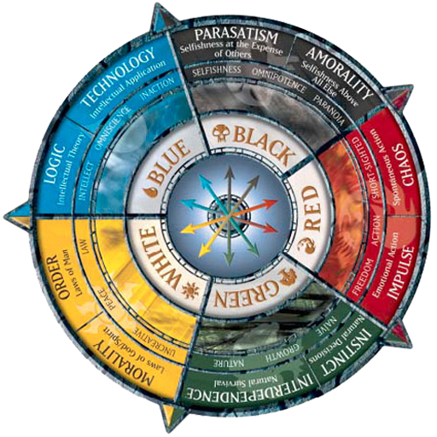
Colors
 Blue
 Black
 Red
 Green
 White
 Colorless

Keywords
DEATHTOUCH 
Damage done by the source destroys the creature instantly.
DEFENDER 
Creature can’t attack.
DOUBLE STRIKE 
Creature can attack twice per turn.
FIRST STRIKE 
Creature does damage before an opponent who does not have First Strike.
FLASH 
Creature can be cast at any time.
FLYING 
Creature can’t be defended, unless the defender has Flying or Reach.
HASTE 
Creature can attack on the same turn it was cast.
HEXPROOF 
Creature can’t be targeted by spells.
INDESTRUCTIBLE 
Creature cannot be destroyed.
LIFELINK 
Damage caused by the creature is turned to the owners life points.
MENACE 
Creature must be blocked by two or more creatures.
REACH 
Creature can defend from Flying creatures.
TRAMPLE 
Extra dmg done by the creature is transferred to the defending creatures owner.
VIGILANCE 
Creature does not tap when attacking.
WARD 
Creature can defend from spells for a mana cost.
How do I make rules for
other card games?
Saltybox is a modular game system. You can make rules for any card games. Here are some tips on how you can write your own rules.
Mana cost
Defining mana cost is pretty simple. If the card a cost to cast it, then use that. If it does not, you can have them cost  or the creatures power, if it seems overpowered to be so cheap.
Power
Creatures Power can be what it says on the card. If the power is in the tens, hundreds or thousands however, you must start dividing. General rule of thumb is to aim for 10 or higher being the high end of the power scale.
Toughness
Same deal as with Power. If the card doesn’t have a number denoting health, use Power also.
Creature type
Pretty straightforward. If the card denotes a creature type, use that. If not, use common sense.
Rules box
These you should try and follow to the best of your abilities. To allow synergization between cards, use keywords to define abilities. On the previous page are some of the most common keywords used in Magic. If the card game has its own keywords, replace them with the previously shown accordingly.
Colors
Other card games colors can be translated to Magics 5-color system by selecting the closest color/colors.
For example yellow = , purple = 
Mana card
Essentially resource cards. If the game uses resource cards to cast cards, they are counted as mana cards, or Lands. If the game doesn’t have them, use any cards as mana as previously told.

Try and use the original games rules as inspiration for gameplay! Keep it simple and make it sensible for Magic’s format.

