
Mana cost: 
Power: Player’s chosen attack / 10
(ex. 30 / 10 = 3)
Toughness: HP / 10 / 2 rounded up
(ex. 150 / 10 / 2 = 7.5 = 8)
Mana card: Energy & card turned upside down.
If a Pokémon is known to be flying, it has Flying .
Players may only have one Pokémon on the field. Players can switch to another Pokémon in their hand on their own turn.
If a player gets a Pokémon on the field some other way, they return the Pokémon already on the field to their hand.
Attach cards to Pokémon for Energy. Attach one per turn. Tap the cards to attack or use abilities. Mana cost is specified on the card.
Bench = Hand
Weakness, Resistance and Retreat are in use. Weakness- and Resistance results are rounded up.
Prize Card = Draw a card
HP → Toughness cheat sheet:
10 - 20 = 1 110 – 120 = 6
30 - 40 = 2 130 – 140 = 7
50 – 60 = 3 150 – 160 = 8
70 – 80 = 4 170 – 180 = 9
90 – 100 = 5 190 – 200 = 10


Mana cost: What it says on the card.
Power: Power / 1000 rounded up.
(ex. 1500 / 1000 = 1.5 = 2)
Toughness: Power / 1000 rounded up.
(ex. 3000 / 1000 = 3)
Mana card: Card turned upside down.
Blocker = Defender 
Double Breaker = Double Strike 
Triple Breaker = Creature can attack three times
Shield Trigger = Instant  or Flash 
Slayer = Deathtouch 
Speed Attacker = Haste 

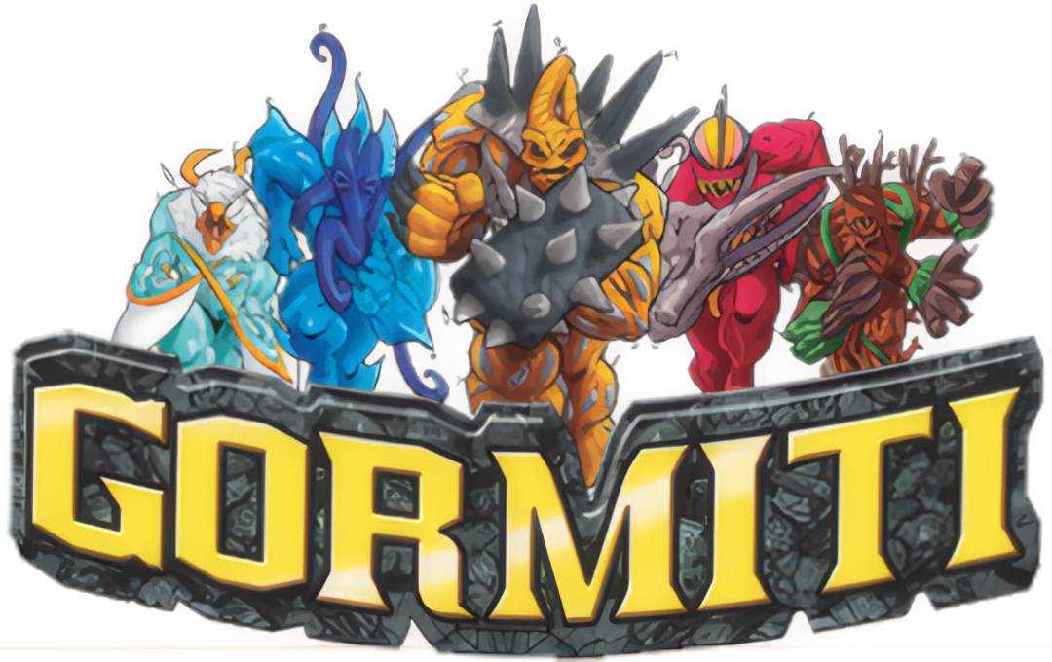
Mana cost: Power
Power: Power
Toughness: Power
Mana card: Card turned upside down.


Mana cost: V x 
Power: M or S (higher value)
(ex. M = 4, S = 5 = 5)
Toughness: A
Mana card: Card turned upside down.
Personality = Legendary
Doomtroopers do not have a color identity, except for Brotherhood and Dark Legion. They are:
Brotherhood 
Dark Legion 
If a creatures S is higher than M, it has Reach .
Weapon cards increasing S give Reach .
All cards, except creatures mana cost is .
Promotion Points (PP) = 
Victory Points (VP) = 


Mana cost: Attack + Defence / 2 rounded up.
(ex. 6 + 7 / 2 = 6.5 = 7)
Power: Attack
Toughness: Defence
Mana card: Card turned upside down based on color identity.
Colored border = Legendary

Monsters of the Past  Trample 
Nightmares of Nature  Reach 
Toxic Terrors  Toxic 1 
Monsters of the Deep  Flash 
Tiny Terrors  First strike 
Strange Wonders  Vigilance 
Monsters of the Mind  Menace 


Mana cost: Cards Level.
Power: ATK / 100 / 2 rounded up
(esim. 500 / 100 / 2 = 2.5 = 3)
Toughness: DEF / 100 / 2 rounded up
(esim. 2100 / 100 / 2 = 10.5 = 11)
Mana card: Card turned upside down based on color identity.
Attributes per color:
LIGHT 
DARK 
WATER 
FIRE 
WIND 
EARTH 
Defense Position can only be forced through spells, abilities etc.
Defense Position = Defender 
Trap Card = Instant 
ATK / DEF → Power / Toughness cheat sheet:
100 - 200 = 1 1100 – 1200 = 6
300 - 400 = 2 1300 – 1400 = 7
500 – 600 = 3 1500 – 1600 = 8
700 – 800 = 4 1700 – 1800 = 9
900 – 1000 = 5 1900 – 2000 = 10
Numberless / Hard to define cards
Mana cost: 
Power: 1 per creature
Toughness: 1 per creature
Mana card: Card turned upside down.
Cards with no creatures are  Artifact cards with the ability: “, Discard this card: Add .”

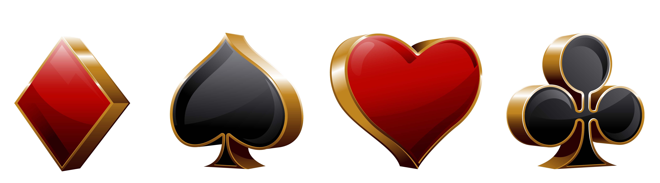
Mana cost: Card value + 1 
Power: Card value
Toughness: Card value
Mana card: Card turned upside down.
 Spade = Menace
 Club = Double Strike
 Heart = Lifelink
 Diamond = First Strike
J =  11/11
Q =  12/12
K =  13/13
A =  1/1
Joker =  Sorcery with the effect “Put target creature card from your graveyard onto the battlefield under your control. You lose life equal to its mana value.”

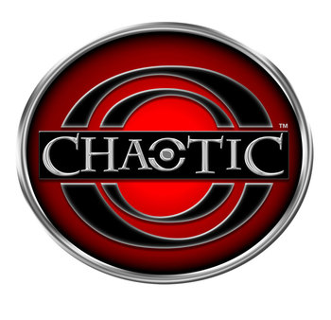
Mana cost: 2d6 
Power: Random stat value / 10 rounded up.
(ex. 95 / 10 = 9.5 = 10)
Toughness: Random stat value / 10 rounded up.
Mana card: Location cards. Other cards turned upside down.
When you cast a card, toss two dice (2d6). Pay the total sum with mana. If you can’t or don’t want to, the card goes to the graveyard.
Cards Power and Toughness are defined by a dice toss made with a d4. Put the thrown die on top of the card as a reminder. During upkeep the die is thrown again.
1 = Wisdom
2 = Power
3 = Courage
4 = Speed
Weapon cards give Power/Toughness by taking the first two values divided by ten rounded up. If the card only has one value, it will only raise Power.
Example:
Wisdom 0, Power +10,
Courage 0, Speed +5
= +1/+1

