# Elasticsearch-Filebeat-Kibana stack to monitor Nginx logs

## Contents
- Nginx: containing build image nginx web server
- Elasticsearch: containing build image and configuration for Elasticsearch
- Filebeat: containing build image and configuration for Filebeat to stream nginx logs Elasticsearch
- Kibana: containing build image and configure for Kibana to visualize data from an Elasticsearch index

## How it works

- Nginx access and error logs are written to a directory. The directory is mapped to a local volume.
- Filebeat reads the nginx logs from the local volume and sends it to an Elasticsearch index [filebeat-*].
- Kibana uses the index to visualize the access and the error logs.

## How to run it

Pre-requisites
```bash
- docker
- docker-compose
```

To run this stack, run the following command

```bash
docker-compose up -d
```

Accessing the components :

nginx : `http://localhost`

Kibana : `http://localhost:5601`

Kibana credentials :
- Username: elastic
- Password: changeme%

Step 1 :- Nginx image build-up and configuration :-
Nginx Dockerfile :-

FROM nginx:latest

COPY nginx.conf /etc/nginx/nginx.conf

COPY html/ /usr/share/nginx/html/

EXPOSE 80

Nginx.conf file :-
events {}

http {

access_log /var/log/nginx/access.log;
error_log /var/log/nginx/error.log;

server {
listen 80;

location / {
root /usr/share/nginx/html;
index index.html;
}
}
}

Index.html :-

<!DOCTYPE html>
<html>
<head>
<title>EFK Stack</title>
</head>
<body>
<h1>Nginx Logging with EFK Stack</h1>
</body>
</html>

Step 2 :- Elasticsearch image build-up and configuration :-

Elasticsearch Dockerfile :-

FROM docker.elastic.co/elasticsearch/elasticsearch:8.12.0

COPY elasticsearch.yml /usr/share/elasticsearch/config/elasticsearch.yml

Elasticsearch.yml file :-

cluster.name: efk-cluster

network.host: 0.0.0.0

discovery.type: single-node

xpack.security.enabled: false

Step 3 :- Filebeat image build-up and configuration :-

Filebeat Dockerfile :-

FROM docker.elastic.co/beats/filebeat:8.12.0

COPY filebeat.yml /usr/share/filebeat/filebeat.yml

USER root

RUN chmod go-w /usr/share/filebeat/filebeat.yml

Filebeat.yml file :-

filebeat.inputs:
- type: log
enabled: true
paths:
- /var/log/nginx/access.log
- /var/log/nginx/error.log

output.elasticsearch:
hosts: ["http://elasticsearch:9200"]
username: elastic
password: 12345678

setup.kibana:
host: "kibana:5601"

Step 4 :- Kibana image build-up and configuration

Kibana Dockerfile :-

FROM docker.elastic.co/kibana/kibana:8.12.0

COPY kibana.yml /usr/share/kibana/config/kibana.yml

Kibana.yml :-
server.host: "0.0.0.0"

elasticsearch.hosts: ["http://elasticsearch:9200"]

Step 5 :- Creating an docker compose file for building up images and containers of services such as elasticsearch, nginx, kibana :-

Docker-compose.yml :-

version: '3.8'

services:

nginx:
build: ./nginx
container_name: nginx

ports:
- "8080:80"

volumes:
- ./logs:/var/log/nginx

depends_on:
- elasticsearch

elasticsearch:
build: ./elasticsearch
container_name: elasticsearch

environment:
- discovery.type=single-node
- ES_JAVA_OPTS=-Xms512m -Xmx512m

ports:
- "9200:9200"

kibana:
build: ./kibana
container_name: kibana

ports:
- "5601:5601"

depends_on:
- elasticsearch

filebeat:
build: ./filebeat
container_name: filebeat

user: root

volumes:
- ./logs:/var/log/nginx

depends_on:
- elasticsearch
- nginx

Step 6 :- After setting up the docker-compose.yml file now running this file through terminal by executing the command “ docker compose up –build -d “

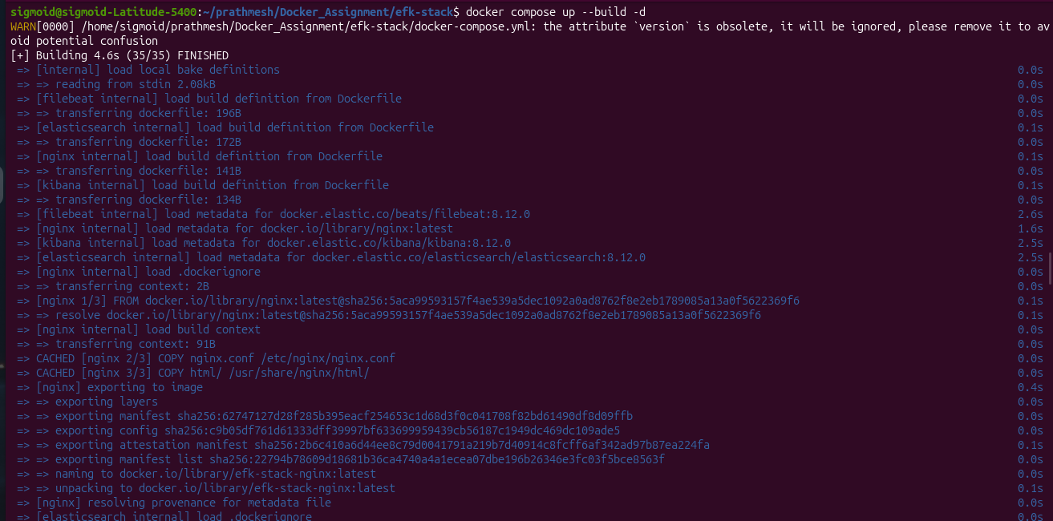
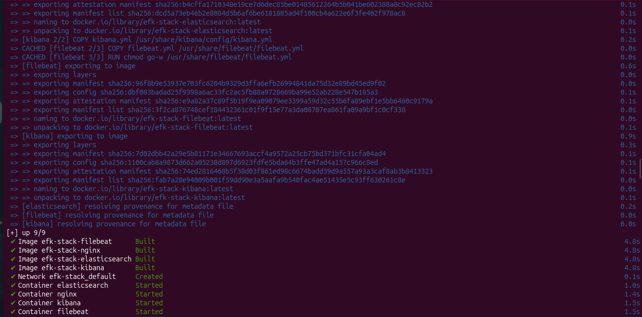

Step 7 :- After creation of images and containers checking it up whether it has created images and running containers or not :-
docker images and docker ps -a
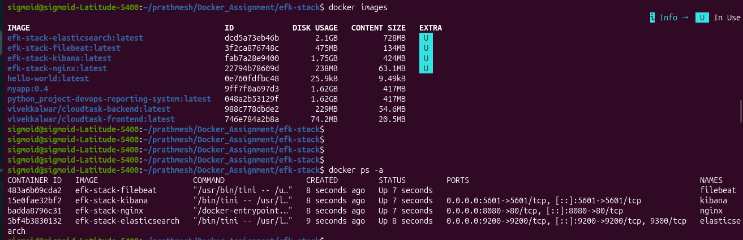

Step 8 :- Accessing those service through internet browser from the mentioned ports such as :-
Nginx server :- Localhost:8080 :-

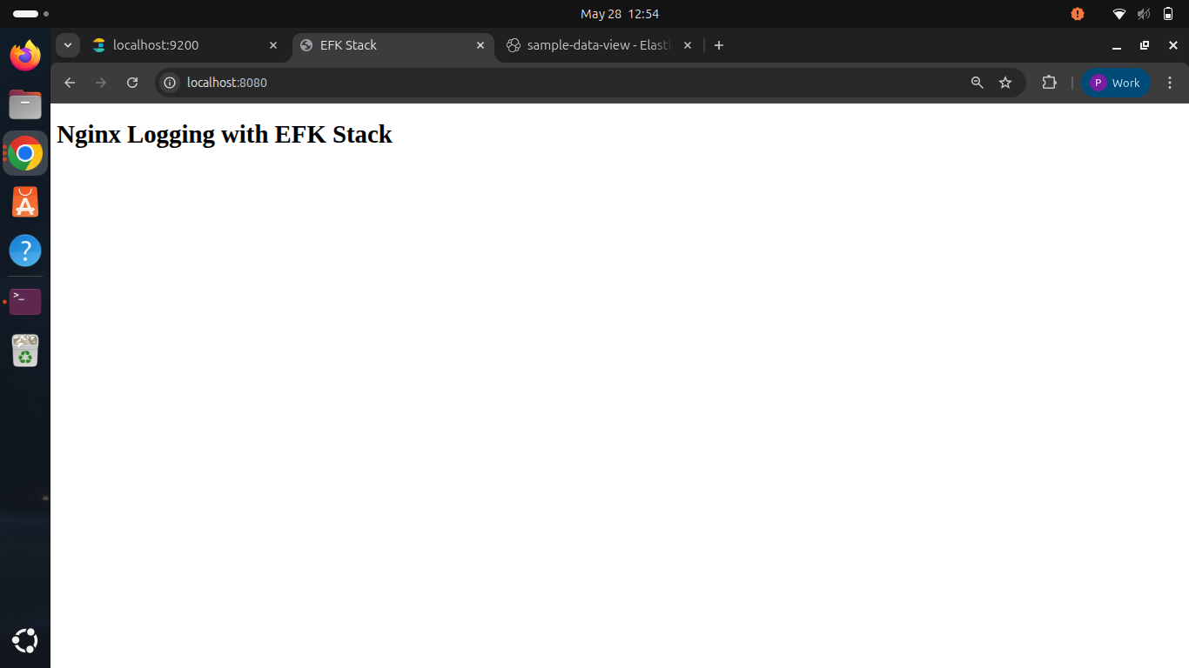

Elasticsearch :- localhost:9200

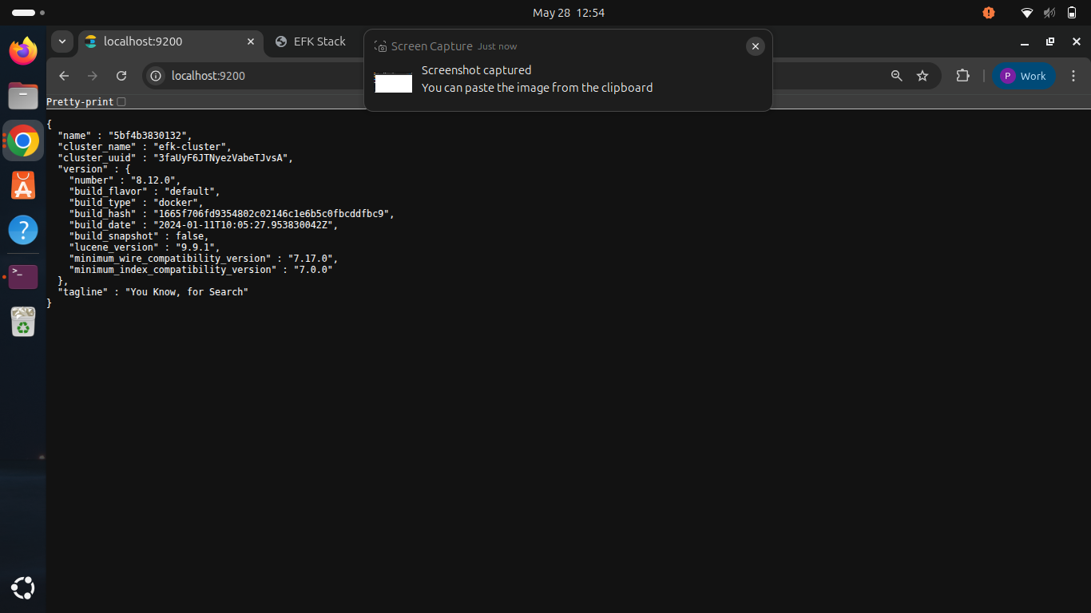

Kibana :- lcoalhost:5601

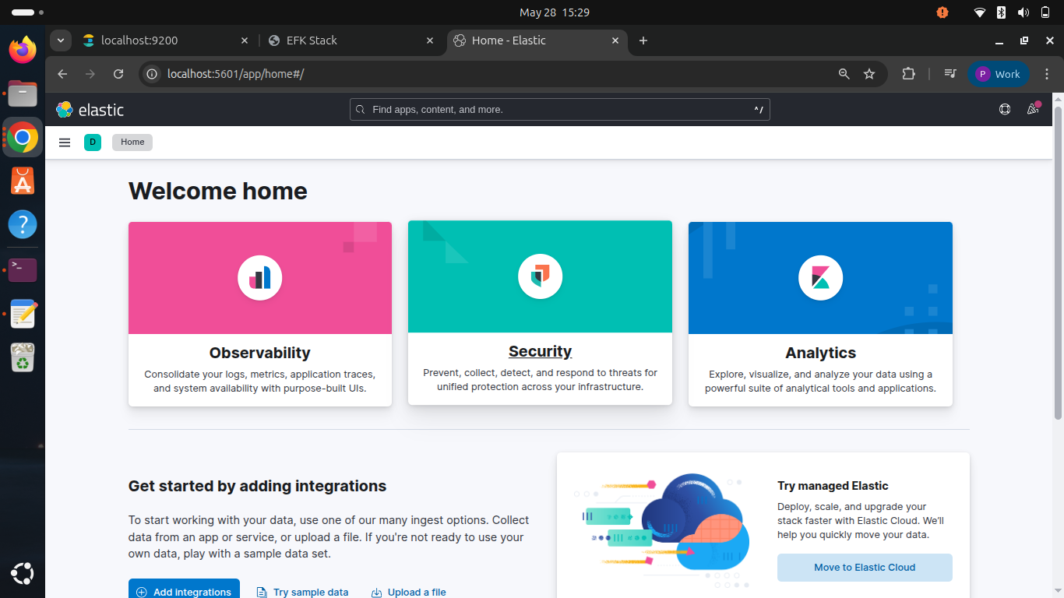

Step 9 :- Creating a dataview through elasticsearch where filebeat will reads the nginx logs from the local volume and sends it to an Elasticsearch index [filebeat-*] and Kibana uses the index to visualize the access and the error logs.

Creating dataview :- Management → Stack Management → Index Patterns

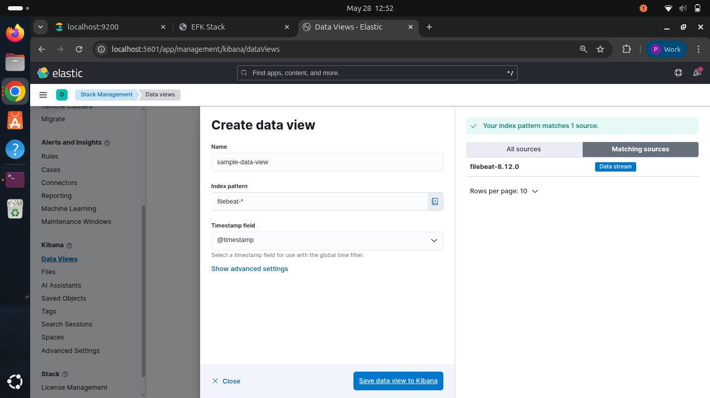

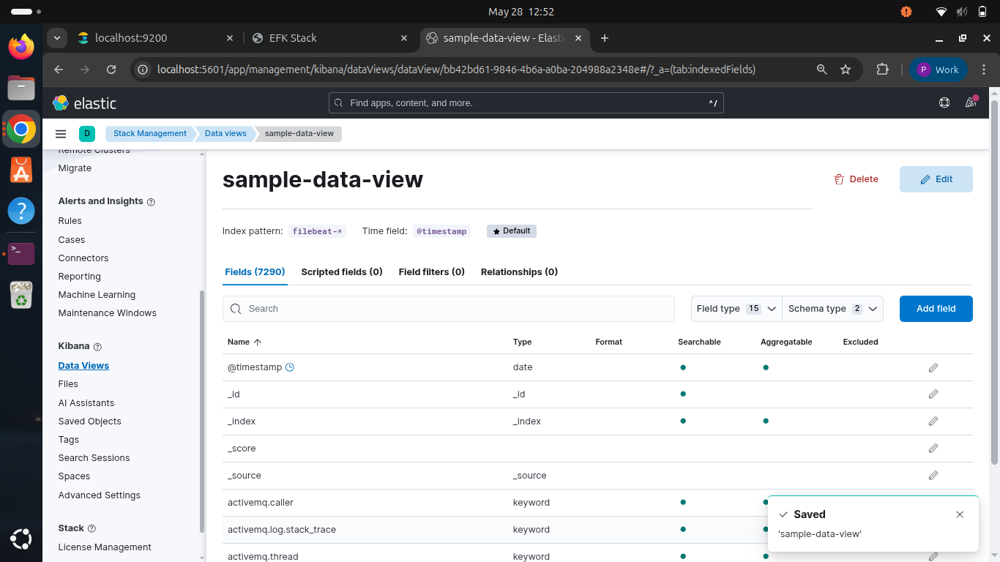
After creating data view of index pattern filebeat* it will be now showing all the access and error logs in the discover section.
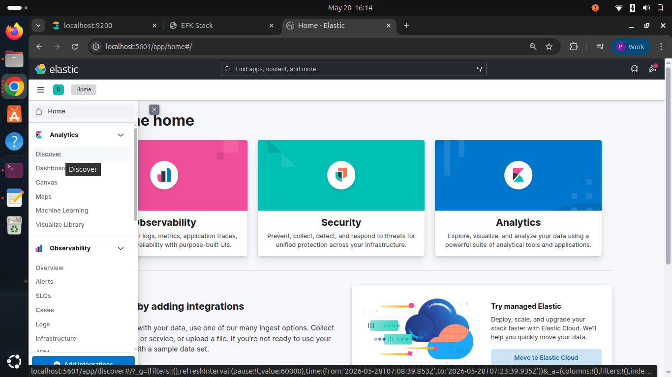

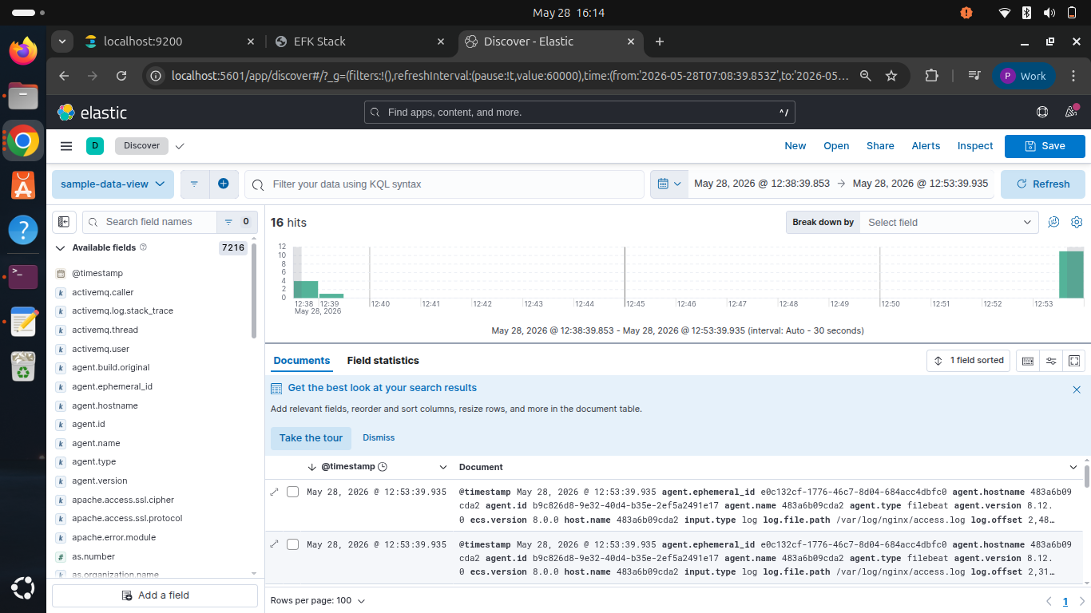

To visualize any yield just hover on the filed for example timestamp you will get option to visualise it :-
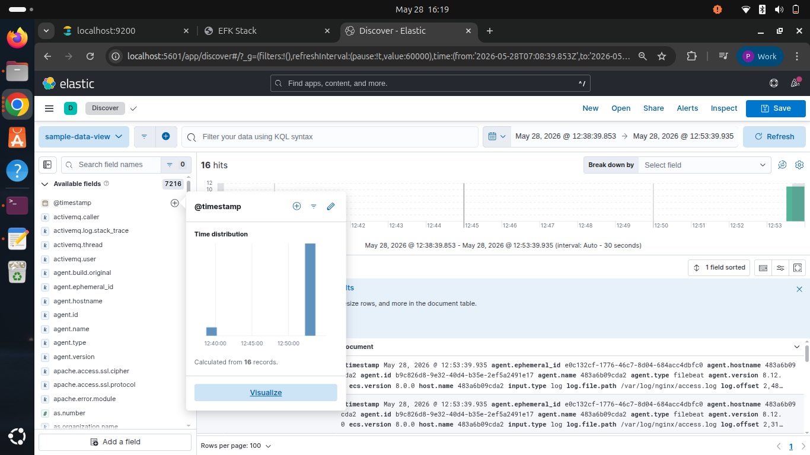

After clicking to visualise it will give a details visualation about it :-

