Medical Image Encryption by Content-Aware DNA Computing for Secure Healthcare

In medical field all patient’s data like text or images (MRI, visual investigations) must be secure and easy to process as physicians are not technicians to apply heavy computation encryption algorithms to secure medical data. So they need more secure and less complicated algorithms for patient data security. In past many security algorithms were introduced such as AES, DES and many more but those algorithms are easy to hack and does not support random permutation or encodings. According to author images encrypted via Random number permutation are more secure as it’s difficult for the hackers to guess Random numbers to properly decode images.

In propose paper author generating PWLCM random value by applying SHA algorithm and then encoding images using DNA encoding which will encode each pixel values based on DNA rules. Each pixel will be divided between ACGT DNA encoding as each character has unique binary values like A is represented from 00 to 11 and C represents between 01 to 10 and if image pixel value falls between any DNA rules then that pixel will get replace with either A or C or G or T.

After DNA encoding we will apply XOR operations on all DNA encoding with public key to encrypt images. Encrypted image will be send to user with public key and by applying reverse operations Receiver can decrypt the image.

After encrypting image we will calculate correlation between plain and encrypted images and if correlation value closer to 0 then encrypted image has no similarity to original image so more security will get. If both plain and encrypted images has correlation 1 then both images are similar and easy to hack. So by applying propose algorithm we can encrypted images with more dissimilarity so hacker cannot guess or decrypt.

This paper proposes a novel content-aware deoxyribonucleic acid (DNA) computing system to encrypt medical images, thus guaranteeing privacy and promoting secure healthcare environment. The proposed system consists of sender and receiver to perform tasks of encryption and decryption, respectively, where both contain the same structure design, but perform opposite operations. In either sender or receiver, we design a randomly DNA encoding and a content-aware permutation and diffusion module. Considering introducing random mechanism to increase difficulty of cracking, the former module builds a random encryption rule selector in DNA encoding process by randomly mapping quantity of medical image pixels to outputs. Meanwhile, the latter module constructs a permutation sequence, which not only encodes information of pixel values, but also involves redundant correlation between adjacent pixels located in a patch. Such design brings awareness property of medical image content to greatly increase complexity in cracking by embedding semantically information for encryption.

In below screen we are showing code which will convert images to DNA encoding rules

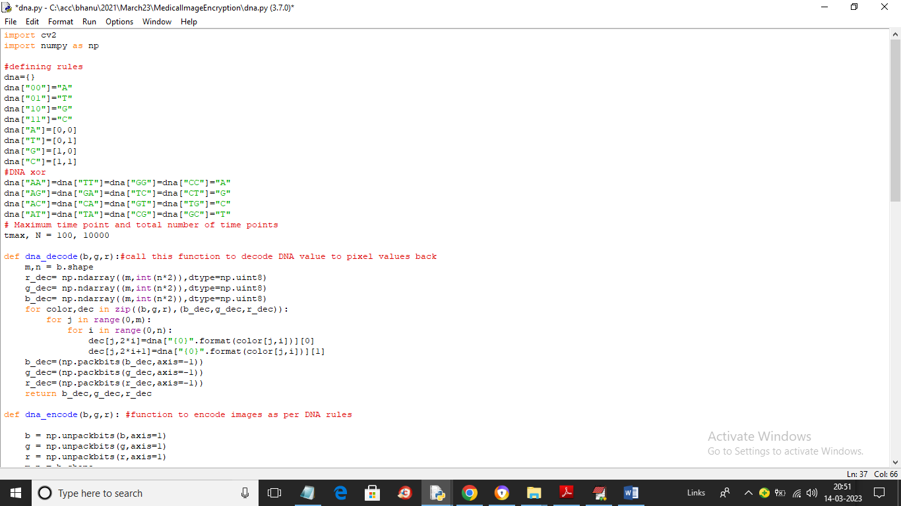

In above screen read red colour comments to know about DNA encoding and decoding

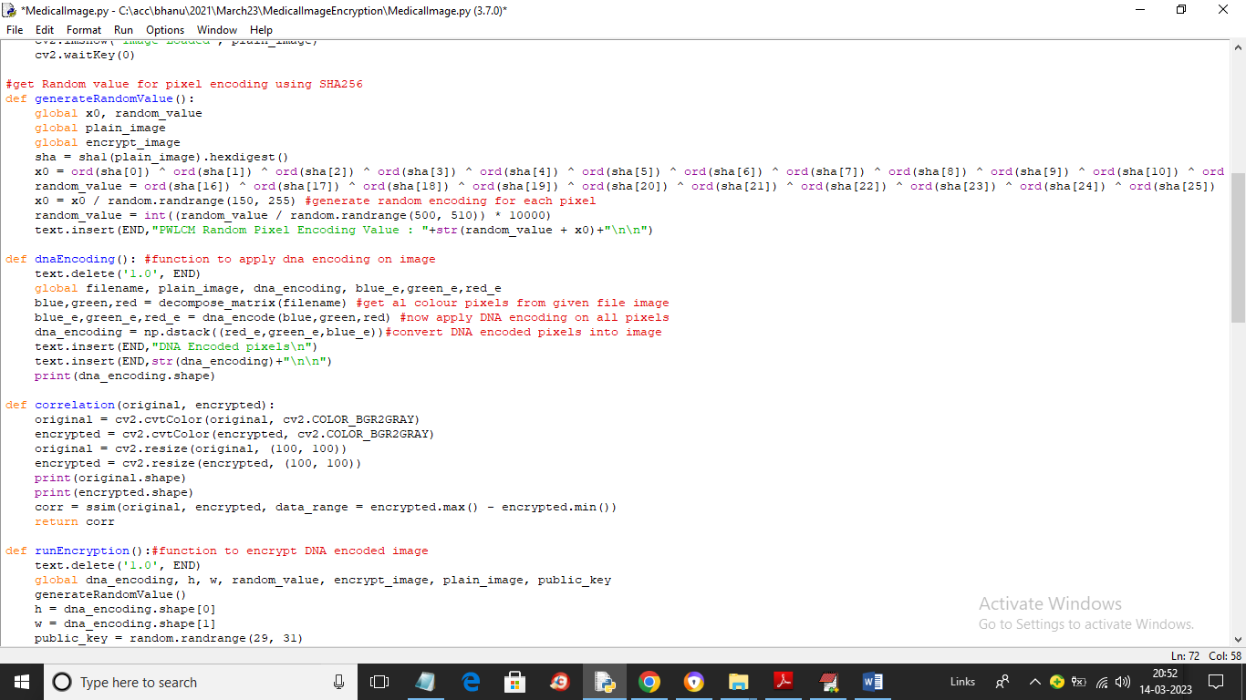

In above screen we are applying DNA encoding on image and then encrypting DNA encoded image using public key and XOR operations

To implement this project we have designed following modules

1. Upload Medical Image: using this module we will upload medical image to application
2. Run Random DNA Encoding Module: using this module we will apply DNA encoding on plain medical image to convert it into DNA format
3. Run Permutation & Encryption: we will apply permutation and XOR operations on DNA encoded image to encrypt the image
4. Run Decryption Algorithm: using this module we will perform reverse operation to decrypt image

SCREEN SHOTS

To run project double click on ‘run.bat’ file to get below screen

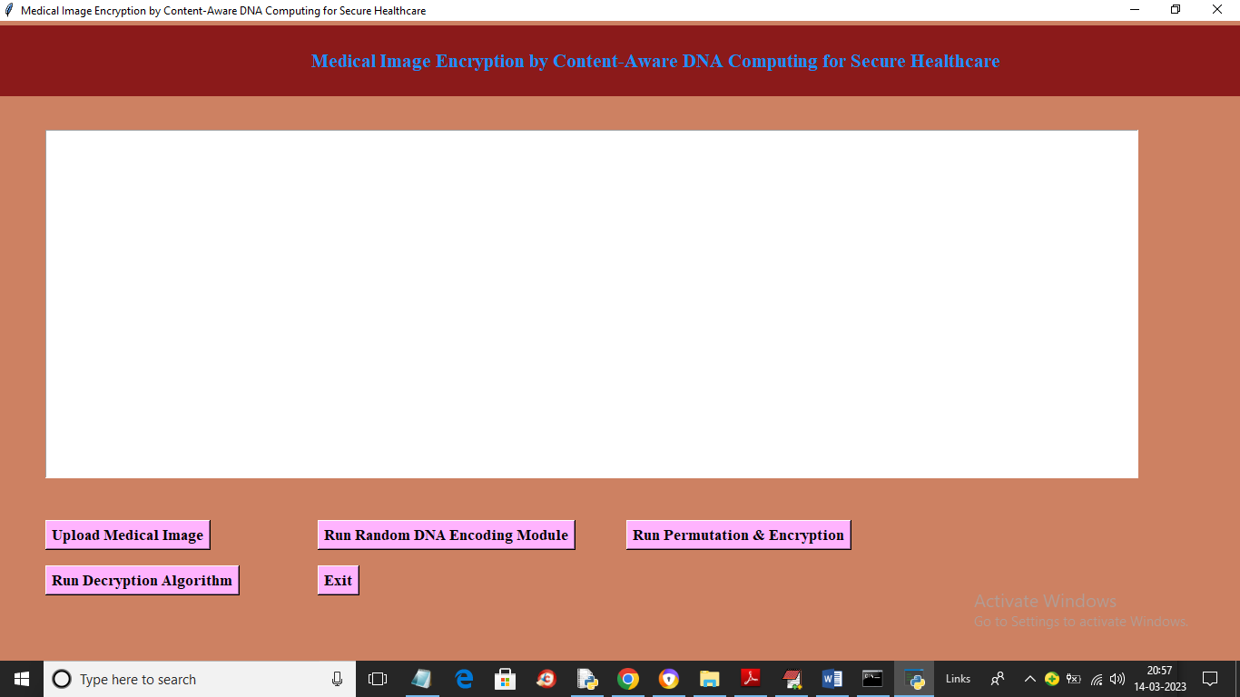

In above screen click on ‘Upload Medical Image’ button to upload image and get below output

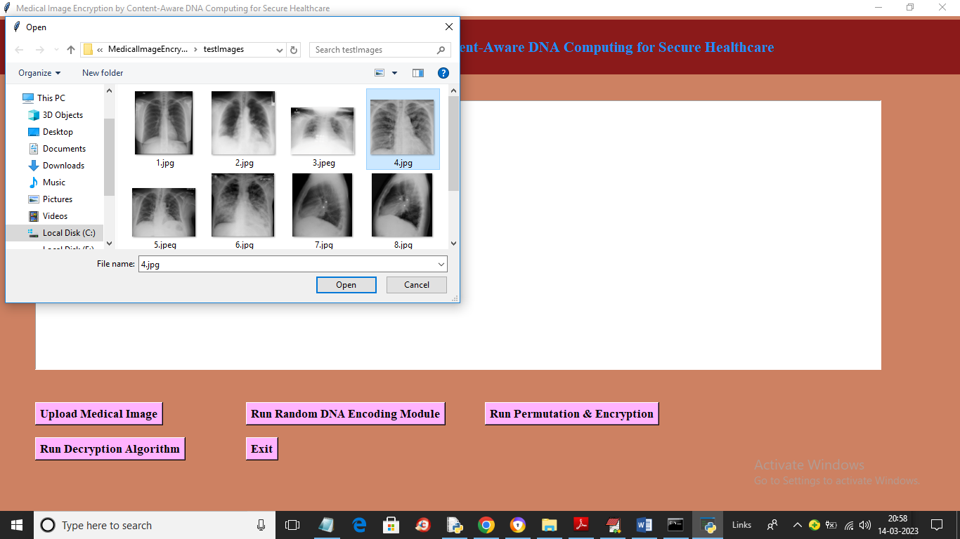

In above screen selecting and uploading medical image and then click on ‘Open’ button to get below output

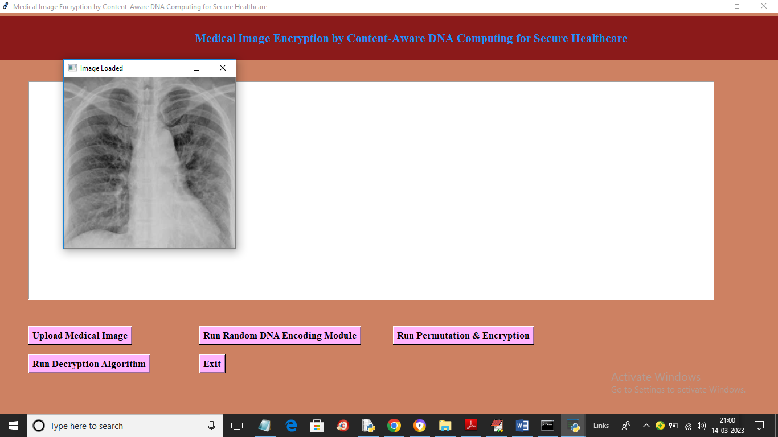

In above screen image is loaded and now click on ‘Run Random DNA Encoding Module’ button to apply DNA encoding on image and get below output

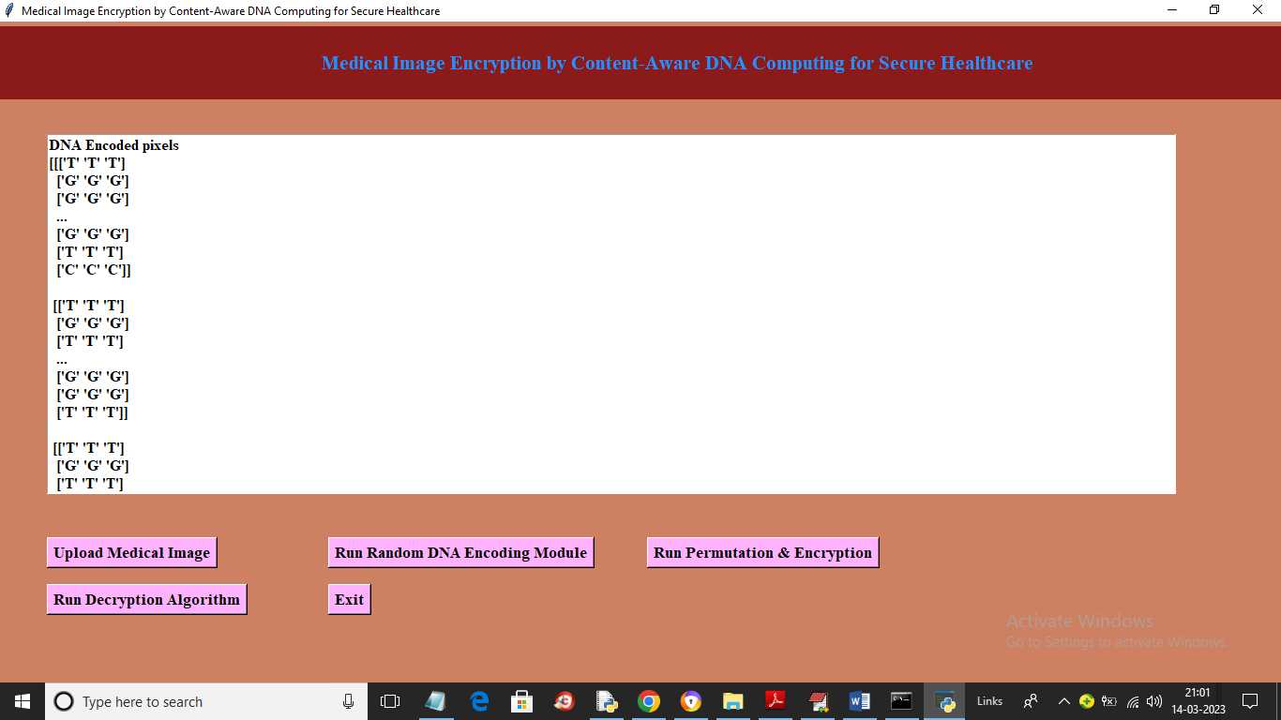

In above screen entire image pixels are converted to DNA encoding and now click on ‘Run Permutation & Encryption’ button to encrypt image and get below output

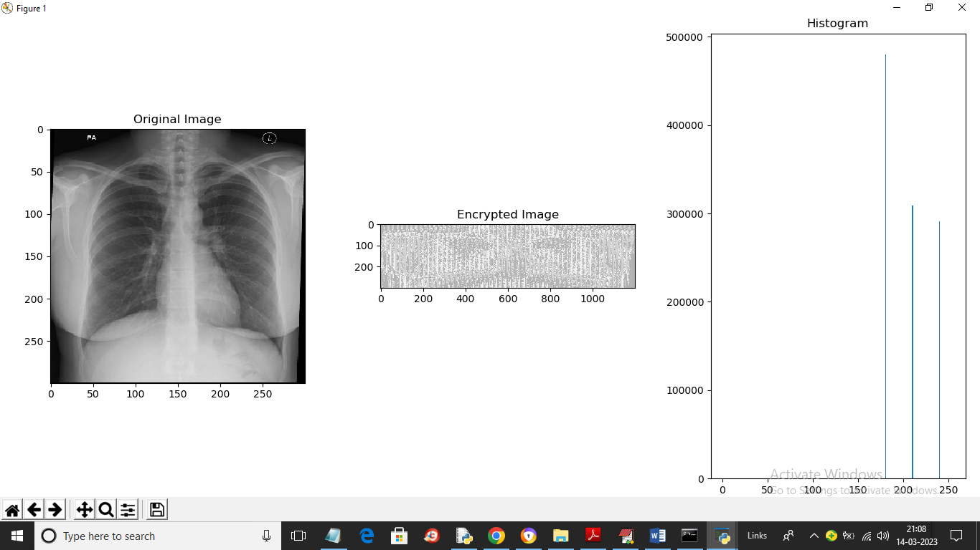

In above screen first image is the original image and second is thee encrypted image and 3rd is the histogram of encrypted image and in histogram we can see more big lines so we can say encrypted image has lots of noise and cannot be understand or hack by the attacker and now close above image to get blow output

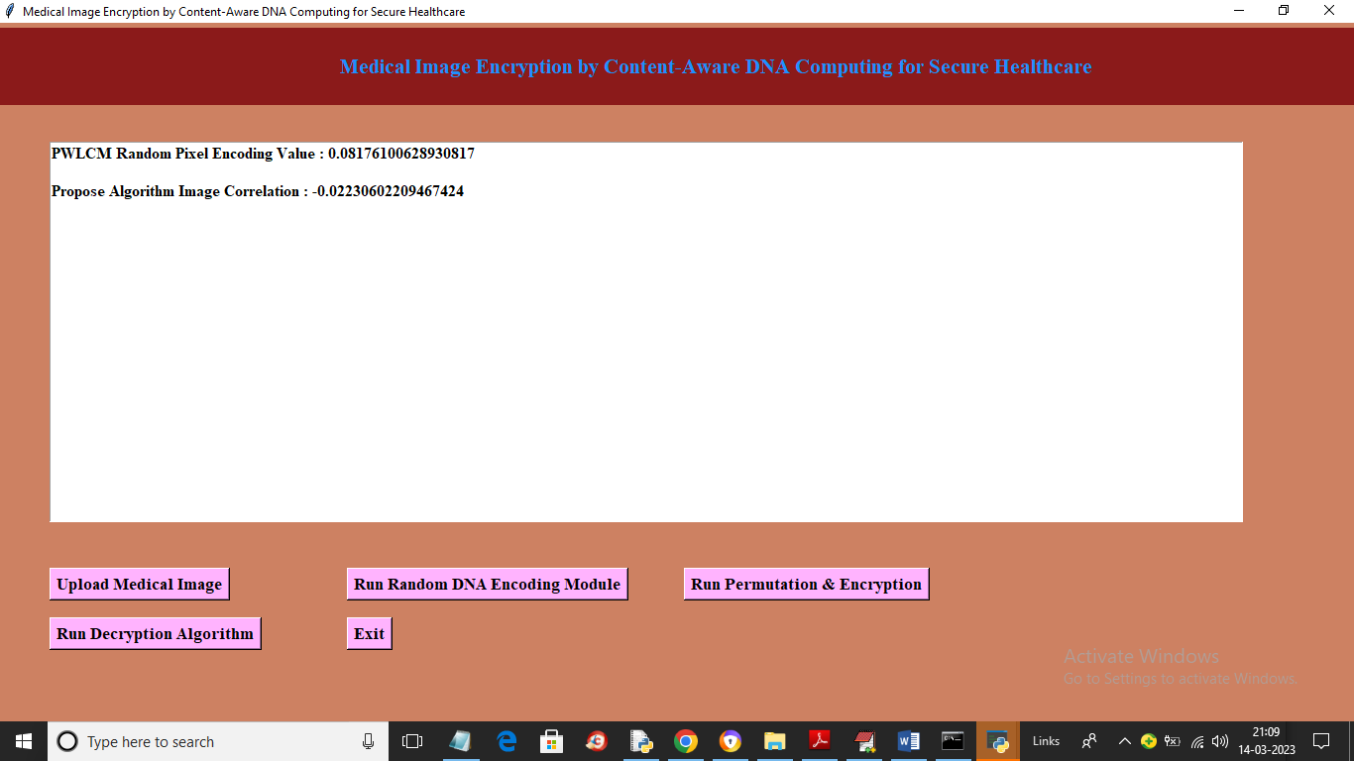

In above screen we can see PWLCM calculated value to encrypt image and in next line we can see correlation between encrypted and plain image as -0.022 so we can say there is not even 1 percent of similarity we can find between original plain image and encrypted image so we can say propose algorithm is more secure. Now click on ‘Run Decryption Algorithm’ button to decrypt image and get below output

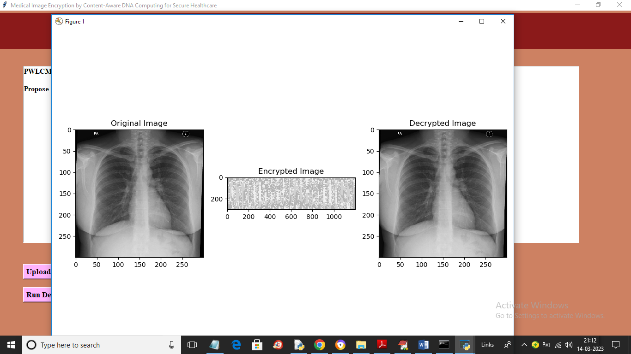

In above screen first is the original image and second is the encrypted image and 3rd is the decrypted image. Similarly you can upload and test other images