NUMER INSTRUKCJI
(WEDŁUG LAB ROADMAP)

ZADANIE A Przygotowanie topologii sieci do przełączania Frame Relay
1. SCHEMAT INSTALACJI WRAZ Z NANIESIONĄ ADRESACJĄ

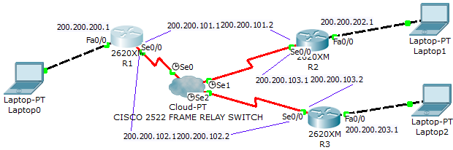

2. KONFIGURACJE URZĄDZEŃ
Router frame-relay

Router(config)#frame-relay switching

#for every serial interface
Router(config-if)#no ip address
Router(config-if)#no frame-relay inverse arp
Router(config-if)#encapsulation frame-relay
Router(config-if)#frame-relay intf-type dce
Router(config-if)#no keepalive
Router(config-if)#clock rate 115200

#DLCI routing rules
Router(config-if)#frame-relay route 222 interface serial2 333

Router#show run
Router#show frame route
3. UWAGI

Końcówka kabla DCE do przełącznika frame-relay.

#frame-relay route 222 interface serial2 333 : dotyczy ramek przychodzących przez dany interfejs, 222 to DLCI ramki przychodzacej, kierujemy do serial2 z nowym DLCI 333

#frame-relay route nie działa dla DTE <-> DTE

ZADANIE B Konfigurowanie ruterów-bramek Frame Relay

2. KONFIGURACJE URZĄDZEŃ
Router  #FR encapsulation  Router(config)#int serial 0/0  Router(config-if)#encapsulation frame-relay  Router(config-if)#no keepalive  Router(config-if)#no shut  Router(config-if)#exit  #subinterface with DLCI  Router(config)#int serial 0/0.50 point-to-point  Router(config-subif)#frame-relay interface-dlci 111  Router(config-subif)#bandwidth 64  Router(config-subif)#ip address 200.200.101.1 255.255.255.0 | Router  #debug  Router#show frame-relay map  Router#show run  #RIP  Router(config)#ip routing  Router(config)#ip classless  Router(config-router)#router rip  Router(config-router)#ver 2  Router(config-router)#network 200.200.200.0  Router(config-router)#network 200.200.100.0

2. FULL CONFIG
frame-relay switching  interface Serial0  encapsulation frame-relay  no keepalive  frame-relay intf-type dce  clock rate 64000  frame-relay route 111 interface serial 1 112  frame-relay route 121 interface serial 2 122  no shut  interface Serial1  encapsulation frame-relay  no keepalive  frame-relay intf-type dce  clock rate 64000  frame-relay route 112 interface serial 0 111  frame-relay route 131 interface serial 2 132  no shut  interface Serial2  encapsulation frame-relay  no keepalive  frame-relay intf-type dce  clock rate 64000  frame-relay route 122 interface serial 0 121  frame-relay route 132 interface serial 1 131  no shut | R1  interface Serial0/0  no ip address  encapsulation frame-relay  no keepalive  no shut  interface Serial0/0.1 point-to-point  frame-relay interface-dlci 111  ip address 200.200.101.1 255.255.255.0  bandwidth 64  no shut  interface Serial0/0.2 point-to-point  frame-relay interface-dlci 121  ip address 200.200.102.1 255.255.255.0  bandwidth 64  no shut

R2  interface Serial0/0  no ip address  encapsulation frame-relay  no keepalive  no shut  interface Serial0/0.1 point-to-point  frame-relay interface-dlci 112  ip address 200.200.101.2 255.255.255.0  bandwidth 64  no shut  interface Serial0/0.2 point-to-point  frame-relay interface-dlci 131  ip address 200.200.103.1 255.255.255.0  bandwidth 64  no shut | R3  interface Serial0/0  no ip address  encapsulation frame-relay  no keepalive  no shut  interface Serial0/0.1 point-to-point  frame-relay interface-dlci 132  ip address 200.200.103.2 255.255.255.0  bandwidth 64  no shut  interface Serial0/0.2 point-to-point  frame-relay interface-dlci 122  ip address 200.200.102.2 255.255.255.0  bandwidth 64  no shut
3. UWAGI

Z uwagi na zdefiniowane połączenia point-point pomiędzy adresami IP reguł statycznych mapowania DLCI-IP już nie definiujemy.

