High-performance atomic structure calculations and the search for new physics

E.V.Kahl1† , J.C.Berengut1

*1School of Physics, UNSW Sydney, NSW 2000 Australia*

† [e.kahl@unsw.edu.au](mailto:aip2017@unsw.edu.au)

**Précis: We present new extensions and techniques in atomic structure calculations, with a focus on applications to the search for physics beyond the standard model.**

Recent improvements in experimental spectroscopy of highly-charged ions and superheavy atoms have enabled a range of new applications in fundamental and applied physics, such as low-energy tests for physics beyond the standard model[1], high precision metrology [2], and EUV photolithography [3]. These applications require systems with open-shell electronic structures and strong many-body correlation effects, which present considerable challenges to accurately model.

One computational approach which has produced promising results for open-shell atoms and ions is Configuration Interaction with Many-Body Perturbation Theory (CI+MBPT). This technique has been used to accurately predict the structure of atoms and ions with up to four valence electrons [4,5], but is known to suffer from severe limitations for larger numbers of electrons.

We will present recent results from our high-performance atomic structure code AMBiT - a modified CI+MBPT implementation which employs the particle-hole formalism to treat open-shell systems with high accuracy. Recent calculations have shown that AMBiT is capable of predicting the optical spectra of highly-charged tin ions with open d-shell configurations with less than 1% error [3]. AMBiT employs a number of new theoretical and computational techniques to achieve this level of accuracy; including the particle-hole formalism and extensive modifications to CI and MBPT. We will provide a detailed overview of these modifications and highlight AMBiT's advantages compared to existing atomic structure codes. These results represent the cutting-edge of atomic structure calculations for many-valence electron systems and provide a benchmark for next-generation precision tests.

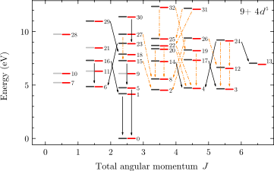

*Comparison of experimentally determined optical spectra of Sn9+ ions (grey) against spectra calculated by the AMBiT atomic structure code (red). Energy levels shown are the fine-structure splitting of the 4d5 configuration ground state. Adapted from [3]*

**References**

[1] V.A. Dzuba *et al, Phys. Rev. Lett.* **109,** 203003 (2012)

[2] A.D. Ludlow *et al*, *Rev. Mod. Phys.* **87,** *637* (2015)

[3] F. Torretti *et al, Phys. Rev. A* ***95****, 042503 (2017)*

[4] V. A. Dzuba, *et al.*, *Phys. Rev. A* **54,** *3948* (1996)

[5] J.C. Berengut, *Phys. Rev. A* **94,** *012502* (2016)