GroundsTruth DMS — Wireframes
Campa Distribution Management System · UI design across all modules & roles
Scope. Low-fidelity wireframes for every module, organised by the three user types in your brief: Drivers (mobile, quick entry), Warehouse Managers (desktop, inventory & loading), and Executives (dashboards & reports). Built to your benchmarks — Onfleet-style for drivers, Odoo-style tables for warehouse, Stripe/Tremor-style for dashboards — on the Campa palette with a clean, minimal background so the data pops.

Answer to your question: the UI library
Recommended: shadcn/ui + Tailwind CSS, with Tremor for the executive charts. This maps directly onto your three benchmarks and our chosen stack (Next.js on Vercel + Supabase):
- Executive dashboards → Tremor (tremor.so) — the KPI cards, charts and bar/area visuals you referenced are exactly its components. Clean, lots of space, themeable to Campa purple.
- Warehouse tables → shadcn/ui Data Table (built on TanStack Table) — the Odoo-style clean tables with sortable columns and status badges.
- Driver mobile → shadcn/ui components sized up for thumbs — big buttons, steppers, high contrast, minimal typing; installable as a PWA so there’s no app-store friction.
All three share one design-token file, so “Campa purple” (#5D2081) is set once and flows everywhere. It’s open-source, copy-in (no vendor lock-in), and is the cleanest fit for the React/Next stack — which is what you invited us to optimise for.

Design language
Token | Value | Use
Campa Purple | #5D2081 | Primary buttons, active nav, chart accent
Purple tint | #EFE7F5 / #F0E8F6 | Selected states, soft cards
Campa Red | #E2231A | Sparingly — alerts/variance only
Ink / Slate | #1A1420 / #6B6675 | Text, labels
Status | Green / Amber / Red | OK / Low / Expiring-Flag badges
Background | #F6F4F8 (near-white) | Clean canvas so data pops
Background stays minimal and near-white everywhere; colour is used only for meaning (brand action = purple, status = green/amber/red), never decoration.

1. Driver — Mobile (Onfleet-style)
Goal: a rep/driver does the whole sale on a phone in a few taps — minimal typing, big targets, high contrast. Covers login, daily route, order entry, invoice + collection.
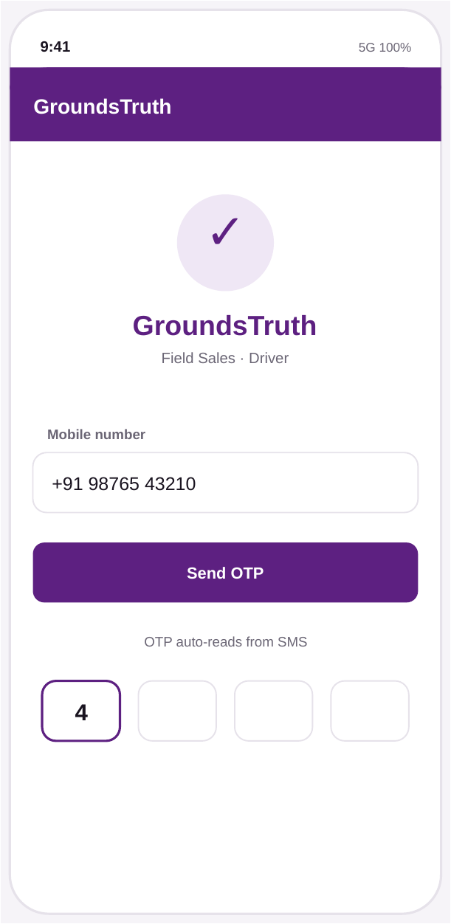
1.1 OTP login — phone-first, auto-reads SMS code.
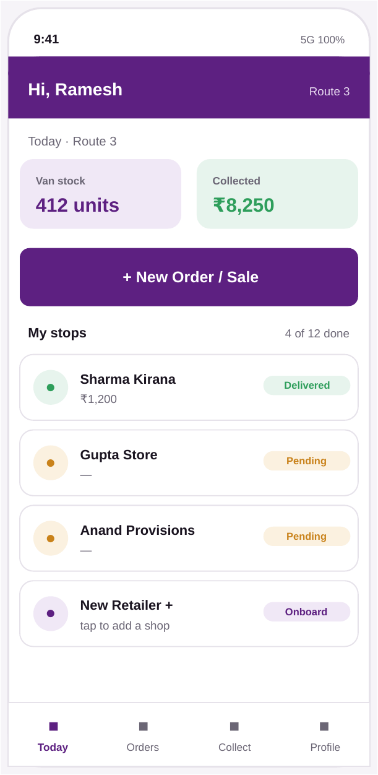
1.2 Today / route home — van stock, collected, stops with status, one big ‘New Order’ action.
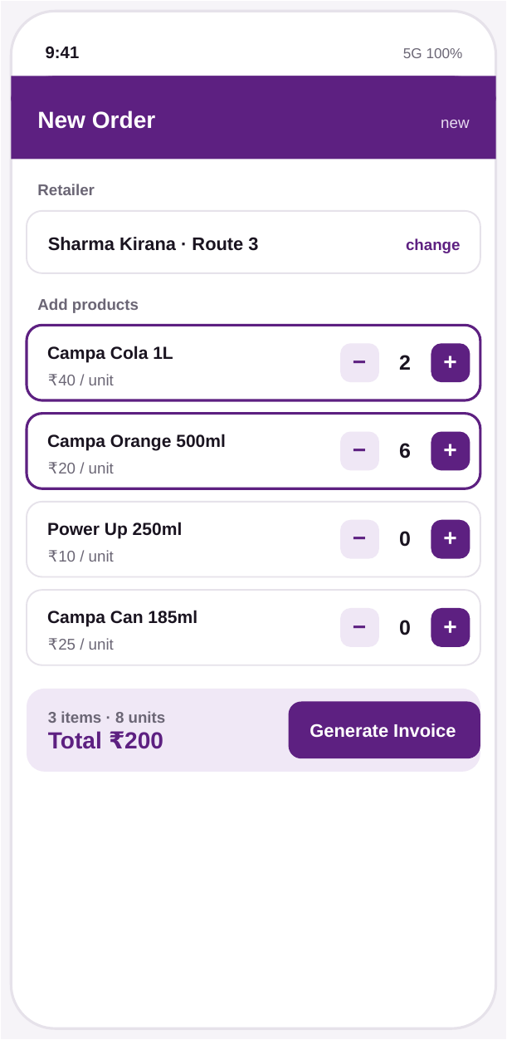
1.3 New order — quick-add Campa SKUs with +/− steppers, live total. (Real prices: Cola 1L ₹40, Orange 500ml ₹20, Can 185ml ₹25.)
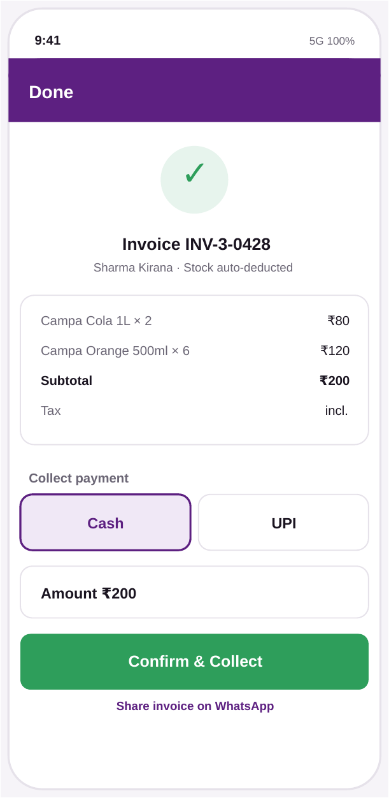
1.4 Invoice + collect — stock auto-deducts, Cash/UPI, confirm, share on WhatsApp.
Driver UX rules: every primary action is a full-width thumb button; quantities use steppers not keyboards; statuses are colour + word (not colour alone); the screen always shows what was saved, since the app needs connectivity (no offline this build).

2. Warehouse Manager — Desktop (Odoo-style)
Goal: clean data tables with clear status badges for inventory, batches and shelf-life, plus the morning van load-out that feeds the day’s reconciliation.
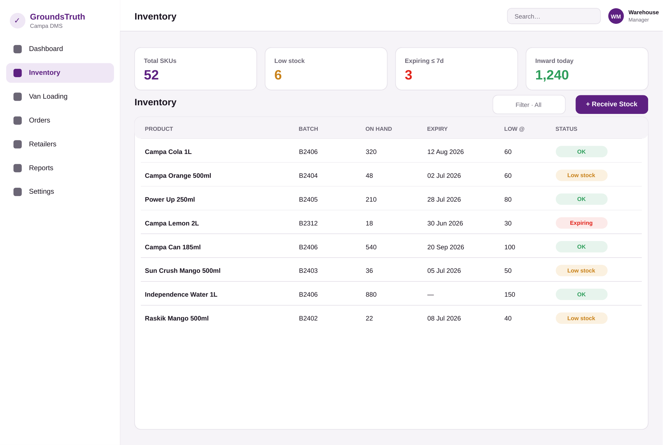
2.1 Inventory — KPI strip + sortable table with batch, expiry, low-stock threshold and status badges (OK / Low stock / Expiring).
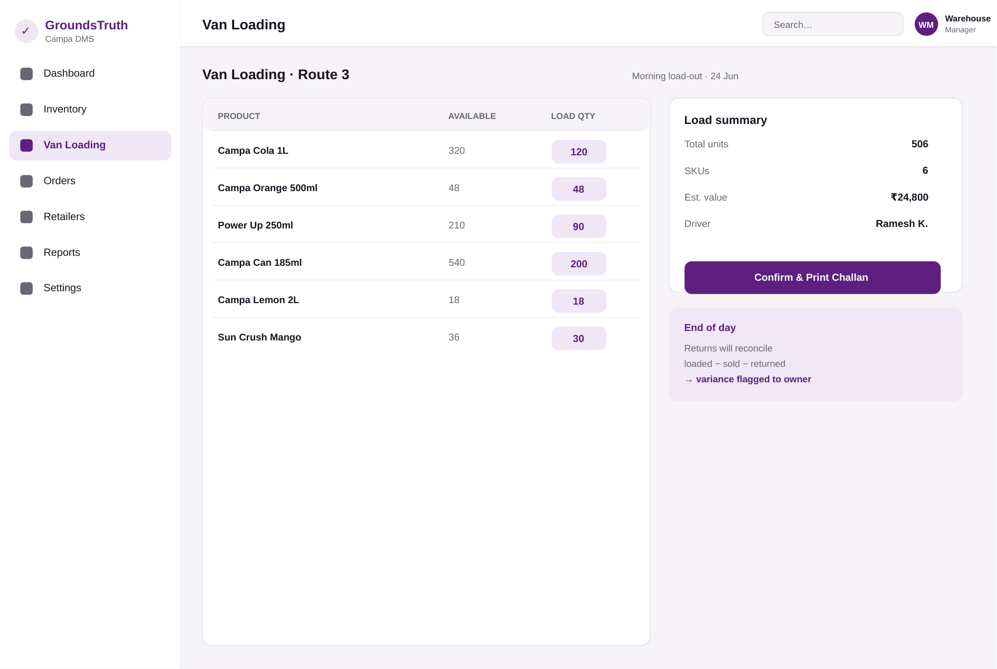
2.2 Van loading — pick list with load quantities, load summary, print challan; flags that end-of-day returns will reconcile loaded − sold − returned into a variance.
Warehouse UX rules: data density is fine here (desktop), but every row’s state is a badge; shelf-life and low-stock are first-class columns; the van load directly seeds the anti-leakage reconciliation.

3. Executive — Dashboard (Stripe / Tremor-style)
Goal: detailed yet readable at a glance — KPI cards, sales trend, route performance, and the things that need the owner’s attention (variance flags, low stock, outstanding collections).
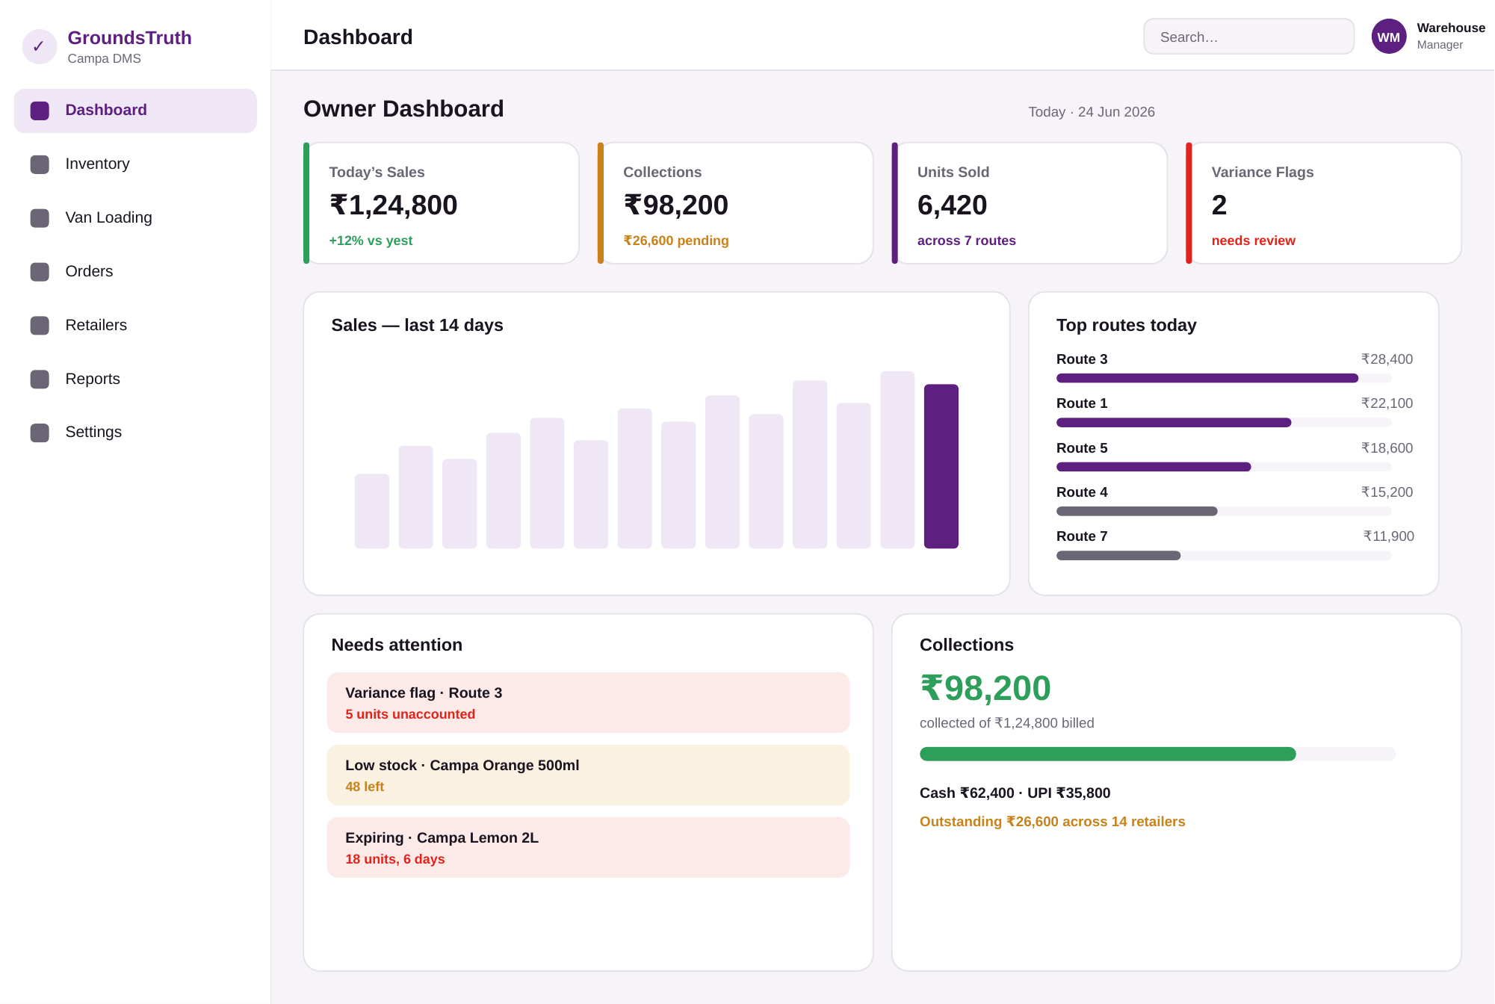
3.1 Owner dashboard — KPI cards (sales, collections, units, variance flags), 14-day trend, top routes, ‘needs attention’ panel, and a collections summary with cash/UPI split and outstanding.
Executive UX rules: the most important number on each card is largest; the anti-leakage variance flags surface here as a first-class KPI and an alert; charts use Campa purple; everything is one screen, no drill-down needed for the morning glance.

4. Module → Screen coverage
Module | Primary screen(s) | Role
Auth / RBAC | OTP login (1.1); role decides what each user sees | All
Catalog & Inventory | Inventory table (2.1) | Warehouse
Van loading + challan | Van loading (2.2) | Warehouse
Order → invoice → deduct | New order (1.3), Invoice (1.4) | Driver
Retailer onboarding | Stops list ‘New Retailer +’ (1.2) | Driver
Collection (cash/UPI) | Invoice + collect (1.4) | Driver
Reconciliation (anti-leakage) | Surfaced on van load (2.2) + dashboard flags (3.1) | Warehouse/Exec
Dashboard & reports | Owner dashboard (3.1) | Executive
Phase 2 (beat/GPS, ledger, PoD, alerts) | Extend the same shells; designed next phase | All
Next step: on your sign-off of this direction, these become high-fidelity Figma screens (with the shadcn/Tremor components and Campa tokens), then we build them. Wireframes intentionally stay low-detail so we agree on flow and layout before polishing.
Note on fidelity: these are wireframes (structure, flow, hierarchy), not final visual design — spacing, exact type and micro-states get refined in Figma/build. The data shown (Campa SKUs, prices, routes) is real from your catalogue and workbook so the screens feel true.

