GROUNDWORK BY JALLA

90-Day Admin Platform
Product & Operational Transformation Plan
Product Owner Proposal

Purpose: create the operational foundation required to move hundreds of existing active projects through setup, milestones, verification evidence, updates and payment workflows end to end.

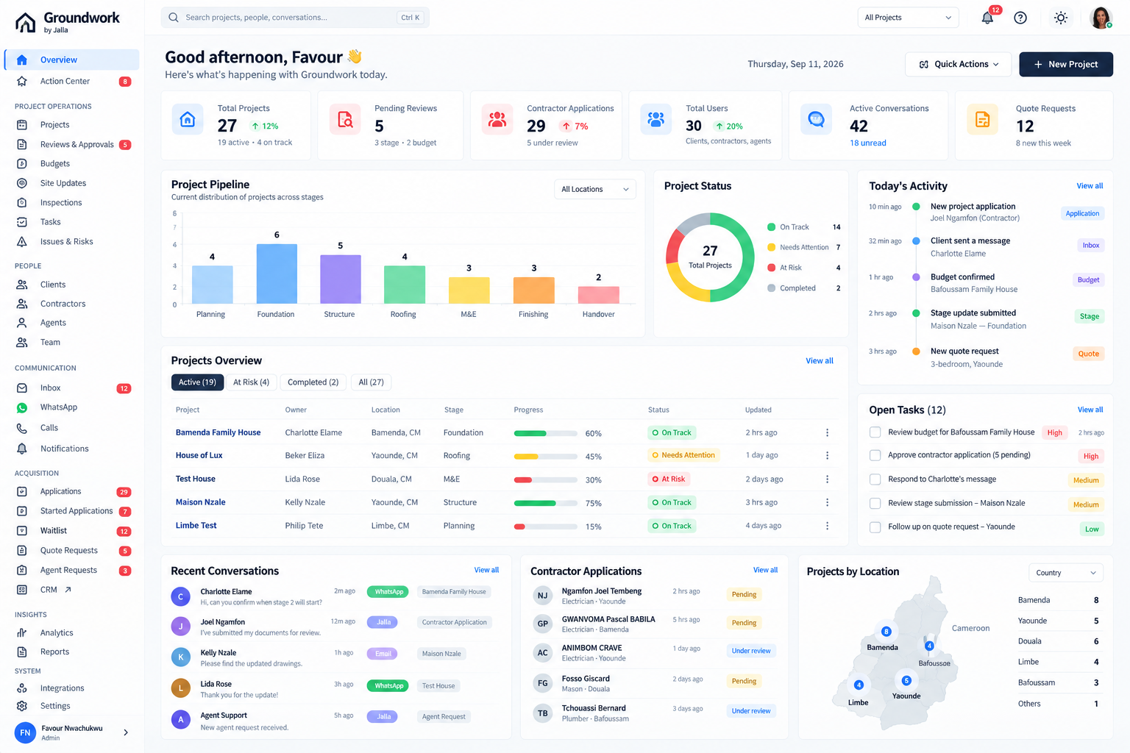
Illustrative future-state Overview direction — final UI will be driven by real Groundwork data and existing integrations.

September 2026

1. Executive Summary
I am proposing a redesign and operational restructuring of the Groundwork admin platform because the 90-day objective is not simply to improve the appearance of the admin. The objective is to make hundreds of existing active construction projects fully operational on Groundwork. That requires an admin system capable of setting projects up correctly, tracking milestones, reviewing and approving work, capturing verification evidence, handling updates, managing financial actions and keeping communication connected to the correct project.
As Product Owner, I am treating the admin as a product and operating system for the Groundwork team—not as an internal back-office collection of pages. The design decisions therefore need to optimize for operational clarity, accountability, speed of response, data integrity, customer trust and scalability.
Core proposition: The admin should become the control center that makes Groundwork's construction operation visible, actionable and auditable.

90-Day OKR
Ensure hundreds of existing active projects are fully operational on Groundwork with project setup, milestones tracking, verification evidence, updates and payment workflows functioning end to end.

What this proposal changes
Current problem | Proposed product decision | Expected benefit
Operational information is distributed across modules. | Center the experience around Project Workspace + Unified Inbox + Action Center. | Fewer context switches and faster decisions.
Dashboard metrics do not necessarily translate into action. | Make Overview an operations control center with actionable queues. | Admins know what needs attention immediately.
Communication can exist separately from project context. | Link conversations to people and projects while preserving GHL. | Every message can lead to a traceable operational action.
Reviews, budgets, evidence and updates can feel like separate workflows. | Connect them through project stages and milestones. | Projects can move end to end instead of through isolated tasks.
Scaling to hundreds of projects increases coordination risk. | Use consistent data relationships, statuses, ownership and audit events. | A repeatable operating model that can scale.

2. My Product Owner Responsibility
My responsibility is not only to specify what screens should be built. I am expected to make product decisions that improve Groundwork as a brand and as an operating business. That means prioritizing the work that reduces operational risk, strengthens transparency, improves the customer experience and enables the team to deliver consistently.

Product decisions I am making
- Prioritize operational readiness over cosmetic redesign.
- Use real Groundwork data as the source for the admin experience; no mock operational datasets in production.
- Make the project the primary operational unit because the 90-day outcome is project execution.
- Make communication contextual by connecting messages to people, projects and actions.
- Surface human work through an Action Center rather than expecting staff to manually search every module.
- Preserve the existing GoHighLevel integration and improve the bridge instead of creating a competing communication system.
- Design for traceability: important decisions, approvals, evidence and financial actions should leave an auditable record.
- Build reusable patterns so new workflows can be added without creating another disconnected module.
- Use measurable operational outcomes to define 'done', not just whether a screen has been shipped.

How this benefits the Groundwork brand
Brand value | Admin product decision
Trust | Evidence, approvals, decisions and updates are traceable.
Transparency | Customers and internal teams can see what happened, what is pending and who owns the next action.
Reliability | Workflows have explicit states, owners, dates and audit events.
Professionalism | The operating interface reflects the same confidence Groundwork promises to customers.
Scalability | Standardized project workflows allow the business to manage more projects without proportional administrative overhead.
Customer experience | Faster responses and better project context reduce avoidable delays and confusion.

3. Why This Needs to Happen Now
The scale implied by the 90-day OKR changes the requirements of the admin. An interface that is adequate for a small number of projects can become a bottleneck when hundreds of active projects need simultaneous attention.
- At higher project volume, small workflow gaps multiply into operational delays.
- Unanswered messages become customer-experience issues when they are not connected to project ownership.
- Milestone and verification gaps make it difficult to determine whether a project is genuinely progressing.
- Payment decisions require context, approvals and traceability.
- Teams need a reliable way to prioritize work rather than rely on memory or scattered module checks.
- Leadership needs portfolio-level visibility without losing the ability to drill into a specific project.

The strategic shift
From: a set of admin modules.
To: an operational system for construction delivery.

4. Proposed Information Architecture
The information architecture is organized around how the Groundwork team works. The most important distinction is between the portfolio view, the individual project, and communication.
Area | Purpose | Primary question
Overview | Portfolio control center | What is happening across Groundwork?
Action Center | Cross-functional work queue | What needs human action now?
Projects | Portfolio + project entry point | What is the state of each project?
Project Workspace | Complete project operational record | What is happening with this project?
Inbox | Unified communication workspace | What are people communicating about?
Reviews & Approvals | Governance workflow | What needs approval?
Budgets | Financial operations | What financial action is pending or completed?
Site Updates | Field evidence | What has happened on site?
Inspections | Verification workflow | Has the work been verified?
Tasks / Issues | Exception management | What needs to be resolved?
People | Relationship management | Who is involved and in what capacity?
Acquisition | Pre-project pipeline | How does a lead become a project/contractor?
Support | Customer issue management | What customer issue needs resolution?
Analytics / Reports | Management insight | What does the operation tell us?
Integrations / Settings | System governance | How does the platform connect and remain controlled?

Navigation principle
Existing modules should not be removed simply for the sake of simplification. They should be refactored into specialized views that lead back to the Project Workspace, Person record or Inbox where operational context is needed.

5. Data Relationships & Product Model
The UI should reflect a coherent domain model. Before implementation, the existing repository and database must be audited so these concepts are mapped to the actual schema rather than invented as parallel structures.
Entity | Key relationships | Why it matters
Person | Client / Contractor / Agent / Team; Projects; Conversations; Tasks | Provides identity and relationship context.
Project | Person(s); Stages; Budget; Updates; Inspections; Issues; Tasks; Documents; Conversations; Activity | Central operational entity.
Project Stage | Project; Milestone; Review; Tasks; Updates; Inspections | Makes progress measurable and governable.
Budget | Project; approvals; payment milestones; transactions/commitments where supported | Connects financial state to project execution.
Site Update | Project; Stage; Submitter; Evidence; Verification | Creates an evidence trail.
Inspection | Project; Stage; Inspector; Checklist; Findings; Result | Turns verification into a workflow.
Issue | Project; Stage; Owner; Task; Resolution | Captures exceptions and risk.
Conversation | Person; Project (nullable until matched); Channel; Messages | Connects communication to operational context.
Message | Conversation; sender; channel; external ID; timestamp | Provides the communication record.
Activity | Actor; entity; project; timestamp; metadata | Provides timeline, audit and notification foundations.

Important product rule
Not every conceptual entity must become a new database table. The implementation should first map these relationships to the existing schema and extend only where a genuine capability gap exists. This prevents unnecessary duplication and protects existing data.

6. Overview Redesign
The Overview should answer a manager's first question when opening the admin: 'What is happening across Groundwork today, and where do I need to intervene?'

Future-state Overview concept: portfolio health + action + project visibility.

Recommended Overview sections
- Global search for projects, people and conversations.
- Headline operational metrics: active projects, pending reviews, pending budgets, open conversations, contractor applications and other real metrics supported by the data.
- Action Center preview showing the most important unresolved work.
- Project health / status distribution, based only on computable real data.
- Project pipeline by current stage.
- Active/recent projects with owner, location, stage, progress, status and last activity.
- Upcoming inspections and milestone deadlines.
- Recent activity feed based on real events.
- Acquisition signals such as applications and quote requests.
- Optional map/location view where project location data is sufficiently reliable.
- GHL sync health indicator so communication/integration failures are visible.

What the Overview should not become
- A dashboard filled with manually entered or hard-coded numbers.
- A decorative analytics page with no path to action.
- A second CRM.
- A substitute for the Project Workspace.

7. Project Workspace
The Project Workspace is the most important new concept. It should be the single operational home for a project and the place an admin can go from initial setup through milestone completion and handover.
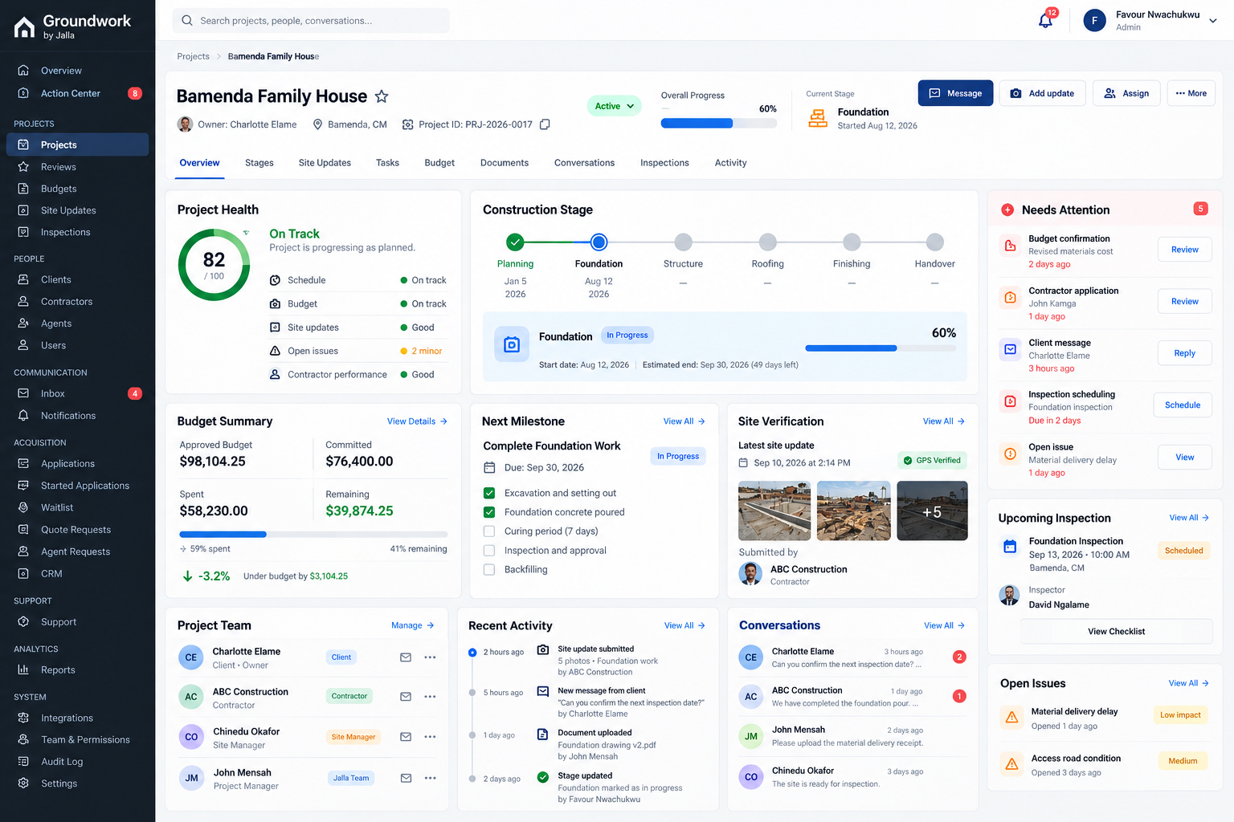
Future-state Project Workspace concept: stage, health, budget, milestone, verification, team, activity and conversations in context.

Persistent project header
- Project name and unique project identifier.
- Client / owner.
- Location.
- Project status.
- Overall progress.
- Current stage.
- Primary actions: Message, Add Update, Assign, More.

Project tabs
- Overview
- Stages / Milestones
- Site Updates
- Tasks
- Budget
- Documents
- Conversations
- Inspections
- Issues
- Activity

Project Overview content
Panel | Purpose
Project Health | Show schedule, budget, evidence/update quality and open issues where the underlying data supports those signals.
Construction Stage | Show current stage, previous/next stages, dates, progress and review state.
Budget Summary | Approved, committed, spent, remaining and pending confirmations where available.
Next Milestone | Show the next operational outcome and its checklist/status.
Site Verification | Latest evidence, verification status and submitter.
Project Team | Client, contractor, site manager, project manager and other relevant roles.
Recent Activity | Chronological project events.
Conversations | Recent project-linked communications.
Needs Attention | Project-specific actions that require intervention.
Upcoming Inspection | Next scheduled verification and checklist access.

8. Unified Communication / Inbox
GoHighLevel can continue to power CRM and external communication, but the Groundwork admin needs a unified operational communication experience. The goal is not to replace GHL; it is to ensure that a message becomes useful operational context.
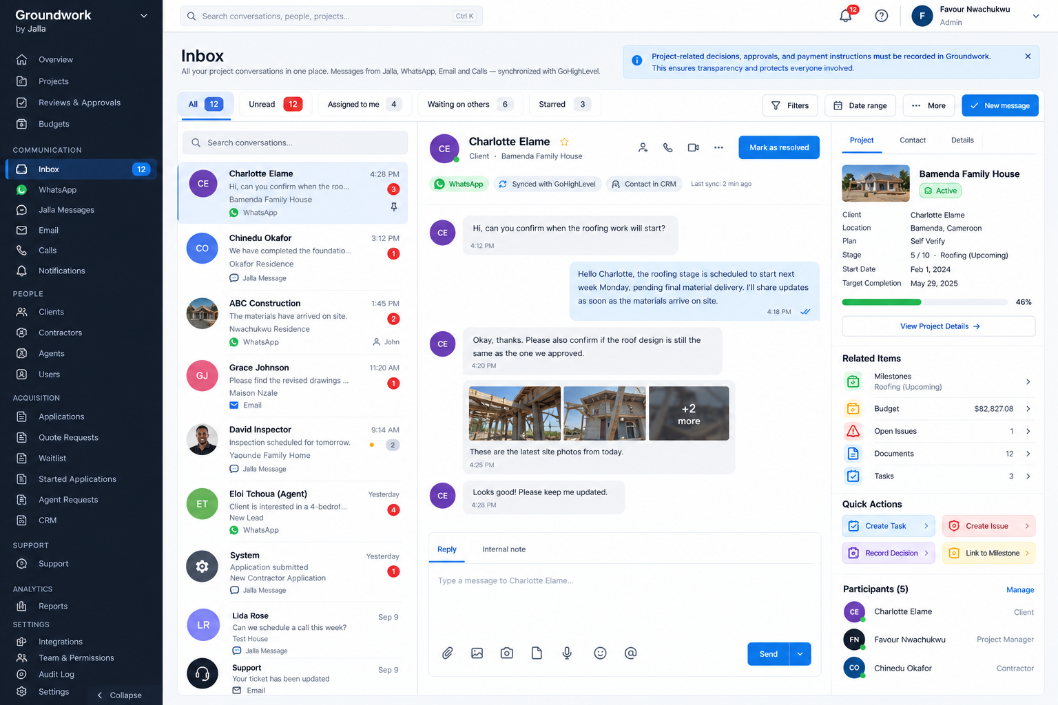
Future-state Unified Inbox concept: conversation + project context + actions in one screen.

Message lifecycle
- Receive message through GHL / supported channel.
- Identify the person using the external contact identity.
- Determine whether the conversation is already associated with a Groundwork project.
- If a project cannot be confidently identified, keep the conversation unlinked and surface a matching/link action.
- Store or reconcile the message using its external message ID to prevent duplicates.
- Notify or assign the responsible admin.
- Allow reply through the originating channel.
- Allow internal notes that never reach the customer.
- Allow the admin to create a task, issue, milestone action or decision from the conversation.
- Write important events to the project activity/audit trail.

The key UX principle
A message should not end with a reply. It should be possible to turn communication into a project action without losing context.

Record Decision
This should be a deliberate capability in the Inbox and Project Workspace. For example: 'Client approved revised material cost.' The record should capture the project, actor, date/time, decision and related budget/milestone when applicable. This strengthens accountability and protects the customer and Groundwork team.

9. Action Center
The Action Center is the operational bridge between information and execution. It aggregates work from across the platform so staff do not need to remember which module contains each pending action.
Action type | Example | Destination
Budget | Budget confirmation required | Project → Budget
Review | Stage review pending | Project → Stages / Reviews
Message | Client message unanswered | Inbox → Conversation
Inspection | Inspection due / result pending | Project → Inspections
Application | Contractor application awaiting review | Applications → Applicant
Issue | Open high-priority project issue | Project → Issues
Task | Overdue task | Task / Project
Quote request | Contractor introduction needed | Quote Request workflow
Support | Customer ticket awaiting response | Support / Inbox

Action item minimum data
- What needs to happen
- Who/what is affected
- Project or person context
- Priority
- Age / due date
- Assigned owner
- One-click next action

10. Groundwork + GoHighLevel Strategy
The proposal deliberately preserves GoHighLevel. The product decision is to define clear ownership between Groundwork's operational data and GHL's CRM/communication capabilities.
Groundwork should own | GHL should own / participate in
Projects | CRM contacts
Project stages and operational milestones | WhatsApp / external messaging
Budgets and Groundwork-specific financial state | Email
Site updates and verification evidence | Calls
Inspections and project issues | CRM pipelines / automations
Project relationships | External communication identifiers

Cross-system identifiers
- ghl_contact_id
- ghl_conversation_id
- ghl_message_id
- ghl_pipeline_id
- ghl_pipeline_stage_id

Integration requirements
- Idempotent synchronization: the same external message/event must not create duplicates.
- Visible sync state where operationally useful.
- Error handling and retry behavior.
- Preservation of existing webhooks.
- Auditability of important sync events.
- Clear source-of-truth rules.
- Do not build a second competing conversation infrastructure.

11. Core Operational Workflows

A. Project activation
Lead / accepted request → project created → client linked → contractor/team assigned → project setup completed → initial stage configured → project becomes operational.

B. Milestone / stage workflow
Stage created → work progresses → update/evidence submitted → review/inspection → approved or issue raised → next milestone becomes active.

C. Site verification workflow
Site update submitted → evidence attached → timestamp/location captured where supported → verification scheduled → inspector records result → issue/review triggered when needed.

D. Payment workflow
Payment milestone becomes due → budget/payment information reviewed → confirmation/approval → payment action recorded → project activity updated → relevant parties notified.

E. Communication workflow
Message received → person identified → project matched → conversation stored → assigned admin notified → reply/action → decision/task/issue recorded where required.

F. Contractor workflow
Waitlist → started application → application review → decision → accepted contractor profile → availability/quote request → project relationship.

12. Visual Direction for the Final Admin
The visual direction I am proposing is intentionally more comprehensive than the current admin. It should combine the seriousness and information density of construction operations software with a modern SaaS experience.
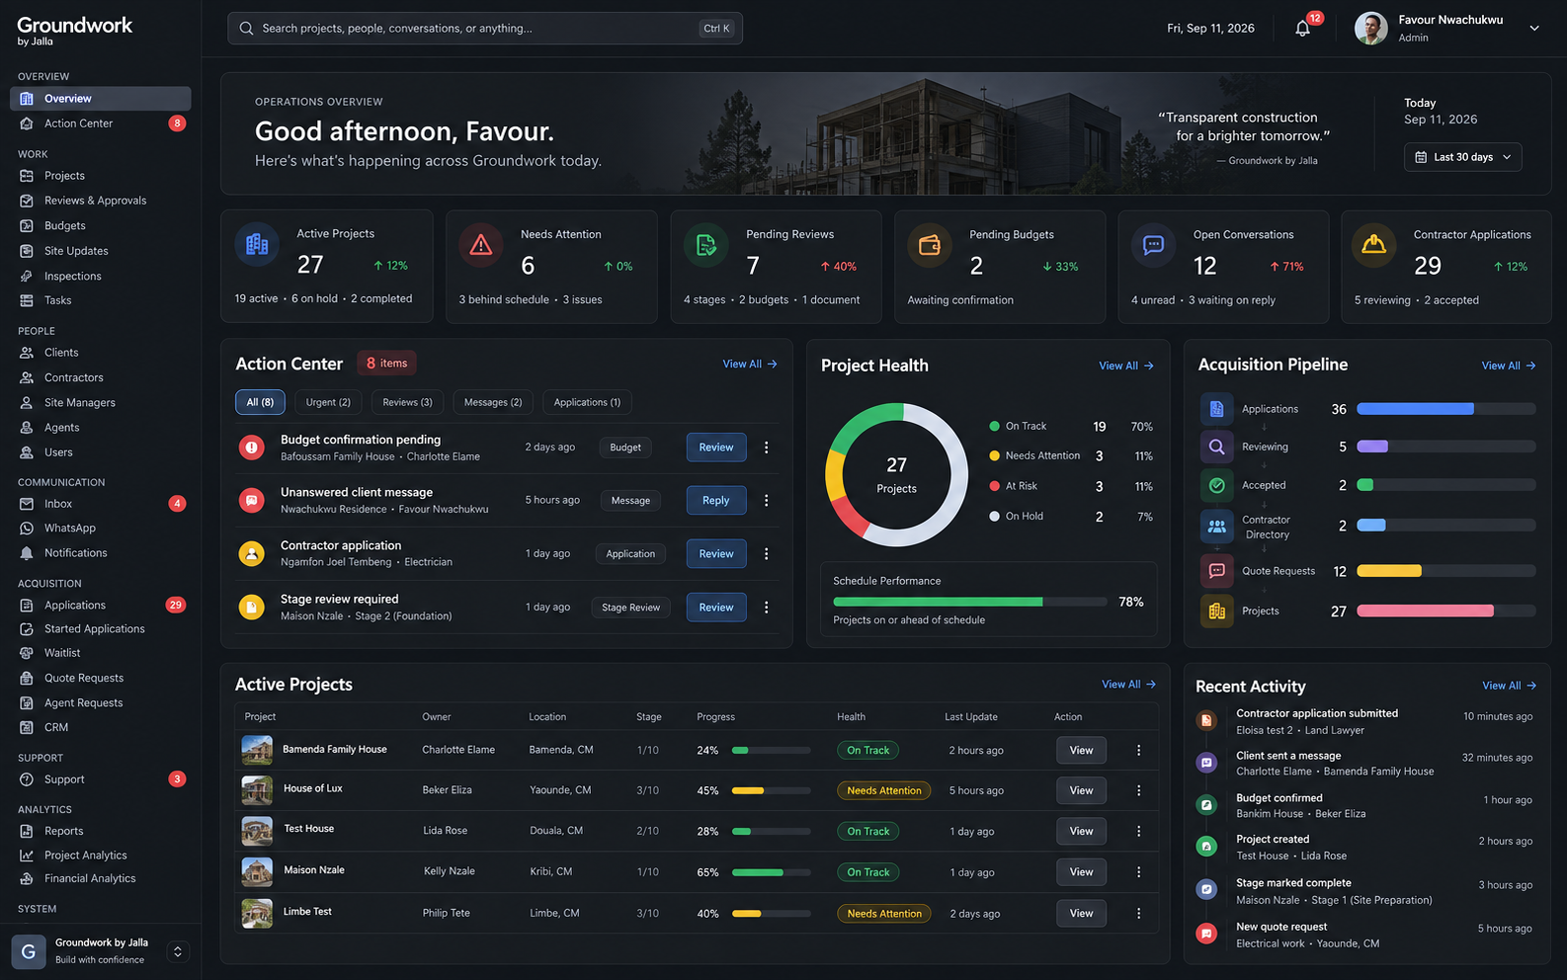
Dark Operations Mode: High-density option for operations teams that prefer a focused console. These are design references, not production data.
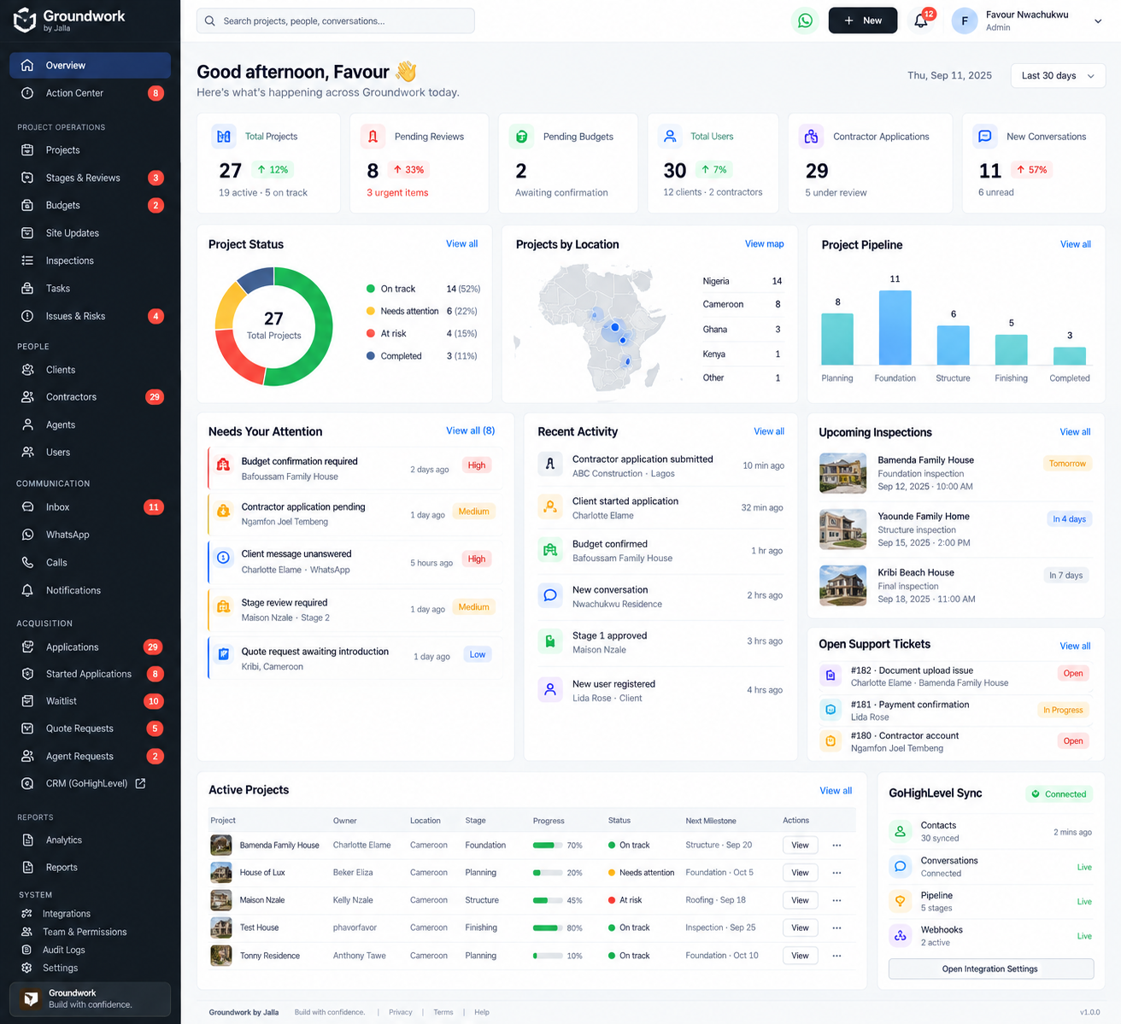
Detailed Portfolio View: Light-mode portfolio view emphasizing projects, attention, inspections and location. These are design references, not production data.
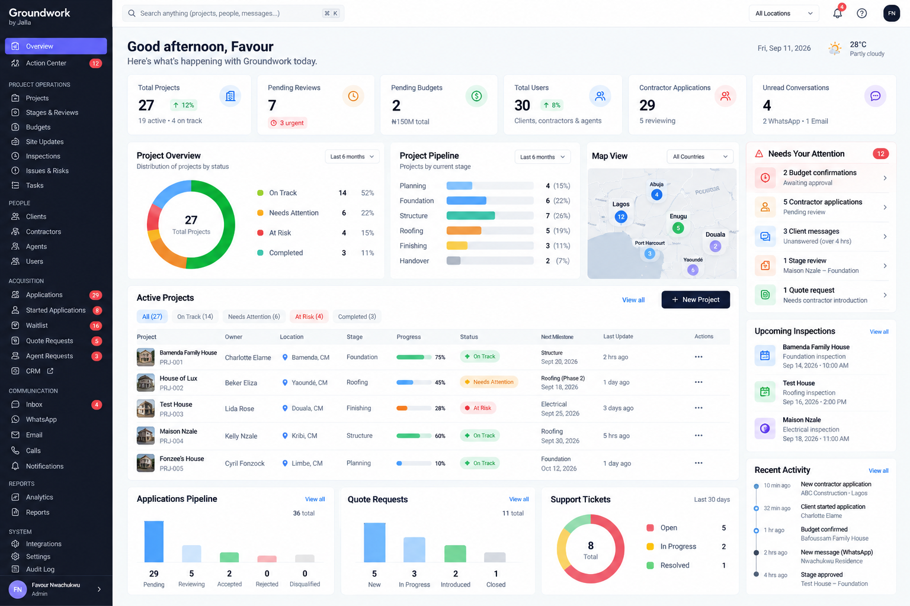
Executive / Reporting View: Leadership-oriented variation emphasizing status, pipeline and activity. These are design references, not production data.

Design principles
- Operational density without visual clutter.
- Clear hierarchy between status, action and context.
- Strong use of progressive disclosure: summary first, detail on demand.
- Consistent status language and severity indicators.
- Every major card should have a path to the underlying record.
- Responsive behavior appropriate for desktop admin use.
- Accessibility and readable contrast.
- Use real data states to determine whether a component appears; avoid fabricated 'health' signals.

13. 90-Day Implementation Roadmap
Period | Focus | Primary outputs | Product Owner responsibility
Days 1–15 | Audit + architecture | Repository/database/GHL/RLS audit; data map; workflow specification. | Confirm scope, identify risks, make source-of-truth decisions.
Days 16–30 | Overview + Action Center | Real-data portfolio view; operational queues; activity aggregation. | Prioritize actions and define acceptance criteria.
Days 31–50 | Project Workspace | Project setup, stages, milestones, budget, evidence, updates, inspections. | Validate end-to-end project workflow and business rules.
Days 51–65 | Unified Inbox | Channels, conversation context, assignment, notes, decisions. | Define communication rules and escalation behavior.
Days 66–80 | Module refactor | Reviews, budgets, contractors, applications, quotes, support linked to core concepts. | Remove duplication and protect existing workflows.
Days 81–90 | Hardening + rollout | Permissions, realtime, GHL reliability, QA, performance, migration and adoption. | Go/no-go decisions, rollout readiness, success measurement.

Claude Code implementation guardrails
- Start with a read-only repository and database audit.
- Do not replace Supabase, GHL or authentication without explicit justification.
- Do not create mock operational data.
- Do not hard-code dashboard metrics.
- Do not disable RLS to solve access problems.
- Do not create duplicate conversation systems.
- Do not remove existing routes without a migration plan.
- Reuse existing components, queries and data models where appropriate.
- Document every schema change and integration change.
- Test critical workflows against real project states.

14. Success Measures
The success of this initiative should be evaluated against operational outcomes, not only UI completion.
Outcome | Possible measure
Project readiness | % of active projects meeting the agreed minimum project-setup completeness standard.
Milestone visibility | % of active projects with current stage and next milestone correctly configured.
Verification coverage | % of relevant site updates/required milestones with verification evidence recorded.
Communication responsiveness | Median age of unanswered project-linked conversations; number of unresolved conversations.
Action completion | Open vs completed actions and overdue action rate.
Payment workflow readiness | % of relevant payment milestones with required confirmation/status recorded.
Data integrity | Duplicate message rate, orphan conversations, sync errors and unresolved external IDs.
Adoption | % of operational work completed through the new admin workflows.
Customer trust signals | Reduction in avoidable follow-ups caused by missing status/context, where measurable.

Important measurement principle
Exact targets should be agreed after the initial system audit establishes the current baseline. The dashboard should never invent a baseline simply to make the redesign look successful.

15. Risks & Mitigations
Risk | Impact | Mitigation
Building UI before understanding the existing schema | Rework and broken workflows | Phase 0 audit before implementation.
GHL and Groundwork duplicate communication state | Confusion / duplicate messages | Explicit ownership + external IDs + idempotent sync.
Too much information on Overview | Cognitive overload | Prioritize actions and progressive disclosure.
Fake or non-computable project health | Loss of trust | Only calculate health from defined, real signals.
Changing existing workflows too aggressively | Operational disruption | Refactor incrementally; preserve routes and data.
Permissions/RLS gaps | Data exposure or blocked workflows | Audit access policies before feature rollout.
Scaling queries poorly | Slow admin experience | Aggregation strategy, indexes and performance testing.
Building screens without adoption | Low ROI | Pilot with actual operations workflows and measure usage.

16. Definition of Done
I would consider this initiative successful when:
- Existing active projects can be configured and managed from a complete Project Workspace.
- Project stages and milestones have explicit status, dates, ownership and review states.
- Site updates and verification evidence are captured and traceable.
- Relevant payment/budget workflows can be initiated, reviewed and recorded in project context.
- Project-related client and contractor communication can be handled through the admin with appropriate GHL synchronization.
- Actions requiring human intervention surface in the Action Center.
- Existing modules link naturally into the Project Workspace, Person context or Inbox.
- Important decisions and operational events are auditable.
- GHL webhooks and existing integrations continue to function reliably.
- Real project data powers production views; no mock operational datasets are required.
- The system can support the operating volume implied by the 90-day OKR.

17. Decisions / Support Requested
To execute this as a Product Owner, I would seek alignment on the following decisions before or during the first phase:
- Approve the admin transformation as an operational-enablement initiative tied directly to the 90-day OKR.
- Agree that Project Workspace, Unified Inbox and Action Center are the three core experiences around which existing modules will be refactored.
- Agree that Groundwork remains the operational source of truth while GHL remains a key CRM/communication system.
- Allow the first phase to audit the existing repository, database, permissions and GHL integration before major implementation changes.
- Agree that success will be measured by operational readiness and workflow completion on real projects, not simply by the number of pages shipped.
- Agree on a phased rollout so existing operations are not disrupted.

Why this is the right product decision
This approach balances immediate business needs with long-term product quality. It does not throw away the existing system. It organizes and strengthens it around the work Groundwork actually needs to perform at scale.

18. Closing Position
My proposal is not to 'redesign the admin.' My proposal is to build the operational layer that makes the 90-day Groundwork objective achievable.
If we expect hundreds of active projects to be fully operational on Groundwork, the team needs a system that can answer, at any point: Who is involved? Which project are they involved in? What has happened? What evidence exists? What is the current milestone? What is waiting for approval? What needs to happen next? What has been communicated? What financial action is pending?
The proposed architecture, workflows and UI are designed around those questions. That is the product decision I am making as Product Owner: prioritize a Groundwork operating system that strengthens trust, accountability and scalability rather than optimizing for a short-term visual refresh.

