1. 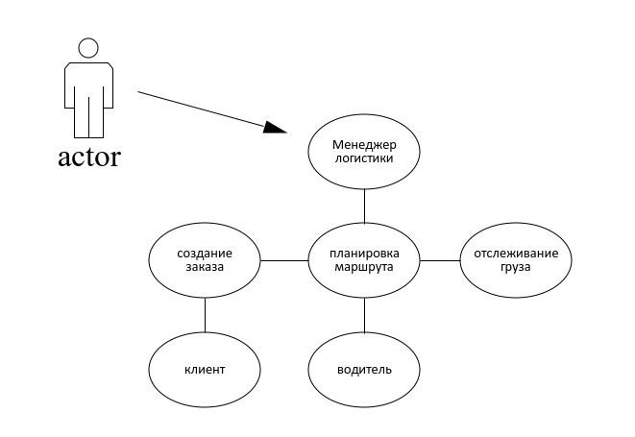

2. Листинг программы

import pandas as pd

import numpy as np

class TransportationProblem:

def __init__(self, supply, demand, costs):

self.supply = np.array(supply)

self.demand = np.array(demand)

self.costs = np.array(costs)

self.allocation = np.zeros_like(self.costs, dtype=int)

self.m = len(supply)

self.n = len(demand)

def min_element(self):

supply_copy = self.supply.copy()

demand_copy = self.demand.copy()

while True:

min_cost = np.inf

min_i, min_j = -1, -1

for i in range(self.m):

for j in range(self.n):

if supply_copy[i] > 0 and demand_copy[j] > 0 and self.costs[i, j] < min_cost:

min_cost = self.costs[i, j]

min_i, min_j = i, j

if min_i == -1:

break

amount = min(supply_copy[min_i], demand_copy[min_j])

self.allocation[min_i, min_j] = amount

supply_copy[min_i] -= amount

demand_copy[min_j] -= amount

def calculate_total_cost(self):

total_cost = np.sum(self.allocation * self.costs)

return total_cost

def to_dataframe(self):

return pd.DataFrame(self.allocation, columns=[f'Потр{i+1}' for i in range(self.n)], index=[f'Пост{i+1}' for i in range(self.m)])

# Пример использования:

supply = [35, 48, 66]

demand = [390, 490, 480, 480]

costs = [[33, 31, 32, 31],

[30, 29, 29, 28],

[32, 33, 31, 29]]

problem = TransportationProblem(supply, demand, costs)

problem.min_element()

print(problem.to_dataframe())

print("Общая стоимость:", problem.calculate_total_cost())

Тест

|  |  |  |  |  |
| --- | --- | --- | --- | --- |
|  | P1 | P2 | P3 | P4 |
| P1 | 0 | 13 | 0 | 2 |
| P2 | 6 | 0 | 5 | 2 |
| P3 | 1 | 0 | 3 | 4 |
| Общая стоимость: 876 | | | | |
|  | P1 | P2 | P3 | P4 |
| P1 | 0 | 150 | 50 | 0 |
| P2 | 100 | 0 | 0 | 0 |
| P3 | 0 | 0 | 50 | 100 |
| Общая стоимость: 3750 | | | | |

|  |  |  |  |  |
| --- | --- | --- | --- | --- |
|  | P1 | P2 | P3 | P4 |
| P1 | 0 | 150 | 50 | 0 |
| P2 | 100 | 0 | 0 | 0 |
| P3 | 0 | 0 | 50 | 100 |
| Общая стоимость: 3750 | | | | |