Group 30 - IS1111 User Manual
Login:
Login Form:
Once the system is started, the user is greeted with the Login Page, where a username and password is required to use the program further. However, if you do not know of a username and password to use, you are able to register your own to login to the YourStyle Ltd online store. Once registered, you will be able to access the store if you have correctly entered your username and password, otherwise you will be greeted with a validation error stating to enter the correct username and password.
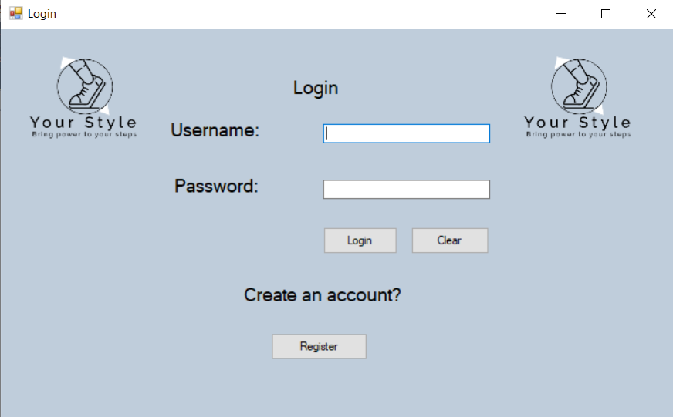
Register Form:
Once the “Register“ button is clicked, the user will be brought to the Register Form, where they can enter their personal details to create their own account to access the store. All the textboxes must be filled in for the user to register a new account successfully. The user has three buttons available to them on this form; Register, Clear and Return to Login. The “Register” button should be used to complete a new account being registered. The “Clear” button is used to clear any characters entered into the textboxes. The “Return to Login” button is used to return to the login form.
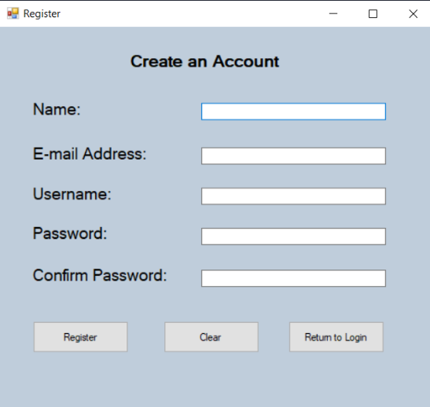
Manager:
Menu Form:
When the manager/ owner signs in, they are greeted by a simple welcome screen, with the addition of a simple menu to ease navigation for the user. These buttons will take the manager to the subsequent form, displaying the relevant information. They have the option to Log Out of the system as well, which will terminate the system.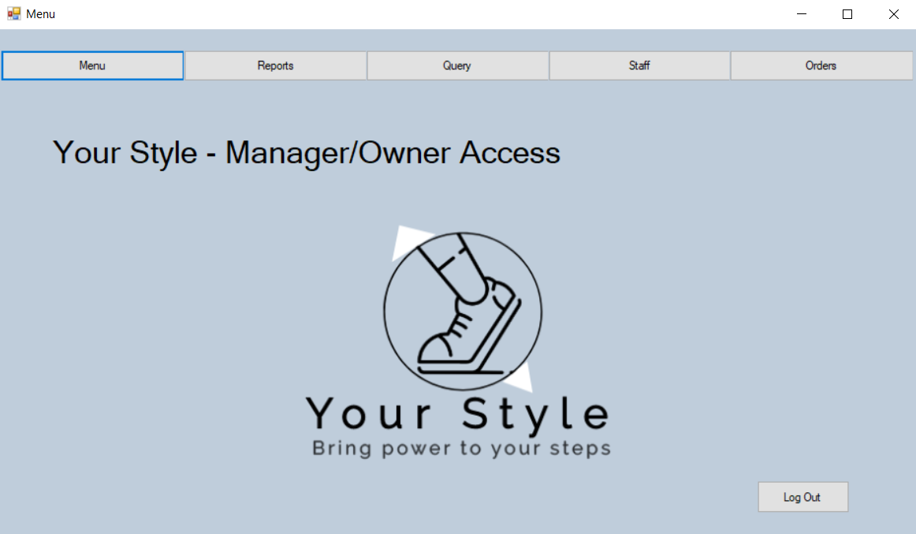
Report Form:
When the manager/ owner clicks on the “Reports” button, they are brought to a simple page, displaying a report on the performance of YourStyle Ltd. From the year 2019. Here they can analyze relevant information and view the sales performance of the company on a monthly basis. They also have the option to print the report out for personal use.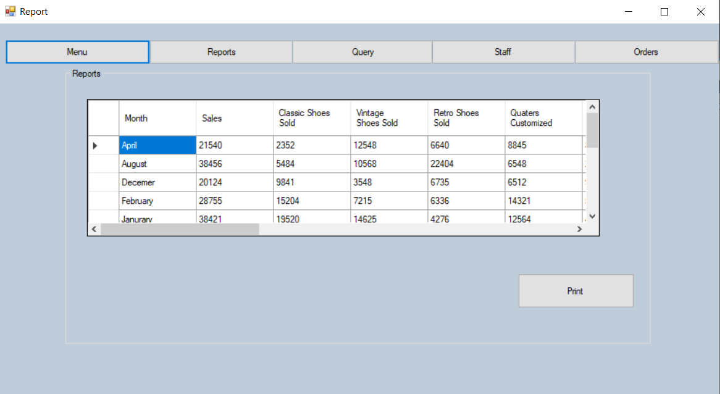
Query Form:
When the manager/ owner clicks on the “Query” button, they are brought to a easy-to-use page to calculate the price of a fully customized shoe after just a few clicks. This is here to help the manager/ owner to quickly check the price of products without having to waster time putting in a full order. This is only used for queries, and therefore an order cannot be processed through this form. The manager can get the Subtotal, VAT and Total value after clicking the “Calculate” button and clear their order if they click the “Clear” button.
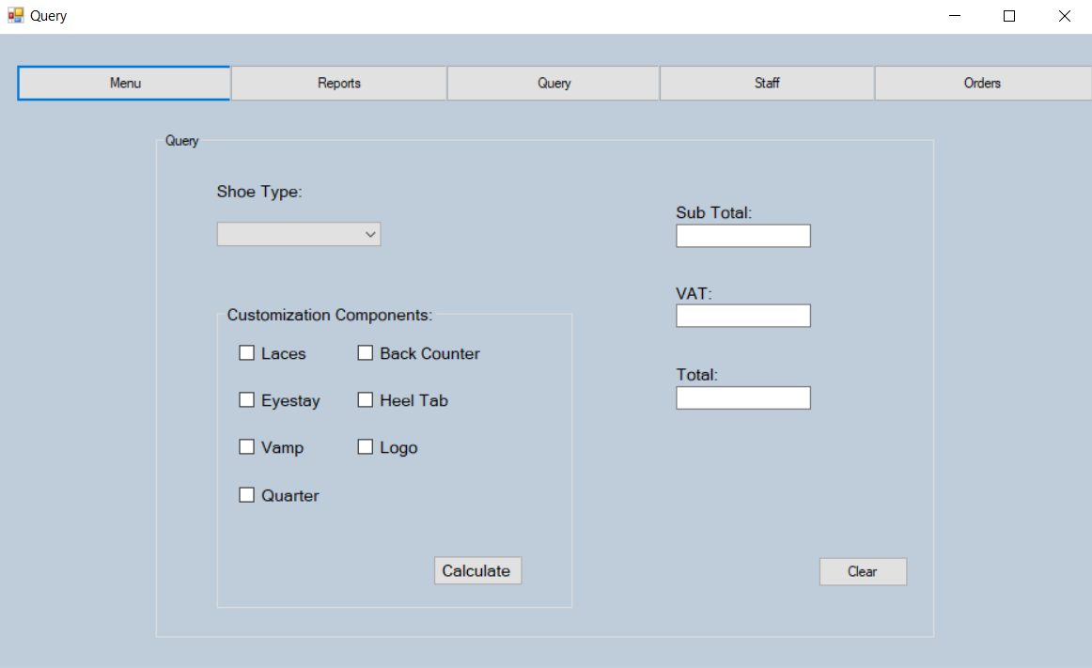

Staff Form:
When the manager/ owner clicks on the “Staff” button, they are brought to a form which displays the information about the staff that are working for him/ her. This displays their full name, staff ID, address and phone number, so the manager/ owner can contact their staff quickly and with ease.
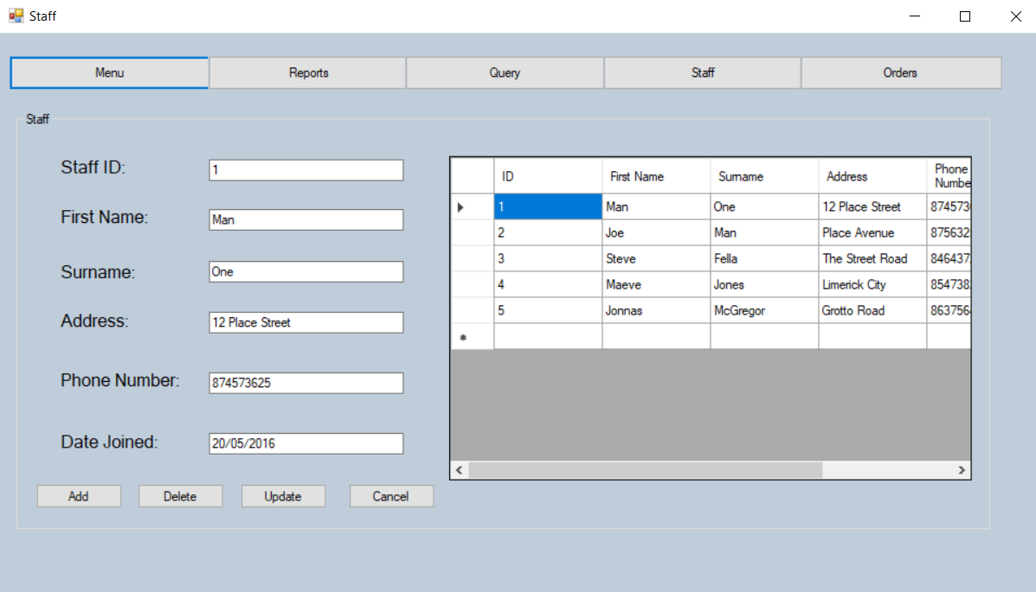
Orders Form:
When the manager/ owner clicks on the “Orders” button, they are brought to a page that displays relevant information regarding the orders processed by staff. This information includes the customer’s information about their order and includes their customization options and gives the total cost of the order.
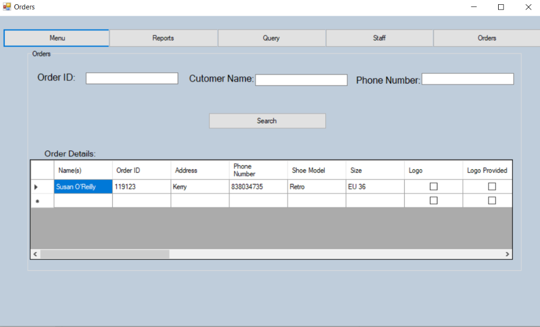
Customer:
Home Form:
After the customer logs in, they are greeted with a home page, similar to the manager/ owner’s home page. The menu consists of three options, Home, Customize Your Shoe and Your Account.
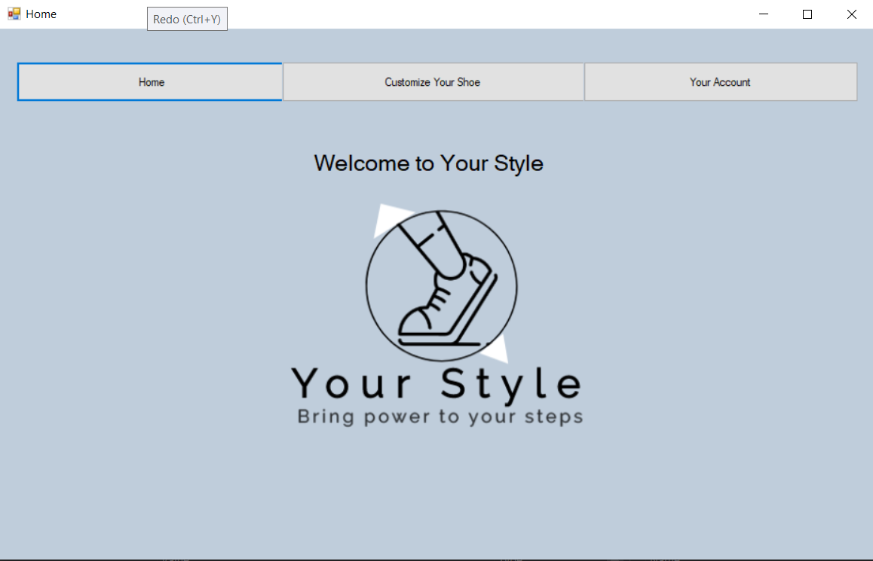
Customer Design Form:
When the user clicks on the “Customize Your Shoe” button, they are brought to the design page, where the customer can design their own custom shows in detail. The customer has the choice of three types of shoes, Classic, Retro and Vintage. Once picked, the customer has several customization options to choose from to design their shoes. They also have the option of adding a logo of their choice to be added to the design of the shoe. Once the user is finished, they should press the “Next” button to continue to place their order.
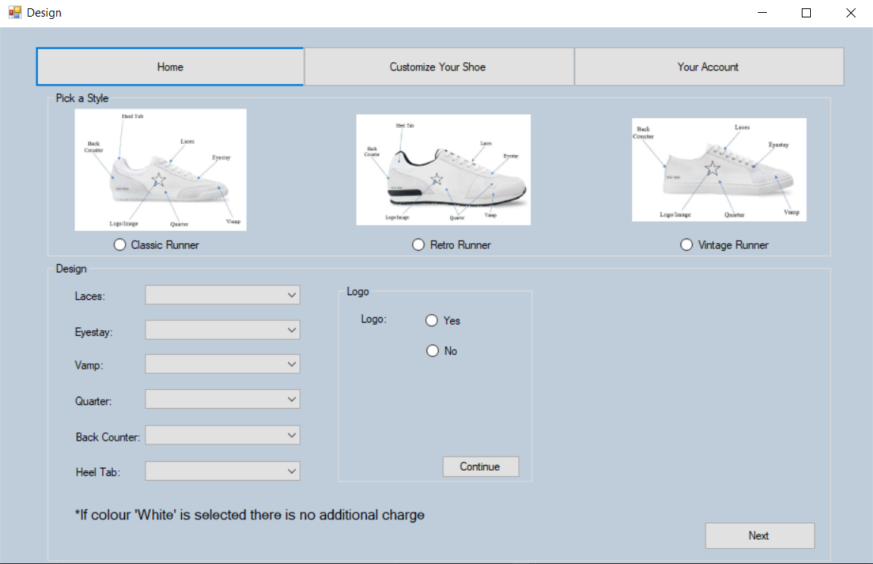
Customer Payment Form:
After the customer presses the “Next” button on the Customer Customization Form, they are brought to the Payment form. Here the user should enter their personal details as well as their order details to complete the order. Customers are also able to calculate the total price of their order before they place their order.
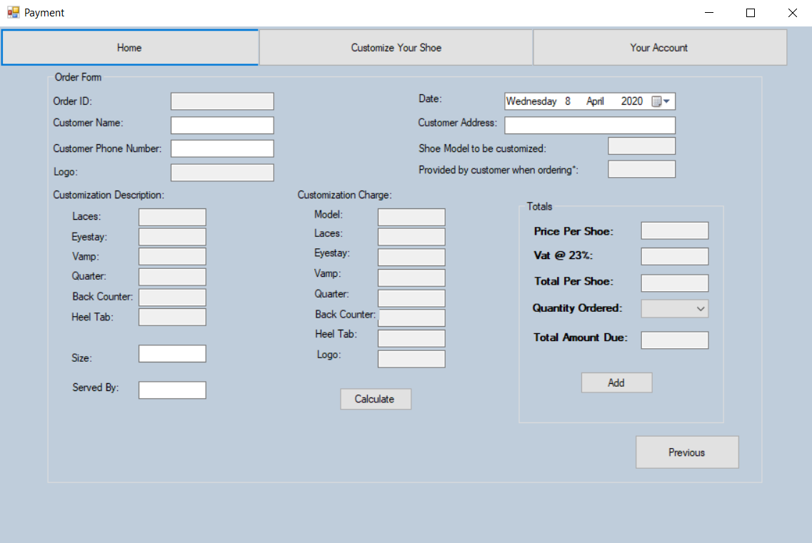
Your Account Form:
When the customer clicks on the “Your Account” button, they are brought to this page. Here the user has options to view their account information as well and their past and current orders. There is also a sign out option here for the user to easily terminate the session.
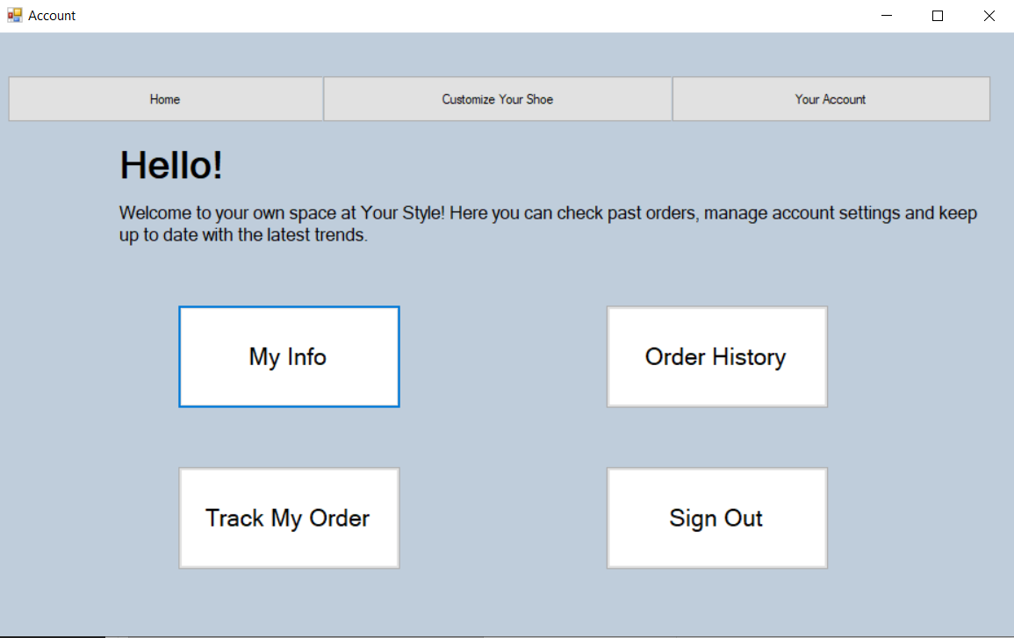
Customer Order Progress Form:
When the customer clicks the “Track My Order” button, the user is brought to the order progress page, where the customer can track their order by entering their personal details into the given textboxes. The user can then continue to view the progress on their delivery by clicking the “View Product Progress” button. The user can also press the “Update Product Status” radio button to get an updated insight into their order progress. There is also a “Log Out” button for the user to log out easily.
