**Encrypted Email**

**High Level Design**

**COP4331, Fall 2015**

Team Name: Encrypted Email

Team Members:

* Ryan Patrick | ryanxanpat@knights.ucf.edu
* Alex Chatham | achatham@knights.ucf.edu
* Thomas Tavarez | peepq@knights.ucf.edu
* David Clapp | [davidclapp@knights.ucf.edu](mailto:davidclapp@knights.ucf.edu)

Modification History:

|  |  |  |  |
| --- | --- | --- | --- |
| Version | Date | Who | Comment |
| 1.0 | 10/29/15 | Ryan Patrick | Initial document |
|  |  |  |  |

**Contents of this Document**

High-Level Architecture

Design Issues

**High-level Architecture**

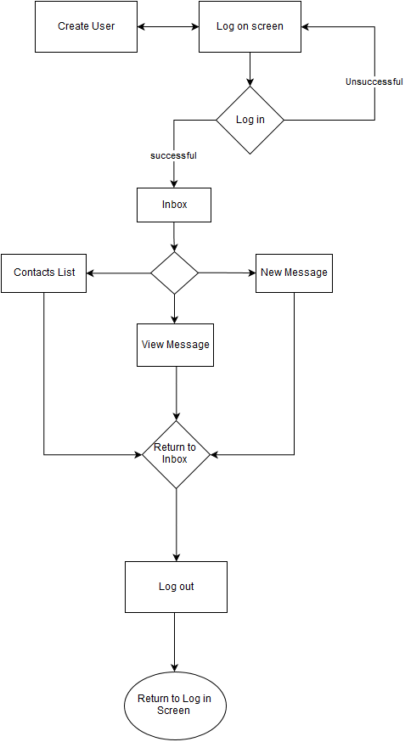

**Design Issues**

The key design issues are with reusability, maintainability, performance, and testability.  There will be no planned reusability of this application for future applications. The main issue for maintainability will be communicating ideas and general areas of where the developers are in the developmental process and also there will be work on maintaining the server. Performance is something that we cannot control because the application is being developed using HTML5. We will handle the testability in different ways. In the end, the testability will help us improve our application and get it ready for the final product to be delivered.

Some of the issues of portability and prototyping, we want this to be a stand-alone web based application using current generation web-browsers. Further development on to Android OS and iOS is expected, but is not planned just yet. Some technical difficulties that would cause an issue deal with the aesthetic appeal of the client.