

**Reminder App**

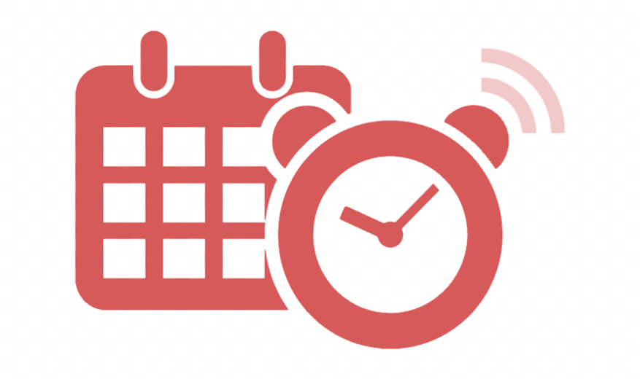

Analysis

CMSC 495 6380

September 8, 2019

Group 4

Dillon Cobb

Melissa Eardley

Allan Yu

**Revision History Table**

|  |  |  |
| --- | --- | --- |
| Date | Changed By | Change(s) |
| 9/6/2019 | Melissa Eardley | Initial Revision |
| 9/8/2019 | Allan Yu | Slight elaboration on functionalities |
|  |  |  |
|  |  |  |
|  |  |  |
|  |  |  |
|  |  |  |
|  |  |  |
|  |  |  |
|  |  |  |
|  |  |  |
|  |  |  |
|  |  |  |
|  |  |  |
|  |  |  |
|  |  |  |
|  |  |  |

**Contents**

1. Initial Analysis 4

a. Input Data 4

b. Sources of Input Data 5

c. Output Data 5

d. Destinations of the Output Data 5

e. Converting Input Data to Output Data 6

2. Detailed Analysis 7

a. System Interfaces 7

b. Input Data and Sources 7

c. Output Data and Destination 7

d. Data Processing 8

e. Sub Systems 9

f. Interface Systems 10

g. Reconcile Solution with Requirements 11

h. Identify Potential Risks 11

i. Identify Possible Enhancements 11

# Initial Analysis

## Input Data

Users will access the Reminder App using a unique username/ID and password. IDs are unique and assigned when the user creates an account. IDs are separate from usernames which are selected by the user and do not need to be unique (so, for example, there can be multiple “UMUC” users, but only one UMUC#0001).

**Account Creation Inputs:**

|  |  |  |
| --- | --- | --- |
| Item | Description | Example |
| Username | * Set by the user * Does not need to be unique | TomTom26 |
| ID | * Set by the app * Is unique | 0000000001 |
| Email | * Provided by the user * Needs to be valid | [Tom1@gmail.com](mailto:Tom1@gmail.com) |
| Phone  *Optional* | * Provided by the user * Needs to be valid | (###)###-#### |
| Password | * Provided by the user * Needs to meet the minimum complexity rules | P@$$word123 |

**Login Inputs:**

|  |  |  |
| --- | --- | --- |
| Item | Description | Example |
| User + ID | * Set by the app * Is unique | TomTom26#0001 |
| Password | * Provided by the user * Needs to meet the minimum complexity rules | P@$$word123 |

**Event Inputs:**

|  |  |  |
| --- | --- | --- |
| Item | Description | Example |
| Event | Event description | Marine Corps Birthday Ball |
| Date | * Date of the event * Date can be typed or selected using a calendar tool | 10/10/2019 |
| Event Time | Start of the event | 1800 |
| Description | * User can write whatever they want/need here, such as: * Where the event is occurring * Who’s involved, what’s it for, etc. | Omni Sheraton DC  2500 Calvert St NW,  Washington, DC 20008 |
| Notification  Time | * When the notification should be sent * Current version will allow for a single notification | 24 hours before |

## Sources of Input Data

With the exception of the application-generated user ID, the user is the sole source of input data. The user enters the data into the system using a keyboard and mouse. A date picker tool can optionally be used to select dates.

## Output Data

The Output Data is the events created by the user along with the notifications for those events.

Other examples of output data would be warnings to the user when they attempt to enter duplicate events, or conflicting events.

## Destinations of the Output Data

A web display splash screen will list the events entered by the user.

Placeholder for Web Display

Notifications will be sent to the user via email as specified in the event. When practical, notifications will be converted to tomorrow, x days from now or x hours from now.

From: Reminder App

Sent: November 9, 2019 6:00PM

To: [Tom1@gmail.com](mailto:Tom1@gmail.com)

Subject: REMINDER: Marine Corps Birthday Ball

TomTom26,

Here is your friendly reminder that the Marine Corps Birthday Ball is tomorrow at 6:00PM.

The event is being held at: Omni Sheraton DC

2500 Calvert St NW,

Washington, DC 20008

Kind regards,

*Reminder App*

Notifications may be sent as text messages, as follows:

Notification App 6:00PM

The Marine Corps Ball is tomorrow at 6:00PM. Login to your ReminderApp to see details.

## Converting Input Data to Output Data

During account creation, the user supplied data will be verified. A new user must supply valid data for all required items. The user can optionally provide valid data for the optional items. Once an account is successfully created, the user account data will be added to the database and the user will be sent an email notification updating their account status.

Events will not be added to the database unless all required items are completed. Once added to the database, the event will be listed in the web display. The web display will allow the user to sort and or filter events by date or type. Notification times will not be altered in the display, and will be listed as selected by the user.

Notifications will be made to the user as specified by the user. The email client will send the notifications at the time elected by the user. The content of the notification will be consistent with the user set event details. Email notifications will contain all event details. Text notifications will contain the name of the event and when it is scheduled to start along with a prompt to login to the Notification App.

# Detailed Analysis

## System Interfaces

The ReminderApp will interface with the user, as well as an email client.

## Input Data and Sources

The source of the data will primarily be the user.

When creating a new account, the user will supply a username, password, and email. The user can optionally provide a phone number. The system will assign the user a unique user ID.

When logging into the ReminderApp the user will enter their user ID along with their password.

When creating an event, the user will be allowed to enter the event_description, event_date, event_time, and event_name, and/or notification_time.

## Output Data and Destination

Events will be added to the database.

Events listed in the database will be displayed in the web browser. The ReminderApp has been designed to work within the Chrome web browser.

Event notifications will be sent as emails.

Event notifications may also be sent as text messages provided a valid phone number was provided for the user.

## Data Processing

The following context diagram shows the outside system interacting with the ReminderApp.

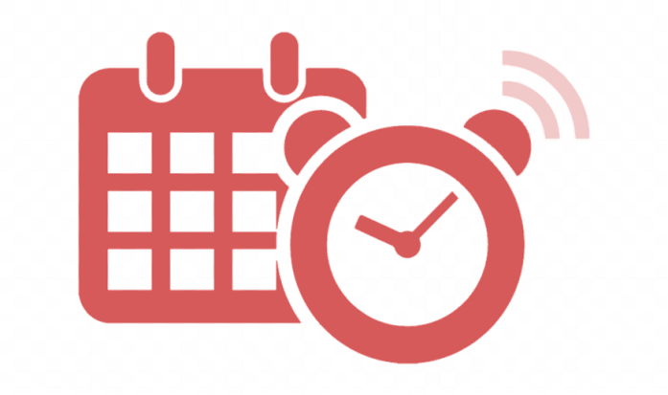

* Event_Name
* Event_Description
* Event_Date
* Event_Time
* Notification_Time



* Displayed in Web
* Reminder Notifications sent

## Sub Systems

The following graphic shows the subsystems which are as follows:

Event entry system: allows user to add, delete or modify events; performs data validation

Database: stores the data entered by the user; interfaces with the email client

ReminderApp display: displays events to the user; interfaces with the database

Email client: sends notifications; interfaces with the database



*User*

*Event Entry System*

*Database*

*ReminderApp Web Display*

*Email Client*

## Interface Systems



*User*

*Event Entry System*

*Database*

*ReminderApp Web Display*

*Email Client*

INPUT

INPUT/OUTPUT

OUTPUT

OUTPUT

## Reconcile Solution with Requirements

| Req# | Description | Met? |
| --- | --- | --- |
| 1 | The system shall allow the user to create a reminder | Y |
| 1.1 | The system shall allow the user to enter a date and/or time | Y |
| 1.1.1 | Depending on whether date/time is given, the reminder can be set to all day or until removed/cancelled. | Y |
| 1.2 | The system will allow users to designate certain date categories | ~ |
| 1.2.1 | This can include Birthdays, Anniversaries, etc. | ~ |
| 1.3 | The system shall allow the user to modify events | Y |
| 1.4 | The system shall allow the user to remove events | Y |
| 2 | The system shall store and retrieve data using a database | Y |
| 3 | The system shall be capable of sending notifications | Y |
| 3.1 | The system shall be capable of sending notifications via email | Y |
| 3.2 | The system shall be capable of sending pop-up notifications | ~ |
| 3.3 | (Optionally, the system will also be capable of sending out SMS Texts) | ~ |
| 4 | The system shall prevent the user from adding duplicate entries | Y |
| 4.1 | A prompt can be given to the user, to remind them of an existing entry and whether they’d like to modify it (in case of collisions, etc.) | Y |
| 5 | The system shall be capable of identifying conflicting appointments | Y |
| 6 | The system shall be capable of preventing the user from entering invalid data | Y |
| 6.1 | The user cannot enter dates in the past | Y |
| 6.2 | The user cannot enter invalid email addresses | Y |
| (6.3) | Validation of notification methods may or may not be checked on account creation | Y |
| 7 | Users will be able to create accounts to login and check for existing reminders | Y |

~1.2, 1.2.1: Everything can be written into an event description.  
~3.2: Event notifications will not appear as popups. Research indicates that pop-up blockers would interfere with such notifications. This requirement may be removed.  
~3.3: May be optionally implemented

## Identify Potential Risks

* Server malfunctions (Add more servers?)
* User enters invalid data (Add validation)
* Daylight Savings time (Use UTC, or add Timezones)
* Updates to web browser interfere with ReminderApp (Keep up with updates)
* Issues interfacing the subsystems

## Identify Possible Enhancements

* Allowing the user to set up a series of reminders
* Allow the user to set up a recurring event
* Allow the user to send notifications to other people
* Allow the user to invite people to events
* Allow user to select time zone when establishing their account
* Auto-delete events after notifications have been sent
* Allow user to add notes about the event