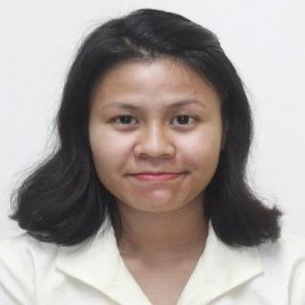

**JESSAVEL A. TORING**

Riverside Canduman, Mandaue City,Cebu

Cell Phone No. 09474972243

Email: [jessavel.toring@student.passerellesnumeriques.org](mailto:jessavel.touring@student.passerellesnumeriques.org)

**OBJECTIVES:**

To be part of a company that indulges professional growth which provides challenging and rewarding career while allowing me to utilize my knowledge and skills.

**STRENGTHS:**

* Initiative and ability to work with minimal supervision.
* Easily adapt to changes.
* Can work under pressure.
* Can do multitasking work.

**ADDITIONAL SKILLS:**

* Programming skills in Java and Python
* Proficient in MS Office Application (Word, Excel, Power Point)
* HTML5

**EDUCATIONAL PROFILE:**

**Tertiary :** University of San Carlos - Talamban Campus

Nasipit, Talamban, Cebu City

2018-2021

**Course :** Certificate of Computer Technology

**Secondary :** Sisters of Mary School - Girlstown, Inc.

J.P Rizal St., Talisay City, Cebu

2012-2016

**Primary :** Canduman Elementary School

Canduman, Mandaue City, Cebu

2005 - 2011

**PERSONAL PROFILE:**

**Birthday :** December 07, 1997

**Age :** 21

**Religion :** Roman Catholic

**Gender :**  Female

**Height :**  5’ 2

**Weight :** 46kg

**Civil Status :** Single

**Father’s Name :** Artemio Toring

**Mother’s Name :** Anally Toring

**CHARACTER REFERENCES:**

**TRESHA MAE TORINO**

Passerelles numeriques Philippines Professional Life Training Teacher

[tresha.torino@passerellesnumeriques.org](mailto:tresha.torino@passerellesnumeriques.org)

**JOHANNA SIRA**

Passerelles numeriques Philippines Second Year Educator

[johanna.sira@passerellesnumeriques.org](mailto:johanna.sira@passerellesnumeriques.org)

**MARIE MAUREEN SALVALEON**

Passerelles numeriques Philippines Academic Officer

[marie.salvaleon@passserellesnumeriques.org](mailto:marie.salvaleon@passserellesnumeriques.org)

**RENE ABDALLAH**

Passerelles numeriques Philippines IT &amp; Training Manager

[rene.abdallah@passerellesnumeriques.org](mailto:rene.abdallah@passerellesnumeriques.org)