**Interface Design**

1. **Homepage**

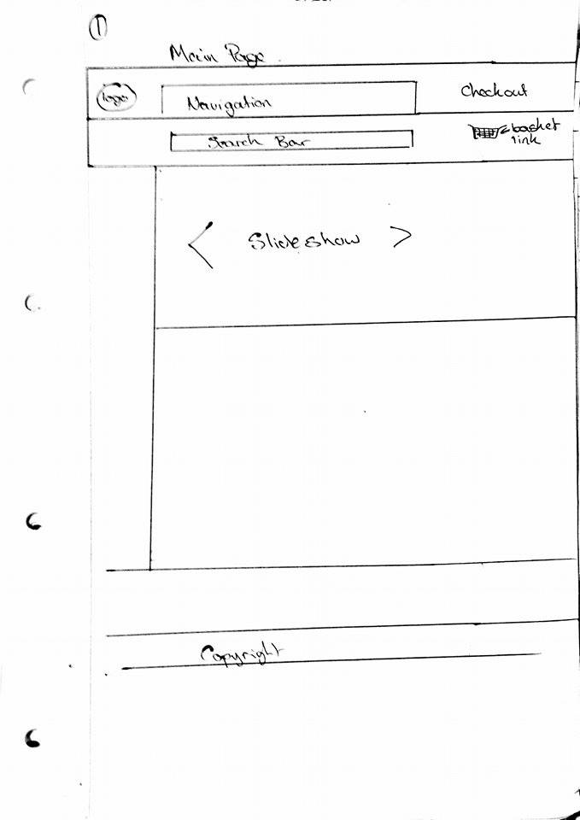

This page will appear when the website is opened. It allows the user to navigate the website.

The side bar will show a list of general search options, such as price filters, artist names, genre filters, Year of release, etc. Options selected on the home page will lead the user to the query page. Alternatively the user can use the search bar which will bring them straight to the results page.

1. **Query page**

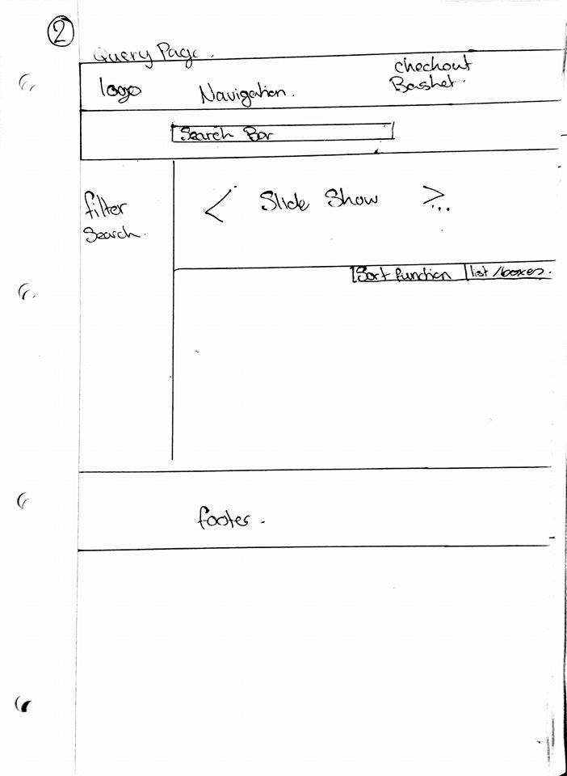

The query page will contain a list of more specific features and search options. It will also only display items which are relevant to the option selected on the home page. When the user searches items on the query page the webpage will display the results on the results page.

1. 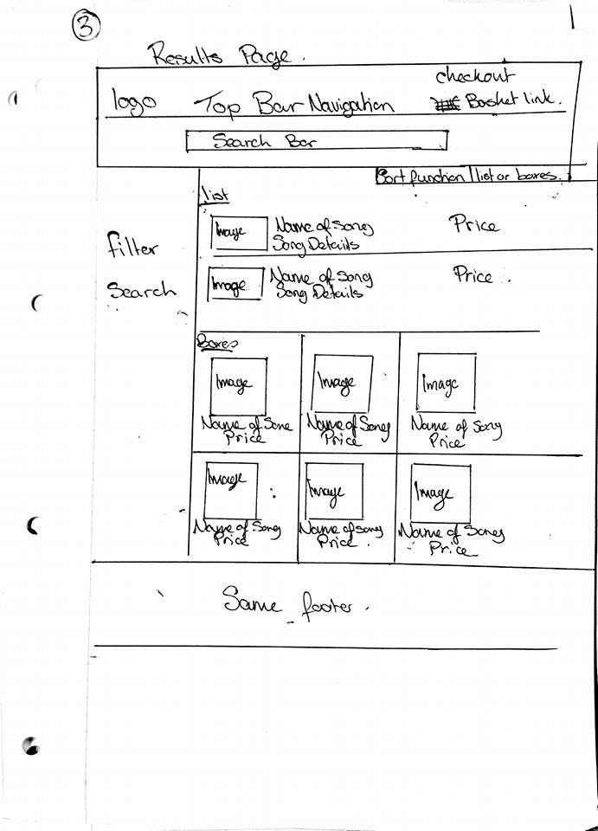**Results page**

The results page will display a list of items relevant to the users search. Users will be able to select items to go to the items description page.

1. **Items description page**

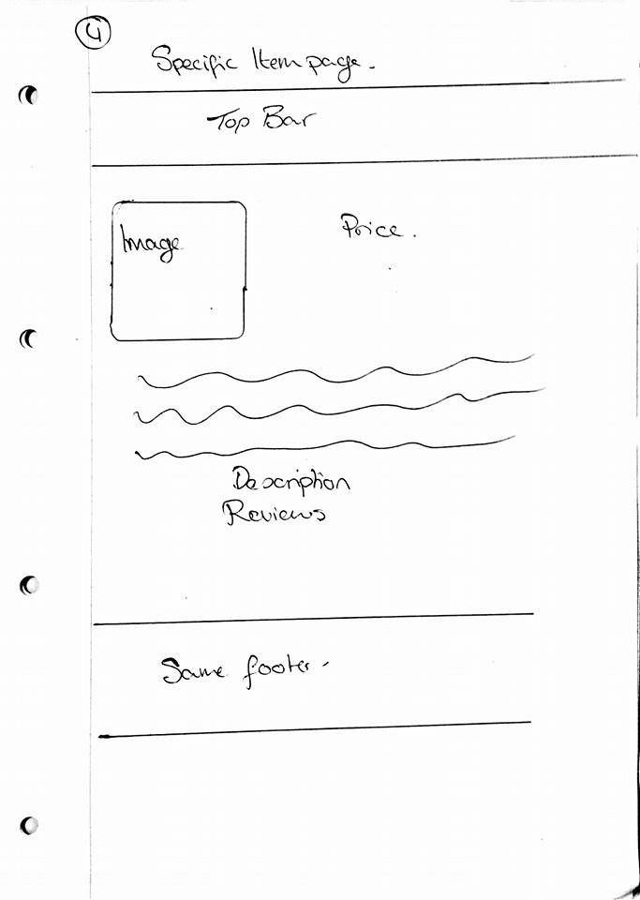

This page will provide a description of the item selected. It will also provide reviews of the item ad an option to add item to shopping basket.

1. **Shopping basket**

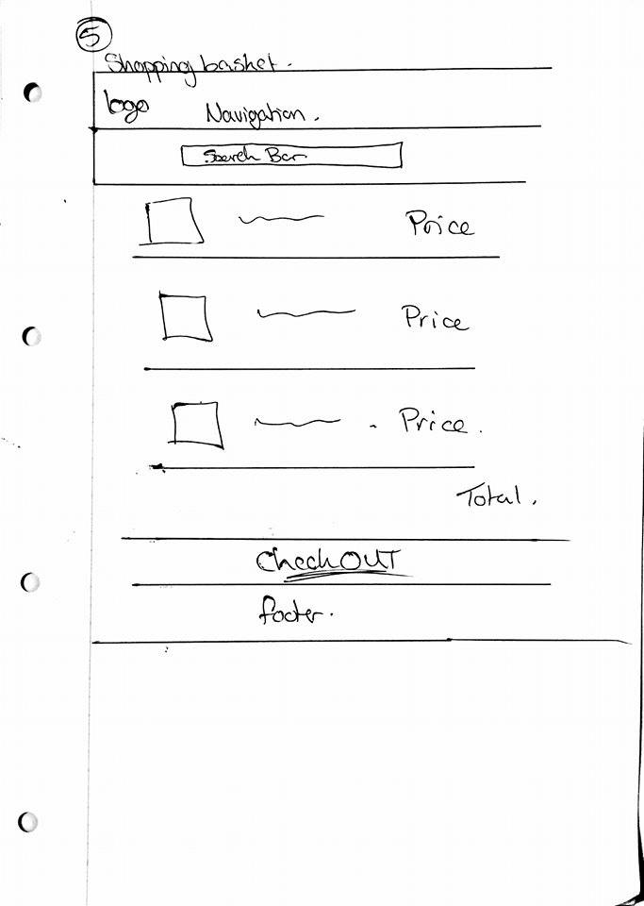

The shopping basket will display a list of all items selected by the user as well as the total price of all the items. The user can then select to go to checkout which will bring them to the checkout page.

1. **Checkout/payment page**

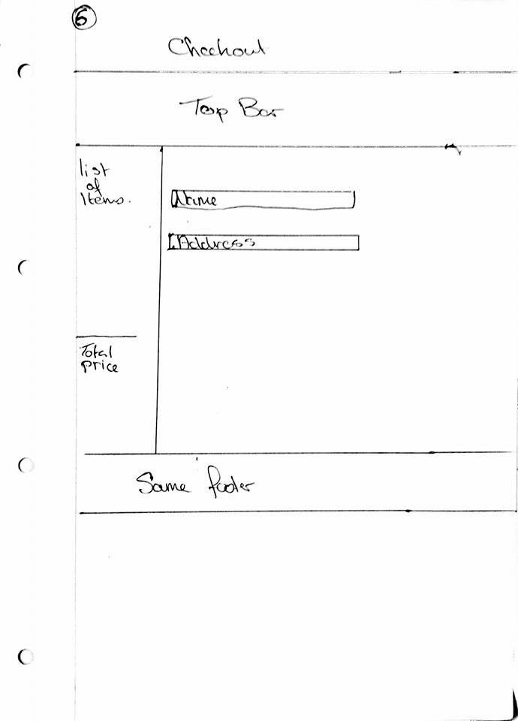

In this page the user will fill in all details needed for delivery and purchase of the item(s). The page will also provide a list of the items in the shopping basket as well as the total price of the items.