## Objective of the Project

As customers have to queue for a long time on phone waiting to make a reservation of car, in order to save customer’s and company’s itself time the project aims to automate the vehicles’ rental and reservation. The primary goal of this project is to make life easier for the Alpha car rental firm by creating a system for online automobile rentals (Howell, Laufer & Ballard 1993). In distinctive, the objectives of this project are:

* Creating a web-based system to handle the company's automobile rental operations and allow customers to register and make reservations for vehicles online.
* To facilitate online car rentals for customers.
* Increase in efficiency and reduce load by speeding up the tasks.

## Project scope and limitations

The web-based application portal is part of the project known as the Car Rental Portal Management System. The main users of the system are the administrators, customers, renters, and staff. This project covers many different subjects, ranging from business to the IT sector. Numerous investigations were necessary for this project, and they enabled us to meet the project's goals (Khan 2006). The area which this project covers are:

* Automobile rental sector
* PHP Technology
* Both workers and regular customers will utilize the system.
* This system will run every second unless there will be server errors

**Limitations of project are:**

* Higher pricing, which indicate that there are other, less expensive possibilities to renting a vehicle online.
* A maintenance issues. It will cost the firm a lot of money if the server is down or the portal is not functioning.
* Security issues

## Assumptions

Developers have access to the software tools needed for system development. The demands gathered are accurate and realistic. The project's final deliverable can be hosted on a server. The operating system that this system will operate under has no restrictions. However, the database and the online car rental portal will operate on a server that must always be online. Any internet browser can be used to access the system by users (Thakur 2021). The project will be completed within the given timeframe without any hassle.

## 5. Use case diagram

In simple word, a use case diagram is a process to summarize the details of the system and the users within that system. It is a graphical presentation of interactions among different elements in the project (Contributor 2020).

The interaction between the actors and their use cases is described in depth in the actor and use case description.

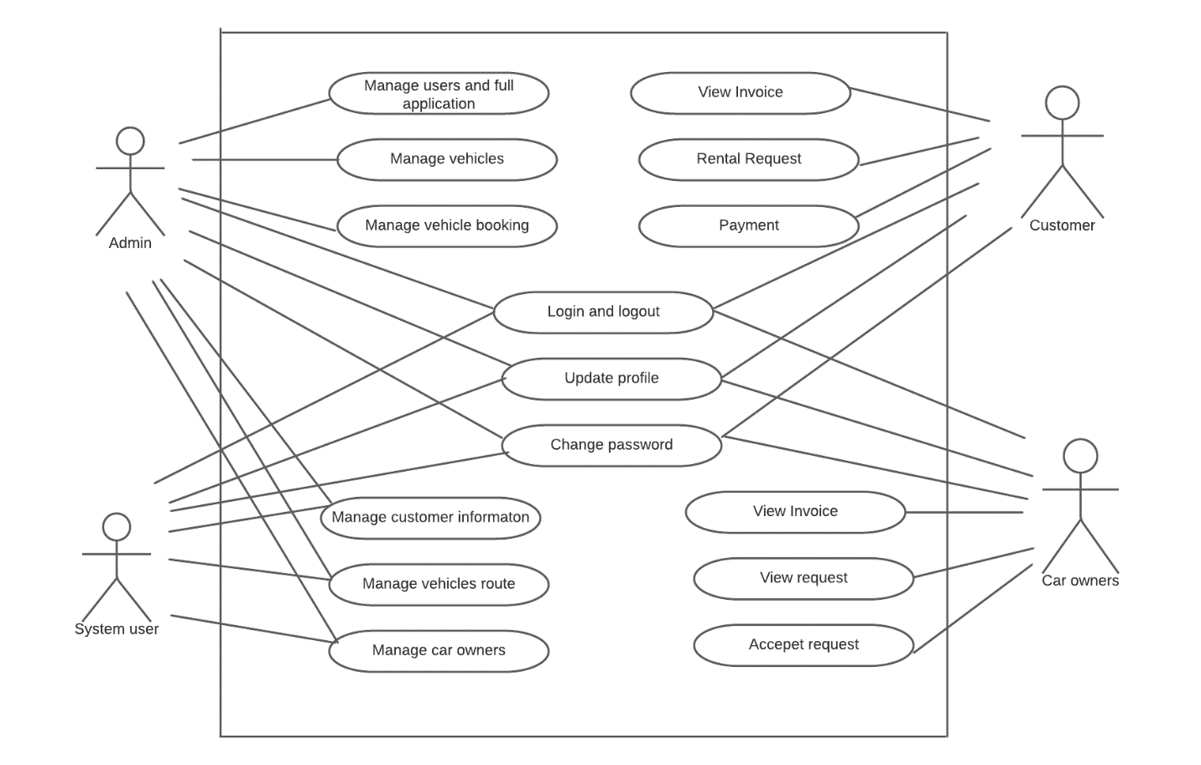 Figure 1: Use Case Diagram

# References

Contributor, T 2020, ‘ *Use case diagram*.’ Retrieved from techtarget: <https://www.techtarget.com/whatis/definition/use-case-diagram>

Howell, G, Laufer, A & Ballard, G 1993, ‘Uncertainty and project objectives’, *Project Appraisal*, vol. 8, no.1, pp.37-43.

Khan, A 2006, ‘Project scope management’, *Cost engineering*, vol.48, no.6, pp.12-16.

Thakur, A 2021, ‘Car Rental System’, *International Journal for Research in Applied Science and Engineering Technology*, vol.9, no.7, pp.402-412.