Unless its stated otherwise , in order to select an option from a selection menu you should type the number in the beginning.

Number) OPTION_A

The system’s main menu is printed the moment you run the program :

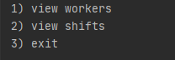

In the main menu you can either view the workers menu , the shift menu or exit the program.

View Workers :

By choosing this option the system will print a list which represents the workers in the company in the following format :

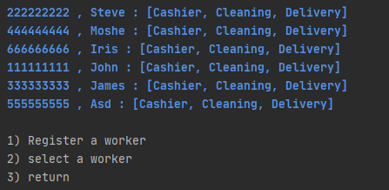

-- Worker ID , Worker Name , [The jobs that the worker can do] --

*If you are interested in adding a new worker to the database choose the “register a worker “ option and it will automatically start a progress which will ask you to fill some essential details and info about the new worker you wish to add. Here is a detailed example :

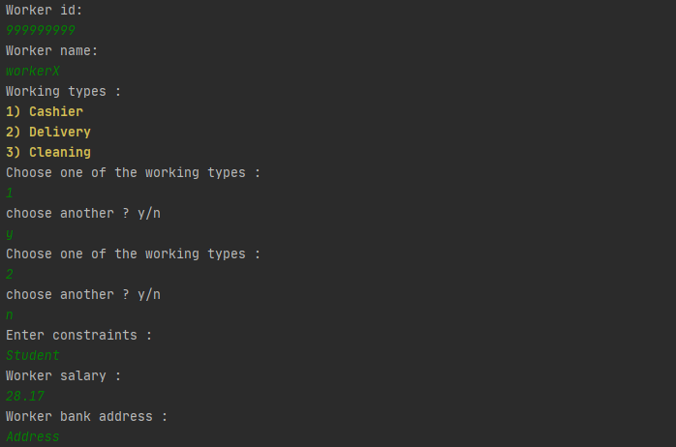

If you wish to allow the worker to work more than one job when asked to “choose another ? y/n “ type “y” and hit Enter , then you can type another number for the “Worker types “ list , you can continue to add job types to the worker and when you decide the its enough type “n” as an answer to the popup “choose another ? y/n.

After registering the new worker , he should appear in the “ view workers “ list :

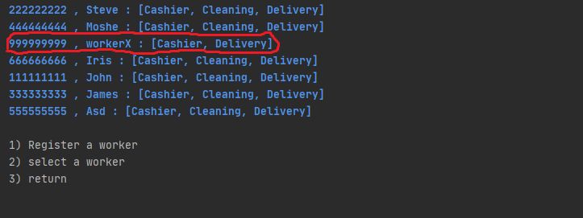

*if you’re rather interested in viewing more details about the workers ( such as his working shifts , contract etc.) or editing his info then choose the “select a worker option “ , you will be required to type the id of this worker , then the user basic details will be printed on the screen followed by a list options that you can choose from :

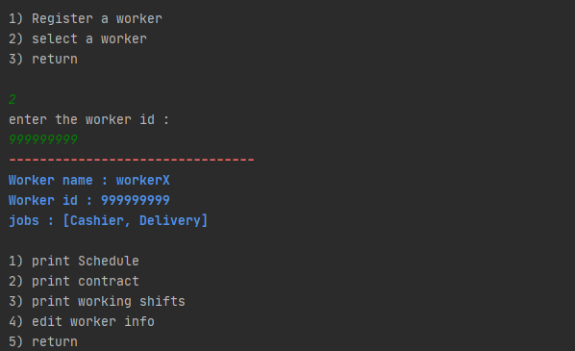

*to view the worker’s schedule , which represents the time he can work in according to his constraints , select the “print schedule “ option , it will print the schedule in this format :

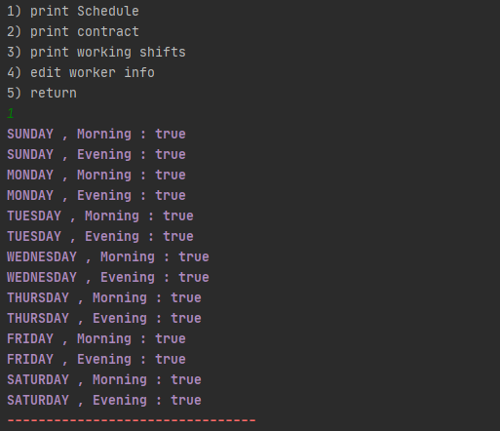

-- Day , ShiftTime : CanWork? –

Note : canWork? doesn’t mean that the worker is **available** , it means that he can work but maybe he is already signed for a shift at that time.

For more details check the shift view session.

*if you wish to view the worker’s contract , then you should select the “print contract “ option , it will be printed in this format :

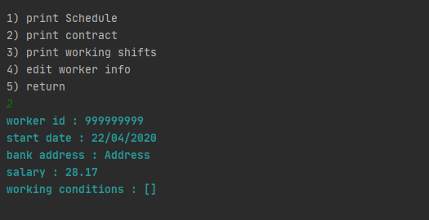

*to view the shifts that the worker is part of , choose “print working shifts “ :

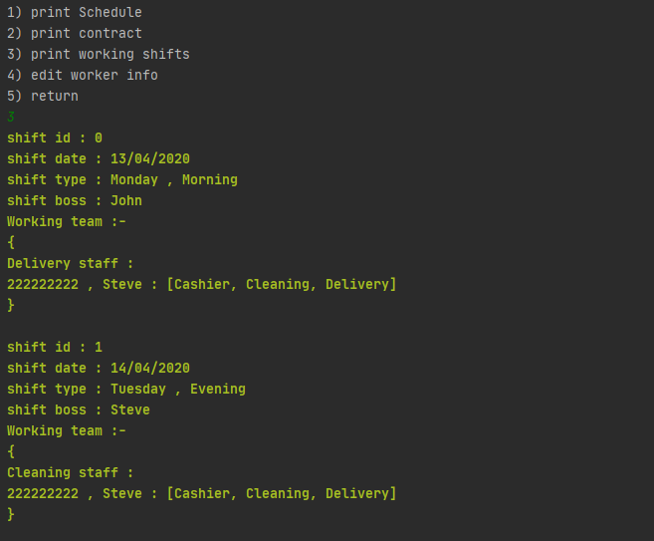

* you can edit the worker’s details using the “edit worker details “ feature , which has a handful of options ,format :

Simply choose the desired piece of info you wish to edit and type the new value , you can see the updated worker from the “worker view ” option we saw earlier :

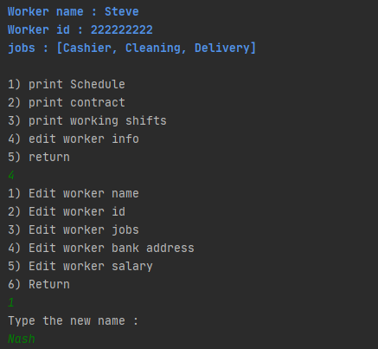

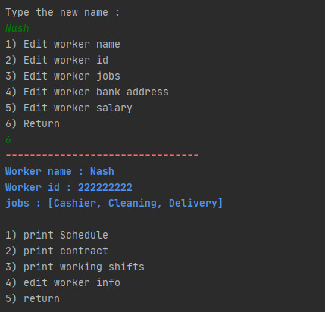Result :

From the main menu you can view all the shifts :

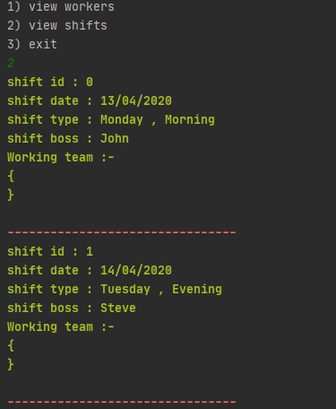

Here we see that there are 2 shifts in the Shift History