Group-IB Threat Intelligence Extension for QRadar
Installation Guide

- Required: QRadar 7.3+
- Open QRadar web interface, log in as administrator.
- You need to create authorized security token. Go to Admin tab, in User Management
Click on Authorized Services.
In opened window click on Add Authorized Service. Use “GIB TI” as a Service Name. “User Role” and “Security Profile” should be "Admin".
Check "No Expiry" as Expiry Date and then press Create Service.
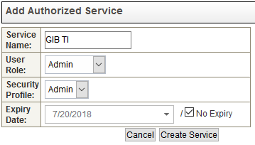
You'll see a new service in the table. Copy “Authentication Token” for this new service for later use.
Close Authorized Services window and get back to Admin tab in QRadar web interface. (Note: Don’t forget to deploy changes)

- In System Configuration open Extensions Management. In opened window click on Add.
- Browse application .zip file and check “Install Immediately” checkbox. Press Add. Ignore "the extension is not signed" warning and press Install.
- QRadar will validate install, after that click on Install.
- Refresh QRadar page after installation.

User Guide

After successful installation you will see new tab “GIB_TI”.
Feed Subscription window
In this tab you should enter your Group-IB Threat Intelligence credentials.
- URL – URL of discovery page: https://bt.group-ib.com/taxii/services/discovery
- Login – Your Group-IB Threat Intelligence Login
- Password – your Group-IB STIX/TAXII key (Note: it’s not the same password as you use for Web-login)
- Security Token – QRadar Authorization security token that you created in step 3 of Installation manual.
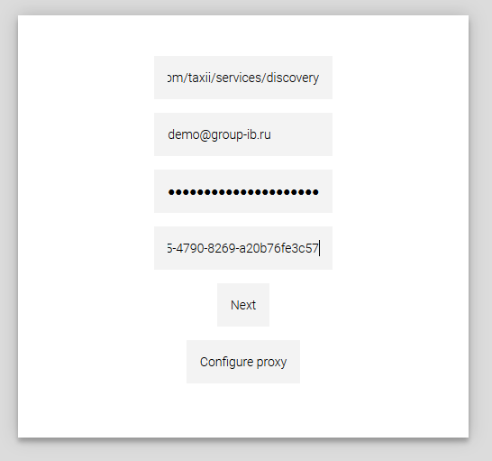

Optionally, you can configure connection to proxy server for downloading STIX data. (Note: After clicking on “Next” button discovery request to GIB server will be sent, so if you want to use proxy, you should configure it now. Although there will be possibility to change proxy settings later.)
After pressing “Next” button you should wait a while before QRadar will request possible collections.

Configuring connection to proxy server
In this tab you should enter data for proxy connection.
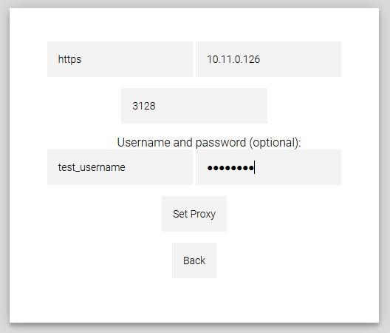
- Protocol – http or https
- Address – proxy server address
- Port – proxy connection port
- (Optional) Username and Password – if your proxy server requires username and password for connection, type it here
“Back button” returns you to previous page, “Set proxy” saves proxy settings. If you don’t want to use proxy connection anymore, you should leave all fields empty and press “Set proxy”.

Collection window
In this window you should check needed collections, choose First Poll date – that is start date from which data should be downloaded, and set living time for data.
NOTE: Choose only needed data and not too early “start date” otherwise initial poll will take too long and will use too much server resources.
NOTE: If reference set for checked collection already exists, living time of its elements won’t be changed, you have either to change it, or to delete reference set manually, so the new one with the proper living time will be created. This doesn’t affect living time for elements is database, it will be taken from this form anyway. GIB reference sets are listed below:
- GIB_accs_logins
- GIB_card_numbers
- GIB_cnc_ips
- GIB_ddos_ips
- GIB_device_imeis
- GIB_files_names
- GIB_hacktivism_names
- GIB_malware_titles
- GIB_mules_accounts
- GIB_phishing_ips
- GIB_proxy_ips
- GIB_sample_names
- GIB_socks_ips
- GIB_threat_emails
- GIB_threat_files
- GIB_threat_ips
- GIB_threat_urls
- GIB_tor_ips

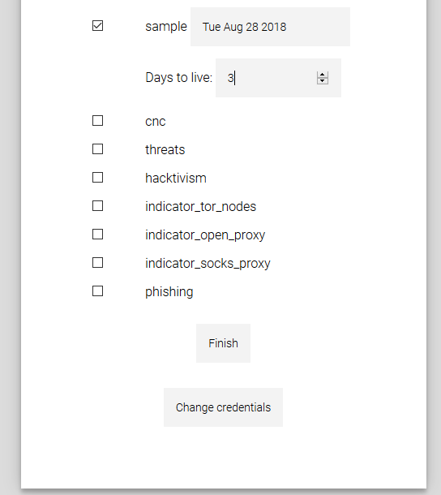
After choosing all necessary collections click “Finish”.
The first poll will start automatically. Click on collection name to see data while downloading.

System management
System downloads new data each hour.
You may configure system, for that you should press “Configure” button in top left corner:
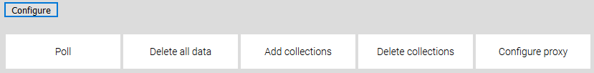
- “Poll” is used to manually poll new data
- “Delete all data” is used to clear database (but not reference sets – you should clear it manually).
- “Add collections” is used to add new collections
- “Delete collections” is used to delete chosen collections
- “Configure proxy” is used to change proxy settings

Collection data and navigation
To view collection press collection name button. You may navigate between different pages and view additional information about each feed by clicking “More info” link.
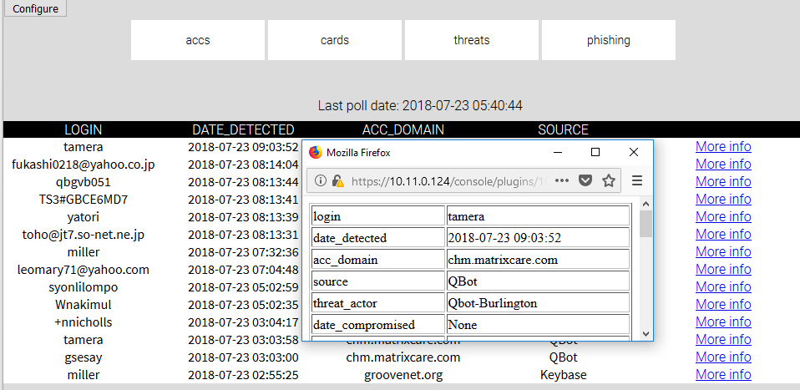

All valuable data is stored in Reference Set, so you may configure “Custom Rules” to correlate information between events and Threat Intelligence feeds.
