Software Project Proposal

Android Map Application

**Group:** M

**Project Time frame:** October 2016 – April 2017

**Project Summary:** To develop an interactive map of the Goldsmiths University Campus

**Project Team:** The roles of each team member are the following:

* **Project Manager** – Bezhad Karimizadehbehbahani (bkari001)
* **Application Designer** – Joel Mayner (jmayn001)
* **Application Developer** – Marcellino Samuels (msamu001)
* **Researcher and Tester** – Thamir Suwar (tsuwa001)

# Contents

[**Software Project Proposal**](https://docs.google.com/document/d/1jKP8HXVuLyKHrEvIHkI3ebOw7RKGz52PHQ6e0_gCdPQ/edit?ts=584dc0d6#heading=h.gjdgxs)[**1**](https://docs.google.com/document/d/1jKP8HXVuLyKHrEvIHkI3ebOw7RKGz52PHQ6e0_gCdPQ/edit?ts=584dc0d6#heading=h.gjdgxs)

[**Overview**](https://docs.google.com/document/d/1jKP8HXVuLyKHrEvIHkI3ebOw7RKGz52PHQ6e0_gCdPQ/edit?ts=584dc0d6#heading=h.30j0zll)[**3**](https://docs.google.com/document/d/1jKP8HXVuLyKHrEvIHkI3ebOw7RKGz52PHQ6e0_gCdPQ/edit?ts=584dc0d6#heading=h.30j0zll)

[**Research and Data Analysis**](https://docs.google.com/document/d/1jKP8HXVuLyKHrEvIHkI3ebOw7RKGz52PHQ6e0_gCdPQ/edit?ts=584dc0d6#heading=h.1fob9te)[**3**](https://docs.google.com/document/d/1jKP8HXVuLyKHrEvIHkI3ebOw7RKGz52PHQ6e0_gCdPQ/edit?ts=584dc0d6#heading=h.1fob9te)

[**Ethical Audit**](https://docs.google.com/document/d/1jKP8HXVuLyKHrEvIHkI3ebOw7RKGz52PHQ6e0_gCdPQ/edit?ts=584dc0d6#heading=h.3znysh7)[**4**](https://docs.google.com/document/d/1jKP8HXVuLyKHrEvIHkI3ebOw7RKGz52PHQ6e0_gCdPQ/edit?ts=584dc0d6#heading=h.3znysh7)

[Core Build](https://docs.google.com/document/d/1jKP8HXVuLyKHrEvIHkI3ebOw7RKGz52PHQ6e0_gCdPQ/edit?ts=584dc0d6#heading=h.tyjcwt) [5](https://docs.google.com/document/d/1jKP8HXVuLyKHrEvIHkI3ebOw7RKGz52PHQ6e0_gCdPQ/edit?ts=584dc0d6#heading=h.tyjcwt)

[Addendum Build](https://docs.google.com/document/d/1jKP8HXVuLyKHrEvIHkI3ebOw7RKGz52PHQ6e0_gCdPQ/edit?ts=584dc0d6#heading=h.j0ibg9um2j9h) [5](https://docs.google.com/document/d/1jKP8HXVuLyKHrEvIHkI3ebOw7RKGz52PHQ6e0_gCdPQ/edit?ts=584dc0d6#heading=h.j0ibg9um2j9h)

[Technology](https://docs.google.com/document/d/1jKP8HXVuLyKHrEvIHkI3ebOw7RKGz52PHQ6e0_gCdPQ/edit?ts=584dc0d6#heading=h.3dy6vkm) [6](https://docs.google.com/document/d/1jKP8HXVuLyKHrEvIHkI3ebOw7RKGz52PHQ6e0_gCdPQ/edit?ts=584dc0d6#heading=h.3dy6vkm)

[Wi-Fi /Mobile networks (4G/3GS/3G)](https://docs.google.com/document/d/1jKP8HXVuLyKHrEvIHkI3ebOw7RKGz52PHQ6e0_gCdPQ/edit?ts=584dc0d6#heading=h.1t3h5sf) [6](https://docs.google.com/document/d/1jKP8HXVuLyKHrEvIHkI3ebOw7RKGz52PHQ6e0_gCdPQ/edit?ts=584dc0d6#heading=h.1t3h5sf)

[GPS/IPS](https://docs.google.com/document/d/1jKP8HXVuLyKHrEvIHkI3ebOw7RKGz52PHQ6e0_gCdPQ/edit?ts=584dc0d6#heading=h.4d34og8) [6](https://docs.google.com/document/d/1jKP8HXVuLyKHrEvIHkI3ebOw7RKGz52PHQ6e0_gCdPQ/edit?ts=584dc0d6#heading=h.4d34og8)

[**Prototype**](https://docs.google.com/document/d/1jKP8HXVuLyKHrEvIHkI3ebOw7RKGz52PHQ6e0_gCdPQ/edit?ts=584dc0d6#heading=h.2s8eyo1)[**8**](https://docs.google.com/document/d/1jKP8HXVuLyKHrEvIHkI3ebOw7RKGz52PHQ6e0_gCdPQ/edit?ts=584dc0d6#heading=h.2s8eyo1)

[**Project Management**](https://docs.google.com/document/d/1jKP8HXVuLyKHrEvIHkI3ebOw7RKGz52PHQ6e0_gCdPQ/edit?ts=584dc0d6#heading=h.17dp8vu)[**12**](https://docs.google.com/document/d/1jKP8HXVuLyKHrEvIHkI3ebOw7RKGz52PHQ6e0_gCdPQ/edit?ts=584dc0d6#heading=h.17dp8vu)

[Milestones](https://docs.google.com/document/d/1jKP8HXVuLyKHrEvIHkI3ebOw7RKGz52PHQ6e0_gCdPQ/edit?ts=584dc0d6#heading=h.3rdcrjn) [12](https://docs.google.com/document/d/1jKP8HXVuLyKHrEvIHkI3ebOw7RKGz52PHQ6e0_gCdPQ/edit?ts=584dc0d6#heading=h.3rdcrjn)

[**Summary**](https://docs.google.com/document/d/1jKP8HXVuLyKHrEvIHkI3ebOw7RKGz52PHQ6e0_gCdPQ/edit?ts=584dc0d6#heading=h.26in1rg)[**13**](https://docs.google.com/document/d/1jKP8HXVuLyKHrEvIHkI3ebOw7RKGz52PHQ6e0_gCdPQ/edit?ts=584dc0d6#heading=h.26in1rg)

[**Bibliography**](https://docs.google.com/document/d/1jKP8HXVuLyKHrEvIHkI3ebOw7RKGz52PHQ6e0_gCdPQ/edit?ts=584dc0d6#heading=h.wokl2kpl91gj)[**14**](https://docs.google.com/document/d/1jKP8HXVuLyKHrEvIHkI3ebOw7RKGz52PHQ6e0_gCdPQ/edit?ts=584dc0d6#heading=h.wokl2kpl91gj)

[**Appendices**](https://docs.google.com/document/d/1jKP8HXVuLyKHrEvIHkI3ebOw7RKGz52PHQ6e0_gCdPQ/edit?ts=584dc0d6#heading=h.35nkun2)[**15**](https://docs.google.com/document/d/1jKP8HXVuLyKHrEvIHkI3ebOw7RKGz52PHQ6e0_gCdPQ/edit?ts=584dc0d6#heading=h.35nkun2)

[Appendix A – Results from Questionnaire](https://docs.google.com/document/d/1jKP8HXVuLyKHrEvIHkI3ebOw7RKGz52PHQ6e0_gCdPQ/edit?ts=584dc0d6#heading=h.w9t58tvmgp58) [15](https://docs.google.com/document/d/1jKP8HXVuLyKHrEvIHkI3ebOw7RKGz52PHQ6e0_gCdPQ/edit?ts=584dc0d6#heading=h.w9t58tvmgp58)

[Appendix B](https://docs.google.com/document/d/1jKP8HXVuLyKHrEvIHkI3ebOw7RKGz52PHQ6e0_gCdPQ/edit?ts=584dc0d6#heading=h.28mh6psum5q4)  [–](https://docs.google.com/document/d/1jKP8HXVuLyKHrEvIHkI3ebOw7RKGz52PHQ6e0_gCdPQ/edit?ts=584dc0d6#heading=h.w9t58tvmgp58) [Gantt Chart](https://docs.google.com/document/d/1jKP8HXVuLyKHrEvIHkI3ebOw7RKGz52PHQ6e0_gCdPQ/edit?ts=584dc0d6#heading=h.28mh6psum5q4) [16](https://docs.google.com/document/d/1jKP8HXVuLyKHrEvIHkI3ebOw7RKGz52PHQ6e0_gCdPQ/edit?ts=584dc0d6#heading=h.28mh6psum5q4)

[Appendix](https://docs.google.com/document/d/1jKP8HXVuLyKHrEvIHkI3ebOw7RKGz52PHQ6e0_gCdPQ/edit?ts=584dc0d6#heading=h.28mh6psum5q4) [C – Meeting Minutes](https://docs.google.com/document/d/1jKP8HXVuLyKHrEvIHkI3ebOw7RKGz52PHQ6e0_gCdPQ/edit?ts=584dc0d6#heading=h.ajykdq1sj007) [1](https://docs.google.com/document/d/1jKP8HXVuLyKHrEvIHkI3ebOw7RKGz52PHQ6e0_gCdPQ/edit?ts=584dc0d6#heading=h.28mh6psum5q4)7

[Appendix D –](https://docs.google.com/document/d/1jKP8HXVuLyKHrEvIHkI3ebOw7RKGz52PHQ6e0_gCdPQ/edit?ts=584dc0d6#heading=h.ajykdq1sj007) Aliases 18

# Introduction

This group intends to develop an interactive virtual map application for android smartphones, designed specifically to help students and visitors navigate their way around the campus of Goldsmith’s University. The application will feature an offline pathfinder that will allow users to navigate their way through the Goldsmiths University Campus. Users will be able to search for locations via room numbers and specific keywords e.g. (from [RHB] *“306*” to the “*canteen*”). Users will have the ability to manually navigate the map using the touch-screen to search buildings floor by floor.

## Research and Data Analysis

The group created different aliases to visualise the difficulties that potential users face when navigating the campus. The questionnaire was design using this information.

The questionnaire was mostly aimed at students with the intention of verifying the target audience, how they navigated the university and any potential competitors in the market. Another criterion for the questionnaire was to receive feedback on the early stage prototype design for the application, in order to determine what the group should be focusing on for the user interface.

The research conducted includes an online questionnaire and field research, which involved members of the team questioning students. Further field research was conducted in order to find out information that had not been covered by the questionnaire.

The research has shown that over 90% of students have experienced difficulty navigating Goldsmith’s University. This happened to 81% of students in their first year at university and 46% in foundation *(Appendix D)*. This aligns perfectly with the predicted target audience of foundation and first year students. From the field research, it was discovered that most students were lost inside the Richard Haggard Building, which led the group to believe that this location would be the ideal place to start when creating the application.

The majority of people who took the questionnaire navigated the university using maps around the campus (65%) and by asking friends (50%). This showed that a map was the most utilised way for the user to navigate the university. More than 60% of those who filled the survey said that an application which would help them navigate the university would be helpful (scored 3 or higher).

From the questionnaire it was found that there is currently no phone application that can be used to effectively navigate the university. This led the group to believe that there is a place in the market available for the navigation application.

The data from the questionnaire has shown mixed results regarding the overall design. This shows that there is an issue occurring due to a design insufficiency or inaccessibility. The icons were not clear enough for some students to understand. This is issue will be addressed by redesigning the prototype based on the feedback received, thus making a more user-friendly interface.

## Ethical Audit

Due to the target audience being university students the team will not need to work with any minors or vulnerable adults for the duration of the project. As the application will potentially enable users to save previous routes (via the features of addendum build), this data will be encrypted to keep the users data safe. This data will be saved exclusively on the user’s phone and will not be collected or shared. The application will not require or ask users to provide any personal information therefore complying with the data protection act (1998).

The application will contain floor plans for each building provide by the university. These plans will be modified to remove any locations that users will not be permitted to access. The file type will be changed so that the plans will only be accessible through the application. Other assets and algorithms used in the project will be open source or custom made by the application designer and developer. All assets created by the team will be closed source as the application being created is specifically for the use of Goldsmiths University students and visitors.

In the addendum build there is the potential for users to log in using the university server (if approved by university). The group will grant the university controlling access to the environment and relevant data, therefore the group will not be responsible for any user’s credentials or personal information.

Although the application could function as a means to exit the building in times of emergency, the group would not approve of students relying on the application as a means to safely leave the premises under these circumstances and stress the importance of following the official fire exit signage within the campus. The group is not responsible for any injuries or misfortune that befalls users of this application.

# 

# Application design

**Core build:** This build contains features that must be implemented within the specified time frame. In addition to the following features and restrictions, the application must also work independently of any network connection (besides the initial download or additional updates).

**Addendum Build**: This build will contain additional feature that will be added once the core build has been completed. Unlike with the core build, a number of these will require an internet connection to operate correctly. These features are not crucial for the application to function but the group intends for at least one of them to be completed before the deadline.

## Core Build

The group is designing this application to allow students of any age or background to navigate around the university with ease using modified floor plans as maps. The maps will have every level of university buildings showing hallways and classrooms to create a detailed map for the user. Since the wireless connection across the university can be sporadic, the focus will be on making the core build have all the main functions accessible offline.

The group is developing an easy to use and understand user interface which will allow users to navigate the university by typing in building names and room numbers. This will give directions to the user, showing them a highlighted path on a detailed map to guide the user towards their destination. The direction will be shown as both a path on the map in addition to written instruction for the user to follow. The start point will be represented with a square and destination with a circle; this is to help keep the application as accessible as possible.

This presented the problem of how to get from point A to point B within the constraints of the building. An algorithm that can solve this issue will be required for the pathfinder function. The A* algorithm is a potential solution for this problem as it is used to create a path between node (Patel, 2016).

The questionnaire also showed that the icons were not clear enough for some of the users. In order to solve this issue and make the user interface easy to understand, the main icons will follow the standard functions for their symbol. An example of this is to use a magnifying glass symbol for the search button. In doing so users will be familiar with the icons and know how to use them. The application will use both colour-coded icons and symbols to allow people with certain accessibility issues such as colour blindness to be able to navigate confidently and comfortably. The group will also add an accessible route finder, which will allow users to find paths using only lifts and ramps to cater for wheelchair users. The goal is for the design to offer an equal experience to all students with difficulties.

Users with smaller phones and/or larger hands may find it difficult to properly interact with buttons without touching another section. The size and placement of the buttons will be designed with this idea in consideration. If necessary, an option to change the icon size can be added to the setting to allow users to choose a size that suits their needs. It is important that the application has a clear font and a good size for users to be able to read the icons without straining their eyes. A clever colour assortment and a less crowded screen will be implemented for the core build.

As the layout of the university can and will change in the future, the group is considering what measures can be taken to ensure the application is easy to update for future developers of this app.

## Addendum Build

The following list of possible features are intended for this build (in order of importance):

* Additional building maps.
* Live updates of room availability and events.
* Student timetable implementation (Users logins may be required).
* Lectures and society logins to book rooms through the application.
* Indoor Positioning System (IPS) implementation.
* Notifications or Text Messages (SMS) from relevant events to registered users.
* IPhone compatibility.

## Technology

The application will initially be developed for android phones due to the support, feasibility, market proliferation and other opportunities that are available on this platform. Using android (which takes advantage of the java programming language, which the group as a whole is most comfortable using) the group is confident in being able to provide a satisfactory service that allows as many users as possible to run the application smoothly. For the addendum build the application will be ported over (using Swift) to the Mac OS to give IPhone users access to the application.

## Wi-Fi /Mobile networks (4G/3GS/3G)

Wi-Fi and Mobile networks will be required to download the application, however the group feels the need to insist that the core build of the application is designed to work offline as it will not be necessary for navigation.

Wi-Fi uses cellular towers and it can capture the user’s location in two ways. RSSI (receive a signal strength indication) that refers signals from the phone with Wi-Fi point database. The other way is to used frequently visited places. It can locate the user position with an accuracy of 2 meters. (Anna, 2016). Once the location is detected, we can use services such as Google maps SDK, which will provide us with maps of the outer campus and Google places API will be responsible for implementing the location of the user on the map. *(PRABEESH R K, 2015)*

In the addendum build live information regarding room booking and events will use the Internet to keep users up to date.

## GPS/IPS

A Global position system chip could be found in any smart phone, GPS uses the information sent from the satellites about position and timing with an accuracy of 60 feet (Anna, 2016). It has been implemented successfully in shopping centres and hospitals.

*‘‘Indoor Positioning is used in hospitals and medical facilities to locate staff and equipment to reduce time being wasted on searching.’’ (indoorAtlas, 2016)*

This system could be implemented in a number of ways such as radio, or beacons.

However, the IndoorAtlas Company for example uses the mobile device’s built in magnetic sensor to detect any anomalies in the Earth’s magnetic field to accurately find the user's location. (indoorAtlas, 2016).

Although the core build of the application may not use this feature, it has not necessarily been ruled out for the addendum build as it could enhance the application immensely at the times when online and network connections allow it to work as intended. An Indoor Positioning System could be among the key elements of our application’s online features. As the IPS market is growing, the group will look closely into it as the project develops and are hopeful it can be implemented in the addendum build.

*Figure 1, illustrates the differences between GPS and IPS inside a building*

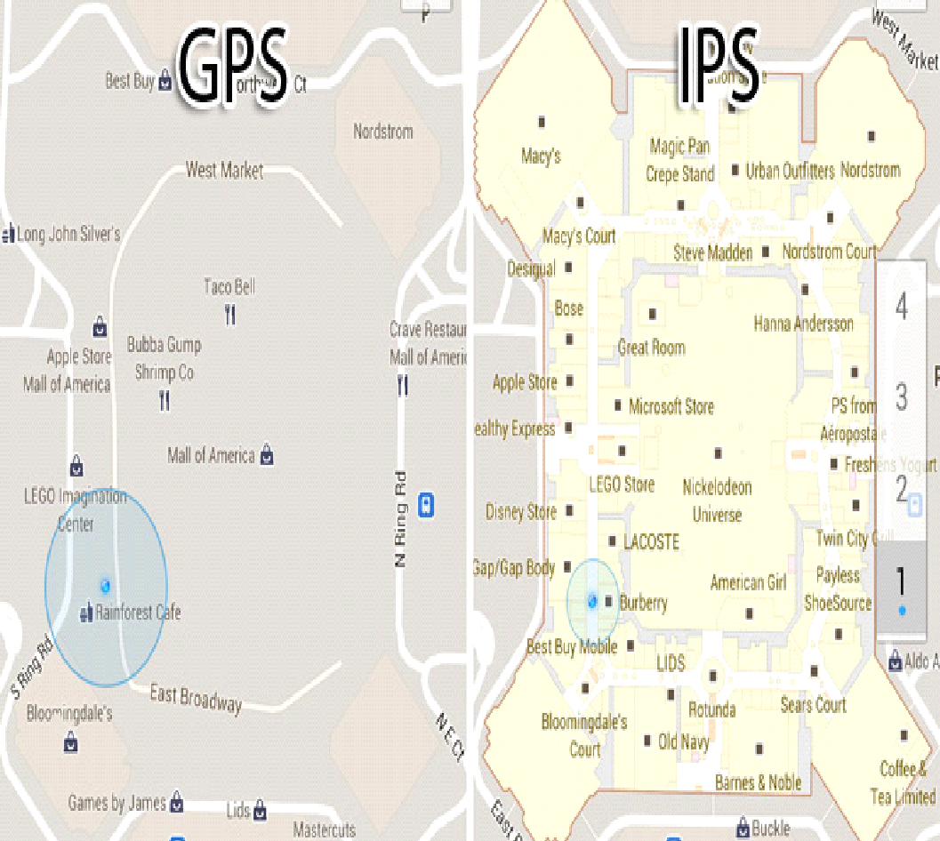

# Prototype

An early stage design layout of the prototype has been developed and added to the questionnaire in order to gather data on which design users will best understand. The group is currently in the process of getting more detailed maps of the buildings from the university administration for use within the application. The figures shown below are examples of this early prototype intended to display various features. The map in use here is of the greater campus, and for all intents and purposes at the time acted as a placeholder and was never intended to be used for internal map navigation, only to illustrate basic functionality. In the core build there will be a unique set of maps for each building that features internal navigation.

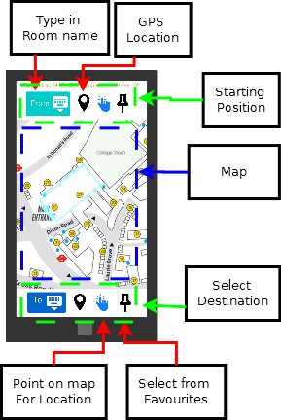

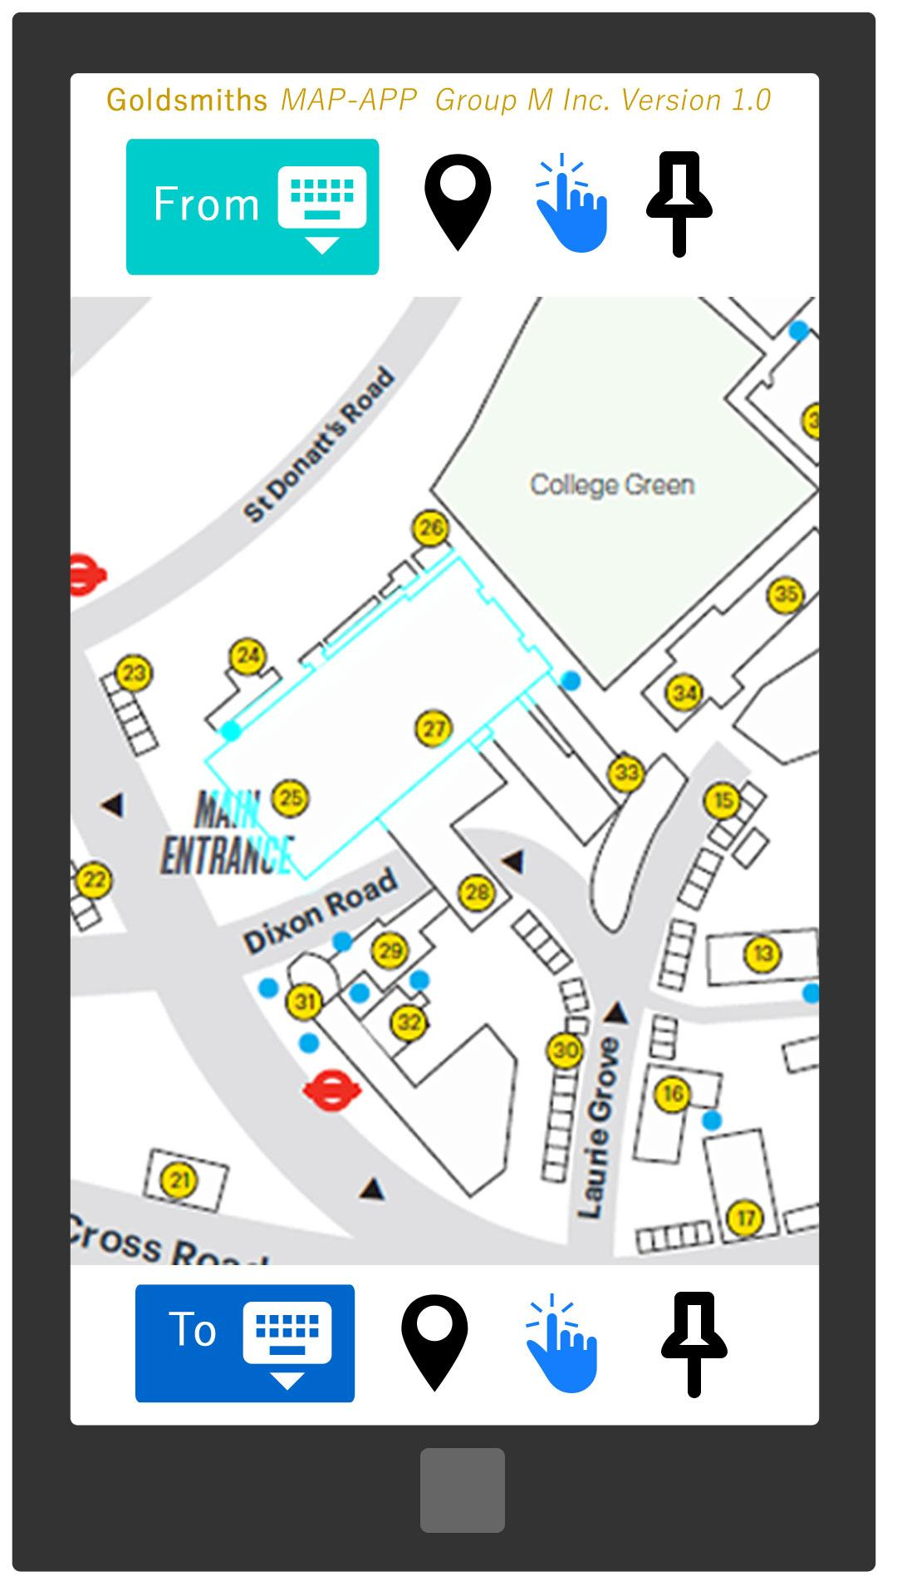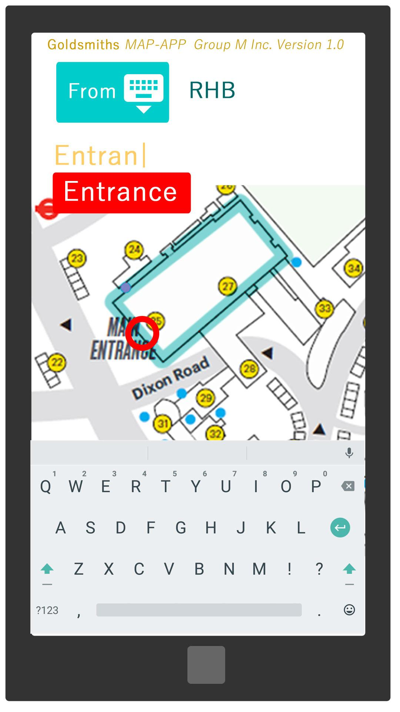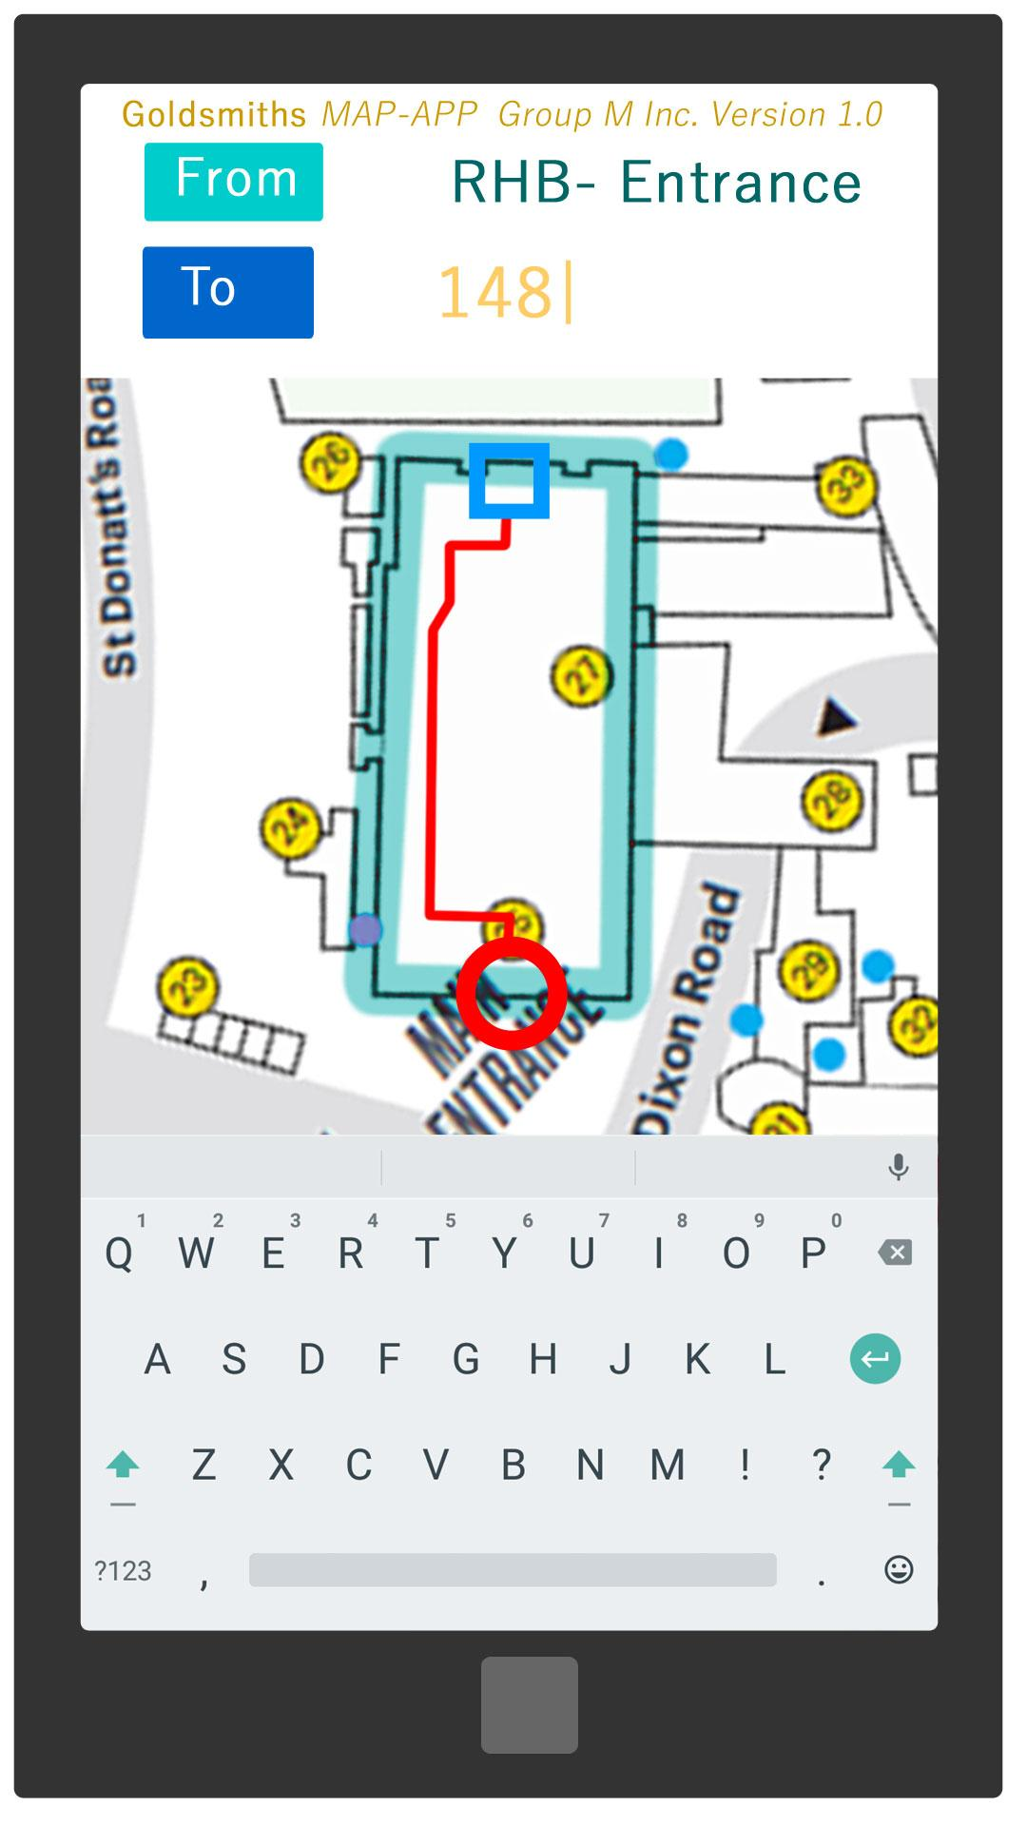

# Project Management

Throughout the project, each member of the group will be assigned a primary area of responsibility based on ability and interest. These roles allow each member a practical level of authority within their domains but still provides the group with a level of flexibility, allowing the group to quickly reallocate personnel depending on the changing demands of the project.

Officially all members of the group have agreed to hold meetings at least once a week with their project supervisor, in order to keep track of the application and to document progress. During each meeting, members will share a summary of the progress they have made on their individual tasks and highlight any issues they may have.

A meeting with the project supervisor is conducted once every week, this is to check that the project is being handled correctly as well as to ask for assistance or guidance. The project supervisor will give usefully feedback and ideas that can be used to improve the project. These meeting keep the project on the right path and allows the group to see the project from another perspective.

The group is currently using a Gantt chart to list all the tasks and deadline. This is to organise the group and give each member visual representation of the schedule. It also highlights which tasks are critical to the development of the application, which will help the group to prioritise the more important tasks. This tool will constantly be evolving as the project grows and changes over the course of the time frame.

Despite being a smaller than intended group (extenuating circumstances has seen two previous members leave the group during its formation), and a longer than expected time taken to find an idea the group was satisfied working with, the group is confident they can turn their smaller numbers into a faster and more efficient team.

## Milestones

The most important feature has been made into a short list. Once these features have been added to the application the core build will be completed:

* A general map of the Goldsmith’s Campus as a whole.
* An in depth floor by floor set of maps for the Richard Hoggart Building.
* Implemented navigation algorithm.
* Adaptation of algorithm for those with difficulty using stairs.
* Navigation of the map via the touch screen.
* An intuitive UI designed to be useable with the colourblind. In addition this feature should work as intended barring any changes to the design. (please see prototype section for a visual representation of this idea)

More information regarding these milestones will be elaborated on at a later date.

# Summary

The project that the group selected to develop fulfils a practical function and addresses a common complaint throughout the university. This was further justified by the results from the research. The core build addresses the complexity of navigating the Richard Haggard Building as well as the broader campus in general, while the addendum build will allow students and staff to find free rooms and book available rooms should they allow it. The group is confident that they will be able to deliver on the core build, allowing them to complete the primary purpose of the application and are enthusiastic about completing the addendum build.

# Bibliography

*Introduction to A*.* Available at: [*http://theory.stanford.edu/~amitp/GameProgramming/AStarComparison.html*](http://theory.stanford.edu/~amitp/GameProgramming/AStarComparison.html)

*Patel, A. (2016) From Amits Thoughts On Pathfinding*

*(Accessed: 12 December 2016).*

*IndoorAtlas*. Available at:<http://www.indooratlas.com> (Accessed: 4 December 2016)

Anna (2016) *How to build a mobile App with Geolocation*. Available at: <http://theappsolutions.com/blog/development/develop-app-with-geolocation/>(Accessed: 4 December 2016).

PRABEESH R K (2015) *Android studio Tutorial - 72 - create Google map application*. Available at: <https://www.youtube.com/watch?v=92f4c2vHrPghttps://www.youtube.com/watch?v=92f4c2vHrPg> (Accessed: 4 December 2016).

### **Art Assets**

iconfinder.com. 2012. *GPS location map pin icon*. [ONLINE] Available at:<https://www.iconfinder.com/icons/126573/gps_location_map_pin_icon>. [Accessed 8 November 2016].

iconfinder.com. 2012. *location marker sticky icon*. [ONLINE] Available at:<https://www.iconfinder.com/icons/134219/location_map_marker_pin_sticky_tack_icon#size=128>. [Accessed 8 November 2016].

iconfinder.com. 2012. *Click finger one icon*. [ONLINE] Available at:<https://www.iconfinder.com/icons/315298/click_finger_one_icon#size=128>. [Accessed 8 November 2016].

iconfinder.com. 2012. *Hide keyboard icon*. [ONLINE] Available at:<https://www.iconfinder.com/icons/352472/hide_keyboard_icon#size=128>. [Accessed 8 November 2016].

PhoneArena.com. 2014. *How to install the Google Keyboard 4.0 from Android Lollipop on your device right now*. [ONLINE] Available at:<http://www.phonearena.com/news/How-to-install-the-Google-Keyboard-4.0-from-Android-Lollipop-on-your-device-right-now_id61941>. [Accessed 7 November 2016].

Goldsmiths university of london. 2016. *Connected*. [ONLINE] Available at:<https://goldevent.wordpress.com/contact-and-directions/>. [Accessed 8 November 2016].

## 

## Appendices

### Appendix A: Survey Results

At the time of writing the questionnaire had 25 responses:

<https://docs.google.com/forms/d/e/1FAIpQLSdMLtbDaeEjNUwHtHo-X-YyKHilaYsvc3Y0UbgjYxvkRZ5Vsg/viewanalytics>

### Appendix B:

### Gantt Chart

### 

### 

### Appendix C: Meeting Minutes

#### First meeting: introductions and brainstorming

4 members in attendance. (Joel, Marcellino, Thamir, Behz)

1. Algorithms that gives better advertising. Instead of advertising the same product that was purchased, other products related to the item purchased should be advertised instead.
2. Organisational app for admin that would make it easier to administrate the subjects. (Avoiding overbooking for a course, cross over timetables between different years, students that have left but the university is not aware.
3. Regarding SystemOne: NHS’s own system to keep track of patients and their medical details, can it be improved upon in any way?

##### Things to do before next meeting:

1. Marcellino will ask health professional health careers ( family members ) about the efficiency of SystemOne.
2. Joel will email the supervisor about setting up a meeting and about missing group members. He will cc the rest of group members.
3. Thamir will ask staff members about their organization problems for the app.
4. Bez will do more research for project ideas.

#### Notes from 2nd Meeting

1. Navigation app idea looks like a good contender. The feedback from students is positive. It has to be different from other apps. Databases. Information for students., WIFI issues.
2. Research needs to be done, is there is a similar app like this, need to speak to staff members.
3. The ad idea from Joel. Need to research if there is something similar.
4. SystemOne needs more research, is it an ambitious project.
5. Need to collect data about our ideas, questionnaires, focus groups etc.

#### Notes from 3rd Meeting

1. Had to confirm that there is only 4 members of the group, originally there were meant to be 6 members
2. Roles were assigned to each member of the group.
3. Questionnaire will be designed and distributed.
4. Research on technologies.
5. Work could start on the prototype.

Appendix D: Aliuses

*Ali is a first year student attending his first day of term. He did not attend opening day so was unfamiliar with the campus.He approaches one of the entry points and notices the map, he tries to figure out the directions to the lecture room, he heads towards his destination with slight uncertainty, once inside the building, he approached the information desk, which was quite busy, so he decides to follow the signs. After the lecture he arranges to meet with another colleague for coffee, but with so many multiple places this takes longer than it should.*

*Mr and Mrs Smith attend the open day with their son Simon at Goldsmiths university. While on tour of the campus they somehow separate from Mrs Smith. Simon tries to send a whatsapp message to his mother informing her of their location, but by the time she receives the message the group has moved on.*