

Submitted By: Submitted to:

AARUL Dr. Monit Kapoor

2110990013 Professor and Dean

Group-1

Experiment1

**Aim: Setting up of Git Client**

Installing and Configuring the Git client

The following sections list the steps required to properly install and configure the Git clients - Git Bash and Git GUI - on a Windows 7 computer. Git is also available for Linux and Mac. The remaining instructions here, however, are specific to the Windows installation. 1) Starting with installing of GIT

Step 1)

To download the Git installer, visit the Git official site and go to the download page.

The link for the download page is https://git-scm.com/downloads

The page looks like as:-

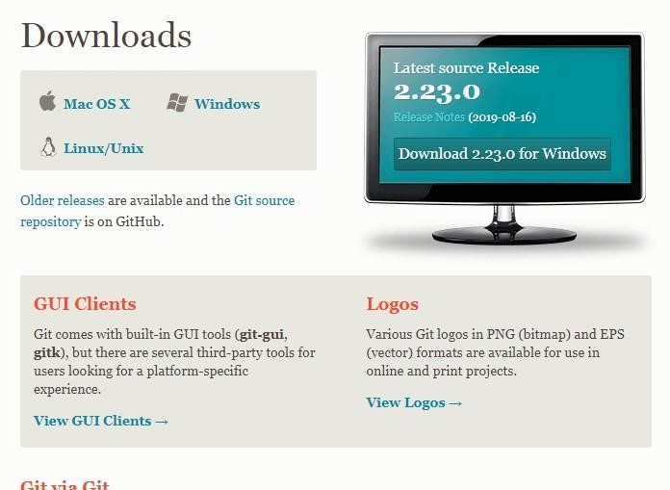

Click on the package given on the page as **download 2.23.0 for windows**. The download will start after selecting the package.

Now, the Git installer package has been downloaded.

Step 2)

Click on the download installer file and then click on next.

The page looks like as:-

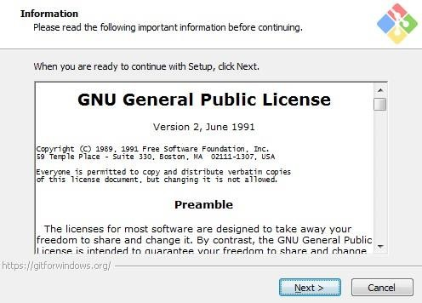

Step 3) Simply click on the next button as it automatically selects the required file. The page looks like as:

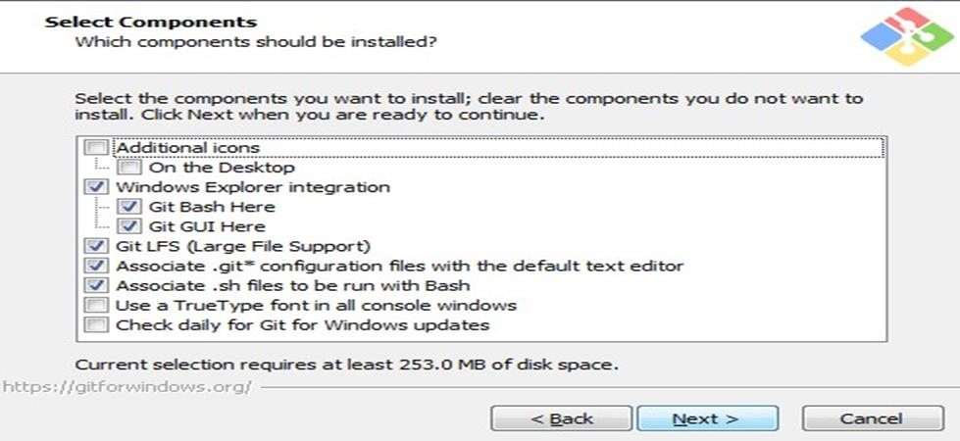

Step 4)

You can choose your preferred choice. Click next to continue. The page looks like as:-

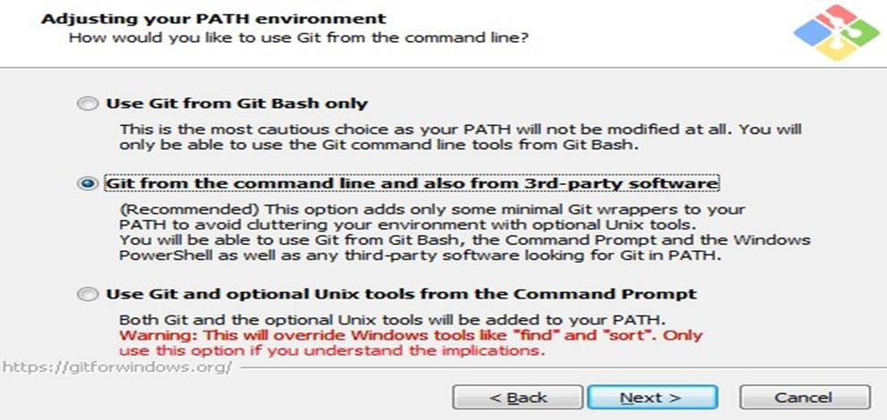



Step 5)

Note:- Just simply click on next as it automatically selects the required file.

The page looks like as:

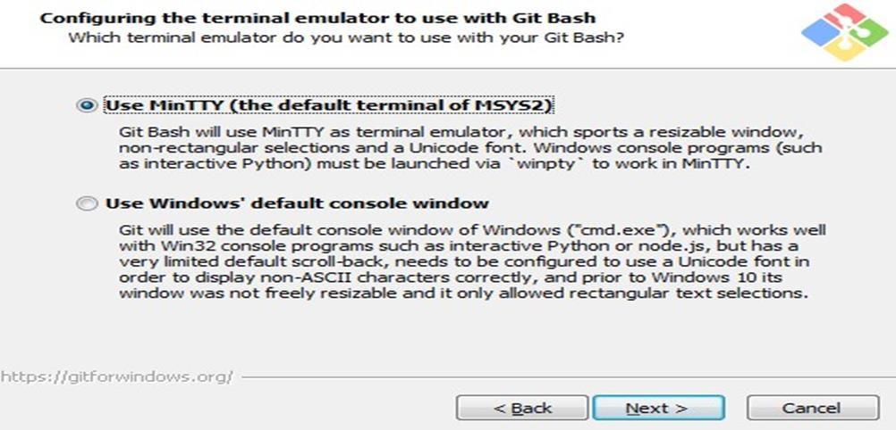

Step6) The Git is getting download in your system

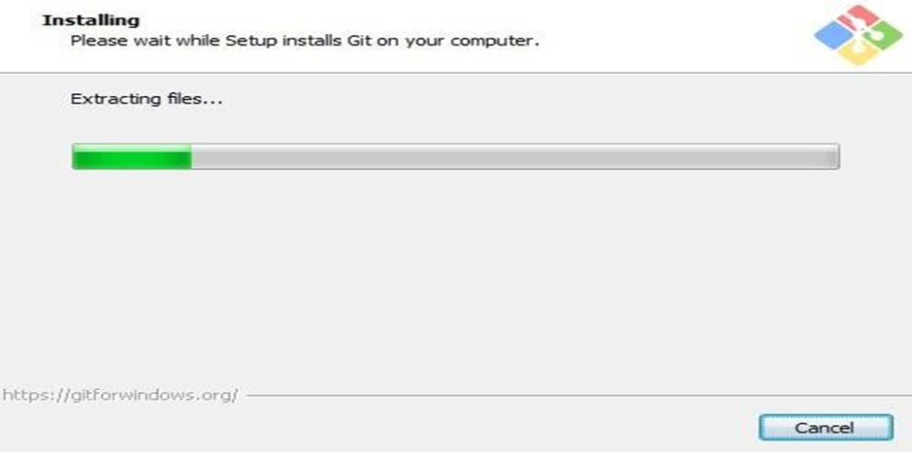

|  |  |  |
| --- | --- | --- |
| |  | | --- | | Experiment3 | |  |

**Aim:Setting of Github Account:**

1.Open Your Web Browser Search “github.com

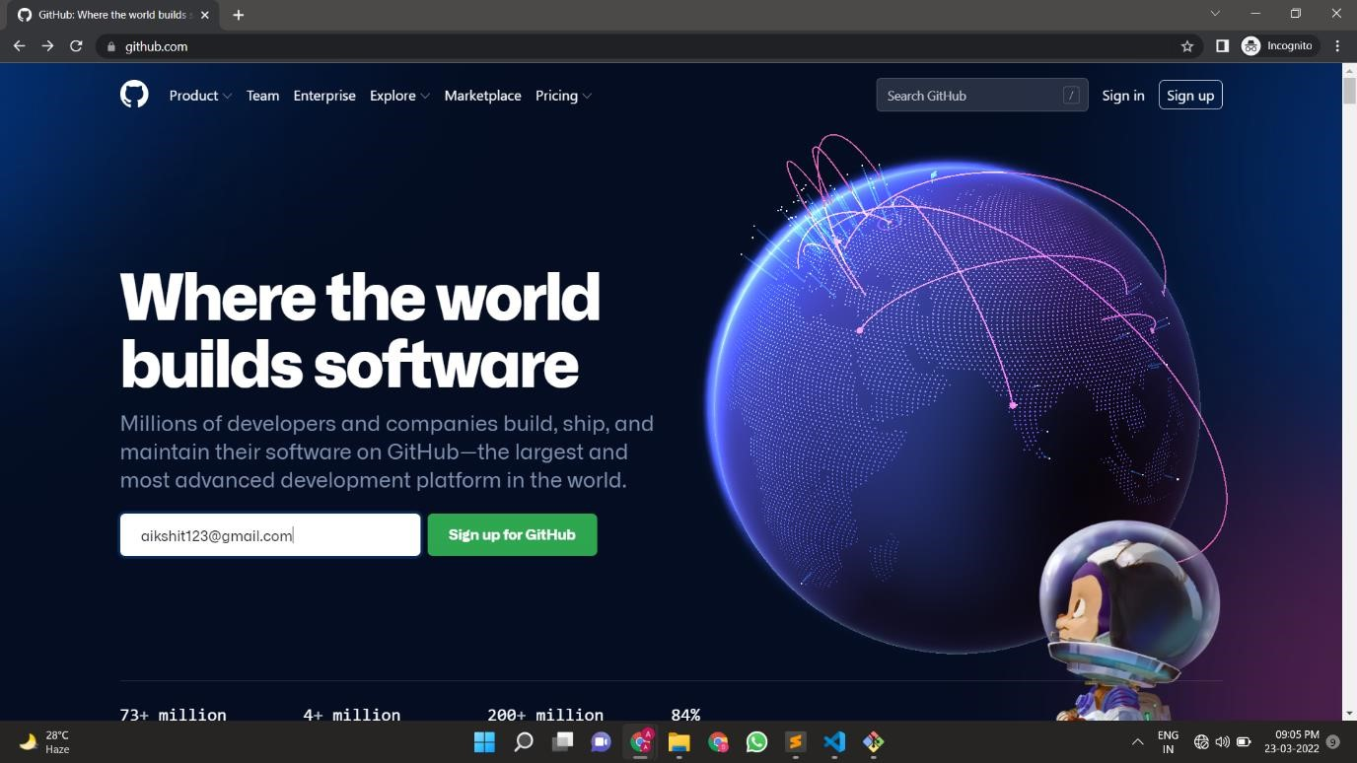

# 2.Creating an account

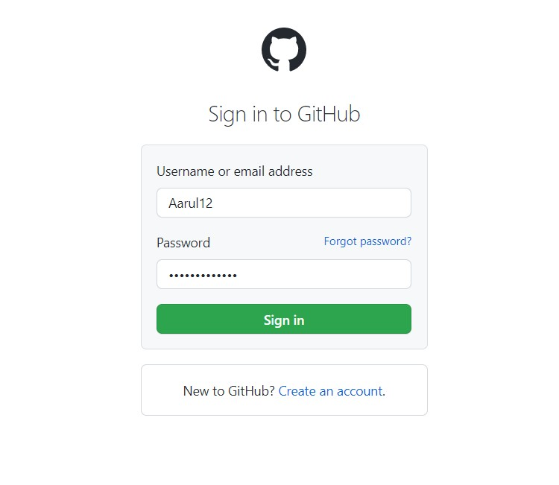To sign up for an account on Github.com,navigate to <https://github.com/and>follow the prompts.



To

keep your Github account secure you should use a Strong and unique password. For more information, see ”Creating a Strong password”.

# Verifying your email address

To ensure you can use all the features in your Github plan,verify your email address after signing up for a new account.

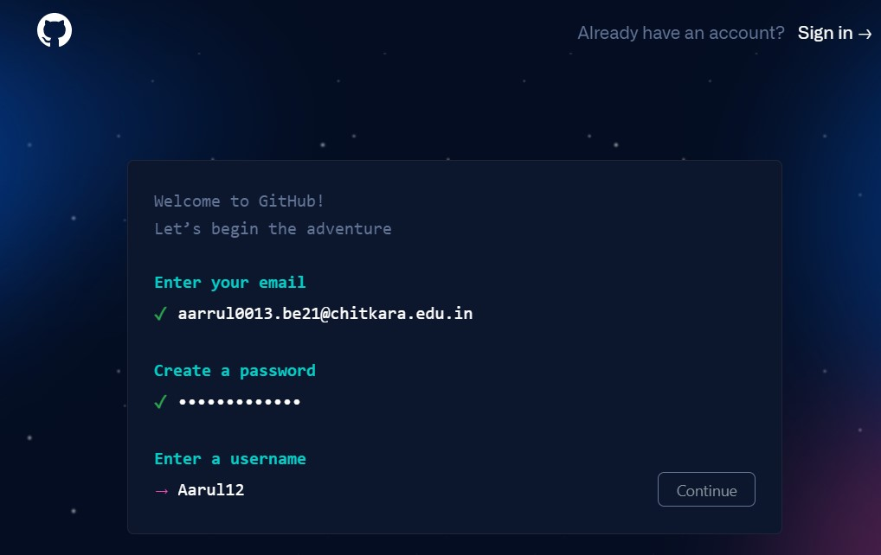

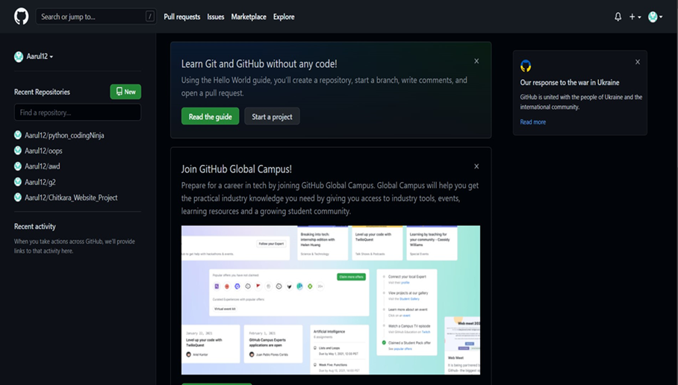Your Github profile tells people the story of your work through the repositories and gists You’ve pinned,the organization membership you have chosen to publicize,the contributions you have made ,and the projects you have created.

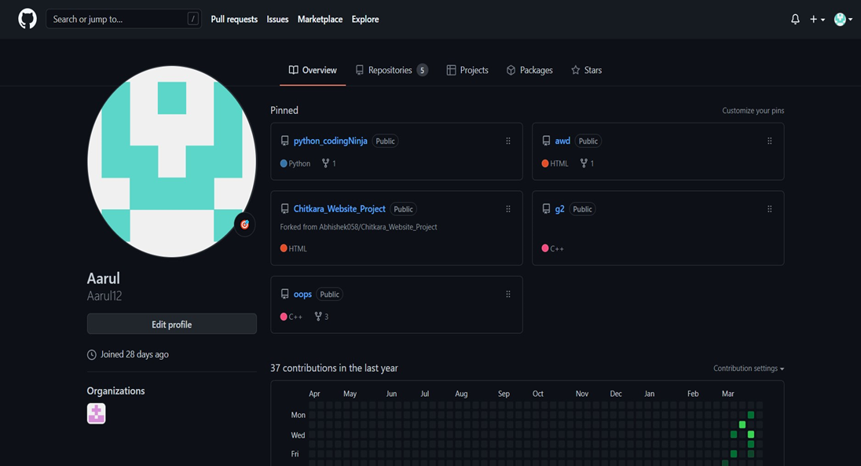



**Aim: Program to Create Logs:**

You can check that Git is install by simply type git - -version in The page looks like as:-



You can configure your Git by typing:-

1. Set your username: git config --global user.name "Your Name"
2. 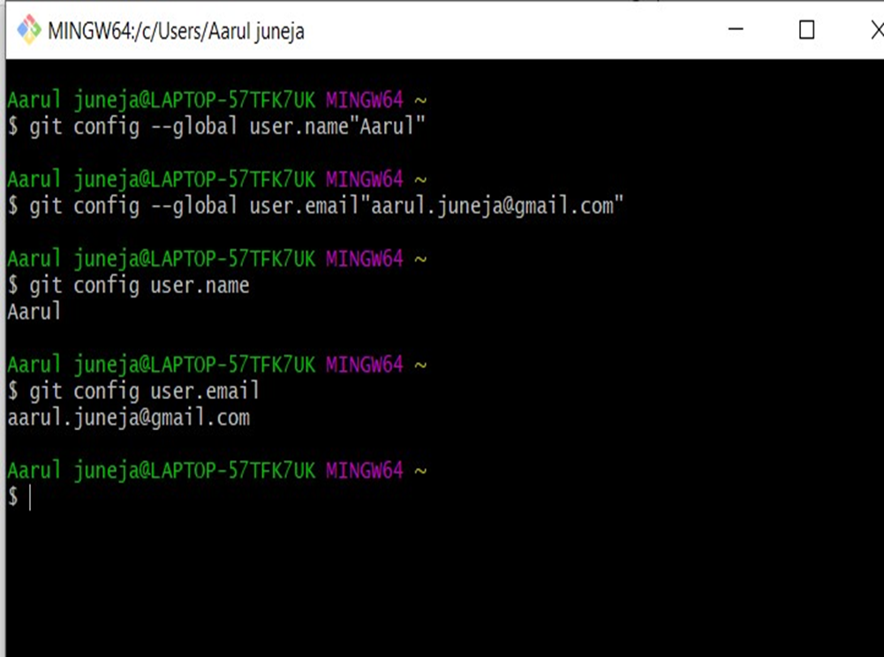Set your email address: git config --global user. email "Your Email "

You can check configuration of Git by typing -

1. git config –list
2. The page looks like as:-

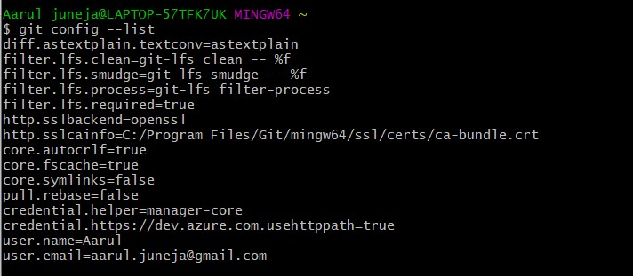

**Hidden files/folders:**

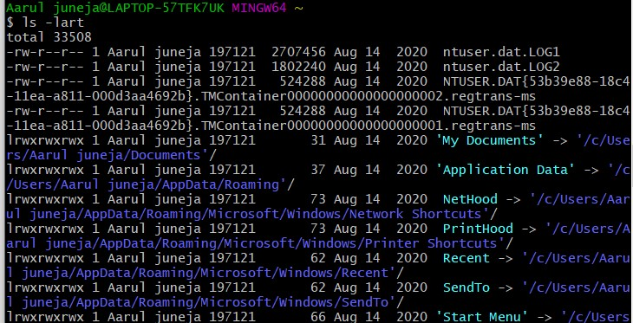Using “ls-lart” command we can know about the hidden folders available.

**A Git repository is a virtual storage of your project. It allows you to save versions of your code, which you can access when needed.**

**OPENING A FILE:**

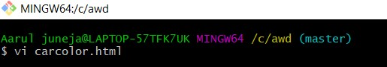

**WRITE CODE IN IT:**

To write any code just press **i** to insert into it.

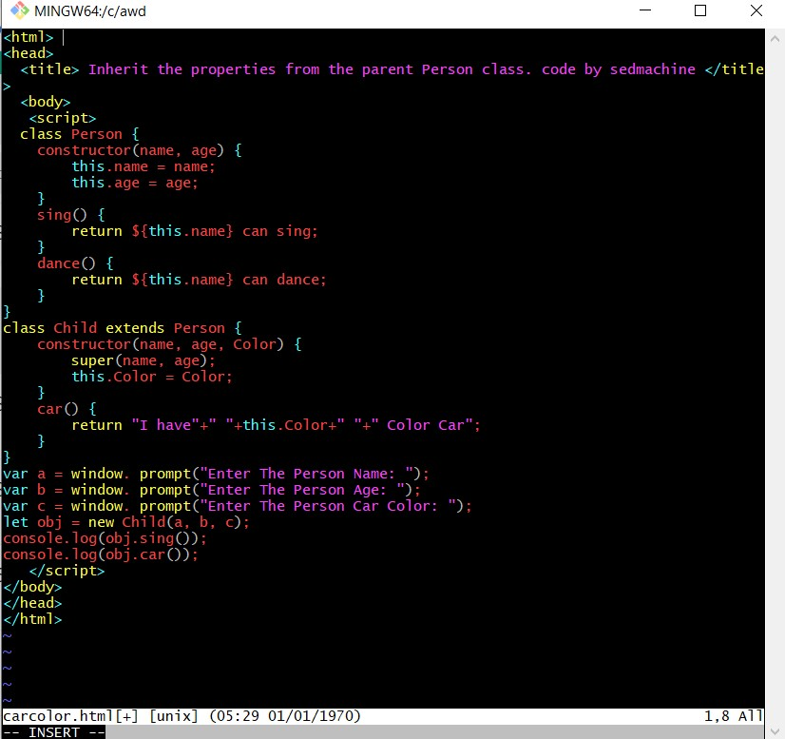

After completing your code press

**:wq**

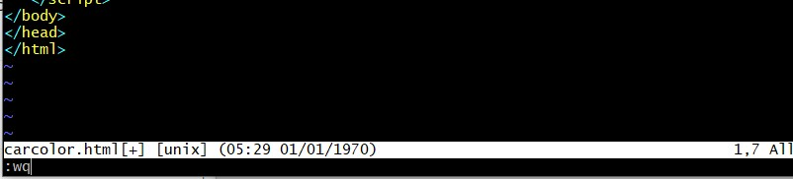

**GIT INIT**

Initializing a new repository, We Can do it by typing :-

1. git init

The page looks like as: -

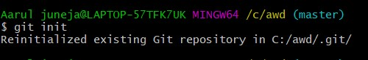

**Git status command:**

The “git status” is command that returns information about the current state of the repository. It have the record of list of file changed, tracked file, untracked file, current branch and commits.

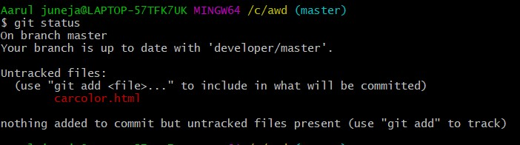

**GIT ADD**

In order to track the untracked file we have to use the “git add” command.

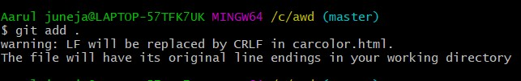

GIT STATUS

Again on checking the file status our file is highlighting in “green colour” which shows that it is now being tracked.

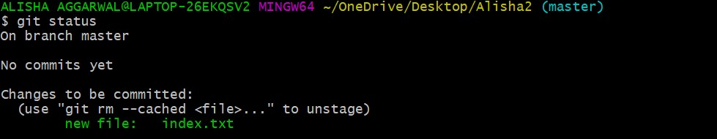

**Git commit command:**

The “git commit” command is used to move files from staging area to a commit. Git Commit created a snapshot of the changes made to git Repository which can then be pushed to the main repository When the developer is ready to do so.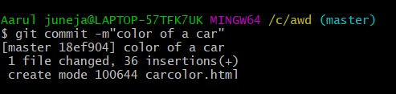

**GIT PUSH:**

By doing this command , we push our repository to our GitHub profile

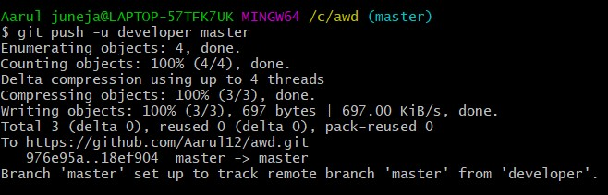.

**Git log command:**

The “git log” command displays all of the commits in a repository’s history. By default ,the command displays each commit.

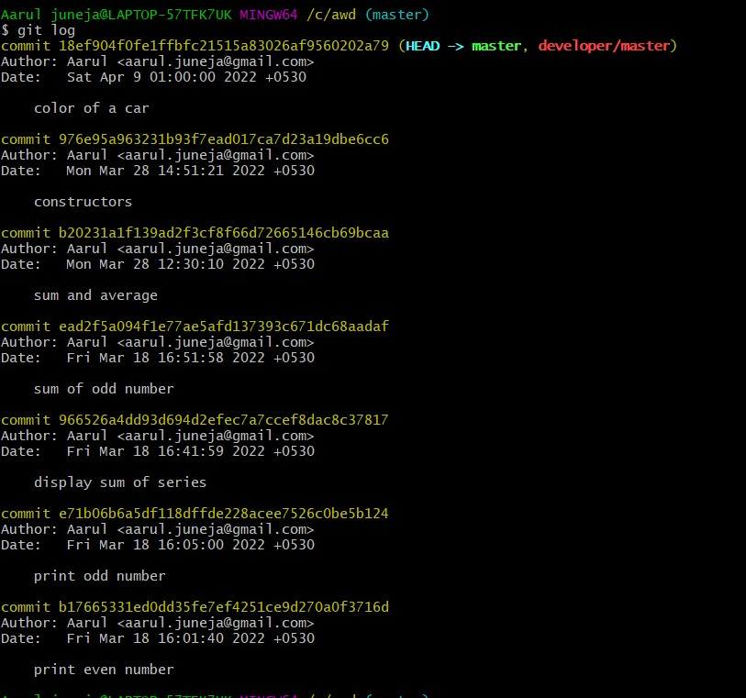

|  |  |  |
| --- | --- | --- |
| |  | | --- | | Experiment4 | |  |

**Aim: Create and Visualize branches:**

Branching: A branch in git is an independent line of work(a pointer to a specific commit).It allows users to create a branch from the original code(master branch)and isolate their work. Branches allow you to work on different parts of a project without impacting the main branch.

Git branch: A branch is version of the repository that diverges from the main working project. It is feature available in most modern version control systems. A git project can have more than one branch. These branches are a pointer to a snapshot Of your changes. When you want to add a new feature or fix a bug, you spawn a new branch to summarize your changes.

Master branch: The master branch is a default branch in Git. It is in stantiated when first commit made on the project. When you make the first commit, you're given a master branch to the starting commit point.When you start makingacommit, then masterbranch pointer automatically moves forward.Arepository can have onlyonemaster branch.

**To check the current branch we can use the “git branch”command**

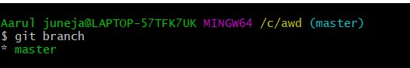

**After tracking and committing the file on checking the status we can see the current branch we are on.**

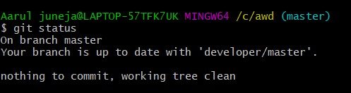

We can check the history of the repository using “git log” command.

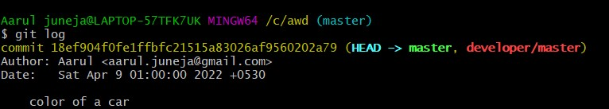



|  |  |  |
| --- | --- | --- |
| |  | | --- | | Experiment5 | |  |

**Git -Life Cycle:**

Git is used in our day to day work we use git for keeping a track of our files,working in a collaboration with our team,to go back to our previous code version if we face some error when a directory is made a git repository,there are mailnly three states which make the essence of git Version Control System.The three states are-

1.Working Directory

2.Staging Area

3.Git Directory

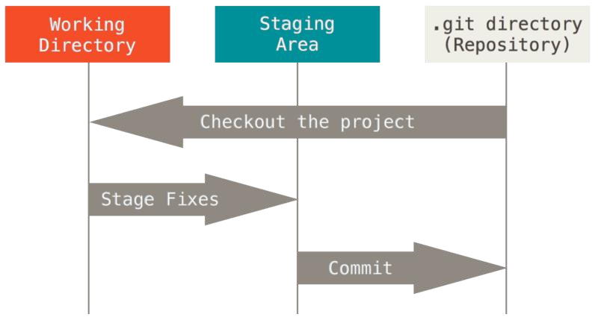

This Photo by Unknown Author is licensed under CC BY-SA

1. Working Directory:

Whenever we want to initialize our local project directory to make it a git repository ,we use the git init command. After this command, git becomes aware of the files in the project although it doesn’t track the files yet. The files are further tracked in the staging area.

1. Staging Area

Now, to track the different version so four files we use the command git add We can’t terms a staging area as a place where different versions of our files stored.

Git add command copies the version of your file from your working directory to the staging area. We can, however, choose which files we need to add to the staging area because in our working.

1. Git Directory

Now since we have all the files that are to be tracked and are ready in the staging area, we are ready to commit our files using the git command. Commit helps us in keeping the track of the meta data of the files in our staging area. We specify every

Message which tells what the commits about. Git preserves the information or the meta data of the files that were committed in a Git .

Directory which helps Git in tracking files and basically it preserves committed files. Commital sostores the name of the author who did the commit, files that are committed and the dateat which they are committed along with the commit message.

