Subject Name: **Source Code Management**

Subject Code: **CS181**

Cluster: **Beta**

Department: **DCSE**



|  |  |  |
| --- | --- | --- |
| **Submitted By:**  Aryan Agarwal  2110990017  G01 |  | **Submitted To:**  Dr. Monit Kapoor |

Installing and Configuring the Git client

The following sections list the steps required to properly install and configure the Git clients

- Git Bash and Git GUI - on a Windows 7 computer. Git is also available for Linux and Mac.

The remaining instructions here, however, are specific to the Windows installation.

Be sure to carefully follow all of the steps in the first five sections.

The last section, 6,

is optional. There is also a section

on common problems and possible fixes at the bottom of the

document

Git installation



When running the installer, various screens appear (Windows screens shown). Generally, you can accept the default selections, ***except in the screens below where you do NOT want the default selections:***

In the **Select Components** screen, make sure **Windows Explorer Integration** is selected as shown:

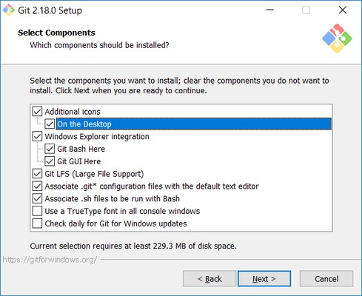

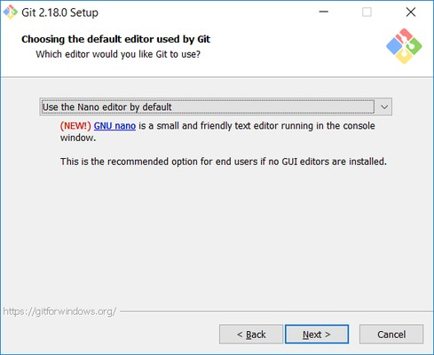

In the **Adjusting your PATH** screen, all three options are acceptable:

**Use Git from Git Bash only**: no integration, and no extra commands in your command path

**Use Git from the Windows Command Prompt**: adds flexibility - you can simply run git from a Windows command prompt, and is often the setting for people in industry - but this does add some extra commands.

**Use Git and optional Unix tools from the Windows Command Prompt**: this is also a robust choice and useful if you like to use Unix commands like grep.

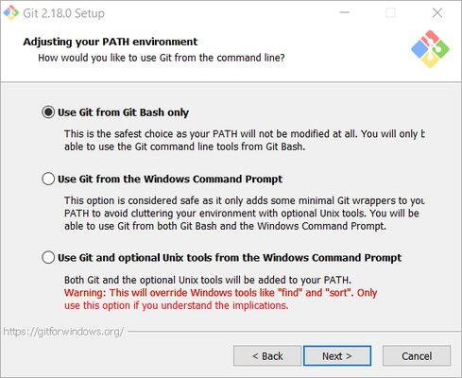

In the Configuring the line ending screen, select the middle option (Checkout as-is, commit Unix-style line endings) as shown. This helps migrate files towards the Unix-style (LF) terminators that most modern IDE's and editors support.The Windows convention (CR-LF line termination) is only important for Notepad (as opposed to Notepad++), but if you are using Notepad to edit your code you may need to ask your instructor for help.

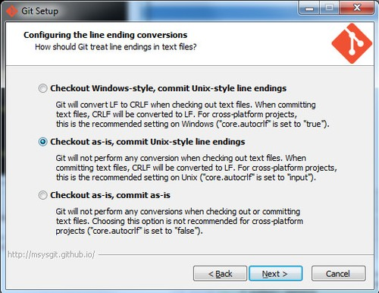

Setting up GitHub Account

The first steps in starting with GitHub are to create an account, choose a product that fits your needs best, verify your email, set up two-factor authentication, and view your profile.

There are several types of accounts on GitHub. Every person who uses GitHub has their own user account, which can be part of multiple organizations and teams. Your user account is your identity on GitHub.com and represents you as an individual

**1. Creating an account**

To sign up for an account on GitHub.com, navigate to <https://github.com/> and follow the prompts.

To keep your GitHub account secure you should use a strong and unique password. For more information, see "[Creating a strong password](https://docs.github.com/en/github/authenticating-to-github/keeping-your-account-and-data-secure/creating-a-strong-password)."

**2. Choosing your GitHub product**

You can choose GitHub Free or GitHub Pro to get access to different features for your personal account. You can upgrade at any time if you are unsure at first which product you want.

For more information on all of GitHub's plans, see "[GitHub's products](https://docs.github.com/en/get-started/learning-about-github/githubs-products)."

**3. Verifying your email address**

To ensure you can use all the features in your GitHub plan, verify your email address after signing up for a new account. For more information, see "[Verifying your email address](https://docs.github.com/en/github/getting-started-with-github/signing-up-for-github/verifying-your-email-address)."

**4. Configuring two-factor authentication**

Two-factor authentication, or 2FA, is an extra layer of security used when logging into websites or apps. We strongly urge you to configure 2FA for the safety of your account. For more information, see "[About two-factor authentication](https://docs.github.com/en/github/authenticating-to-github/securing-your-account-with-two-factor-authentication-2fa/about-two-factor-authentication)."

**5. Viewing your GitHub profile and contribution graph**

Your GitHub profile tells people the story of your work through the repositories and gists you've pinned, the organization memberships you've chosen to publicize, the contributions you've made, and the projects you've created. For more information, see "[About your profile](https://docs.github.com/en/github/setting-up-and-managing-your-github-profile/customizing-your-profile/about-your-profile)" and "[Viewing contributions on your profile](https://docs.github.com/en/github/setting-up-and-managing-your-github-profile/managing-contribution-graphs-on-your-profile/viewing-contributions-on-your-profile)."

**About Version Control:--**  
  
Version control is a system that records changes to a file or set of files over time so that you can recall specific versions later. Version control, also known as source control, is the practice of tracking and managing changes to software code. Version control systems are software tools that help software teams manage changes to source code over time.  
  
**benefits of version control systems:-**

* **Generate Backups:** Creating a backup of the current version of that repository is perhaps the most important benefit of using a version control system. Having numerous backups on various machines is beneficial because it protects data from being lost in the event of a server failure.
* **Experiment:**When a team works on a software project, they frequently use clones of the main project to build new features, test them, and ensure that they work properly before adding them to the main project. This could save time as different portions of the code can be created simultaneously.
* **Keep History:** Keeping track of the changes in a code file would assist you and new contributors understand how a certain section of the code was created. How did it begin and evolve over time to get at its current state.
* **Collaboration:** One of the most important advantages of version control systems, particularly DVCS, is that it allowed us to participate to projects we enjoyed despite the fact that we were in separate countries

**Local Version Control Systems**  
Many people’s version-control method of choice is to copy files into another directory. This approach is very common because it is so simple, but it is also incredibly error prone. It is easy to forget which directory you’re in and accidentally write to the wrong file or copy over files you don’t mean to.

**Centralized Version Control Systems**Centralized version control systems are based on the idea that there is a single “central” copy of your project somewhere (probably on a server), and programmers will “commit” their changes to this central copy. Committing a change simply means recording the change in the central system.

**Main benefits (CVCS):**

* Centralized systems are typically easier to understand and use
* You can grant access level control on directory level
* performs better with binary files

**Distributed Version Control Systems**In distributed version control, every developer “clones” a copy of a repository and has the full history of the project on their own hard drive. This copy (or “clone”) has all of the metadata of the original.  
  
**Main benefits (DVCS):**

* Performance of distributed systems is better
* Branching and merging is much easier
* With a distributed system, you don’t need to be connected to the network all the time (complete code repository is stored locally on PC)

What is Git?

Git is software for tracking changes in any set of files, usually used for coordinating work among programmers collaboratively developing source code during software development.

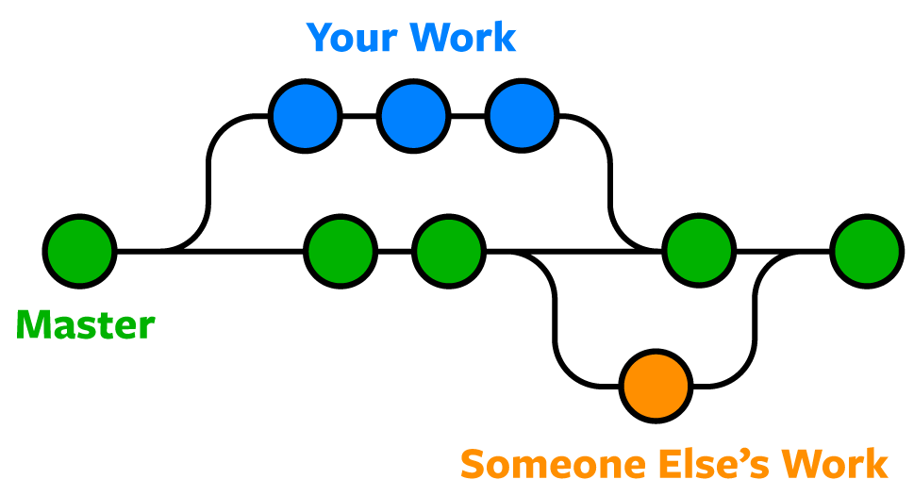

Git Life Cycle:-  
  
Git is used in our day-to-day work, we use git for keeping a track of our files, working in a collaboration with our team, to go back to our previous code versions if we face some error. Git helps us in many ways. Let us look at the Life Cycle that git has and understand more about its life cycle. Let us see some of the basic steps that we follow while working with Git

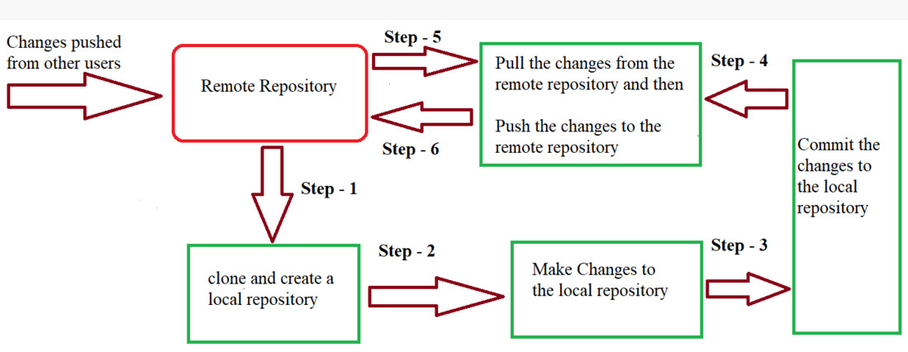

* ***In Step – 1****, We first clone any of the code residing in the remote repository to make our won local repository.*
* ***In Step-2****we edit the files that we have cloned in our local repository and make the necessary changes in it.*
* ***In Step-3****we commit our changes by first adding them to our staging area and committing them with a commit message.*
* ***In Step – 4 and Step-5****we first check whether there are any of the changes done in the remote repository by some other users and we first pull that changes.*
* *If there are no changes we directly proceed with****Step – 6****in which we push our changes to the remote repository and we are done with our work.*

When a directory is made a git repository, there are mainly 3 states which make the essence of Git Version Control System. The three states are-  
  
 • Working directory

• Staging area

• Git directory

Working Directory  
  
Whenever we want to initialize our local project directory to make it a git repository, we use the ***git init*** command. After this command, git becomes aware of the files in the project although it doesn’t track the files yet. The files are further tracked in the staging area.

*git init*

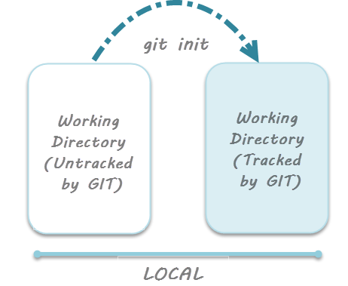

Staging Area

Now, to track the different versions of our files we use the command ***git add***. We can term a staging area as a place where different versions of our files are stored. ***git add*** command copies the version of your file from your working directory to the staging area. We can, however, choose which files we need to add to the staging area because in our working directory there are some files that we don’t want to get tracked, examples include node modules, env files, temporary files, etc. Indexing in Git is the one that helps Git in understanding which files need to be added or sent. You can find your staging area in the ***.git*** folder inside the ***index*** file.

*// to specify which file to add to the staging area*

*git add <filename>*

*// to add all files of the working directory to the staging area*

*git add .*

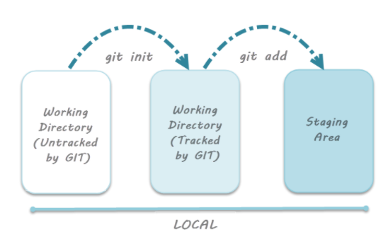

Git Directory

Now since we have all the files that are to be tracked and are ready in the staging area, we are ready to commit our files using the ***git commit***command. Commit helps us in keeping the track of the metadata of the files in our staging area. We specify every commit with a message which tells what the commit is about. Git preserves the information or the metadata of the files that were committed in a Git Directory which helps Git in tracking files and basically it preserves the photocopy of the committed files. Commit also stores the name of the author who did the commit, files that are committed, and the date at which they are committed along with the commit message.

*git commit -m <Commit Message>*

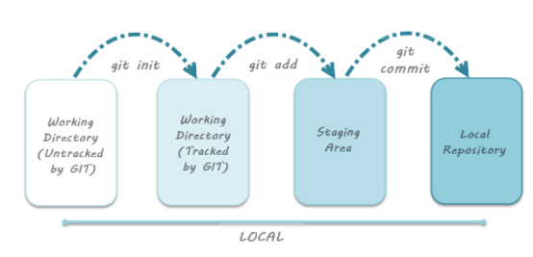

COMMAND

ls

The ls command lists the current directory contents and by default will not show hidden files. If you pass it the -a flag, it will display hidden files. You can navigate into the . git directory like any other normal directory.

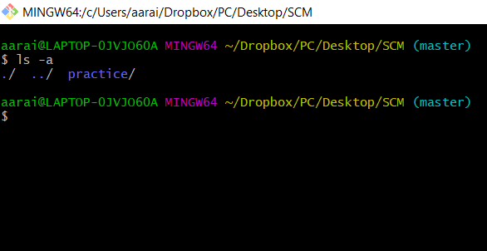

pwd

The Bash command pwd is used to print the 'present working directory'

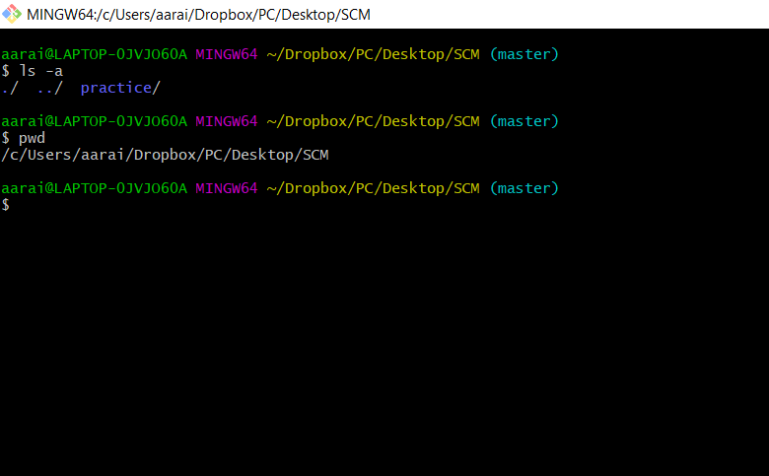

git init

The git init command is used to generate a new, empty Git repository or to reinitialize an existing one. With the help of this command, a .git subdirectory is created, which includes the metadata, like subdirectories for objects and template files, needed for generating a new Git repository.

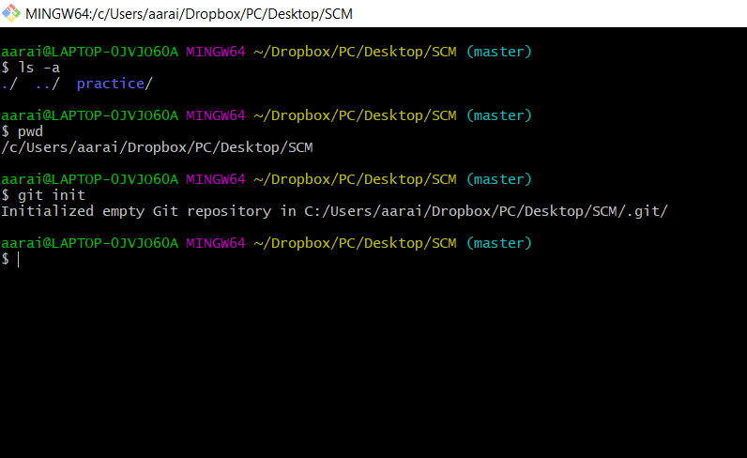

git clone <url>

The git clone command is used to target an existing repository and create a clone, or copy of the target repository.

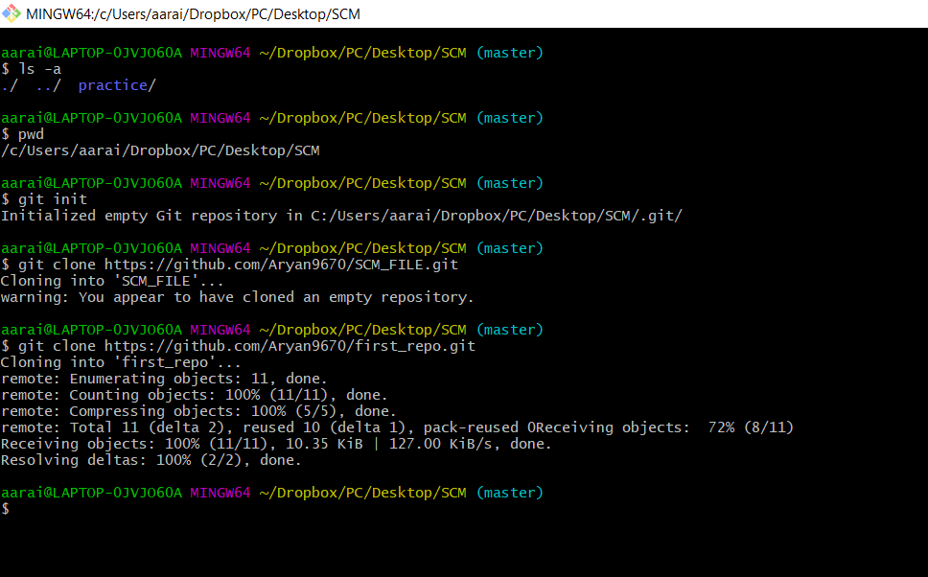

git status

The git status command displays the state of the working directory and the staging area

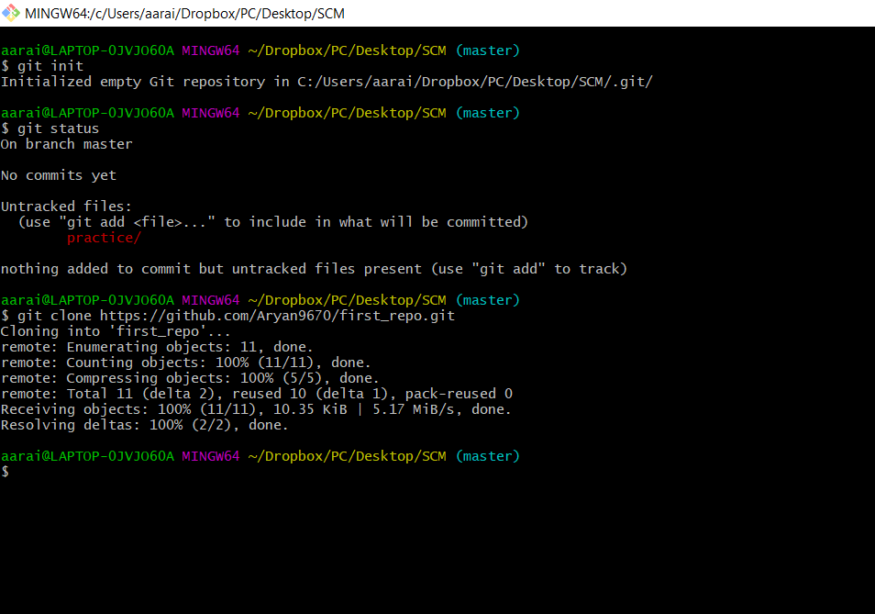

git add --a

The git add --a command is used to add file contents to the Index (Staging Area). This command updates the current content of the working tree to the staging area. It also prepares the staged content for the next commit.

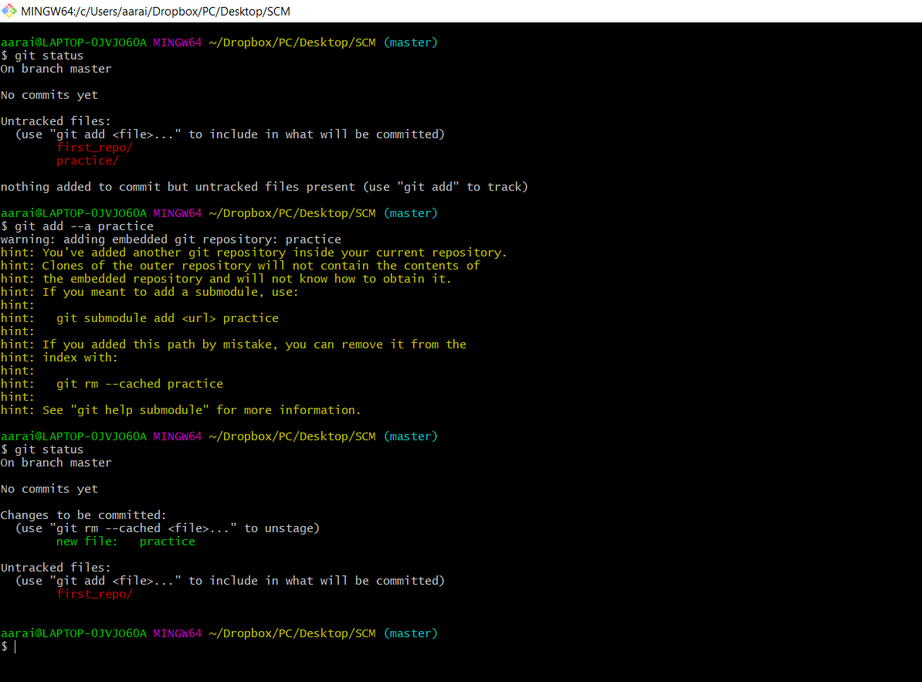

git commit -m “message”

The git commit -m command captures a snapshot of the project's currently staged changes. Committed snapshots can be thought of as “safe” versions of a project

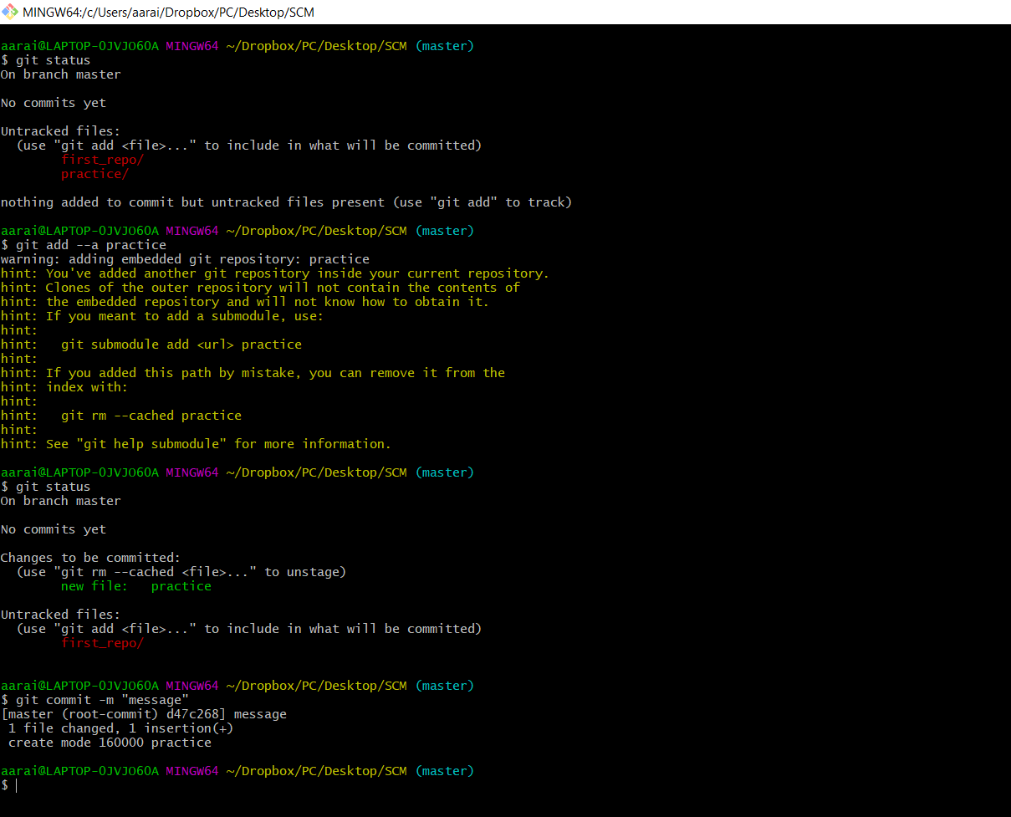

git branch

The git branch command is used to List all of the branches in your repository.  
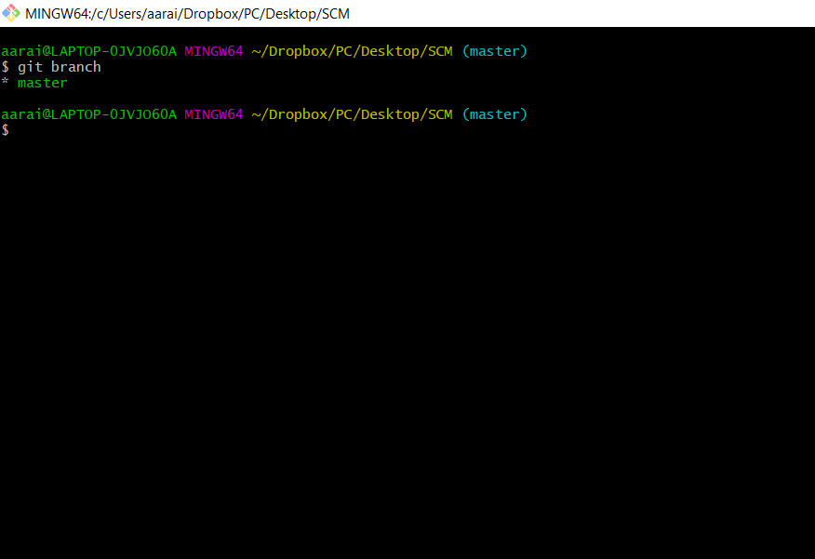

git branch <branch>

The git branch <branch> command is used to Create a new branch called ＜branch＞.

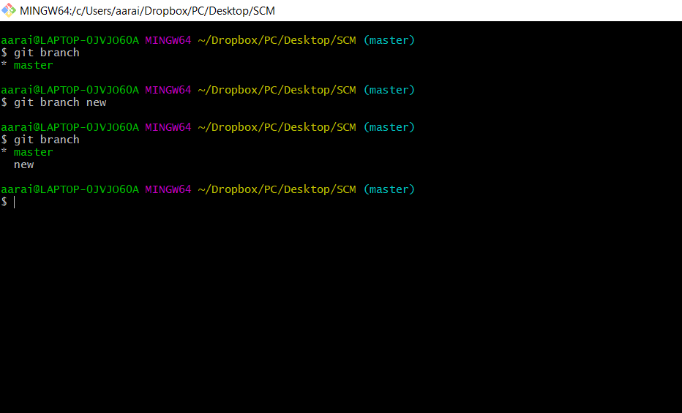

git checkout <branch name>

The git checkout command is used to switch the currently active branch.  
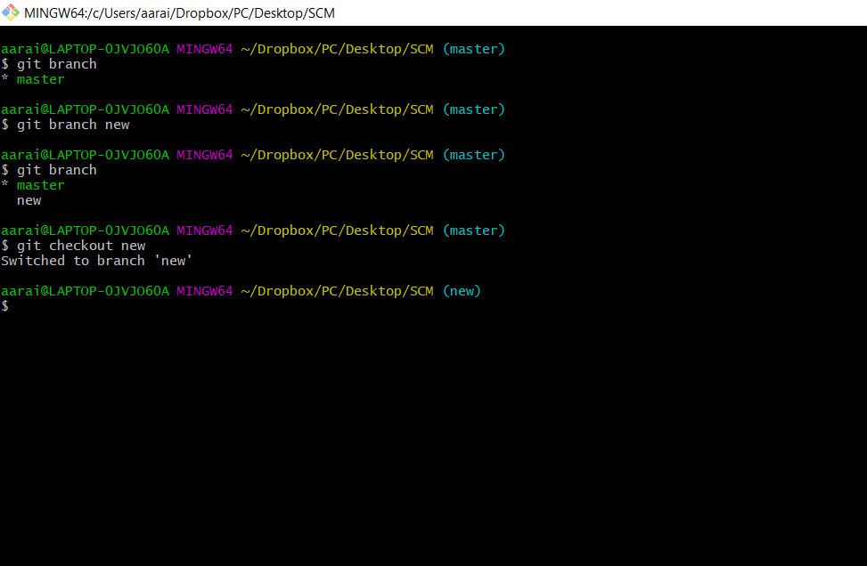

git merge <branch name>

The git merge command is used to merge the branches.

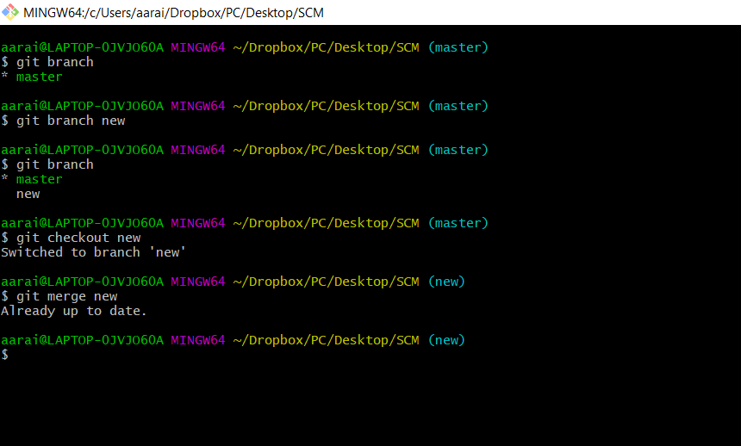

git log

The git log command shows a list of all the commits made to a repository.

