Subject Name: Source Code Management

Subject Code: CS181

Cluster:

B

eta

Department: DCSE

Submitted By:

Abhinav Rawat

2110990055

Team Members:

Aaryan Prabhakar – 2110990018

Abhimanyu Kashyap - 2110990042

G1

Submitted To:

Mr. Monit Kapoor



**INDEX**

|  |  |  |
| --- | --- | --- |
| S. No | Experiment Name | Page No. |
| 1. | Create a distributed Repository and add members in project team | 3-9 |
| 2. | Create a pull request on a team member’s repo and close pull requests generated by team members on own Repo as a maintainer | 9-11 |
| 3. | Resolving the merge conflict created by the pull request | 11-14 |

**Experiment No. 01**

**Experiment No. 01**

# Aim: Create a distributed Repository and add members in project team

* Login to your GitHub account and you will land on the homepage as shown below.
* Click on the ‘New’ button in the top left corner.

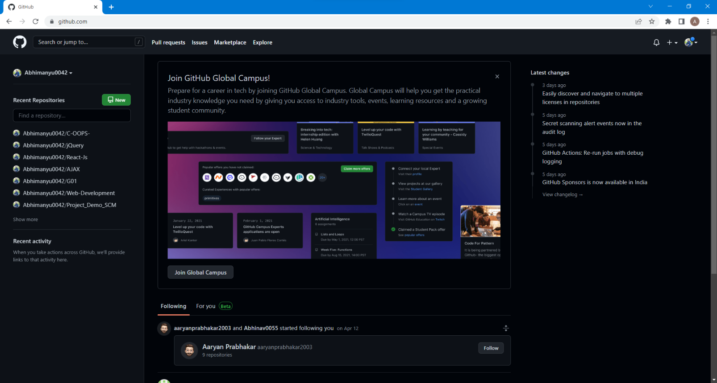

* Enter the Repository name and add the description of the repository.
* Select if you want the repository to be public or private.

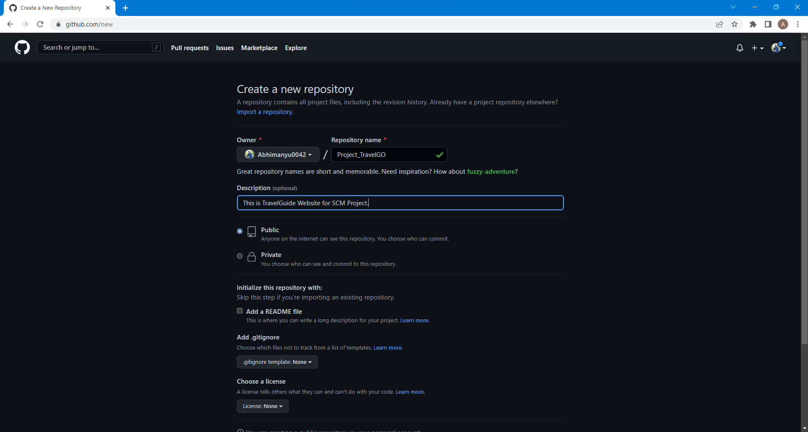

* Now, you have created your repository successfully.
* 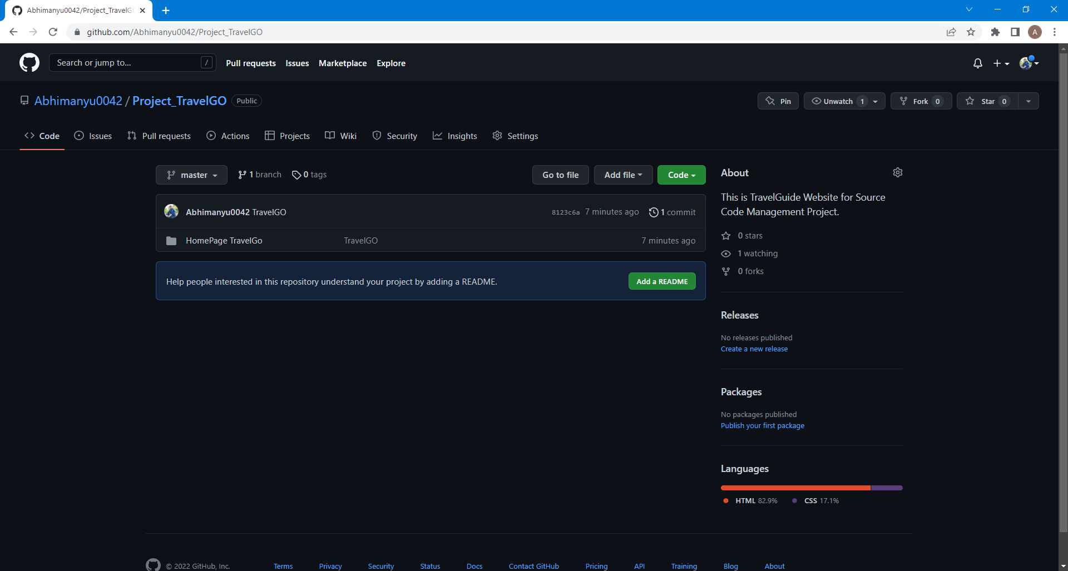To add members to your repository, open your repository and select settings option in the navigation bar.
* Click on Collaborators option under the access tab.

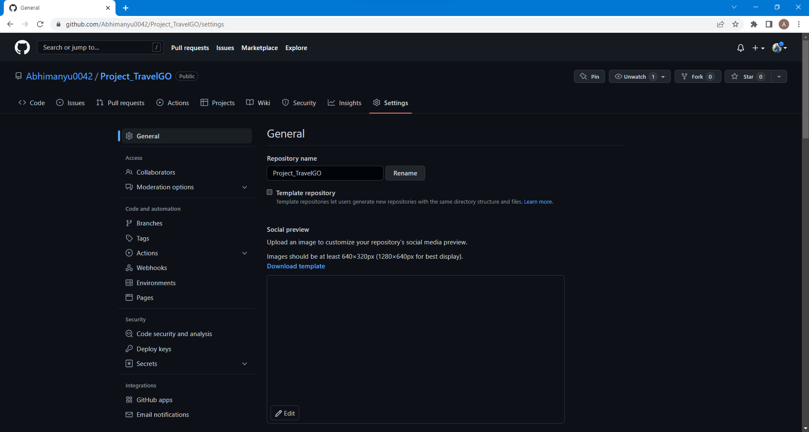

* After clicking on collaborators GitHub asks you to enter your password to confirm the access to the repository. 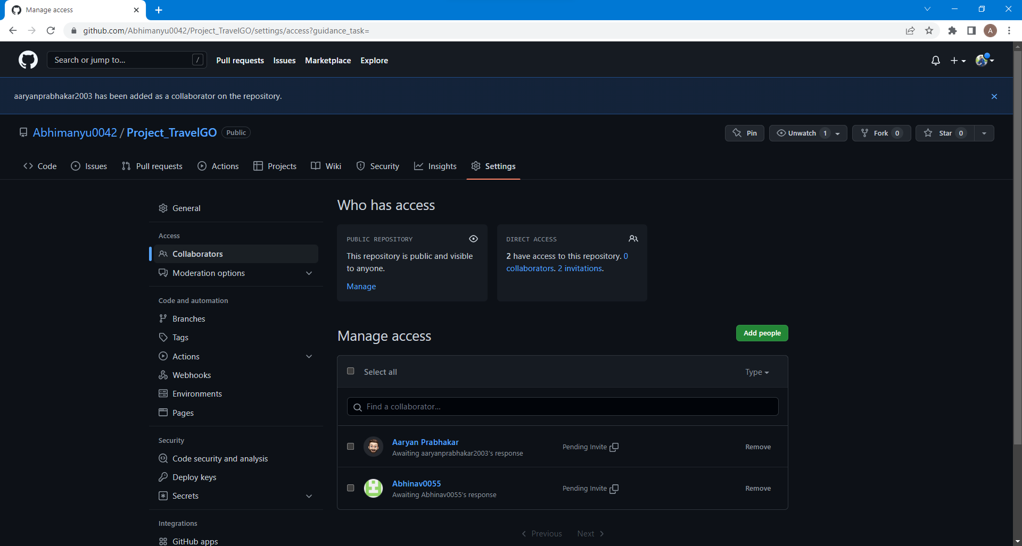
* To add member, click on the add people option and search the id of your respective team member.
* You will receive an invitation mail from the repository owner. Open the email and click on accept invitation.
* You will be redirected to GitHub where you can either

select to accept or decline the invitation.

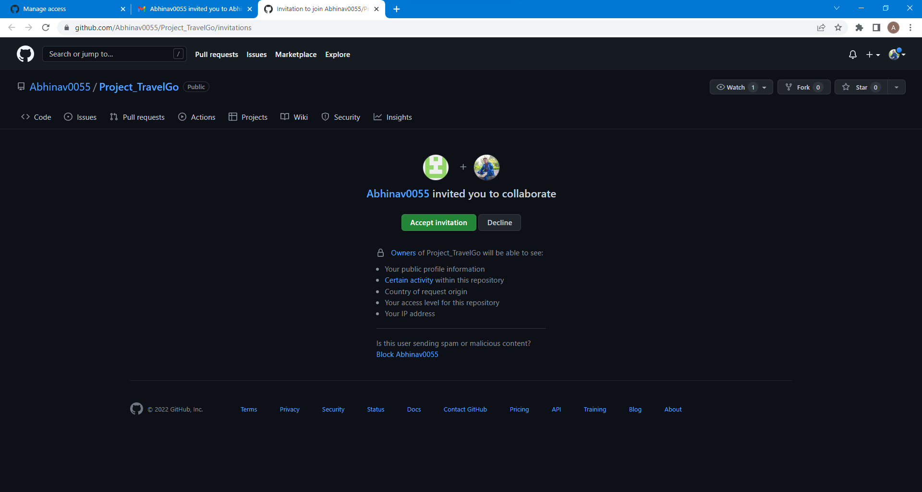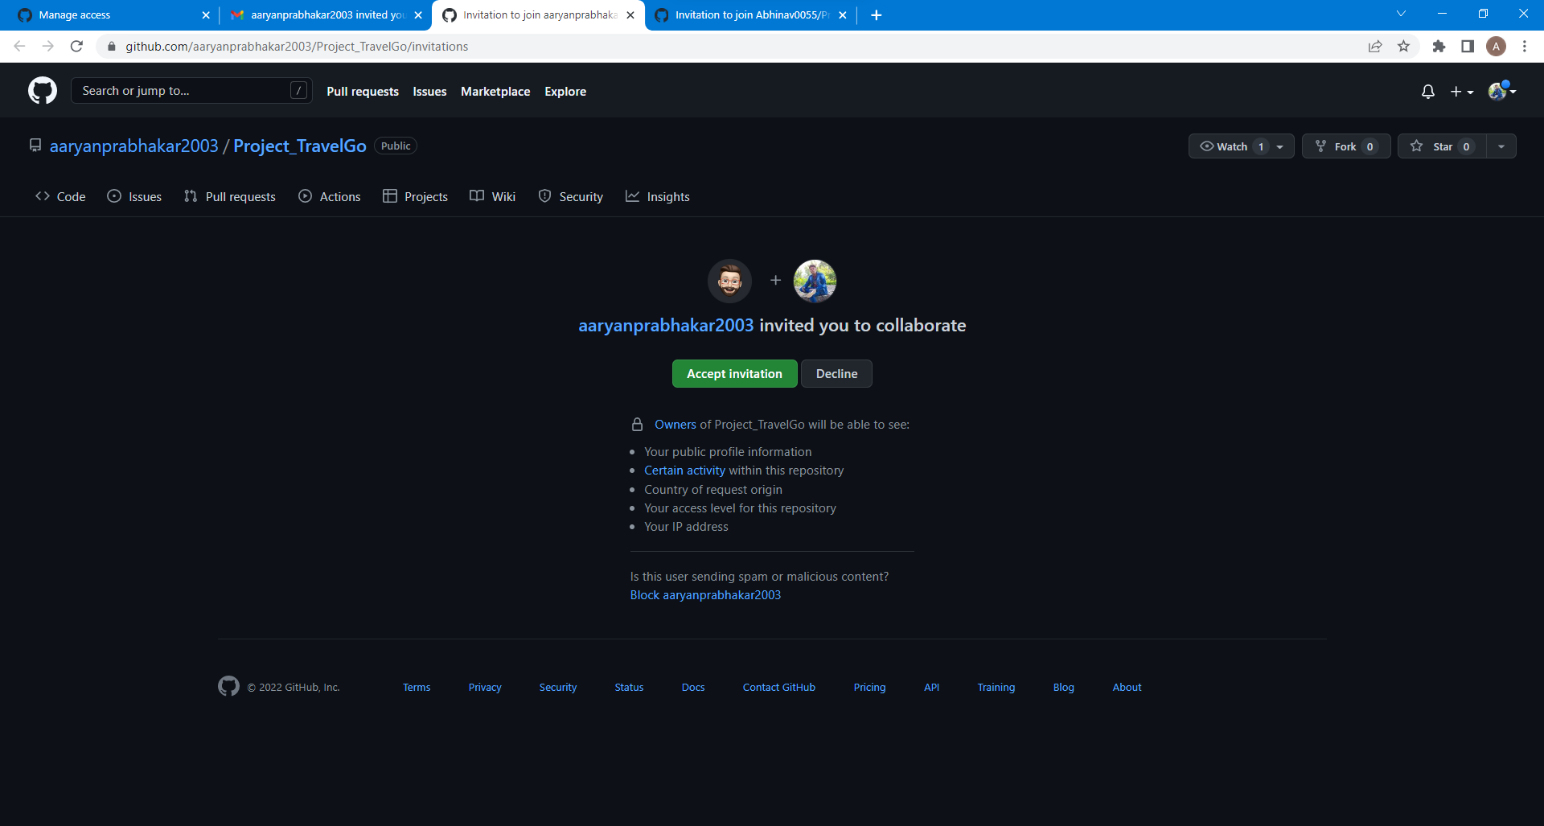

* You will be shown the option that you are now allowed to push.

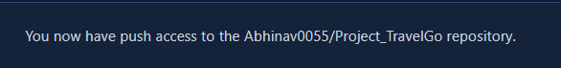

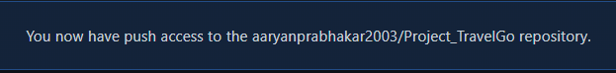

* Now all members are ready to contribute to the project.

**Experiment No. 02**

# Aim: Create a pull request on a team member’s repo and close pull requests generated by team members on own Repo as a maintainer

Create a new Repository in the existing Organization, and commit the required files.

To create a pull request on a team member’s repository and close requests by any other team members as a member follow the procedure given below: -

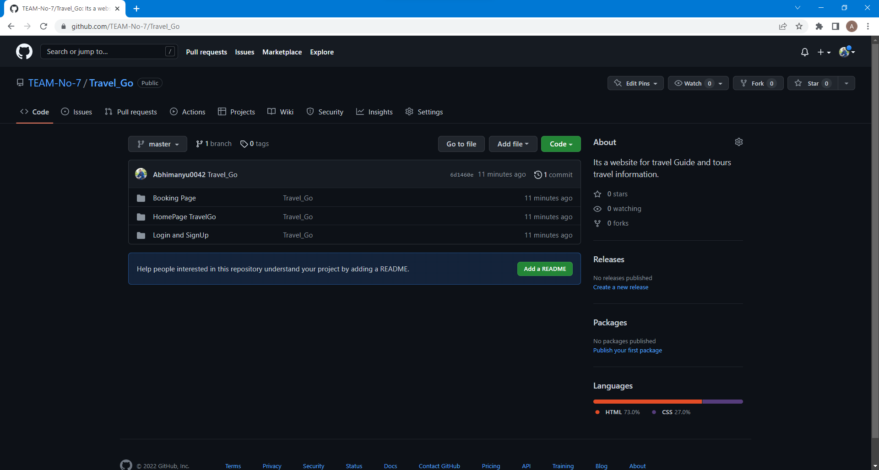

* 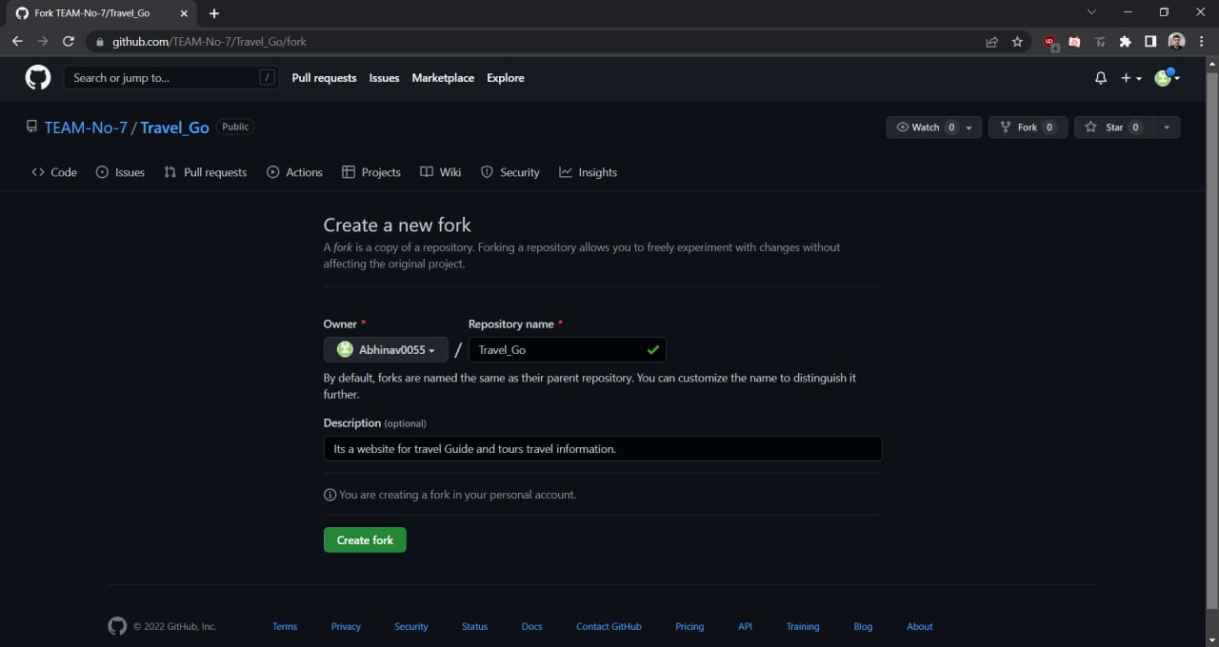First, we have to fork the existing repository.
* 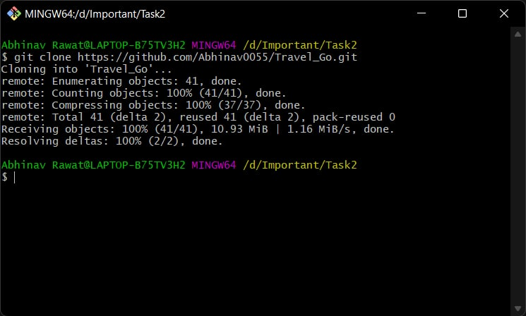Then clone the repository in your existing Directory.
* Create a new branch on the existing repository say its name is ‘abhinav’ and use git checkout command to switch to the new branch.

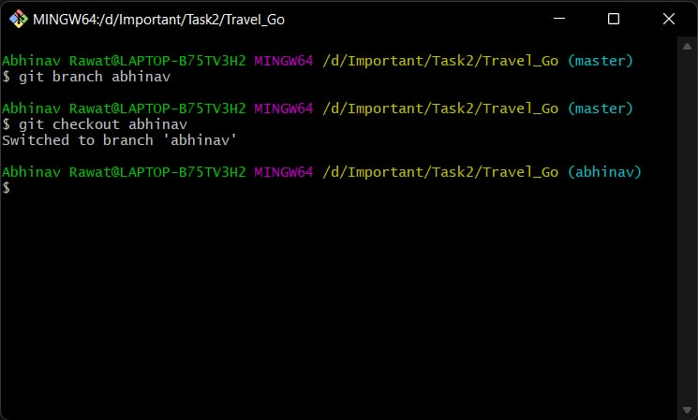

* Do the required changes in the repository, add and commit these changes in the local repository in old branch ‘master’.
* 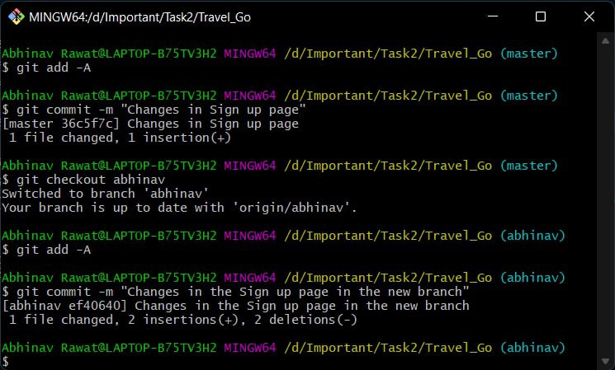Now do the following changes in the new branch.
* Push the modified branch using git push origin branch name.

* 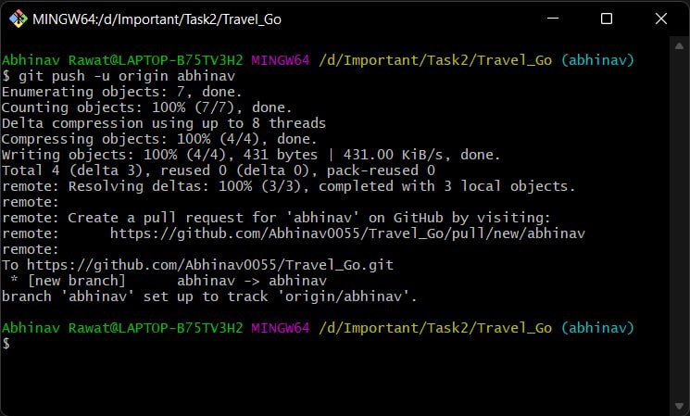Open a pull request by following the procedure from the above experiment.
* 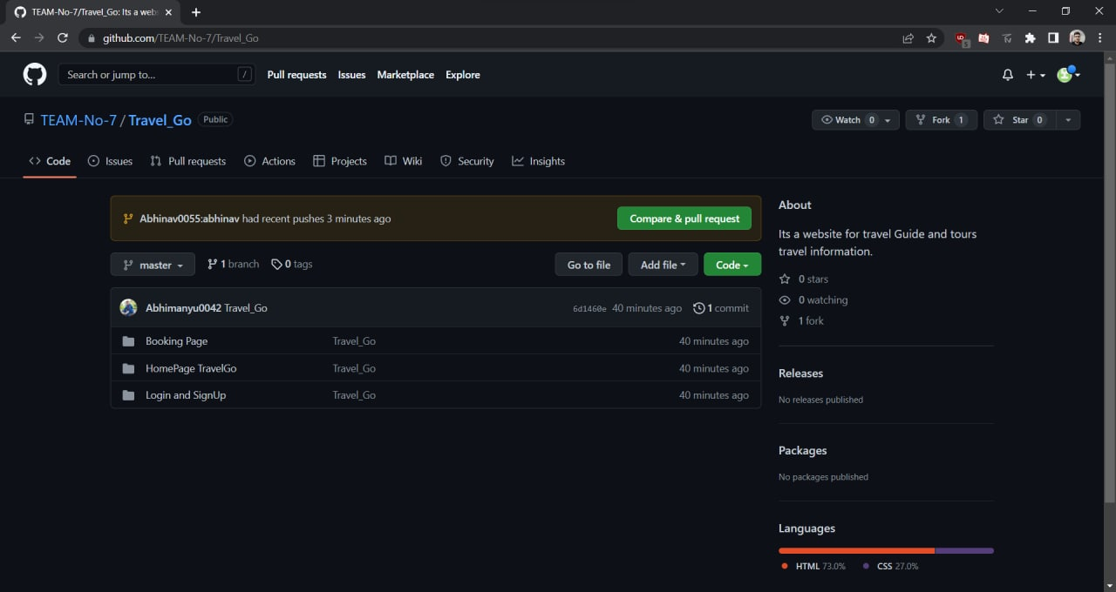The pull request will be created and will be visible to all the team members.

* Click on it. The pull request generated by you will be visible to them.
* Click on the pull request. Two options will be available, either to close the pull request or merge the request with the main branch.

**Experiment No. 03**

# Aim: Resolving the merge conflict created by the pull request

* 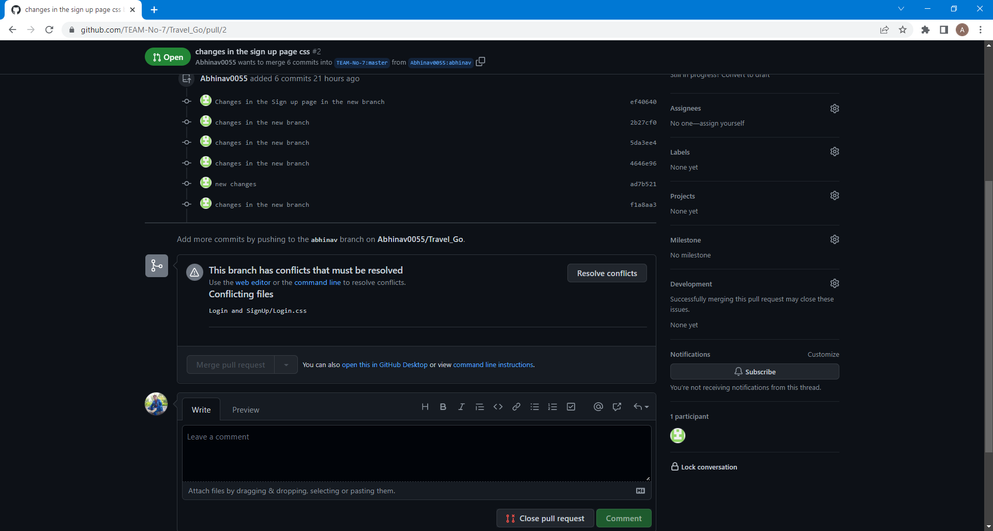To resolve the conflict occurring in the new branch, click on the resolve conflict button.
* After clicking the button, conflict will be displayed as shown below.
* 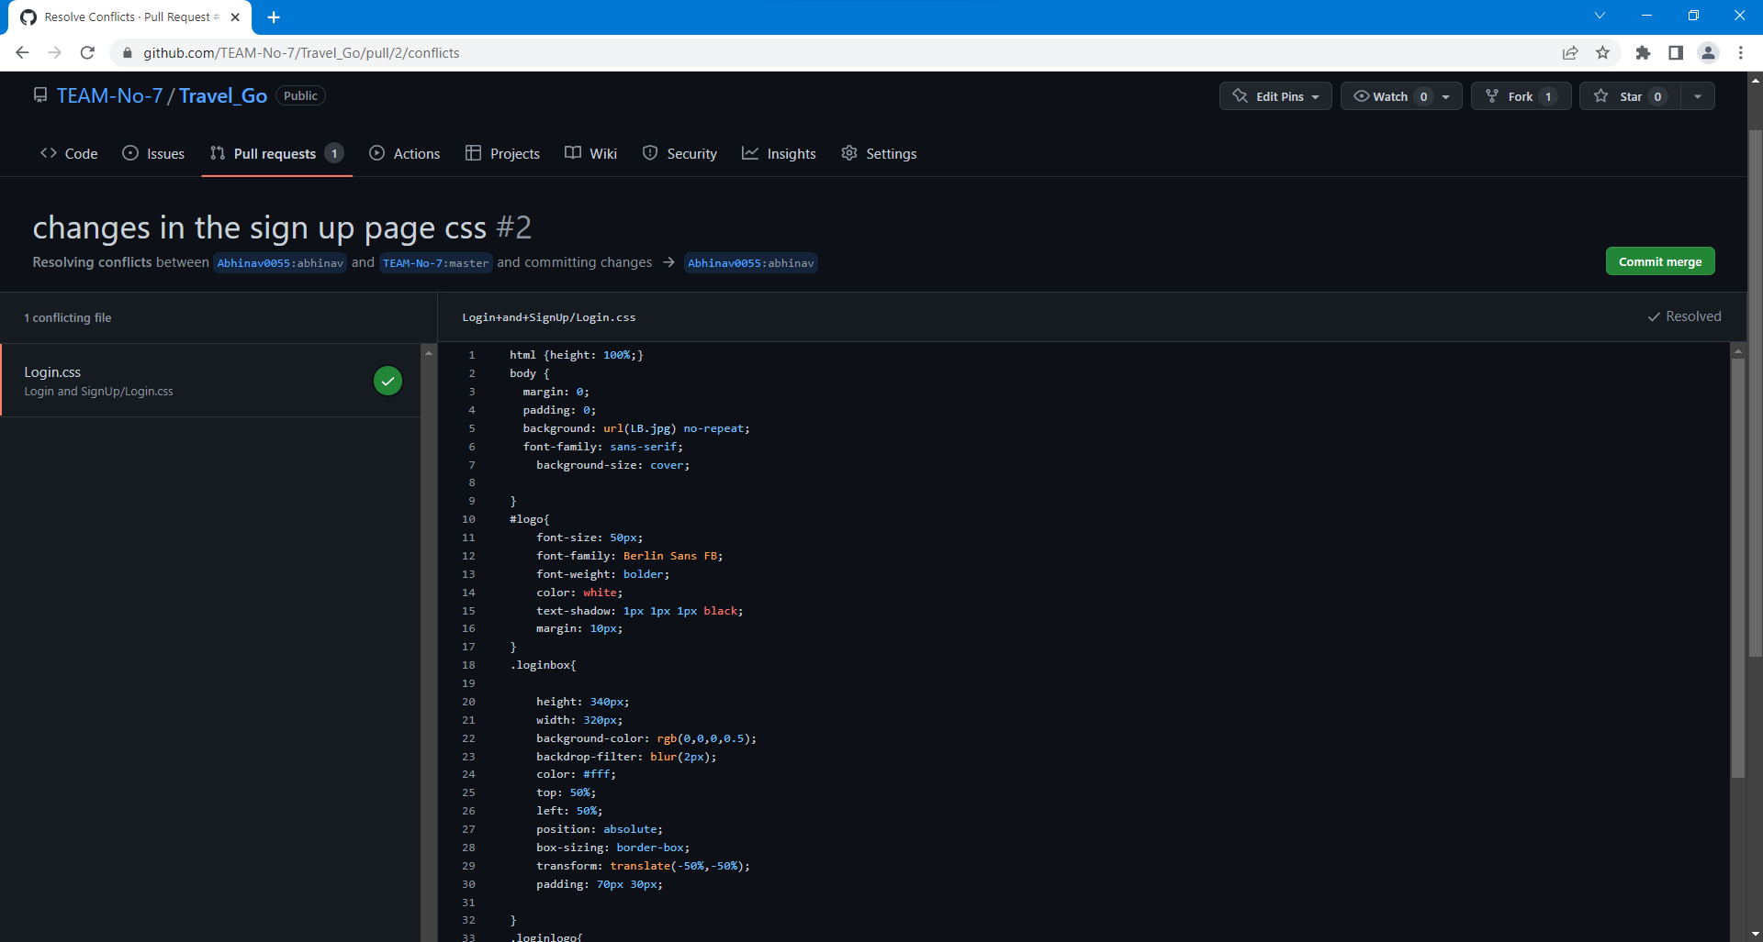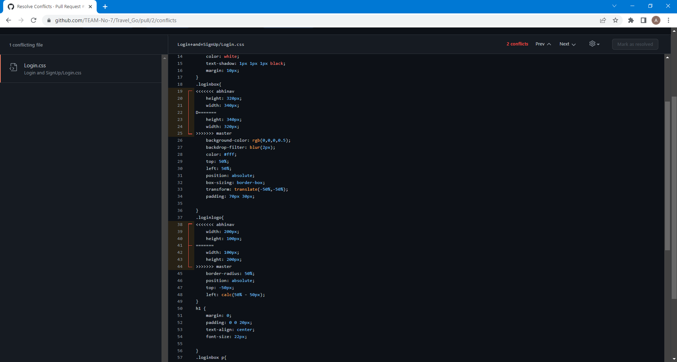After resolving the conflict, click on ‘Mark as resolved’ button. Now click on the ‘Commit merge’ button.
* By clicking the ‘Commit merge’ button, branch will be merged with the default ‘master’ branch. We can select ‘close the pull request’ button, the pull request is not accepted and not merged with main branch.
* 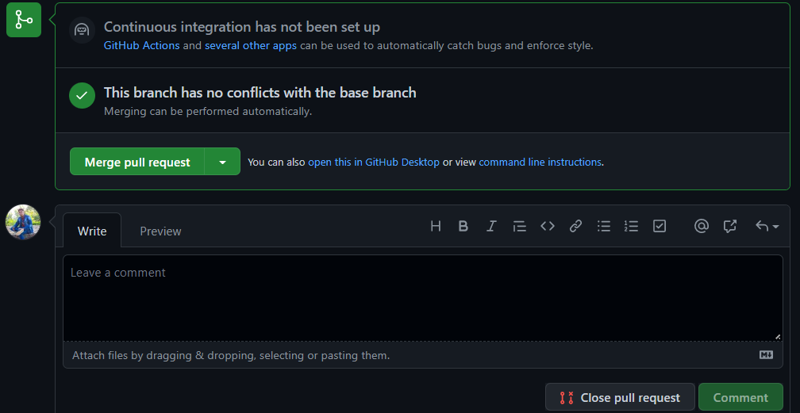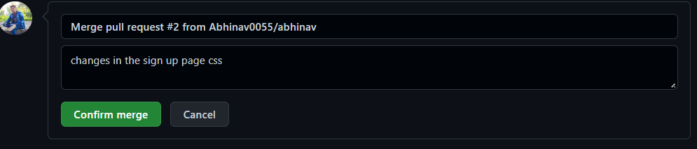By clicking the ‘merge pull request’, a dialogue box will appear where we can edit commit message.



* The process is similar to closing and merging the pull request by you. It simply includes an external party to execute.
* 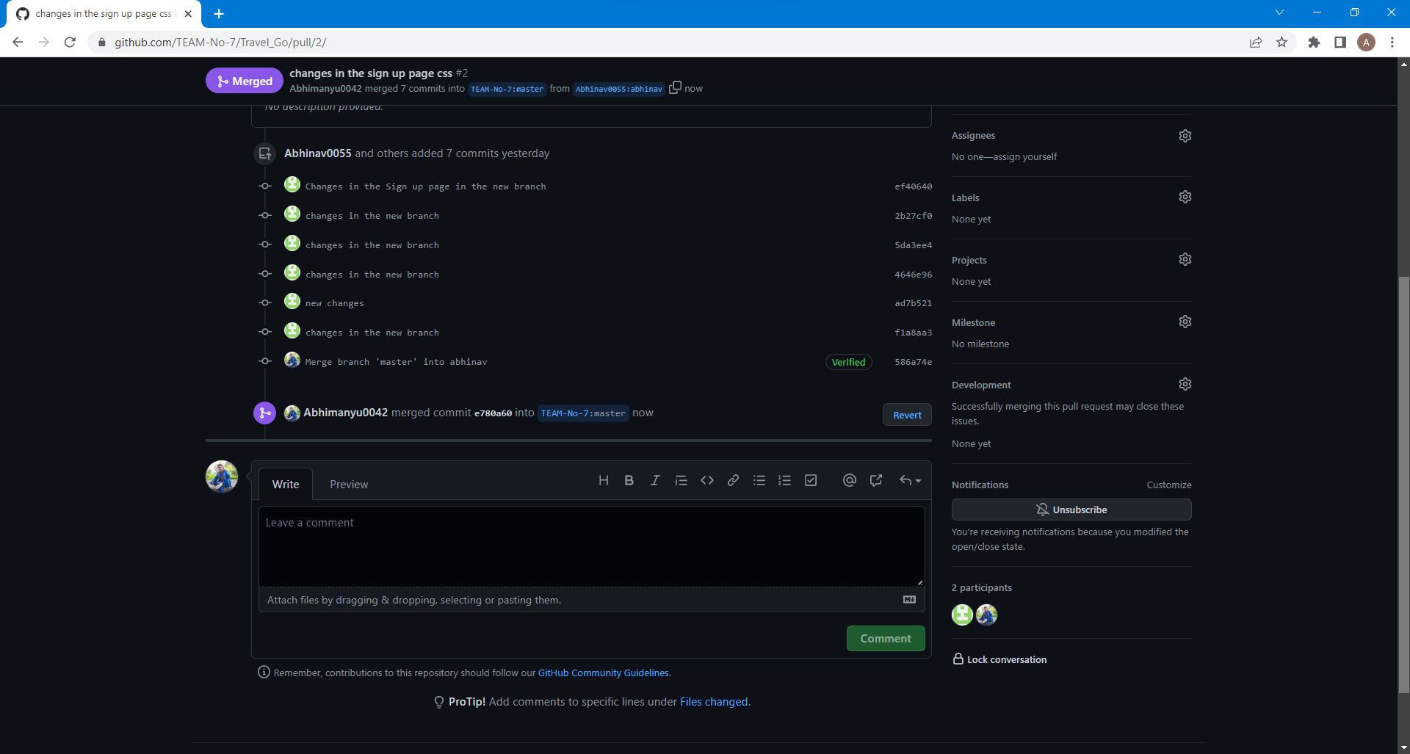The result of merging the pull request is shown below.
* 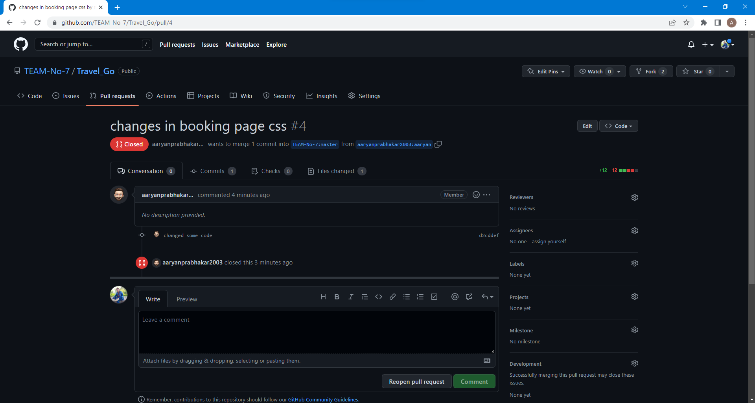Now for instance if we close a certain pull request, the below page will appear.
* Thus, we conclude opening and closing of pull request. We also conclude merging of the pull request to the main branch.