<Convenience Store Sales

Management Database Specification>

Software Development Plan (Small Project)

Version <1.0>

[Note: The following template is provided for use with the Rational Unified Process. Text enclosed in square brackets and displayed in blue italics (style=InfoBlue) is included to provide guidance to the author and should be deleted before publishing the document. A paragraph entered following this style will automatically be set to normal (style=Body Text).]

[To customize automatic fields in Microsoft Word (which display a gray background when selected), select File>Properties and replace the Title, Subject and Company fields with the appropriate information for this document. After closing the dialog, automatic fields may be updated throughout the document by selecting Edit>Select All (or Ctrl-A) and pressing F9, or simply click on the field and press F9. This must be done separately for Headers and Footers. Alt-F9 will toggle between displaying the field names and the field contents. See Word help for more information on working with fields.]

Revision History

|  |  |  |  |
| --- | --- | --- | --- |
| **Date** | **Version** | **Description** | **Author** |
| <dd/mmm/yy> | <x.x> | <details> | <name> |
|  |  |  |  |
|  |  |  |  |
|  |  |  |  |

Table of Contents

1. Introduction 4

1.1 Purpose 4

1.2 Scope 4

1.3 Overview 4

2. Project Overview 4

2.1 Project Purpose, Scope, and Objectives 4

2.2 Assumptions and Constraints 4

2.3 Project Deliverables 4

3. Project Organization 4

3.1 Organizational Structure 4

3.2 Roles and Responsibilities 4

4. Management Process 4

4.1 Project Estimates 4

4.2 Project Plan 4

4.2.1 Phase Plan 4

4.2.2 Iteration Objectives 4

4.2.3 Releases 4

4.2.4 Project Schedule 4

4.2.5 Project Resourcing 4

4.3 Project Monitoring and Control 4

4.3.1 Requirements Management 4

4.3.2 Reporting and Measurement 4

4.3.3 Risk Management 4

4.3.4 Configuration Management 4

Software Development Plan (Small Project)

# 

# Introduction

[The introduction of the **Software Development Plan** provides an overview of the entire document. It includes the purpose, scope, definitions, acronyms, abbreviations, references, and overview of this **Software Development Plan**.]

## Purpose

[Specify the purpose of this **Software Development Plan**. The text below is provided as an example**.** ]

The purpose of the *Software Development Plan* is to gather all information necessary to control the project. It describes the approach to the development of the software and is the top-level plan generated and used by managers to direct the development effort.

The following people use the *Software Development Plan*:

* The **project manager** uses it to plan the project schedule and resource needs, and to track progress against the schedule.
* **Project team members** use it to understand what they need to do, when they need to do it, and what other activities they are dependent upon.

## Scope

[A brief description of the scope of this **Software Development Plan**; what Project(s) it is associated with and anything else that is affected or influenced by this document. The text below is provided as an example.]

This *Software Development Plan* describes the overall plan to be used by the <project name> project, including deployment of the product. The details of the individual iterations will be described in the Iteration Plans.  
The plans as outlined in this document are based upon the product requirements as defined in the *Vision Document*.

## Overview

[This subsection describes what the rest of the **Software Development Plan** contains and explains how the document is organized. The text below is provided as an example.]

This *Software Development Plan* contains the following information:

Project Overview — provides a description of the project's purpose, scope, and objectives.  It also defines the deliverables that the project is expected to deliver.

Project Organization — describes the organizational structure of the project team.

# Project Overview

## Project Purpose, Scope, and Objectives

[A brief description of the purpose and objectives of this project and a brief description of what deliverables the project is expected to deliver.]

## Assumptions and Constraints

[A list of assumptions that this plan is based and any constraints, for example. budget, staff, equipment, schedule, that apply to the project.]

## Project Deliverables

[A list of the artifacts to be created during the project, including target delivery dates. The text below is provided as an example.]

# Project Organization

## Organizational Structure

[Describe the organizational structure of the project team, including management and other review authorities.]

## Roles and Responsibilities

[Identify the project organizational units that will be responsible for each of the disciplines, workflow details, and supporting processes. The text below is provided as an example.]

|  |  |
| --- | --- |
| **Person** | **Role** |
| Sally Slalom, Senior Manager |  |
| Matt Mogul, VP Operations |  |
| Tom Telemark, Senior Software Engineer |  |
| Susan Snow, Software Engineer  Henry Halfpipe, Junior Software Engineer  TBD1, Software Engineer  TBD2, Junior Software Engineer |  |
| Patrick Powder, Administrative Assistant | Responsible for maintaining the Project web site, assisting the Project Manager role in planning/scheduling activities, and assisting the Change Control Manager role in controlling changes to artifacts. May also provide assistance to other roles as necessary. |

# Management Process

## Project Estimates

[Provide the estimated cost and schedule for the project, as well as the basis for those estimates, and the points and circumstances in the project when re-estimation will occur.]

Our project would last till the end of this semester (for 6-weeks), with design and build database sample of the database in the back-end and connect with the UI from the front-end to make a complete sample of convenience store management.

The point of this project is making a program for a real convenience store with the real features like: the system control the goods in warehouse, manage all staffs in store, the manager will have more special authorities than sales staff or warehouse staffs, can calculate the money that customers have to pay for what they’ve buy in bag, stored member of the store and plus,…

## Project Plan

[This section contains the schedule and resources for the project.]

Dòng này bỏ được

### Phase Plan

[Include the following:

• Work Breakdown Structure (WBS) — optional for small projects

• a timeline or Gantt chart showing the allocation of time to the project phases or iterations

• identify major milestones with their achievement criteria

Define any important release points and demos.]

* WBS for this project:

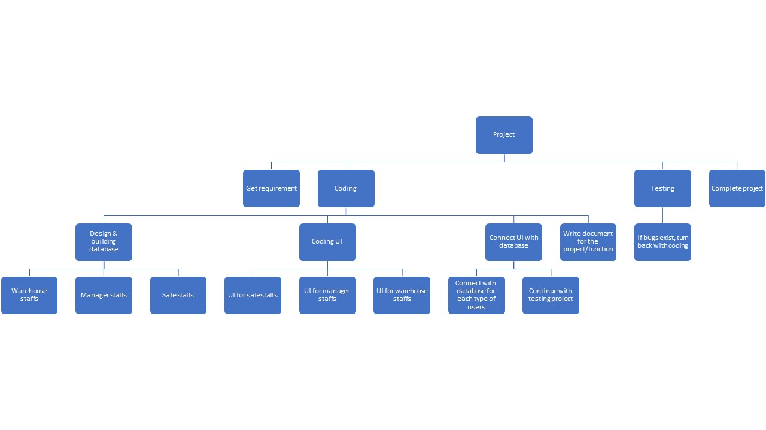

* Gantt Chart for this project:

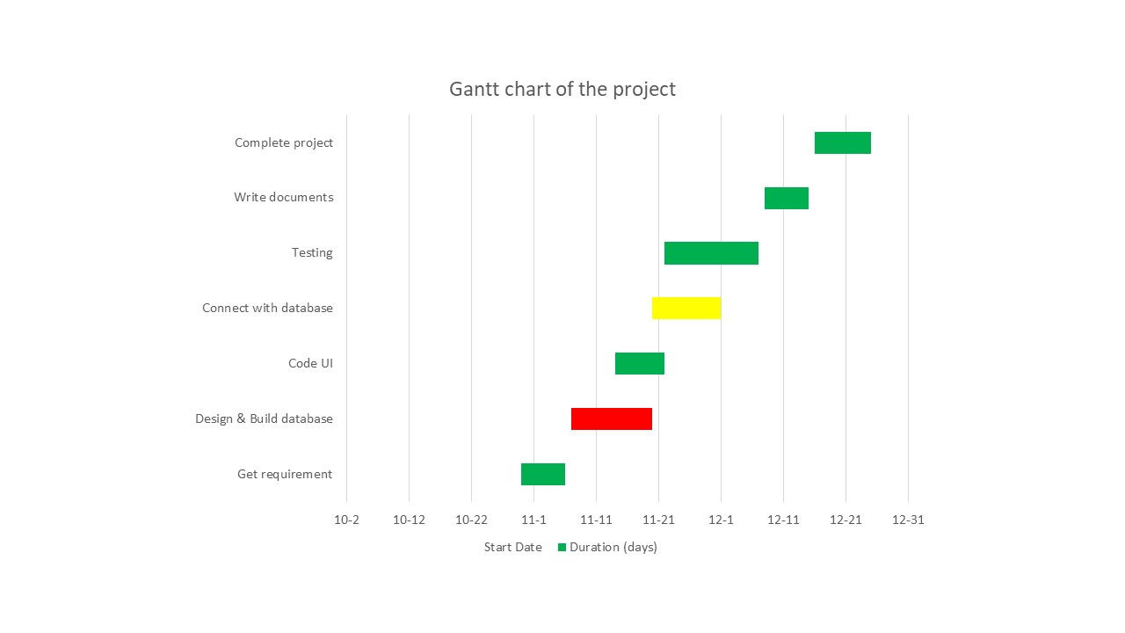

* Important part of this project
  + Well-working database, so we have to build it correctly
  + The user interface has to interactively, easy for user to use
  + The most common problems would get error must be fixed

### Iteration Objectives

[List the objectives to be accomplished for each of the iterations.]

* **Common:**
  + Log in.
  + Change password.
  + Log out.
* **Normal employee:**
  + Insert the bill information to the system.
  + Add member for new guest if they want to register.
  + Read the member customer information.
  + Read the bill information
* **Warehouse staff:**
  + Insert goods information to the system.
  + Insert the supplier information to the system.
  + Delete goods information to the system.
  + Delete the supplier information to the system.
  + Import the goods list to the system.
  + Read the goods information.
* **Manage staff:**
  + Statistics of sales revenue by day, month, year.
  + Statistics of sales revenue by items, item type.
  + Statistics of sales revenue by customer type.
  + Read the staff information.
  + Read the good information.
  + Read the supplier information.
  + Read the bill information.
  + Read the customer information.

### Releases

[A brief description of each software release and whether it’s demo, beta, and so on.]

Not having any demo or beta program yet.

### Project Schedule

[Diagrams or tables showing target dates for completion of iterations and phases, release points, demos, and other milestones.]

Can using the Gantt chart upper

### Project Resourcing

 [Identify the numbers and type of staff required here, including any special skills or experience, scheduled by project phase or iteration.

 Describe how you will approach finding and acquiring the staff needed for the project.

 List any special training project team members will require, with target dates for when this training should be completed.]

|  |  |  |
| --- | --- | --- |
| No. | Team’s members name | Roles |
| 1 | Lý Thanh Long | Project manager, provide task for team’s members |
| 2 | Nguyễn Lý Nhật Phương | Design database, build database |
| 3 | Nguyễn Tuấn Phùng | Design database, build database and UI |
| 4 | Hồ Bùi Văn Quang | Code UI, connect with database |
| 5 | Võ Khánh Vy | Code UI, connect with database, secretary for team |

* Special skills that each member have to train for the project:
  + .NET
  + MSSQL
  + Solving transaction/deadlock when occur

## Project Monitoring and Control

 [The following is a checklist of items to consider:

* Requirements Management : Specify the information and control mechanisms which will be collected and used for measuring, reporting, and controlling changes to the product requirements.
* Reporting and Measurement: Describe internal and external reports to be generated, and the frequency and distribution of publication. Specify which metrics should be collected and why.
* Risk Management: Describe the approach that will be used to identify, analyze, prioritize, monitor and mitigate risks. Include a list of risks and their current status.
* Project Close-out: Describe the activities for the orderly completion of the project, including staff reassignment, archiving of project materials, post-mortem debriefings and reports, and so forth.
* Configuration Management: Describe the process by which problems and changes are submitted, reviewed, and dispositioned. Describe how project or product artifacts are to be named, marked, and numbered, including hardware, system software, Commercial-Off-The-Shelf (COTS), plans, models, components, test software, results and data, executables, and so on. Describe retention policies, and the back-up, disaster, and recovery plans. Also describe how the media is to be retained—online, offline, media type, and format.

The text that follows is provided as an example.]

### Requirements Management

The requirements for this system are captured in the Vision document. Requested changes to requirements are captured in Change Requests, and are approved as part of the Configuration Management process.

* + - There is still doesn’t have any change of requirement f

### Reporting and Measurement

Updated cost and schedule estimates, and metrics summary reports, will be generated at the end of each iteration.

The Minimal Set of Metrics, as described in the RUP [Guidelines: Metrics](..\..\..\process\modguide\md_metri.htm), will be gathered on a weekly basis. These include:

Earned value for completed tasks. This is used to re-estimate the schedule and budget for the remainder of the project, and/or to identify need for scope changes.

Total defects open and closed – shown as a trend graph. This is used to help estimate the effort remaining to correct defects.

Acceptance test cases passing – shown as a trend graph. This is used to demonstrate progress to stakeholders.

In addition, overall costs will be monitored against the project budget.

### Risk Management

Risks will be identified in Inception Phase using the steps identified in the RUP for Small Projects activity “Identify and Assess Risks”. Project risk is evaluated at least once per iteration and documented in this table. The risks of the greatest magnitude are listed first in the table.

|  |  |  |
| --- | --- | --- |
| **Risk Ranking (High, Medium, Low)** | **Risk Description and Impact** | **Mitigation Strategy and/or Contingency Plan** |
| Medium | Deadlock while insert data | Build the stored procedure/ function prevent deadlock |
| Medium | Dirty read when read data | Build the stored procedure/ function prevent dirty read |
| High | Wrong query | Carefully build the database |

### Configuration Management

Appropriate tools will be selected which provide a database of Change Requests and a controlled versioned repository of project artifacts.

All source code, test scripts, and data files are included in baselines. Documentation related to the source code is also included in the baseline, such as design documentation. All customer deliverable artifacts are included in the final baseline of the iteration, including executables.