<Project Name>

Use-Case Specification: <Use-Case Name>

Version <1.0>

Revision History

|  |  |  |  |
| --- | --- | --- | --- |
| **Date** | **Version** | **Description** | **Author** |
| 15/11/2019 | 1.0 | Make use-case and specialization for the use-case | Group 4 |

Table of Contents

1. Use-case Model 4

2. Use-case Specifications 4

2.1 Use-case: Add a product to cart 4

2.2 Use-case: Create a new account 4

2.3 Use-case: Statistic per month, year 5

2.4 Use-case: Statistic profit 5

# Use-case Model

[*Put an image of the use-case diagram modeling all use-cases in this section*]

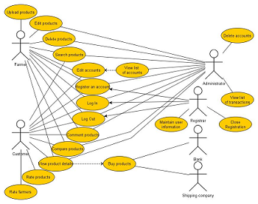

# Use-case Specifications

## Use-case: Add a product to cart

|  |  |
| --- | --- |
| Use case Name | Add a product to cart. |
| Brief description | This use case describes how the Customer can buy a product. |
| Actors | Customer |
| Basic Flow | 1. At the homepage, the user enters keywords on the ‘Search’ field 2. Users clicks on ‘Search’ button to start searching a product 3. System displays the products found 4. User clicks ‘Add to cart’ button on the expected product 5. System adds a new product to shopping cart 6. System displays the quantity of all products in the cart to the user |
| Alternative Flows | **Alternative flow 1: User cannot find products searched**   1. From #1 of the basic flow, user enters another term 2. Continue step #2 in the basic flow   **Alternative flow 2: Shopping cart has already had the product**   1. From #5 of the basic flow, system increases the quantity of the product 2. Continue step #6   **Alternative flow 3: …** |
| Pre-conditions | User goes to homepage at [www.hailua.com.vn](http://www.hailua.com.vn) |
| Post-conditions | The user successfully adds new item to the cart or increases quantity of the existing item in the cart. |

## Use-case: Create a new account

## Use-case: Statistic per month, year

|  |  |
| --- | --- |
| Use case Name | Statistic per month, year |
| Brief description | This use-case shows the user the statistic goods in warehouse (best-selling or inventory). |
| Actors | Manager |
| Basic Flow | * At the manager’s homepage, the manager presses the Statistic per month/year button. * User selects the start date and end date in date box, press show to see the data. * System will show how many products still in warehouse, which one is the best-selling, which is the inventory (depend on numbers of product from the). |
| Alternative Flows | **Alternative flow 1: User cannot find products searched** |
| Post-conditions | The user can see the statistic of the store after one month, many month or year |

## Use-case: Statistic profit

|  |  |
| --- | --- |
| Use case Name | Statistic of profit per month, year |
| Brief description | The use-case is show user the profit of store |
| Actors | Manager |
| Basic Flow | * At manager’s homepage, the manager presses the Statistic profit button * User select the start date and end date in date box, press show to see the data * System will show the total profit of store per month, year. |
| Alternative Flows |  |
| Post-conditions | The user can see the statistic profit of store per month, year. |

## 